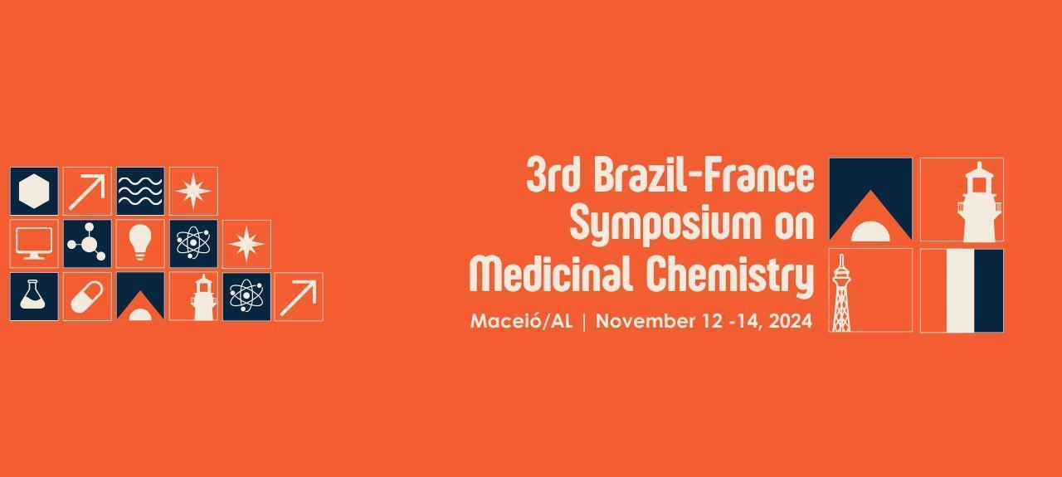
EVALUATION OF THE HEALING ACTIVITY OF 623 NM LIGHT-EMITTING DIODE ASSOCIATED WITH FARNESOL IN RODENTS
Danielle Lucila Fernandes de Araújo (G)¹, Bianca Ventura Medeiros de Araújo, Danielle Custódio Leal , Marcelo Roberto Xavier de Melo, Daniel dos Santos Almeida¹, Juliane Cabral Silva (Prof) ¹
daniellelucila.araujo@gmail.com;
1State University of Health Sciences of Alagoas (UNCISAL); 2 Federal University of the São Francisco Valley; 3 Postgraduate Program in Family Health (PPGSF/RENASF) – center UNCISAL.

Keywords: Cicatrization, Farnesol, Phototherapy

BACKGROUND: The LED (Light Emitting Diode) is a device that emits different wavelengths and is widely used in phototherapeutic therapy, as it accelerates the healing of skin lesions by optimizing angiogenesis and increasing collagen production. However, in contrast to the irradiation generated by LEDs, there is a growing interest in treatments utilizing natural compounds. Farnesol, for instance, is a natural compound that modulates inflammation and also demonstrates wound-healing potential; however, studies comparing the efficacy of farnesol with LED phototherapy remain scarce. Therefore, it is necessary to investigate the effectiveness of both methods in wound repair. OBJECTIVES: To compare the effects of phototherapeutic resources (low-intensity red LED) and natural products, such as farnesol, in the treatment of skin wounds in mice. METHODS: The study, approved by the Animal Ethics Committee of UNCISAL, was experimental, randomized, and double-blind, involving 72 Swiss albino mice. The animals were divided into four groups: A (red LED), B (red LED + Natrosol), C (red LED + Farnesol), and D (red LED + Bepantol). Farnesol was applied in gel form, while the LED emitted light at a wavelength of 623 nm. After anesthesia, a 1 cm skin lesion was created on the mice. Treatment began on the day of the procedure and lasted for 21 days, with daily assessments of the wound, including area, contraction, evaluation of edema, and secretion. The LED was applied for 5 minutes prior to the gel substance corresponding to each group. Data were statistically analyzed using GraphPad Prism 5® software. RESULTS / DISCUSSION: After 7 days of treatment, Group B exhibited a greater reduction in lesion area compared to Group A. In the other groups, no significant differences were observed, even at 14 days. At the end of the experiment, on day 21, Group C showed the greatest wound contraction, which was significant compared to Groups A and B. Research has also been conducted on the efficacy of the combination of LED and natural oils in certain types of treatments, indicating its anti-inflammatory effect in bacterial infections; however, the association between farnesol and LED has not been specifically tested. Nevertheless, in the present study, no significant differences were found regarding the inflammatory process among the groups, except for Group D, which exhibited edema up to day 10. CONCLUSION: The combination of farnesol and LED may not be effective, as no significant differences were observed compared to the control groups. The study suggests the need for further research on these methods.
ABSTRACT

