
EXPLORING THE ANTI-UREOLYTIC POTENTIAL OF BIGINELLI ADDUCTS: A COMPUTATIONAL STUDY
Nathalia Monteiro Lins Freire (PG),¹ Nathália Evelyn Morais Costa (PG),² Pedro Henrique Costa dos Santos (PG),² Victorya Gabryelle Silva Medeiros (PG),¹ Ari Souza Guimaraes (PG),¹ Josué Carinhanha Caldas Santos (Prof),¹ Júlio Cosme Santos da Silva (Prof),¹ Luzia V. Modolo (Prof)², Eduardo E. Alberto (Prof)², Angelô de Fátima (Prof)², Thiago Mendonça de Aquino (Prof)¹.
nathalia.freire@icf.ufal.br
¹ Federal University of Alagoas, ² Federal University of Minas Gerais.
Keywords: Urease inhibitors, Biginelli adducts, Molecular dynamics, DFT.
ABSTRACT
Urease is considered a virulence factor of human pathogens, including Helicobacter pylori, Cryptococcus neoformans, Proteus mirabilis, and Klebsiella aerogenes. Bacteria whose metabolism and survival rely on urease often exhibit antibiotic resistance, making the treatment challenging. Because of this resistance, urease-dependent bacteria have been recognized by the World Health Organization (WHO) as priority pathogens. The antiureolitic activity of Biginelli Adducts (BA) has been documented in the literature. Boric acids and boronic acids are well-known urease inhibitors, Benini et al. suggest that B(OH)₃ could interact with Ni(II). It was suggested that boric acid inhibits urease through a mechanism involving a binding topology like urea, thereby functioning as a competitive inhibitor. The in-silico simulations utilized the co-crystallized structure of Jack bean urease (PDB entry: 4H9M) sourced from the Research Collaboratory for Structural Bioinformatics Protein Data Bank (RCSB PDB) (htt ps://www.rcsb.org/). Initially, the native conformation of the target protein was acquired through preliminary molecular dynamics (MD) simulations, and subsequently it was performed molecular docking studies in GOLD. The lowest energy binding pose of the ligand was chosen as the initial conformation for further 200 ns MD simulations of the protein–ligand complex in DESMOND. The models for DFT calculations were based on the residues located within a 4.0 Å radius of the nickel ions in the final MD simulated structures. These DFT calculations were conducted using the ωB97x-D3/def2-SVP level of theory with the DFT modules in ORCA version 5.0.1. As results, the in-silico study aimed to elucidate the interactions between Biginelli Adduct derivatives 4b and 4e and the target residues. Furthermore, both complexes were stabilized by ionic interactions and hydrogen bond involving key residues for urease activity, such as His407, His409, KCX490, His519, His545, and Asp633. For derivative 4b, density functional theory (DFT) geometry optimization revealed that the proton of the OH group in KCX is transferred to the His519 residue. This proton transfer facilitates the displacement of His519 from the first coordination sphere of Ni(II) and enables direct covalent coordination of KCX via the O-Ni chemical bond. Conversely, DFT calculations suggest that for compound 4e, the coordination process involves the formation of a covalent monodentate bond between the OH group of the boronic acid and one of the Ni(II) ions, with the spatial orientation of the KCX490 residue not facilitating the proton transfer observed in the 4b coordination process. In conclusion, docking studies indicate that the interaction of 4e with urease is likely through coordination of its carbonyl or boronic acid group with the nickel atoms present in the enzyme active site. The ability of Biginelli adducts bearing thiourea and boronic acid moieties to reversibly bind to urease make such urease inhibitors eligible as additive for incorporation into urease as a strategy to decrease nitrogen losses in agriculture due to ammonia volatilization.
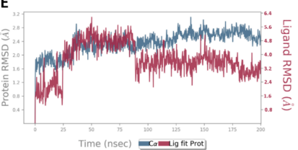
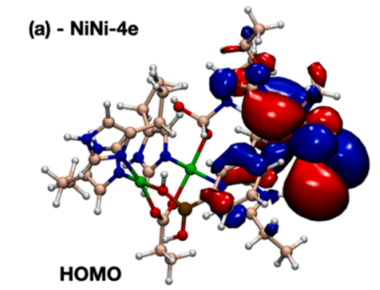
Figure 1: RMSD plots of the urease backbone and ligands 4e and Frontier Kohn-Sham frontier molecular orbitals calculated.

