KNOWLEDGE MANAGEMENT FOR INNOVATIONS BASED ON THE WISDOM OF AMAZONIAN PEOPLES

Raizza Miranda¹, Alvimar Lucena Costa Junior¹, Adriana Kinoshita² , Níssia Bergiante³, Carmen Belderrain¹ e Carlos Nobre²

¹Instituto Tecnológico de Aeronáutica, Departamento de Ciência e Tecnologia Aeroespacial CEP 12.228-900 – São Jose dos Campos – SP – Brazil
² Universidade de São Paulo (USP) – CEP 05508-010 – São Paulo – SP – Brazil
³Universidade Federal Fluminense, Departamento de Engenharia de Produção - CEP 24220-900 – Niteroi – RJ - Brazil

raizzamiranda@gmail.com, alvimar.lucena@gmail.com, satiko218@gmail.com, nissiabergiante@id.uff.br, carmen.beld@gmail.com

Abstract. This study explores how knowledge management in sustainable innovation ecosystems integrates indigenous wisdom and modern strategies to drive innovation and sustainability. Indigenous knowledge, developed over millennia, provides valuable insights into sustainable management, agriculture, and healing traditions. By combining this wisdom with social technologies and scientific approaches, the research identifies leverage points for co-creating solutions that enhance cultural heritage and community well-being. Using system dynamics principles, a causal loop diagram (CLD) maps interactions between variables, revealing the transformative role of R&D investment. This variable is identified as central to fostering incremental and disruptive innovations, addressing systemic imbalances, and promoting local value retention through bioindustrialization. The findings demonstrate that integrating traditional and modern knowledge strengthens collaboration networks, mitigates structural barriers, and generates social, economic, and environmental benefits. The study concludes that prioritizing indigenous wisdom alongside robust R&D strategies is critical for sustainable innovation and resilience. Public policies supporting community autonomy and local innovation are essential for long-term socio-environmental sustainability.

Keywords: Knowledge management; Sustainable innovation; System dynamics.
Área Temática: Sistemas Complexos, Pensamento Sistêmico e Teorias Sistêmicas;

- Introduction
Indigenous knowledge represents a vast repository of wisdom accumulated over millennia, encompassing practices in sustainable management, healing, agriculture, and more. (Zidny, Jesper, e Ingo 2020) explain that this body of knowledge reflects particular worldviews developed by diverse Indigenous peoples. Unlike Western science, which often fragments knowledge into specializations, Indigenous wisdom is inherently systemic, integrating the interdependence between human beings and nature. This knowledge is exceptionally rich as it offers alternative perspectives on nature and science, frequently diverging from conventional Western approaches (Zidny, Jesper, e Ingo 2020).
The application of modern knowledge, combined with the use of social technologies, methods and processes adapted to local, cultural, and environmental contexts, allows these traditional insights to be leveraged in addressing contemporary challenges. Recent research highlights that the co-production of knowledge systems, integrating Indigenous wisdom and Western science in educational and academic contexts, strengthens Indigenous sovereignty, promotes mutual respect, and contributes to more sustainable innovations (Jones, Williams-Jones, e Nyce 2025). In this sense, when science and technology engage respectfully and complementarily with Indigenous practices, they foster not only innovative solutions but also the recovery of communities’ leading role in shaping their own development trajectories.
In this context, knowledge management emerges as an essential factor in developing sustainable innovations, especially in scenarios that require the integration of traditional and scientific knowledge.
Knowledge management, according to Nonaka & Von Krogh, (2009), involves the creation, expansion, and integration of individual knowledge into the organizational knowledge system. The authors propose that organizational knowledge is based on two main types: tacit knowledge, which is subjective, intuitive, and related to personal experiences, and explicit knowledge, which is formal and can be articulated in words, numbers, and documents. The process of converting knowledge between these two forms (tacit and explicit) is central to innovation and learning in organizations. This process is known as the SECI model (Socialization, Externalization, Combination, and Internalization), which explains how tacit knowledge can be transformed into explicit and vice versa, promoting the creation of new organizational knowledge.
In this perspective, the effective management of knowledge becomes a key enabler of sustainable innovation. Sustainable innovation is defined as the development of new practices, products, or services that create value in a way that balances the three pillars of sustainability: economic, social, and environmental (Elkington 1998). Moreover, product innovation can be understood as the introduction of goods or services that present substantial improvements, whether in their technical characteristics, raw materials used, incorporated software, or even in ease of use and functionality. These innovations can significantly transform a product's value and applicability in the market (OECD 2005). This concept is particularly relevant when considering the need to incorporate indigenous peoples' traditional knowledge into new products and services that promote sustainability and economic development in their communities.
In this study, the Amazon emerges as the central context for analyzing the integration of Indigenous knowledge and modern strategies. The region, recognized as one of the planet’s largest socio-biodiversity reserves, faces critical challenges such as deforestation, climate change, and biopiracy, which directly affect both ecosystems and local communities. These systemic pressures threaten not only ecological balance but also the cultural continuity and well-being of Indigenous peoples, whose traditional knowledge plays a fundamental role in managing biodiversity and ensuring sustainability (Miranda et al. 2023). Addressing these challenges requires innovative approaches that combine scientific and technological resources with Indigenous wisdom, thereby strengthening community autonomy and promoting inclusive socio-bioeconomic development in the Amazon.
The integration of diverse knowledge systems, such as indigenous and scientific, has the potential to generate new approaches and solutions to contemporary challenges in environmental governance and organizational sustainable development. This is especially relevant in the context of the Brazilian Amazon rainforest where local communities possess fundamental knowledge for managing their territories and maintaining biodiversity.
The use of collaborative approaches and the creation of knowledge co-production networks, as suggested in studies on open science practices and communities of practice (Roca and Ochoa-Arias, 2024), demonstrate how this integration can lead to innovation and resilience in complex systems. Such networks promote continuous knowledge exchange and the creation of new adaptive solutions, fostering more effective ecosystem management.
Thus, our research seeks to understand how knowledge management in sustainable innovation ecosystems can integrate indigenous peoples' traditional wisdom by identifying strategic levers to drive innovation and promote sustainable solutions.
In this sense, the objective of this work is to systematically analyze how knowledge management in sustainable innovation ecosystems can identify strategic levers to foster innovation, while integrating indigenous peoples' traditional wisdom and promoting innovative solutions.
The interplay between indigenous wisdom and scientific knowledge presents a unique opportunity to create sustainable innovations that balance environmental, social, and economic priorities. However, this integration demands a systemic approach to understanding the dynamics of knowledge creation, diffusion, and application within complex socio-environmental ecosystems.
By employing principles of knowledge management and systemic thinking, this research seeks to identify strategic levels that can bridge traditional and modern practices, fostering innovations that respect cultural heritage while addressing contemporary challenges. The objective is to explore how these processes can catalyze transformative solutions, ensuring that both indigenous and scientific knowledge contribute equitably to the development of sustainable innovation ecosystems.

- Problem Context
The integration of knowledge systems is an urgent necessity in addressing the inequalities and challenges faced by Indigenous peoples within the context of global sustainability. Indigenous peoples, particularly in the Brazilian Amazon, are often relegated to marginalized positions, while their vast reserves of traditional knowledge remain underutilized or exploited without equitable benefits. This knowledge, accumulated over millennia, embodies a holistic and systemic worldview, emphasizing the interconnectedness between humans and nature. Zhang et al., (2021) highlight that innovation in complex networks relies on effective collaboration among diverse stakeholders. However, the lack of integration between Indigenous knowledge and scientific systems limits its contribution to innovative and sustainable solutions, perpetuating cycles of exclusion and vulnerability. This complex interaction between distinct knowledge systems can be illustrated in Figure 1.
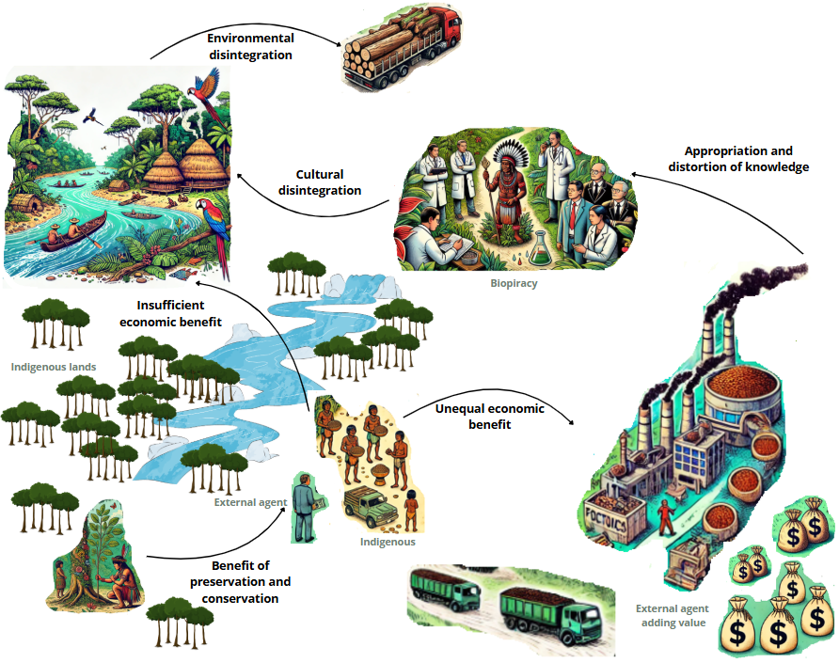
Figure 1. Problematic Situation
The benefits derived from preservation and conservation of Indigenous territories are largely appropriated by external actors. While these actors concentrate the gains and obtain disproportionate economic benefits, local communities remain restricted to insufficient returns, which deepens their condition of vulnerability. As highlighted by Miranda et al., (2023), such exclusion reinforces systemic traps that combine poverty, environmental degradation, and economic marginalization. In this sense, the absence of fair redistribution weakens the social foundations that could sustain preservation itself, reinforcing a logic of environmental disintegration, since communities are not empowered to guarantee the continuity of sustainable territorial management (Barros 2024). Furthermore, when external actors who capture the greatest share of benefits also appropriate and distort traditional knowledge, whether through biopiracy or through market-oriented reinterpretations of ancestral wisdom, a process of cultural disintegration is set in motion. Tengö et al., (2014) caution that the failure to validate knowledge within its own systems results in the loss of complementarities and undermines the creation of equitable solutions. The erosion of practices, rituals, and ways of life weakens the bonds of communities with their territories, which in turn increases vulnerability to extractive pressures and accelerates environmental disintegration, confirming Kusumastuti et al., (2022) critique that conventional development models tend to reproduce cultural and ecological inequalities.
Miranda et al., (2023) emphasize that systemic models are essential to understanding the interactions between poverty, environmental degradation, and economic exclusion, providing a framework to break cycles of vulnerability and elevate Indigenous knowledge. Both perspectives converge on the idea that articulating these systems can foster innovations that respect local realities while addressing global sustainability challenges.
Despite the potential of this integration, significant barriers persist, such as the lack of participatory mechanisms that promote horizontal dialogue and respect Indigenous cultural structures. Nonaka & Von Krogh, (2009) argue that the conversion of tacit knowledge into explicit knowledge is crucial for creating innovations tailored to the specific needs of communities, but they caution that the process must preserve cultural integrity. Tengö et al., (2014) further stress the importance of validating knowledge within its own systems, avoiding a scientific imposition that could undermine its original value.

- Materials and Method
This section outlines the methodological approach used to explore the complex relationships between knowledge systems and innovation dynamics within socio-environmental ecosystems. Figure 2 illustrates the methodological process, which integrates the principles of System Dynamics to model and analyze feedback loops and interactions that drive sustainable innovation. The study adopts a structured sequence to systematically identify key variables, map their interconnections, and uncover leverage points that promote resilience and strategic decision-making within the system.

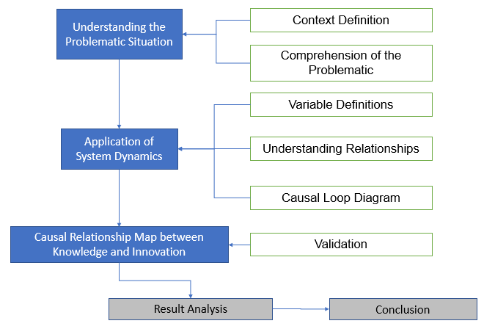
Figure 2. Methodological Process

  - Understanding the Problematic Situation
This phase involves two initial steps:
Step 1 - Context Definition: Identify and define the central problem or context to be studied.
Step 2 - Comprehension of the Problematic Situation: Analyze the problem in depth by integrating insights from the literature and empirical evidence.

  - Application of System Dynamics Concepts
After the initial understanding, System Dynamics is applied in three steps:
Step 3 - Variable Definitions: Identify the key variables that influence the studied system.
Step 4 - Understanding Relationships: Analyze how these variables are interconnected and how they influence each other.
Step 5 - Causal Loop Diagram: Create a diagram that represents the feedback cycles within the system, visualizing the cause-and-effect relationships between variables.

  - Causal Relationship Map between Knowledge and Innovation
The result of these steps is the creation of a Causal Loop Map that illustrates the causal relationships between traditional knowledge and innovation, revealing how they influence each other. In addition to presenting the map as a whole, the analysis involves examining the feedback loops individually, identifying reinforcing and balancing dynamics that explain the systemic behavior observed. This process makes it possible to extract insights into the role of knowledge in innovation ecosystems and to generate recommendations and final reflections. To ensure cultural relevance and legitimacy, the resulting model was validated through consultation with an Indigenous leader recognized for their role in social innovation, whose feedback helped to refine the interpretation of the loops and strengthen the integration between scientific and traditional perspectives. The Causal Loop Map was analyzed using Decision Explorer, which enabled the identification of feedback loops and their interpretation in terms of reinforcing and balancing dynamics. This process allowed us to generate insights into the role of knowledge in innovation ecosystems and to formulate recommendations and final reflections.

- Results and Discussion

  - Variable definition
The variables defined in this study represent the multidimensional nature of the system under analysis. They highlight the intricate relationships and dynamics inherent to socio-environmental ecosystems, particularly those aiming for sustainable innovation and community development. The conceptual basis of these variables is supported by a broad body of literature, including: Alavi and Leidner (2001), Choo (2006), Davenport and Prusak (1998), Drucker (1993), Elkington (1997), Fagerberg, Mowery and Nelson (2005), Galanakis (2006), Kusumastuti et al. (2022), Meadows (2008), Moellers et al. (2019), Nonaka (1994), Nonaka and Takeuchi (1995), Nonaka and von Krogh (2009), OECD (2005), Roca and Ochoa-Arias (2024), Rubenstein-Montano et al. (2001), Schumpeter (1934), Sterman (2000), Tapsell and Woods (2014), Trott (2005), Wierzbicki and Nakamori (2005), Zidny, Sjöström and Eilks (2020), and Zhang et al. (2021):

- Indigenous Wisdom: Represents the collective knowledge, practices, and traditional values of indigenous communities, forming the foundation for sustainable practices and cultural preservation.
- Cultural Heritage: Refers to the transmission of traditions, practices, and cultural values across generations, ensuring continuity and identity.
- Intangible Value: Denotes spiritual, cultural, and social values that strengthen collective identity and cohesion.
- Social Construction: Highlights how knowledge is socially constructed through interactions and shared visions among actors.
- Intergenerational Transmission: Ensures that knowledge and practices are passed down across generations, preserving cultural and social identity.
- Community Well-being: Refers to the social, economic, and cultural quality of life of community members.
- Opportunity: Conditions that enable innovation and economic activities, creating pathways for development.
- Tangible Value: Direct economic benefits generated through the sustainable use of resources.
- Explicit Knowledge: Formalized, documented, and shareable knowledge that promotes organizational learning and collaboration.
- Organizational Learning: The process through which organizations adapt and innovate continuously, leveraging explicit and tacit knowledge.
- Creation of New Knowledge: The process of generating innovative ideas based on existing knowledge.
- Tacit Knowledge: Knowledge embedded in personal experiences and cultural practices, often difficult to formalize.
- Continuous Innovation: Incremental improvements in products, services, or processes, promoting sustainable advancements.
- Worldview: The way communities perceive their social and natural environment, influencing collective decision-making.
- Social Technologies: Technological solutions adapted to the cultural and environmental context of communities.
- Collaborative Networks: Connections between actors to exchange knowledge, foster innovation, and strengthen social ties.
- Co-creation of Value: Collaborative processes where different actors work together to generate economic, social, and cultural value.
- Cultural Disintegration: The weakening or loss of cultural elements, often caused by systemic imbalances.
- Social and Cultural Strengthening: The reinforcement of cultural identity and social cohesion within communities.
- Influence on Public Policies: The impact of public policies on sustainable development and innovation.
- Self-determination: The ability of communities to make autonomous decisions about their territories, practices, and futures.
- Knowledge Diffusion: The process of disseminating knowledge within and outside communities.
- Market Demand: The identified need for products or services that drive the local economy.
- Product Demand: Consumer interest in acquiring local products, particularly those with added value.
- Lack of Access: Barriers that prevent communities from accessing resources, markets, or technologies.
- Biopiracy: The unauthorized or unethical exploitation of natural resources and traditional knowledge.
- External Benefit of Value Addition: Value generated outside the community through resource utilization, without direct local benefits.
- Generation of Community Benefits: Social, economic, and cultural returns to communities from sustainable innovations.
- Functional Economic, Social, Environmental, and Cultural System: A balanced system where economic, social, cultural, and environmental factors interact harmoniously.
- Pathologies: Systemic problems or imbalances negatively affecting communities or the environment.
- R&D Investment: Resources allocated to research and development to create innovative solutions.
- Intercultural Knowledge: The integration of traditional and modern knowledge, fostering adaptive solutions.
- Insufficient Investment: Inadequate financial resources to address complex challenges or pathologies.
- Suppliers of Inputs: Actors responsible for providing materials and resources necessary for productive processes.
- Sufficient Investment: Adequate resources to tackle complex challenges and implement effective innovations.
- Innovative Capabilities: Abilities to create and implement adaptive and disruptive solutions.
- Incremental Innovation: Gradual improvements to existing products, services, or processes.
- Disruptive Innovation: Transformations that replace existing paradigms with new models or technologies.
- Access to Technologies and Capability: Availability of tools and technological resources for communities.
- Local Bioindustrialization: Processing and adding value to local resources to generate high-value products.
- Local Benefit of Value Addition: Economic returns to communities from local resource transformation.
- Systemic Pathology Resolution: Solutions addressing social, environmental, or economic imbalances in an integrated manner.

  - Understanding System Behavior
It is crucial to understand that socio-environmental systems, such as the one analyzed in this study, exhibit intrinsically interconnected and multidimensional dynamics. In this context, Indigenous Wisdom plays a central role, not as a mere resource or tool for exploitation, but as a living essence that reflects the spirit, identity, and values of the communities that preserve it. Its value extends beyond quantification or materialization, being deeply connected to cultural heritage, social cohesion, and well-being, as represented in Figure 3.
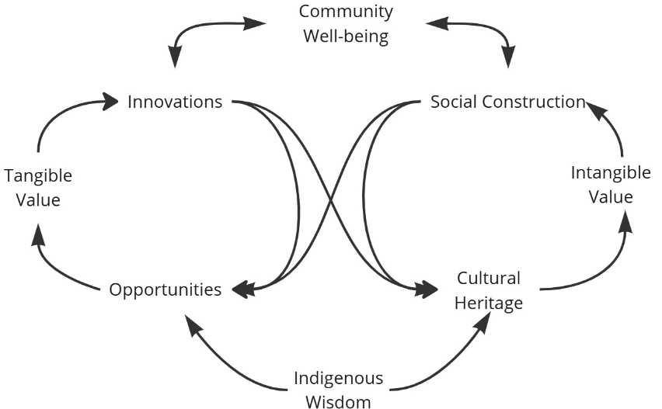
Figure 3. Overview of Indigenous Wisdom
For this analysis, we acknowledge the profound nature of this wisdom, yet we strategically unfold its application to drive the systemic dynamics represented in the model.
The analysis of the Causal Loop Diagram (CLD) enables a deeper understanding of the complex systemic interactions that characterize socio-environmental ecosystems. This section will analyze the dynamic interactions within the system as depicted in Figure 4 (CLD). It will discuss how variables influence one another, emphasizing feedback loops, balancing mechanisms, and reinforcing dynamics.

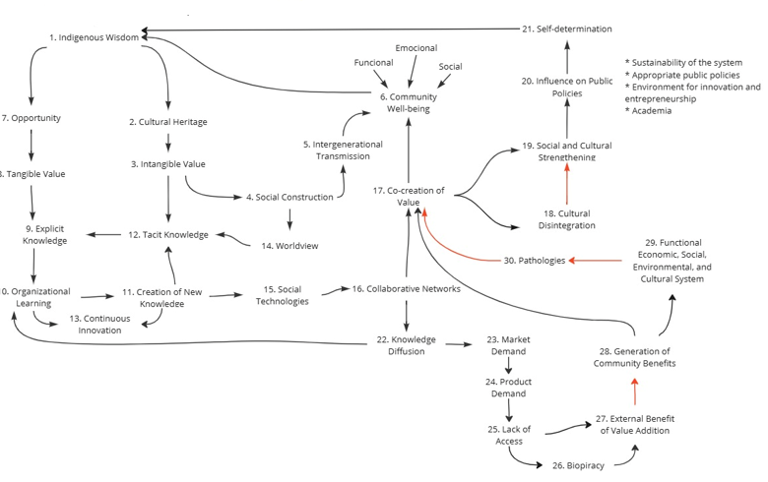
Figure 4. Causal Loop Diagram
Figure 4 shows the knowledge acquired through bibliographic research, in the form of a System Dynamics model. The diagram was then analyzed using Decision explorer, that identified all the feedback loops in the system under study. Decision identified 42 general loops, that were assessed by the authors and from which 4 were chosen as of importance to explain the connection between traditional knowledge and innovation.

  - Loops
- Cultural Resilience and Well-Being (Loop1)
1(+) → 2(+) → 3(+) → 4(+) → 5(+) → 6(+) → 1(+).
This is a Positive Reinforcement Loop 1, where the interaction between indigenous wisdom, cultural heritage, intangible value, social construction, and intergenerational transmission creates a virtuous cycle of cultural preservation and increased community well-being.
Indigenous Wisdom (1) reinforces Cultural Heritage (2) by preserving practices and values passed down through generations. Kusumastuti et al., (2022) highlight that indigenous knowledge is maintained through rituals, traditions, and oral narratives, ensuring cultural continuity. This process guarantees that fundamental practices and values are transmitted and adapted over time, creating a solid foundation for community identity.
Cultural Heritage (2) generates Intangible Value (3), such as spirituality, social cohesion, and collective identity. Tapsell & Woods, (2010) argue that intangible value is intrinsic to communities that maintain a strong connection to their ancestral traditions and practices, reinforcing a sense of belonging and collective purpose (Tapsell e Woods 2010). Moellers et al., (2019) add that these intangible values also create an environment of mutual trust, essential for productive and innovative social interactions.
Intangible Value (3), in turn, promotes Social Construction (4) by articulating a shared vision among community members. Nonaka, (1994) describes social construction as occurring when individuals share tacit and explicit knowledge in interaction spaces, such as community meetings or collaborative projects. This interaction allows for the creation of consensus and common goals, strengthening the foundation for collective actions.
Social Construction (4) facilitates Intergenerational Transmission (5), ensuring that knowledge and practices are perpetuated across generations. Kusumastuti et al., (2022) explain that this intergenerational transmission occurs through family and community networks, where the young learn from the elders, absorbing essential knowledge for cultural continuity. This transmission reinforces not only traditional practices but also their adaptation to modern contexts, creating cultural resilience.
Intergenerational Transmission (5) directly contributes to Community Well-Being (6) in its emotional, functional, and social dimensions. Zhang et al., (2021) note that communities prioritizing intergenerational learning exhibit greater social cohesion, access to opportunities, and economic stability. Additionally, the perpetuation of cultural practices fosters a sense of emotional security and belonging, fundamental for well-being.
Finally, the increase in Community Well-Being (6) positively feeds back into Indigenous Wisdom (1), strengthening worldview and ensuring cultural resilience. Kusumastuti et al., (2022) suggest that communities with high well-being levels tend to value their cultural practices even more, creating a virtuous cycle that preserves and amplifies indigenous wisdom.

- Knowledge Creation and Social Empowerment (Loop2)
1(+) → 2(+) → 3(+) → 12(+) → 9(+) → 10(+) → 11(+) → 15(+) → 16(+) → 17(+) → 19(+) →20(+)→21(+) 1(+)
This is a Positive Reinforcement Loop 1. This Indigenous Wisdom (1) contributes to Cultural Heritage (2) by preserving and transmitting traditional practices and values through generations. Kusumastuti et al., (2022) emphasize that rituals, oral narratives, and collective traditions ensure cultural continuity, laying the foundation for sustainable practices. In turn, Cultural Heritage (2) enriches Intangible Value (3) by fostering spirituality, social cohesion, and collective identity. Tapsell & Woods, (2010) highlight how communities deeply connected to their heritage develop a shared sense of belonging and purpose, strengthening social structures.
Intangible Value (3) enhances Tacit Knowledge (12) by embedding unique cultural insights into everyday practices and experiences. Nonaka, (1994) describes tacit knowledge as deeply rooted in personal and cultural experiences, making it essential for innovation and adaptation. This Tacit Knowledge (12) is transformed into Explicit Knowledge (9) through documentation and formalization, making traditional insights accessible and shareable. Moellers et al., (2019) stress the importance of explicit knowledge in creating systems capable of collective learning and adaptation.
Explicit Knowledge (9) fuels Organizational Learning (10) by enabling communities to adapt and innovate continuously. Zhang et al., (2021) argue that such learning is foundational for empowering communities and fostering resilience. As Organizational Learning (10) deepens, it leads to Knowledge Creation (11), which drives the generation of new ideas and solutions. Knowledge Creation (11), in turn, supports the development of Social Technologies (15), tools tailored to local cultural and environmental contexts. Kusumastuti et al., (2022) note that these technologies integrate traditional practices with modern innovations, enhancing community capabilities.
Social Technologies (15) foster Collaborative Networks (16), facilitating knowledge exchange and cooperation among diverse actors. Tapsell & Woods, (2010) observe that such networks amplify a community’s capacity for innovation and value co-creation. This process leads to the Co-creation of Value (17), where actors collaboratively generate economic, social, and cultural solutions. Nonaka, (1994) emphasizes the significance of shared efforts in driving meaningful innovations.
Co-creation of Value (17) strengthens Social and Cultural Strengthening (19), reinforcing mutual trust and collective identity. Moellers et al., (2019) highlight that this reinforcement creates a sense of pride and ownership, bolstering community resilience. Social and Cultural Strengthening (19) impacts Influence on Public Policies (20) by demonstrating the effectiveness of community-driven approaches. Zhang et al., (2021) argue that cohesive communities often inspire policies that support autonomy and sustainable development. Finally, effective Public Policies (20) enhance Self-determination (21), enabling communities to govern their resources and practices independently. Kusumastuti et al., (2022) suggest that policies aligned with community needs empower local governance and foster sustainable growth.
Finally, Self-determination (21) feeds back into Indigenous Wisdom (1), completing the loop by ensuring that traditional knowledge evolves while maintaining its essence. This Positive Reinforcement Loop highlights how interconnected dynamics drive cultural preservation, social empowerment, and innovation, creating a sustainable and resilient system.

- Sustainable Innovation and Social Dynamics (Loop3)
1(+) → 7(+) → 8(+) → 9(+) → 10(+) → 11(+) → 15(+) → 16(+) → 22(+) → 23(+) → 24(+) → 34(+) → 27(-) → 28(+) → 29(-) → 30(-)→ 17(+) → 18(-) → 19(+) → 20(+) → 21(+) 1(+).
This is a Positive Reinforcement Loop 3, a cycle that demonstrates how Indigenous Wisdom (1) acts as a catalyst for sustainable innovation by connecting traditional practices to modern processes. Indigenous wisdom is fundamental in creating Opportunities (7) by providing the necessary knowledge to identify unique sustainable uses of resources. Kusumastuti et al., (2022) emphasize that traditional knowledge is crucial for leveraging the economic potential of communities while preserving their cultural identity. These opportunities translate into Tangible Value (8), promoting direct economic benefits that can be formalized as Explicit Knowledge (9), essential for organizational learning (Nonaka, 1994).
The cycle progresses with the strengthening of Organizational Learning (10), which generates the Creation of New Knowledge (11), transformed into Social Technologies (15) adapted to the local context. Kusumastuti et al. (2022) highlights that social technologies amplify local impact when disseminated through Collaboration Networks (16), connecting community and external actors to promote integrated solutions. Enhanced Knowledge Diffusion (22) supports the identification of Market Demand (23), which drives Product Demand (24) for sustainable products developed by the community.
Suppliers of Inputs (34) play an important role here, ensuring that communities have access to the materials and resources necessary for production. However, challenges such as External Benefit of Value Addition (27) highlight how value often leaves the community without returning local benefits. This dynamic risk exacerbates Pathologies (30) and strains the balance of a Functional System (29), emphasizing the need for corrective measures to address inequities in value distribution.
Despite these balancing effects, Generation of Community Benefits (28), such as reinvestment into social and economic structures, mitigates some of these risks, promoting community development. The process of Co-creation of Value (17) strengthens community engagement, though Cultural Disintegration (18) may arise as a risk if external pressures undermine local traditions. Yet, Social and Cultural Strengthening (19) counterbalances this risk, reinforcing community identity and resilience.
As Social and Cultural Strengthening (19) influences Public Policies (20), these policies align with the community’s needs and aspirations, ultimately reinforcing Self-determination (21). This final variable completes the loop, ensuring that communities maintain control over their resources, innovative processes, and futures while sustaining a dynamic interplay between local wisdom, social systems, and market integration.

- Integrated Sustainability and Empowerment (Loop4)
1(+) → 7(+) → 8(+) → 9(+) → 10(+) → 11(+) → 15(+) → 16(+) → 22(+) → 23(+) → 24(+) → 25(+) → 26(+) → 27(-) → 28(+) → 29(-) → 30(-) → 17(+) → 18(-) → 19(+) → 20(+) → 21(+) → 1(+).
This Positive Reinforcement Loop, tempered by balancing interactions, illustrates how Indigenous Wisdom (1) and systemic dynamics enable integrated sustainability and empowerment. Opportunity (7) arises from leveraging traditional practices, biodiversity, and community skills to foster economic activities. This creates conditions that support the generation of Tangible Value (8), where the sustainable use of local resources translates into direct economic benefits. These benefits often manifest in locally produced goods and services that carry cultural and environmental significance, providing measurable returns for communities.
The process of documenting and formalizing practices leads to the generation of Explicit Knowledge (9), an essential asset for scaling and sharing community-driven innovations. This knowledge forms the basis of Organizational Learning (10), enabling systems to adapt, improve, and innovate continuously. As a result, Knowledge Creation (11) emerges as a driving force behind tailored Social Technologies (15) that bridge traditional methods with modern solutions.
Social Technologies (15) foster the development of Collaborative Networks (16), which enable knowledge exchange and resource-sharing across diverse actors. These networks amplify Knowledge Diffusion (22), facilitating the spread of both traditional and newly generated knowledge within and beyond the community. Knowledge Diffusion (22) supports the identification of Market Demand (23) and Product Demand (24), ensuring that community innovations align with economic opportunities.
Lack of Access (25) is a critical barrier that communities often face in reaching markets, resources, and technology. Overcoming this challenge requires addressing systemic inequalities and ensuring that communities have pathways to equitable participation. However, the risk of Biopiracy (26), where traditional knowledge and resources are exploited without consent or benefit-sharing, threatens to undermine these efforts. Such exploitation often results in External Benefit of Value Addition (27), where the value generated from local resources benefits external actors rather than the originating community.
Despite these challenges, Generation of Community Benefits (28) strengthens local systems by reinvesting economic and social returns into the community. This reinvestment mitigates the strain on a Functional System (29), ensuring that economic, social, environmental, and cultural factors remain in balance. Nevertheless, systemic Pathologies (30), such as inequality or resource depletion, can disrupt this balance, highlighting the need for proactive management.
Co-creation of Value (17) counteracts these risks by fostering inclusive innovation processes that engage diverse actors in generating shared economic, social, and cultural benefits. Although Cultural Disintegration (18) may emerge as a risk if external pressures erode traditional practices, Social and Cultural Strengthening (19) counters this by reinforcing identity, mutual trust, and community cohesion.
Public Policies (20) informed by these dynamics play a pivotal role in enabling Self-determination (21). By ensuring that policies align with community needs and aspirations, they empower communities to govern their resources and futures autonomously. This, in turn, feeds back into Indigenous Wisdom (1), completing the loop and reinforcing the system’s foundation of sustainability and empowerment.

  - Analysis of Relationships by Including R&D
The inclusion of the R&D Investment (31) variable in the CLD model highlights its strategic role as a catalyst for incremental and disruptive innovations, promoting economic, social, and cultural benefits for communities. Its central position in the system allows reconfiguring knowledge flows, overcoming structural barriers such as lack of access and value externalization, and strengthening innovative capacities and collaboration networks. By connecting critical dimensions such as social technologies and local benefit generation, R&D investment transforms challenges into opportunities, driving organizational learning cycles and promoting a balance between tradition and modernity, essential for community sustainability, Figure 5.
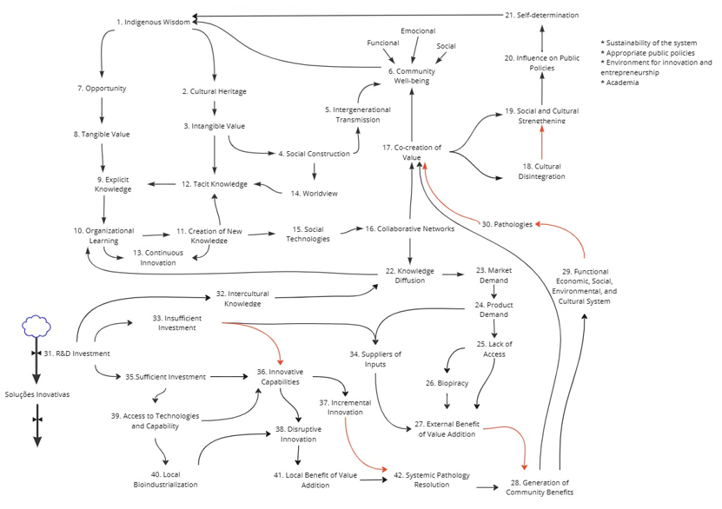
Figure 5. System behavior when inserting R&D

New Feedback Loops can be found using this upgraded model as follows:
- Relationship of Mitigating External Impacts (Loop5)
31(+) → 33(+) → 34(+) → 27(-) → 28(+) → 17(+) → 6(+) 31(+)
This Negative Reinforcement Loop. In this sequence, R&D Investment (31) strengthens Insufficient Investment (33), which, paradoxically, can create the need to seek creative solutions or additional resources to overcome financial limitations. This insufficient investment, in turn, drives the need to attract Suppliers (34), connecting different actors in the ecosystem to provide necessary resources. This relationship often results in External Benefit of Value Aggregation (27), where part of the value generated by innovations and inputs is captured by external actors, reducing the direct impact on communities. Despite this, the retained gains result in Community Benefit Generation (28), strengthening Co-creation of Value (17), a collaborative dynamic that connects local actors in the search for solutions. This co-creation directly promotes Community Well-being (6), positively impacting social, economic, and emotional dimensions.

- Relationship of Incremental Systemic Resolution (Loop6)
31(-) → 33(-) → 36(+) → 37(-) → 42(+) → 28(+) → 17(+) → 6(+)
This Positive Reinforcement Loop. Here, R&D Investment (31) reduces Insufficient Investment (33), allowing more robust resources to be applied in creating Innovative Capacities (36). These, in turn, generate Incremental Innovation (37), promoting continuous but moderate improvements in existing systems. Although positive, incremental innovation is often insufficient to resolve deeper structural problems. This limitation is overcome by advancing to Systemic Pathology Resolution (42), where integrated strategies address social, economic, and environmental imbalances, promoting sustainable improvements in the system. The direct impact is perceived in Community Benefit Generation (28), which strengthens Co-creation of Value (17) and, finally, enhances Community Well-being (6), creating a virtuous cycle.

- Relationship of Disruptive Innovations (Loop7)
31(+) → 35(+) → 36(+) → 37(+) → 41(+) → 42(+) → 28(+) → 17(+) → 6(+)
This Positive Reinforcement Loop. In this sequence, R&D Investment (31) ensures Sufficient Investment (35), creating the necessary conditions to drive Innovative Capacities (36), that is, the skills and resources needed to develop innovative solutions. These investments guarantee that communities or organizations can adapt and create both incremental and disruptive responses to complex problems. Nonaka (1994) argues that the combination of robust investments and innovative capacities is fundamental for advancing new models. Strengthening innovative capacities leads directly to Disruptive Innovation (37), which transforms existing paradigms by introducing solutions that break with previous structures. This type of innovation allows the development of technologies, processes, and business models that can completely redefine local and regional markets. Kusumastuti et al. (2022) highlights that disruptive innovations are essential for achieving high-impact changes and addressing systemic challenges. These transformations translate into Local Value Aggregation Benefit (41), ensuring that the generated gains remain within the communities, strengthening their local economies. By prioritizing local value retention, communities increase their economic autonomy, aligning with the concept of local sustainability proposed by Zhang et al. (2021). Local benefits strengthen Systemic Pathology Resolution (42), addressing structural problems such as social inequalities, market exclusion, and environmental degradation in an integrated manner. Moellers et al., (2019) reinforce that pathology resolution is essential for creating sustainable and resilient systems. These efforts are translated into Community Benefit Generation (28), which promotes Co-creation of Value (17) and, finally, improves Community Well-being (6), both socially and economically, creating a sustainable virtuous cycle.

- Conclusion
The causal loop diagram (CLD) model highlights how variables interact in a systemic manner, promoting sustainable innovation, social balance, and cultural preservation. The centrality of the variable R&D Investment (31) in the system is clear, acting as a strategic lever that connects traditional practices to innovative processes, transforming complex challenges into opportunities for communities. This study shows how R&D is fundamental in catalyzing incremental and disruptive innovations, promoting economic, social, and cultural benefits in socio-environmental ecosystems.
R&D Investment (31) plays a transformative role by reconfiguring knowledge flows, integrating social technologies, and strengthening collaboration networks. This variable not only fosters the creation of adapted technological solutions but also supports the capacity of communities to innovate in challenging contexts, such as those represented by structural inequalities and value externalization. Authors like Nonaka, (1994) and (Zhang et al. 2021) point out that organizational learning, when driven by robust investments, promotes the generation of explicit and tacit knowledge, fundamental for addressing systemic imbalances.
R&D also directly contributes to strengthening critical variables such as Innovative Capacities (36) and Social Technologies (15). These capacities allow communities to adapt traditional practices to contemporary contexts, expanding their impact on local and global markets. Local bio industrialization, enabled by these processes, emerges as a central strategy for retaining value within communities and avoiding the externalization of gains to external actors.
The CLD model highlights both reinforcing cycles and balancing factors that affect the system. Cycles such as “Cultural Resilience and Well-Being (Loop1)” and “Knowledge Creation and Social Empowerment (Loop2)” demonstrate how the interaction between variables like Indigenous Wisdom (1), Cultural Heritage (2), and Value Co-creation (17) generates positive impacts in terms of cultural resilience and organizational learning. These dynamics reinforce the importance of valuing traditional practices as a basis for sustainable innovations. However, structural barriers such as Lack of Access (25) and Insufficient Investment (33) limit the system's capacity to reach its full potential. Zhang et al. (2021) argue that these barriers can be overcome with public policies that encourage access to technologies and the integration of local actors into collaboration networks. Overcoming these barriers is essential for mitigating systemic pathologies such as social inequalities and economic exclusion.
The resolution of systemic pathologies, represented by the variable Systemic Pathology Resolution (42), emerges as one of the main results of R&D investment. Integrated strategies that combine traditional knowledge with modern practices are essential for addressing structural problems like biopiracy and value externalization. Kusumastuti et al. (2022) highlights that the balance between modernity and tradition is fundamental for creating resilient and inclusive systems.
Another important impact of R&D is the retention of local value, represented by the variable Local Value Aggregation Benefit (41). Local bioindustrialization allows resources to be transformed into high-value-added products, creating economic opportunities while preserving the environment. This dynamic is essential for strengthening community economies and reducing dependence on external actors. R&D Investment also promotes the integration of traditional and modern knowledge, represented by the variable Intercultural Knowledge (32). This integration not only amplifies the impact of innovations but also ensures that cultural practices are preserved and adapted. (Nonaka 1994) argues that the interaction between tacit and explicit knowledge is central to creating innovative solutions, while (Moellers et al. 2019) reinforce that mutual trust created by these processes is essential for the success of collaborative projects.
Social technologies, supported by R&D, play a crucial role in connecting local actors to global innovation networks. These networks facilitate knowledge diffusion and increase the demand for value-added products, creating a virtuous cycle that strengthens community autonomy. (Zhang et al. 2021) highlight that these networks are fundamental for creating circular economies that balance economic development and environmental sustainability.
The CLD model analysis demonstrates that R&D Investment is a strategic variable for transforming socio-environmental ecosystems into resilient and sustainable systems. Its ability to integrate knowledge, overcome structural barriers, and promote disruptive innovations reinforces its importance as a driver for community development. Reinforcing cycles like Loop1 and Loop2 highlight the importance of valuing traditional practices while promoting organizational learning and technological innovation.
However, challenges such as lack of access to resources and value externalization show that strengthening the system requires targeted public policies and robust investments. Local value retention, combined with bio industrialization, is essential for ensuring that economic, social, and cultural benefits remain within communities, promoting long-term autonomy and sustainability. Finally, this study emphasizes that the combination of tradition and modernity, enabled by R&D investment, is the path to addressing systemic challenges and building a more balanced and inclusive future. Applying this approach in public policies and organizational strategies can catalyze significant changes, promoting not only sustainable innovation but also social justice and cultural preservation.
- Acknowledgments
This study was financed in part by the Coordenação de Aperfeiçoamento de Pessoal de Nível Superior - Brasil (CAPES) - Finance Code 001.

References
BARROS, BENEDITA. Coletânea de Experiências de Tecnologia Social na Amazônia. Belém, PA: Museu Paraense Emilio Goeldi. 2024.
ELKINGTON, JOHN. Cannibals with Forks: The Triple Bottom Line of 21st Century Business. Gabriola Island, BC: New Society Publishers. 1998.
JONES, THOMAS J., GLYN WILLIAMS-JONES, E HARRY NYCE. “Braiding Indigenous Knowledge Systems and Western Science through Co-Creation and Co-Teaching”. Frontiers in Earth Science 13: 1587092. doi:10.3389/feart.2025.1587092. 2025.
KUSUMASTUTI, RETNO, MESNAN SILALAHI, ANUGERAH YUKA ASMARA, RIA HARDIYATI, E VISHNU JUWONO. “Finding the Context Indigenous Innovation in Village Enterprise Knowledge Structure: A Topic Modeling”. Journal of Innovation and Entrepreneurship 11(1): 19. doi:10.1186/s13731-022-00220-9. 2022.
MIRANDA, RAIZZA, MARKUS SCHWANINGER, ALVIMAR LUCENA, YGOR LOGULLO, MISCHEL CARMEN N. BELDERRAIN, TEREZA C. M. B. CARVALHO, E RENATO C. SATO. “Sustainable Amazon: A Systemic Inquiry with Native Populations”. Sustainability 15(9): 7517. doi:10.3390/su15097517. 2023.
MOELLERS, THOMAS, LARS VON DER BURG, BASTIAN BANSEMIR, MAX PRETZL, E OLIVER GASSMANN. “System Dynamics for Corporate Business Model Innovation”. Electronic Markets 29(3): 387–406. doi:10.1007/s12525-019-00329-y. 2019.
NONAKA, IKUJIRO. “A Dynamic Theory of Organizational Knowledge Creation”. Organization Science 5(1): 14–37. 1994.
NONAKA, IKUJIRO, E GEORG VON KROGH. “Perspective—Tacit Knowledge and Knowledge Conversion: Controversy and Advancement in Organizational Knowledge Creation Theory”. Organization Science 20(3): 635–52. doi:10.1287/orsc.1080.0412. 2009.
OECD. 3rd ed Organisation for Economic Co-operation and Development. Paris: OECD Publishing. 2005.
TAPSELL, PAUL, E CHRISTINE WOODS. “Social Entrepreneurship and Innovation: Self-Organization in an Indigenous Context”. Entrepreneurship & Regional Development 22(6): 535–56. doi:10.1080/08985626.2010.488403. 2010.
TENGÖ, MARIA, EDUARDO S. BRONDIZIO, THOMAS ELMQVIST, PERNILLA MALMER, E MARJA SPIERENBURG. “Connecting Diverse Knowledge Systems for Enhanced Ecosystem Governance: The Multiple Evidence Base Approach”. AMBIO 43(5): 579–91. doi:10.1007/s13280-014-0501-3. 2014.
ZHANG, YAN, HIS-HSIEN WEI, DONG ZHAO, YILONG HAN, E JIAYU CHEN. “Understanding Innovation Diffusion and Adoption Strategies in Megaproject Networks through a Fuzzy System Dynamic Model”. Frontiers of Engineering Management 8(1): 32–47. doi:10.1007/s42524-019-0082-8. 2021.
ZIDNY, ROBBY, SJÖSTRÖM JESPER, E EILKS INGO. “A multi-perspective reflection on how indigenous knowledge and related ideas can improve science education for sustainability.” Science & Education 29: 145–85. 2020.

https://banxia.com/

