A WATER-ENERGY-FOOD NEXUS APPROACH FOR SUSTAINABILITY IN NEGLECTED COLOMBIA

Monica Castaneda, Pontificia Universidad Católica de Valparaíso, monica.castaneda.pucv.cl Isaac Dyner, Universidad Jorge Tadeo Lozano, isaac.dynerr@utadeo.edu.co

Andres Julian Aristizabal, Universidad Jorge Tadeo Lozano, andresj.aristizabalc@utadeo.edu.co

Luis Alejandro Arias, Universidad Jorge Tadeo Lozano, luis.arias@utadeo.edu.co

# Overview

# The Water-Energy-Food (WEF) nexus argues that through their linkages and trade-offs sustainable development maybe achieved. Colombia is a developing country with a relatively good WEF-nexus index indicator compared to other Latin American countries. However, WEF resources are not only inequitable distributed across the geography but also broadly unsustainably used as environmental conditions are swiftly deteriorating due to climate change. Such is the case of La Guajira, a department located at the north of Colombia which a large indigenous Wayuu community that suffers extreme poverty and child starvation. The objective of this paper was to assess a dynamic hypothesis for sustainable development, based on the WEF nexus trade-offs, applied to the livelihoods of Wayuu indigenous communities in the High Guajira, being an isolated and challenging desertic territory. A system dynamics model approach is undertaken to understand feedbacks, delays and non-linear relationships inherent in the WEF dynamics. Results were validated using structure behavioral tests.

Some studies have researched about water energy food nexus using simulation models (Huang et al., 2020; Dargin et al 2019; Purwanto et al., 2021; Sušnik et al., 2021; Wen et al., 2022). However, to date none study has assessed the WEF nexus trade-offs, applied to the livelihoods of Wayuu indigenous communities in the High Guajira using a system dynamics model remains a novelty.

**Methods**

System dynamics methodology was applied (Sterman, 2004, 2010), which describes the process of building simulation models based on system dynamics. This methodology starts from the definition and therefore delimitation of the problem, the formulation of the dynamic hypothesis, formulation of the system of equations, validation, and finally, formulation of policies that improve the state of the system. Figure 1 contains three reinforcing feedback loops, R1 loop is related to wef nexus relationship. R2 loop also includes revenues obtained from agriculture production and their effect on energy, while R3 loop presents the effect of these revenues on water available.

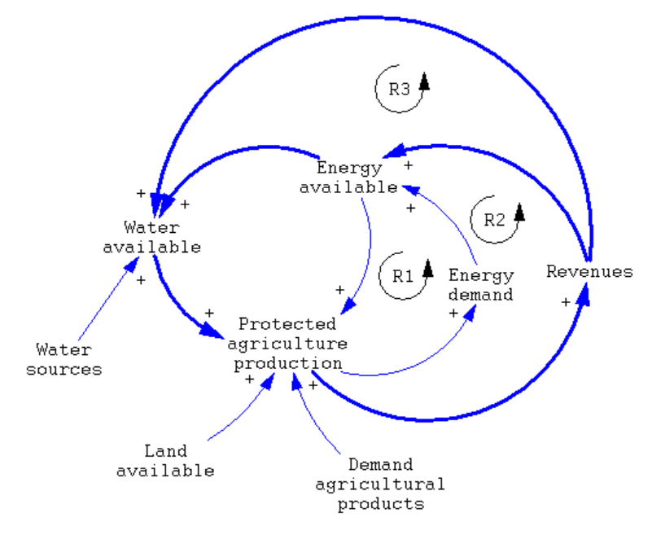

Figure 1. Dynamic hypothesis

# Results

The Water-Energy-Food Nexus (WEF) recognizes the interconnected nature of water, energy and food systems. In this nexus, the interdependencies and exchanges between subsystems are essential; integrated and sustainable management to address the challenges of resource scarcity is necessary. Therefore, it is important to understand quantifying the water footprint and the carbon footprint within the wef nexus. In this sense, the following subsystem diagram of the simulation model developed in Figure 2 has been proposed. According to Sterman (2010), a subsystem model shows the general architecture of each model, dividing it into modules or subsystems where it is possible to appreciate the interdependence. between them.

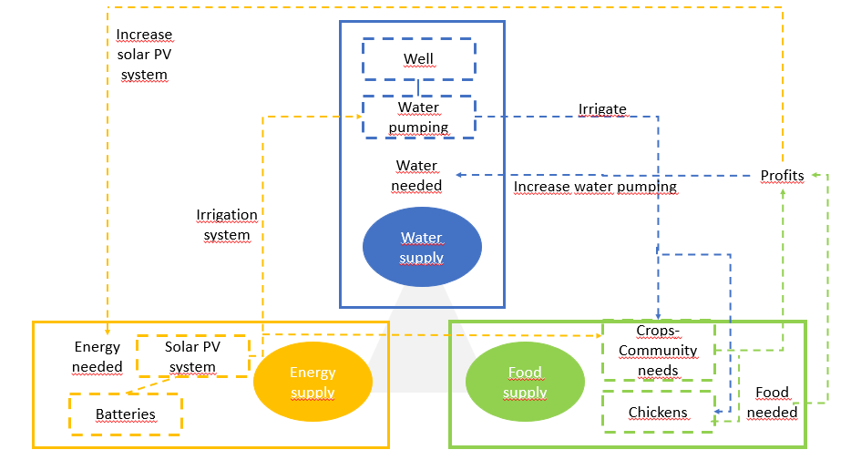

Figure 2. Subsystem diagram of the simulation model

**Conclusions**

Findings suggest that solar PV systems must be implemented to improve energy access and applications. Efficient ground water management is required for pumping and irrigate small areas to produce horticultural crops. Under these conditions, crops could generate surplus and improve the food security and economic wellbeing of communities.

# References

Dargin, J., Daher, B., & Mohtar, R. H. (2019). Complexity versus simplicity in water energy food nexus (WEF) assessment tools. Science of the Total Environment, 650, 1566-1575.

Huang, D., Li, G., Sun, C., & Liu, Q. (2020). Exploring interactions in the local water-energy-food nexus (WEF-Nexus) using a simultaneous equations model. Science of the Total Environment, 703, 135034.

Purwanto, A., Sušnik, J., Suryadi, F. X., & de Fraiture, C. (2021). Quantitative simulation of the water-energy-food (WEF) security nexus in a local planning context in indonesia. Sustainable Production and Consumption, 25, 198-216.

Sušnik, J., Masia, S., Indriksone, D., Brēmere, I., & Vamvakeridou-Lydroudia, L. (2021). System dynamics modelling to explore the impacts of policies on the water-energy-food-land-climate nexus in Latvia. Science of The Total Environment, 775, 145827.

Sterman, J. (2004). Business dynamics: Systems thinking and modeling for a complex world.

Sterman, J. (2010). Business dynamics (p. 982). Irwin/McGraw-Hill c2000.

Wen, C., Dong, W., Zhang, Q., He, N., & Li, T. (2022). A system dynamics model to simulate the water-energy-food nexus of resource-based regions: A case study in Daqing City, China. Science of the Total Environment, 806, 150497.