Reducing the carbon footprint in the production of biofuels from vegetable oils: a technological prospection

Marcos Vinicius Lima dos Santos ^{1*}, Solciaray Cardoso Soares Estefan de Paula², Sofia Laura Valverde Alves de Meneses ¹, Agnes Sophia Braga Alves ¹, Thalia Catherine Sacramento Ferreira ¹, André Feitosa Brito¹, Thâmilla Thalline Batista de Oliveira ¹
¹ SENAI CIMATEC, Department Microbiologia Industrial, Salvador, Bahia, Brazil
² SENAI CIMATEC, Department Agroindústria, Salvador, Bahia, Brazil
*Corresponding author: SENAI CIMATEC; addresses; marcos.lima@fbter.org.br

Abstract: Biofuels have a smaller carbon footprint than fossil fuels, but this depends on how they are produced. Therefore, it is essential to ascertain the entire production chain, from the raw materials to the extraction process and other strategies to ensure effective CO₂ reduction. The aim of this study was to prospect for technologies aimed at producing biofuels from oilseeds, with an emphasis on reducing the carbon footprint. A structured search using combinations of keywords, filters and restriction criteria was carried out in the consolidated patent/application databases: Espacenet, The Lens and Derwent Innovation. After screening and eliminating duplicates between the platforms, 11 documents were counted, dating back to 2017, with the highest concentration of filings in 2024. Countries such as the USA, Brazil, China and Indonesia are the main depositors of intellectual property relating to the production of biofuels from oilseeds, mainly exploiting the species: soy, palm and macauba. The most commonly used extraction methods are physical, such as centrifugation and pressing, followed by chemical conversions such as transesterification, pyrolysis, catalytic alkylation or the Fischer-Tropsch process. As a strategy for reducing the carbon footprint of this process, the results point to the practice of energy self-sufficiency through the reuse of residual vegetable oil extraction cake for energy cogeneration. The capture of CO₂ by microorganisms and membranes, as well as the production of biochar, are other promising and widespread strategies for mitigating GHG emissions. In addition to the advances reported, the survey carried out was essential for verifying gaps, such as technological maturity, optimization of operating costs, specific regulations and integration of agro-ecological practices, and also serves to foster future research that will make it possible to scale up oilseeds for biofuel production.

Keywords: decarbonization; intellectual property; oilseeds; bioeconomy.

1. Introduction
The use of oilseeds for biofuel production plays a key role in minimizing environmental impacts, especially in relation to greenhouse gas (GHG) emissions and climate change. This is because their combustion emits lower levels of pollutants compared to fossil fuels, contributing to better air quality, sustainability, and the fight against the global energy crisis [1].
The carbon footprint refers to the quantification of GHG emissions based on an assessment of the entire production chain and life cycle, in this case, in grams of CO₂ equivalent per megajoule of biofuel produced (gCO₂-eq/MJ). Although they are widely promoted as a sustainable alternative, several aspects of biofuel production can increase CO₂ emissions, making them contradictory [2].
Among other aspects, deforestation associated with the cultivation of plant species -mainly through burning, the use of fertilizers and changes in soil, the use of agricultural equipment and transport vehicles powered by fossil fuels, among others - are sources of GHG emissions in the biofuel production chain [3].
Based on these factors, innovative solutions have been explored and developed to achieve negative emissions. Carbon capture technologies, more sustainable agricultural practices, and the use of renewable energy in the process are examples that are being adopted. However, optimizations commonly require investments and, in this case, supportive policy frameworks and applicable decarbonization verification procedures are also necessary. Therefore, it is of great importance to explore alternatives and partnerships [2].
Thus, the objective of this study was to explore technologies aimed at producing biofuels from oilseeds, with an emphasis on reducing the carbon footprint, based on a technological survey, and thereby identify strategies and scenarios for integrated use and scenarios for application in agroforestry systems and the regional bioeconomy.

2. Material and Methods
In order to assess the technological landscape for the production of biofuels from vegetable oils, with an emphasis on reducing the carbon footprint, a technological survey was conducted using international patent databases. The platforms consulted—The Lens, Espacenet, and Derwent Innovation—were chosen due to their broad geographic coverage, continuous updating, and ability to index technical documents with specific descriptors related to the field of biofuels.
The search was structured based on a combination of keywords, Boolean operators (AND and OR) and truncation (asterisk), in addition to filtering by the C10L code of the International Patent Classification (IPC), which encompasses patents related to processes involving fuels and their additives.
Thus, the expression (vegetable* OR fruit* OR seed) AND (oil* OR lipid* OR fatty* acid*) AND (biofuel* OR fuel*) AND (“carbon footprint”) was searched for in the “Title, Abstract, and Claims” fields of the platforms mentioned above, with the search period restricted to 2015–2025.
As exclusion criteria, results were not considered if there was no specification of the raw material used, if there were duplicate records, or if there was no correlation with biofuel production or carbon footprint mitigation strategies. The results in line with the objective underwent a refinement process, conducted through careful analysis of the abstracts and main claims, with priority given to documents that detailed the biomass used, the technological methods involved, and the direct relationship with the reduction of greenhouse gas emissions.
Finally, the following information was collected from the included results: code, original title, publication date, country, oilseed species used, oil source (root, stem, seed, pulp, or leaf), extraction technology, conversion method, type of biofuel generated, integration with SAFs, and document status, organized in a spreadsheet for data processing and inferences.

3. Results and Discussion
The search yielded 79 relevant documents in the databases consulted—1 in The Lens, 23 in Espacenet, and 55 in Derwent Innovation. After screening and eliminating duplicates between platforms, 11 documents were selected for detailed analysis. These belong to the main jurisdictions: USA (3), WO (3), Brazil (2), China (2), and Indonesia (1), reflecting global interest in low-carbon technologies.
During the period analyzed, it was possible to see a higher concentration of filings in the year 2024 (7), as shown in Figure 1.

Figure 1. Number of technological documents per year during the period considered.
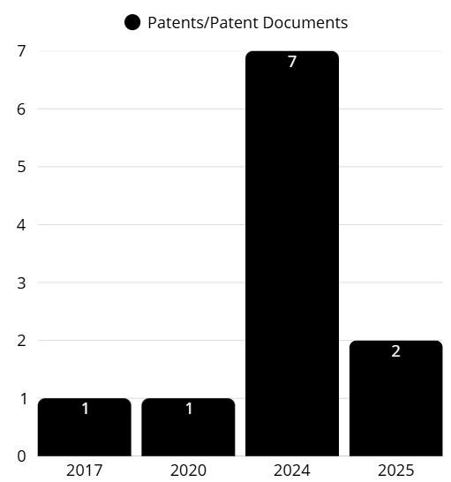
Despite the quantities achieved and their distribution over the years, the results reflect the recent concern with decarbonization in biofuel production over the last 10 years. In this scenario, the most exploited species were soybeans (Glycine max), palm (Elaeis guineensis), and macauba (Acrocomia aculeata), shown in Figure 2.

Figure 2. Most used oilseeds according to survey.
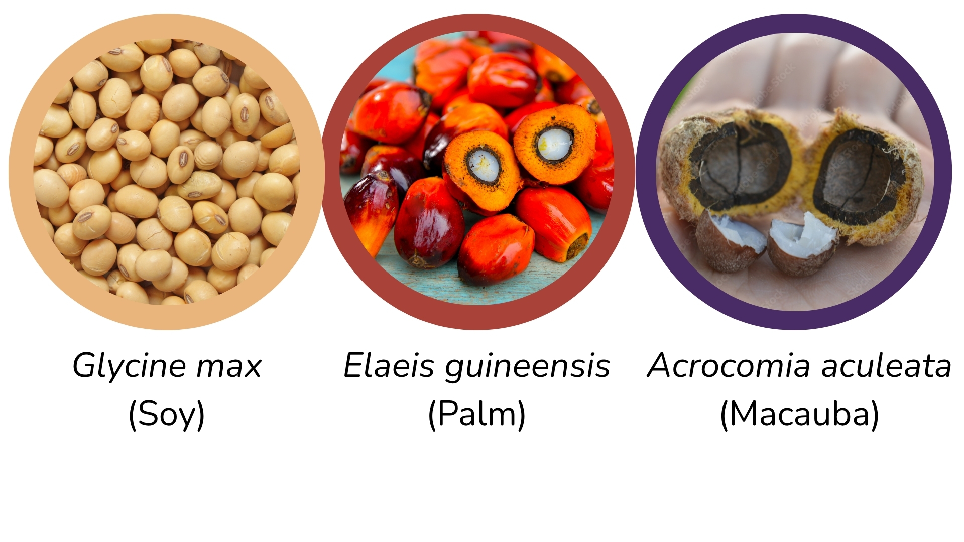
The oil produced by these species shares characteristics relevant to biofuel production, especially related to carbon footprint, making it an environmentally friendly alternative and a promising replacement for fossil fuels. Among the options, macauba stands out, with a bioenergy productivity of around 6.2 tons per hectare, surpassing soybeans and equaling palm oil [4].
The seeds are the most commonly used parts of the fruit. According to the survey, oil is extracted from the seeds mainly by physical methods, particularly centrifugation and pressing. These methods have a relatively lower carbon footprint compared to extraction with chemical solvents, which produces thermal, toxic, and polluting waste [5]. The oil is then subjected to chemical and/or thermal conversion, such as transesterification, pyrolysis, catalytic alkylation, or the Fischer-Tropsch process, to be converted into biofuel. Each of the conversion methods has different degrees of decarbonization, so there is a need to establish strategies to offset the carbon emissions inherent in the biofuel production process.
The carbon footprint reduction strategies observed in the documents analyzed can be summarized as follows: burning oil extraction waste for energy integration and biochar production through pyrolysis, and CO₂ capture using membranes or microorganisms, as illustrated in Figure 3.

Figure 3. Strategies to reduce carbon footprint.
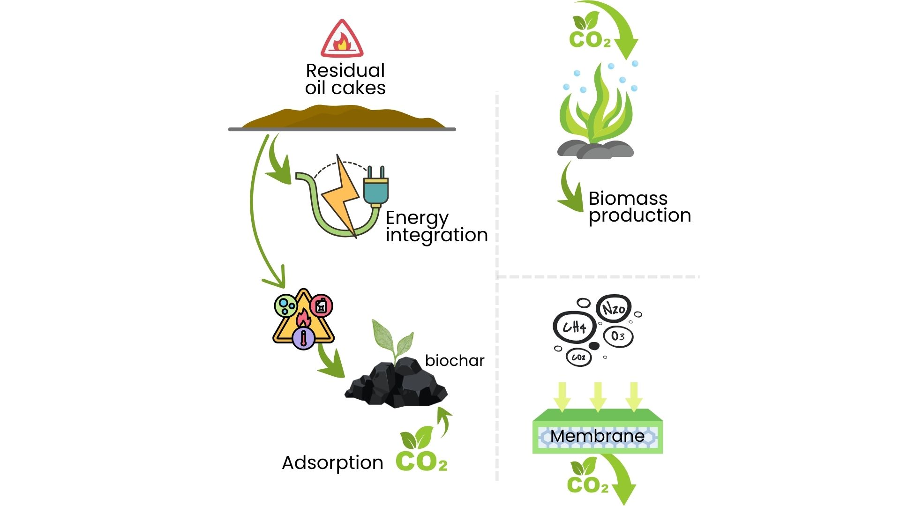

The integration of energy in patent document ID202407036A was achieved by feeding residual biomass from palm vegetable oil processing into a steam cogeneration system, consisting of turbines and boilers, to generate biofuel. Thus, the burning of residual cake from extraction is used to generate steam and feed the biorefinery [6]. By generating the electricity and steam needed for industrial operations internally, GHG emissions associated with the use of conventional grid electricity or fossil fuels are avoided [7]. This energy integration not only reduces the carbon footprint of biofuel but also enables the generation of carbon credits when there is surplus energy exported to the grid.
As for biochar, in patent document WO2024076524A2, it was produced by pyrolysis of biomass residue from initial pressing and/or oil extraction [8]. This process generates, in addition to combustible gases and oils (which can be used for energy), a carbon-rich solid material called biochar. Biochar is chemically stable and, when incorporated into the soil, retains carbon for long periods (hundreds to thousands of years), effectively sequestering it from the atmosphere [9]. In addition, biochar can improve soil fertility, increase water and nutrient retention, and reduce N₂O emissions from the soil, indirectly contributing to a lower carbon footprint for agriculture associated with the production of raw materials for biofuels [10].
Direct CO₂ capture mechanisms in biofuel production can be achieved through the use of microorganisms, such as bacteria and microalgae, or using selective membranes. Both techniques can play a crucial role in reducing GHG emissions at various stages. Microalgae, for example, can perform photosynthetic biofixation of CO₂, using carbon dioxide emitted by industrial processes or present in the atmosphere as a carbon source for their growth and biomass production, which can later be converted into biofuel [11]. In addition to direct CO₂ capture, certain microorganisms can optimize fermentation processes, increasing the efficiency of biomass conversion into biofuel and reducing the formation of unwanted by-products that are GHGs, or even act in the treatment of production effluents, reducing emissions of methane (CH₄) and nitrous oxide (N₂O) emissions.
The use of membranes offers a promising approach for the separation and capture of CO₂ from industrial gas streams, including those generated during the production of biofuels or the combustion of biomass. Membranes are selective barriers that allow CO₂ to pass through preferentially over other gases (such as N₂, O₂, or CH₄), concentrating it for subsequent geological storage (CCS - Carbon Capture and Storage) or use in other processes (CCU - Carbon Capture and Utilization) [12]. In patent document CN117460806A, it was possible to effectively and efficiently remove carbon dioxide effluent from the oilseed hydroprocessing stage, approximately 50% to 90% of the initial CO₂ (by volume), depending on the size of the membrane, to be used as fuel gas [13].
Although the technology still faces challenges in terms of cost, durability, and large-scale efficiency for some specific applications in biorefineries, continuous advances in membrane materials and design are promising for reducing the carbon footprint of biofuels by mitigating direct CO₂ emissions [14].
Among the strategies identified, energy self-sufficiency stood out for its feasibility, low cost, and technological maturity, and was recommended as the main strategy. Biochar appears to be an effective complementary solution, with multiple benefits for soil and climate [7]. Other approaches, such as the use of microorganisms for large-scale mitigation and CO₂ capture with membranes, although promising, still require further technological development and cost optimization to enable their widespread and competitive industrial application in the biofuel sector.
Despite the progress observed in technological strategies aimed at reducing the carbon footprint in biofuel production, significant barriers still exist that limit their widespread industrial adoption. Among the main obstacles are high operating and capital costs, the need to develop more efficient and robust technological routes at scale, and the absence of specific regulations that encourage the adoption of these technologies in emerging markets.
On the other hand, the analysis reveals significant opportunities for innovation, such as the integration of agroecological practices, especially Agroforestry Systems (AFS), which are not yet covered by the patents identified. This gap represents promising potential for the development of sustainable solutions that reconcile biomass production with environmental conservation, amplifying the positive impacts of biofuels in the context of climate change.
The technologies identified in the patents ranged from TRL 4 to TRL 7 levels of technological maturity, indicating a predominance of innovations in the pilot validation and pre-commercial phases, reinforcing the need for additional efforts toward scalability and market insertion.
The lack of integration with SAFs in the patents analyzed reveals an opportunity for innovation that is still largely unexplored in the context of sustainable biofuels.

4. Conclusion
In view of the above, although biofuels derived from vegetable oil seeds are considered a green alternative to fossil fuels, it must be recognized that their production is not without environmental impacts, especially in terms of carbon footprint. The excessive use of agricultural raw materials, deforestation associated with oilseed cultivation, and energy consumption in stages such as extraction and refining are factors that can increase emissions from the process. In view of this, strategies identified through technological prospecting -such as burning oil extraction waste for energy purposes, converting this waste into biochar through pyrolysis, and capturing CO₂ using membranes or microorganisms - appear to be promising ways to reduce this impact. Thus, technological development combined with sustainable practices, such as waste recovery and emissions capture, is crucial to consolidating biofuels as an effectively clean solution for the energy sector.

Acknowledgement

The authors would like to acknowledge Equinor and ANP (Brazil’s National Oil, Natural Gas, and Biofuels Agency) for the support provided through regulatory incentives for Research & Development. Also acknowledge EMBRAPII and SENAI CIMATEC for the encouragement and funding.

References

- GARG, Renuka; SABOUNI, Rana; AHMADIPOUR, Mohsen. From waste to fuel: Challenging aspects in sustainable biodiesel production from lignocellulosic biomass feedstocks and role of metal organic framework as innovative heterogeneous catalysts. Industrial Crops and Products, v. 206, p. 117554, 2023. DOI: https://doi.org/10.1016/j.indcrop.2023.117554.
- IEA (2024), Carbon Accounting for Sustainable Biofuels, IEA, Paris https://www.iea.org/reports/carbon-accounting-for-sustainable-biofuels, Licence: CC BY 4.0.
- Farmer, Sean & Zorner, Paul. Methods for Producing Reduced Carbon Footprint Biofuels. US2024117260A1. Depósito: 02 de setembro de 2022.
- Duque, T.S., Barroso, G.M., Borges, C.E. et al. Current and future development of Acrocomia aculeata focused on biofuel potential and climate change challenges. Sci Rep 15, 8120 (2025). https://doi.org/10.1038/s41598-025-92681-7.
- Favaro, Simone Palma et al. Princípios da extração sem solvente e tecnologias potenciais para obtenção de óleos vegetais. 2022. Brasília - DF: Embrapa Agroenergia. ISSN 21774439; 43. Available in: https://www.infoteca.cnptia.embrapa.br/infoteca/bitstream/doc/1142245/1/DOC-43-SEG-.pdf.
- Hendry, ID. Biofuel Production Method Integrated With Palm Oil Factory. ID202407036A. Application: 24 de outubro de 2022.
- Calciolari, C. I. F.; Da Silva Rossato, F. G. F. Feasibility of energy self-sufficiency by biomass production in a Brazilian state. 2024. Revista de Gestão Social e Ambiental, v. 18, n. 2, p. 1–17. https://doi.org/10.24857/rgsa.v18n2-072.
- Fiato, Rocco A. & De Swart, Jeroen W A. Integrated Process For Converting Camelina And Carinata To Fuels And Lubricant Base Stocks. WO2024076524A2. Application: 02 de outubro de 2023.
- Lehmann, J. et al. Stability of biochar in soil. Biochar for environmental management: science and technology. London: Routledge, 2012. p. 215–238.
- Sohi, S. P. et al. A review of biochar and its use and function in soil. Advances in Agronomy, v. 105, p. 47–82, 2010.
- Razzak, S. A. et al. Integrated CO₂ capture, wastewater treatment and biofuel production by microalgae culturing—a review. Renewable and Sustainable Energy Reviews, v. 27, p. 622–653, 2013.
- Inocencio-García, P. J. C1 biorefineries: The CO2 case (Doctoral dissertation, Universidad Nacional de Colombia).
- Debonis, Daniel. Process for converting biological feedstock to middle distillates with removal of catalytic inhibitors. CN117460806A. Application em: 16 de maio de 2022.
- Mollahosseini, A. et al. Polymeric membranes in carbon capture, utilization, and storage: current trends and future directions in decarbonization of industrial flue gas and climate change mitigation. Energy & Environmental Science, 2025. DOI: https://doi.org/10.1039/D4EE05328A.

