
Thiadiazines as Efflux Pump Inhibitors: Evaluation of the immunomodulatory effect against resistant Staphylococcus aureus strains
Rita C. B. F. Santana (G) ¹, Igor J.S. Nascimento (PG) ¹, João X. Araújo (Prof) ^{1,} Edeildo F. Silva-Júnior (Prof) ¹, Priscilla R. Freitas (Res) ^{2,} Ana C.J. de Araújo (Res) ², Isaac M. Araújo (Res) ² , Ray S. de Almeida (Res) ², João A.O. Borges (Res) ², Cícera L.R. Paulo (Res) ², Cícera D.M. Oliveira-Tintino (Res) ², Francisco A.B. Cunha (Res) ², Irwin R.A. Menezes (Res) ², Saulo R. Tintino (Res) ², Henrique D.M. Coutinho (Res) ², Gustavo M. Siqueira (Res) ², Daniel S. Alves (Res) ², José B. Araújo-Neto (Res) ³, Emmanuel S. Marinho (Res) ⁴, Helcio S. Santos (Res) ⁴, Julia M.A. Silva (Res) ⁵, Tereza C.L. Balbino Instituto (Res) ⁵, Franscisco J.B. Mendonça (Res) ⁶, Ahmad J. Obaidullah (Res) ⁷, Sheikh F. Ahmad (Res) ⁷, Sabry M. Attia (Res) ⁷, Talha Bin Emran (Res) ⁸, Clara M. G. Lima (Res) ⁹, Gustavo M. Miranda (Res) ¹⁰, Thiago M. Aquino (Prof) ¹.
rita.santana@icf.ufal.br;
¹ University of Alagoas; ² Regional University of Cariri; ³ University of Pernambuco, ⁴ University of Ceará, ⁵ Instituto Aggeu Magalhães, ⁶ Paraiba State University, ⁷ King Saud University, ⁸ Brown University, ⁹ Federal University of Lavras, ¹⁰ Instituto Gonçalo Moniz (IGM).
Keywords: Thiadiazine derivatives, NorA, Gentamicin, Norfloxacin.
ABSTRACT
The World Health Organization (WHO) estimates that by 2050, bacterial resistance will result in 10 million deaths globally. Among the primary molecular mechanisms of microbial resistance is the expression of efflux pumps. This underscores the urgent need for the development of new antibacterial drugs or modulators of clinically-used antibiotics that are free of adverse effects and cost-effective. This study aims to evaluate in vitro and validate the immunomodulatory activity of the antibiotics norfloxacin and gentamicin against resistant S. aureus strains, assess MepA efflux pump inhibition, investigate mepA gene inhibition, and examine changes in membrane permeability by thiazine derivatives against S. aureus K2068. Bacterial strains were cultured, and norfloxacin and gentamicin were tested at a concentration of 1024 μg/ml to assess antibiotic potentiation. For MIC determination, microtubes were prepared in triplicate for each bacterium, and resazurin staining was used to detect bacterial growth, indicated by blue for no growth and red for growth. In assays with MDR strains, resazurin staining revealed modified action. Efflux pump inhibition activity was confirmed through increased EtBr fluorescence emission. These compounds demonstrated significant results, inhibiting these proteins when tested by microdilution with ethidium bromide and further confirmed by ethidium bromide fluorescence emission. Additionally, the mechanism of action of compound IJ17 was elucidated, showing both gene expression inhibition and changes in membrane permeability. Moreover, antibacterial activity tests indicated mild direct action, especially by the IJ23 analog. Some compounds successfully modified the action of gentamicin and norfloxacin against multi-drug-resistant strains, suggesting a potential synergistic effect. Among all the results obtained in the study, the relevance of thiadiazine analogs as possible coadjuvant drugs in the antibacterial, anti-inflammatory, and neurological action with low toxicity is clear.
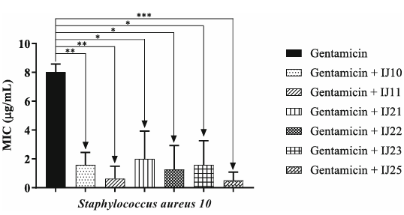
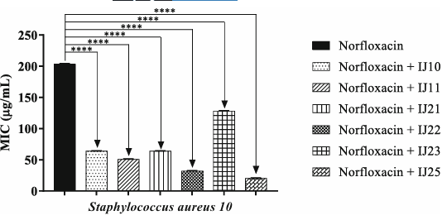
FIGURE 1: Modifying effect of norfloxacin and gentamicin action through the association with thiadiazines against S. aureus 10.

