**ARÉA TEMÁTICA: ECOLOGIA**

**SUBÁREA TEMÁTICA: INVERTEBRADOS**

**BENTHIC MACROFAUNA ON THE PHYTAL OF DISTINCT MACROALGAE IN BRAZILIAN TROPICAL COASTAL REEFS**

Davy Barbosa Bérgamo¹, Gislayne Cristina Palmeira Borges¹, Nykon Craveiro¹; José Souto Rosa Filho¹

¹ Universidade Federal de Pernambuco (UFPE), Campus Recife. E-mail (DBB): davybberg@gmail.com; (GCPBF): gislayne.borges@ufpe.br, (NC): nykoncraveiro@gmail.com, (JSRH): souto.rosa@ufpe.br

**INTRODUCTION**

Coastal regions are dynamic environments composed of sedimentary and rocky bottoms, exemplified by sandy beaches and sandstone reefs (Barcellos et al., 2020). In particular, reefs are colonized by a high diversity of benthic species that are exposed to significant variations in environmental conditions at different scales, such as those associated with currents, waves, tides, fluvial sources, and climatic variations due to seasonal dry and rainy seasons (Mclachlan and Defeo, 2018).

In the northeast of Brazil, reef organisms are mainly belong to the Phytal, composed of macroalgae, invertebrates from the phylum Annelida, Arthropoda, Bryozoa, Chordata, Cnidaria, Echinodermata, Mollusca, and Porifera (Tano et al., 2016; Craveiro et al., 2021), as well as vertebrates, especially fishes. The macrofauna associated with macroalgae as a development substrate responds to the fluctuations of environmental conditions through changes in communities, reflecting substrate characteristics and along the year due to seasonal variations (Cacabelos et al., 2010; Ba-Akdah et al., 2016). Therefore, our aim was to analyze the macrofaunal response to the different macroalgal species and to seasonal dry and rainy seasons from 2020 to 2022 on the northeast coast of Brazil.

**MATERIAL AND METHODS**

The study area was the coastal reef of the tropical sandy beaches of Enseada dos Corais (08° 19' 24.74"S - 34° 56' 56.85"W), located in the southern coastal zone of the State of Pernambuco, Northeast-Brazil. Five samples of two macroalgal species, *Gelidiella acerosa* (Forsskal) Feldmann and Hamel and *Padina* spp. Adanson, were collected twice a year during the dry (September to February) and rainy season (March to August) between the years 2020 and 2022. During the collection, the macroalgae were carefully placed in plastic bags, removed from the reef with a spatula, and then stored and fixed in 4% formalin.

In the laboratory, the macroalgal samples were sieved using a 300 µm mesh under running water to remove all macrofaunal families. Subsequently, they were identified under a stereomicroscope. The macroalgae were then dried (60°C) and weighed (0.1 g precision balance).

For each sample, richness, abundance, evenness (Pielou's index), and diversity (Simpson – 1-λ´) were calculated. The data were subjected to ANOVA and Tukey's test, and PERMANOVA followed by plot CAP were performed through similarity matrices based on Bray Curtis similarity, which was calculated from data square root transformed. These analyzes were conducted to compare the macrofaunal community between macroalgal species and the seasonal dry and rainy periods. The statistical analyses were carried out using the programs Statistica®12 and PRIMER 7 + PERMANOVA, considering a significance level of 5%.

**RESULTS AND DISCUSSION**

A total of 13,002 specimens were recorded, belonging to the phylum Arthropoda (66.8% - 4 families, 3 orders, and 1 class), Mollusca (17% - 11 families and 3 classes), Annelida (14% - 11 families and 1 order), Platyhelminthes (2%), and Cnidaria (0.2%) (Fig. 1a). A typical faunal composition found on reef macroalgae in the coastal zone of Pernambuco (Craveiro et al., 2021), dominated by crustaceans represented by amphipods, isopods, ostracods, and tanaidaceans, as well as polychaetes from the families Syllidae, Nereididae, and Amphinomidae, and molluscs from the families Phasianellidae and Fissurellidae.

The values of richness and diversity showed no significant variation, however, there was a significant increase of the abundance from the dry to the rainy season, with higher values observed in *Padina* spp. Additionally, there was a significant decrease in evenness during the rainy season, with lower values in *Padina* spp. (Tab. 1).

Table 1. Macrofaunal community descriptors associated with macroalgal species and results of ANOVA and Tukey's test. Samples from Enseada dos Corais, Northeast Brazil.

|  |  |  |  |  |  |  |
| --- | --- | --- | --- | --- | --- | --- |
|  | **Mean ± Standard deviation** | | | | **F (ANOVA)1** | **Tukey's test result2** |
|  | *Gelidiella acerosa* | | *Padina* spp. | |
| **Descriptors** | Dry | Rainy | Dry | Rainy |
| Richness | 4.87 ± 1.92 | 4.33 ± 2.16 | 3.33 ± 1.29 | 4.1 ± 1.79 | Algae ns |  |
| Seasonal ns |  |
| Alg. vs Sea.ns |  |
| Abundance | 98.77 ± 77.18 | 208.38 ± 245.8 | 268.58 ± 160.68 | 436.59 ± 108.49 | Algae * | G < P |
| Seasonal * | Dry = Rainy |
| Alg. vs Sea.ns |  |
| Evenness | 0.78 ± 0.25 | 0.74 ± 0.32 | 0.78 ± 0.25 | 0.54 ± 0.24 | Algae * | G > P |
| Seasonal * | Rainy < Dry |
| Alg. vs Sea.* | GD=GR=PD>PR |
| Diversity | 0.63 ± 0.23 | 0.58 ± 0.25 | 0.53 ± 0.21 | 0.4 ± 0.23 | Algae ns |  |
| Seasonal ns |  |
| Alg. vs Sea.ns |  |

**1**\*: p< 0.05, ns: not significant, Alg. = algae, and Sea. = seasonal; **2**G = *Gelidiella acerosa*, P = *Padina* spp., R = Rainy, and D = Dry

Variation in the macrofaunal community was found to be significantly partitioned between macroalgal species (pseudo-F: 7.17; p:<0.01 - similarity between species: 30.63) and between seasons (pseudo-F: 6.10; p:<0.01 - similarity between seasons: 29.81) (Tab.1 ). These variations were observed in four groups on CAP plot, highlighted on the high canonical correlation values of the axes (*δ*2 CAP 1: 0.58; *δ*2 CAP 2: 0.41) and on the high values of correct classification samples in their respective groups (65.46% of correct classification) (Fig. 1b).

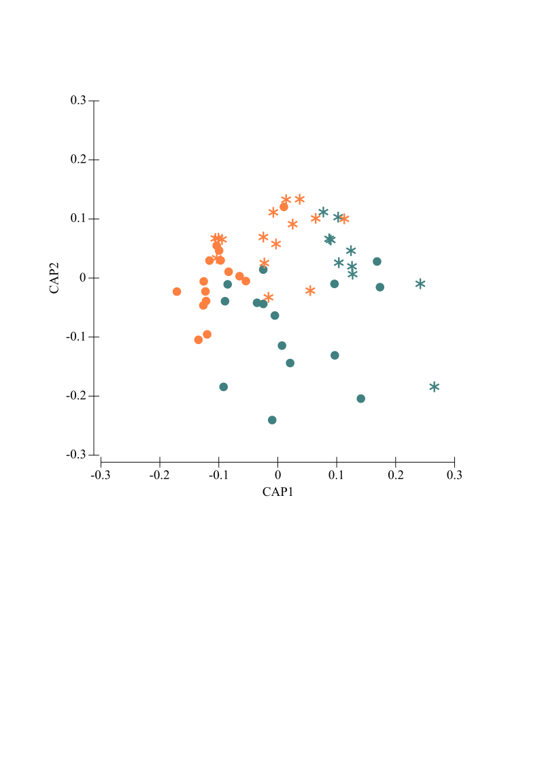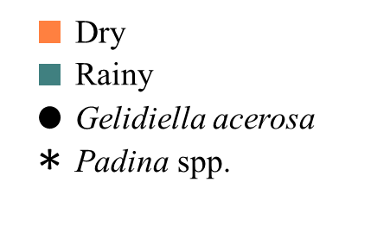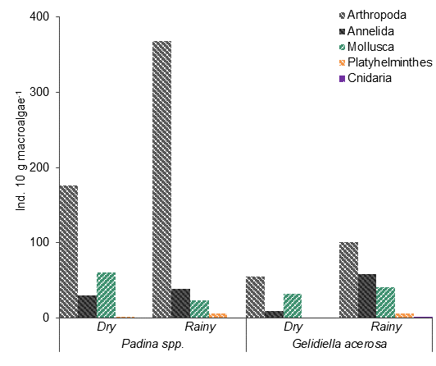

Figure 1. (a) Macrofaunal composition on the macroalgal species *Gellidiela acerosa* and *Padina* spp. and (b) plot CAP of the macrofaunal community from Enseada dos Corais, Northeast Brazil.

The variation of macrofauna between macroalgal species can be related as a response of increase of arthropods and annelids, and decrease of molluscs due to the variation of chemical composition (Amsler, 2008), presence of secondary metabolites, and fractal complexity (Gee and Warwick, 1994; McAbendroth et al., 2005), with increased diameter area (DA) and higher sediment accumulation (SA) in *Padina* spp. (DA:1.91 ± 0.05; SA: 46.67 ± 67.91 per 10g of macroalgae) than *G. acerosa* (DA:1.73 ± 0.05; SA: 5.35 ± 4.75 per 10g of macroalgae)(author’s unpublished data). These characteristics influence the microhabitat provisioning and also weaken the periphyton growth (McAbendroth et al., 2005), which is essential for surface scraping as mollusc species.

In contrast to the season, the increase in all phylum, except molluscs, occurred during the rainy season, initially associated with an increase in precipitation and nutrients, and a decrease in desiccation and salinity, which for most species represent more favorable environmental conditions for feeding and the initiation of reproduction (Souza et al., 2013). Moreover, algae tend to be more branched during the rainy season, which also increases the fractal complexity and the microhabitat supply (Gee and Warwick, 1994; McAbendroth et al., 2005). On the other hand, for molluscs, mainly represented by *Eulithidium affine*, *E. bellum*, and *Fissurella* sp., the decrease during the rainy season occurs due to the herbivorous and scraping feeding habits of these species, the reproductive behavior of egg deposition, and the osmotic sensitivity, which in rainy moments can be factors more easily stressed by the variation of environmental conditions (Elfwing and Tedengren, 2002).

**CONCLUSION**

For macrofauna, adaptation to substrate types and to seasonality were determinants factors to the different fluctuation behaviors of marine species populations, being the macroalgae characteristics (e.g., fractal complexity and chemical composition) and the environmental conditions, such as nutrient concentration and salinity variation, moment indicates more favorable to macrofaunal development and reproduction of the coastal reef from the northeast of Brazil.

**REFERENCES**

Amsler, C.D. 2008. Algal Chemical Ecology: Springer, Berlin, 313 p.

Ba-Akdah, M.A.; Satheesh, S. & Al-Sofyani, A.A. 2016. Habitat preference and seasonal variability of epifaunal assemblages associated with macroalgal beds on the Central Red Sea coast, Saudi Arabia. Marine Biological Association of the United Kingdom. Journal of the Marine Biological Association of the United Kingdom, 96(7): 1457.

Barcellos, R.L.; Melo, M.C.S.S.; Sial, A.N. & Manso, V.A.V.N. 2020. Sedimentary organic matter characterization on a tropical continental shelf in northeastern Brazil. International Journal of Geosciences, 11: 393-419.

Cacabelos, E.; Olabarria, C.; Incera, M. & Troncoso, J.S. 2010. Effects of habitat structure and tidal height on epifaunal assemblages associated with macroalgae. Estuarine, Coastal and Shelf Science, 89(1): 43-52.

Craveiro, N.; Alves, R.V.A.; Silva, J.M.; Vasconcelos, E.; Alves-Junior, F.A. & Rosa Filho, J.S. 2021. Immediate effects of the 2019 oil spill on the macrobenthic fauna associated with macroalgae on the tropical coast of Brazil. Marine Pollution Bulletin, 165: 1-8.

Elfwing,T. & Tedengren, M. 2002. Effects of copper and reduced salinity on grazing activity and macroalgae production: a short-term study on a mollusc grazer, Trochus maculatus, and two species of macroalgae in the inner Gulf of Thailand. Marine Biology, 140: 913–919.

Gee, J. M., & Warwick, R. M. 1994. Metazoan community structure in relation to the fractal dimensions of marine macroalgae. Marine Ecology Progress Series, 103(1-2): 141–150.

McAbendroth, L.; Ramsay, P.M.; Foggo, A.; Rundle, S.D. & Bilton, D.T. 2005. Does macrophyte fractal complexity drive invertebrate diversity, biomass and body size distributions?. Oikos, 111(2): 279-290.

Mclachlan, A. & Defeo, O. 2018. The Ecology of Sandy Shores, 3 ed. Elsevier, Academic Press, 560 p.

Remane, A. 1933.Verteilung und organisation der benthischen mikrofauna der Kieler Bucht. Wiss, Meeresunters, 21: 161 – 221.

Souza, F.M.; Gilbert, E.R.; Camargo, M.G. & Pieper, W.W. 2013. The spatial distribution of the subtidal benthic macrofauna and its relationship with environmental factors using geostatistical tools: a case study in Trapandé Bay, southern Brazil. Zoologia, 30(1): 55-65.

Tano, S.A.; Eggertsen, M.; Wikstöm, S.A. & Berkström, C. 2016. Tropical seaweed beds are important habitats for mobile invertebrate epifauna. Estuarine Coastal and Shelf Science, 183: 1-12.