Analysis of the occurrence of defects in 3D concrete printing

Edilson Oliveira Rangel Júnior¹, Rute Gabriela Vasconcelos Simões Robatto², Lídia Nara de Almeida Severo³, Bruna Bueno Mariani^{4*}, Marianna Luna Sousa Rivetti⁵
¹ Universidade Senai Cimatec, Departamento de Construção Civil, Salvador, Bahia, Brazil
² Universidade Senai Cimatec, Departamento de Construção Civil, Salvador, Bahia, Brazil
³ Universidade Federal de Minas Gerais, Departamento de Engenharia de Materiais e Contrução, Belo Horizonte, Minas Gerais, Brazil
⁴ Universidade Senai Cimatec, Departamento de Construção Civil, Salvador, Bahia, Brazil
⁵ Universidade Senai Cimatec, Departamento de Construção Civil, Salvador, Bahia, Brazil
*Corresponding author: Universidade Senai Cimatec; addresses; bruna.mariani@fieb.org.br

Abstract
Additive manufacturing of cementitious materials, especially 3D Concrete Printing (3DCP), has emerged as a promising technology in the construction industry. This technique allows for the execution of complex geometries, eliminates the use of traditional formwork, reduces material waste, and optimizes resource consumption. However, its large-scale implementation still faces significant technical challenges, mainly concerning the structural integrity and durability of printed structures due to inherent process defects. This study combines a bibliometric review, using the bibliometrix package, with a systematic technical analysis of recent literature to identify the most recurring anomalies in the 3D concrete printing process, evaluate their influence on the mechanical performance and durability of structures, and present mitigation strategies. The results demonstrate that porosity, discontinuities between layers, and anisotropy caused by successive deposition negatively affect compressive, flexural, and shear strengths, and increase susceptibility to the penetration of aggressive agents like chlorides. Among the main mitigation strategies highlighted are: optimizing extrusion parameters (layer width-to-height ratio), using more efficient infill patterns, incorporating treated recycled aggregates, employing fibers with controlled orientation, mechanical stapling between layers, and external confinement with Fiber-Reinforced Polymers (FRP). In conclusion, rigorous control of material properties and printing parameters, combined with targeted reinforcement techniques, is essential to prevent defects and ensure the structural performance of 3D printed constructions.
Keywords: 3D printed concrete. Defects. Porosity. Anisotropy. Durability.

1. Introdução

The construction industry, traditionally characterized by low productivity and high resource consumption, is at an inflection point driven by automation and digitalization. In this scenario, 3D concrete printing (3DCP) emerges as a disruptive technology with the potential to redefine construction paradigms. By employing a layer-by-layer deposition method, 3DCP enables the efficient fabrication of complex geometries, drastically reducing the use of formwork, material waste, and labor costs [1].
However, the transition of this promising technology from the laboratory to large-scale application faces a fundamental challenge: ensuring structural integrity. Unlike conventional cast concrete, the additive manufacturing process introduces discontinuities inherent to the material's structure, known as interfacial defects [2]. These interfaces, located between successive layers (inter-layers) and between adjacent material beads (intra-layers), manifest as regions of high porosity and weak adhesion, significantly compromising the mechanical performance and durability of printed components [3,4].
The presence of these defects results in an anisotropic behavior, where mechanical properties vary drastically depending on the direction of the applied load relative to the print orientation [5]. This anisotropy not only reduces load-bearing capacity but also creates preferential pathways for the penetration of aggressive agents, such as chloride ions, accelerating degradation and shortening the structure's service life [6]. The complexity of these defects is exacerbated by a series of factors, including material composition, printing process parameters, and the eventual incorporation of aggregates and reinforcement [7,8].
Given this scenario, understanding the origin, morphology, and impact of defects is essential for the advancement and consolidation of 3DCP as a viable and safe construction method. This article aims to analyze the occurrence of defects in 3D printed concrete, based on a systematic review of recent studies. The investigation includes an analysis of different types of defects associated with porosity, presents their impact on mechanical performance and durability, and explores the mitigation and reinforcement strategies being developed. In this way, the study provides an overview of some of the challenges associated with defects in 3D printing.
2. Research Method
This research adopted a mixed-methods approach, combining a bibliometric review to identify and analyze trends and gaps in the literature on 3D concrete printing and its anomalies, seeking a deep understanding of the technology's challenges in the printing process.

2.1 Step 1 – Bibliometric Review
The bibliometric review was conducted using the Bibliometrix tool, an open-source package for the R software that allows for a comprehensive analysis of bibliographic data. Bibliometrix offers an extensive set of functions that enable researchers to perform complete bibliometric analyses, from data import to the visualization of collaboration and co-citation networks. It also facilitates the identification of research trends, influential authors, important journals, and the evolution of study fields over time [9].
To use Bibliometrix, the following steps were taken: (1) exporting data from bibliographic databases in compatible formats (csv, RIS, BibTeX); (2) importing the data into the R environment; (3) cleaning and pre-processing the data; and (4) applying the package's various functions to generate the desired bibliometric analyses.
The bibliometric research was conducted on the Scopus database, known for its vast coverage of scientific publications. The search strategy used a combination of terms related to the technology and quality issues, ensuring the retrieval of articles relevant to the scope of this study. The main keywords used were:
- Technology: "3D Printed Concrete" OR "3D Printing Concrete"
AND
- Faults/Anomalies: "Anomalies" OR "Defects" OR "Faults" OR "Irregularities".
The search was restricted to publications between 2020 and 2025, covering the last 5 years of research. This period is considered relevant given the rapid advancement of 3D concrete printing technology. The bibliometric analysis, aided by Bibliometrix, allowed for:
(1) Identification of the most productive and influential authors;
(2) Mapping of research institutions and countries with the greatest contributions;
(3) Analysis of keyword occurrences to identify trends and emerging topics;
(4) Evaluation of the temporal evolution of publications;
(5) Detection of collaboration networks between authors and institutions;
(6) Identification of the highest-impact articles (most cited).

2.2 Step 2 – Failure Analysis
This step involved analyzing the main anomalies (failures) associated with 3D concrete printing.

2.3 Step 3 – Integration of Results
The final step consisted of integrating the results from the bibliometric review and the 3D concrete printing failures.

3. Results

3.1 Step 1 – Bibliometric Review
The analysis of the results focused on the frequency of keywords present in the titles, abstracts, and keywords of the retrieved articles, which allowed for the identification of the most relevant topics and the terminology most used by the scientific community.
The initial analysis of the results revealed that the most frequently used keywords in papers on 3D printed concrete were "3D printing" (present in 30 papers), followed by "compressive strength" (21 papers), and "3D printed concrete" (18 papers). Regarding terms associated with defects and anomalies, the most prominent keywords were "anisotropy" (mentioned in 13 papers) and "defects" (present in 11 papers). This frequency distribution can be observed in the word cloud presented in Figure 1 below, which visually highlights the prominence of these terms.

Figure 1. Most frequently used keywords in the investigated. papers.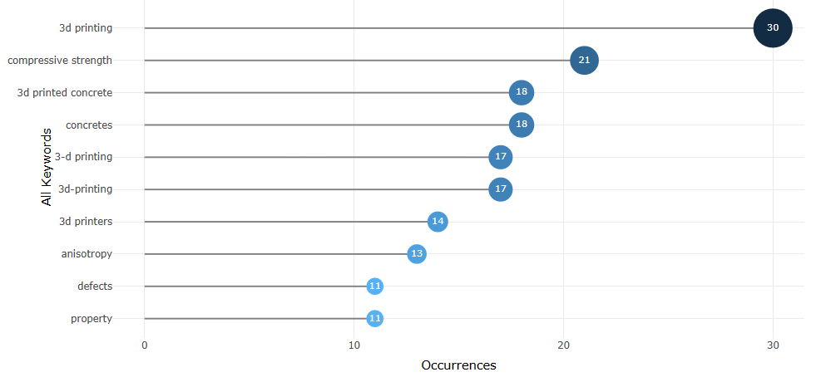
Figure 2. Word cloud of the most frequently used keywords in the investigated papers.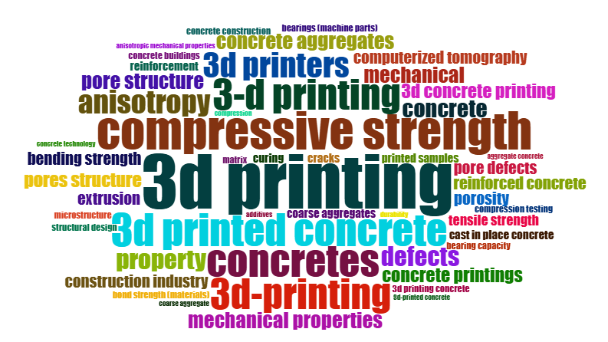
Figura 2 shows a word cloud of the most cited keywords in the selected articles. The relationship between keywords and their year of occurrence is presented in Figure 3, demonstrating the evolution of interest and research over time. A significant increase in the occurrence of most keywords can be observed from 2022 to 2025, indicating growing research activity and interest in this area.
The most cited articles, which indicate their greater relevance and impact on the scientific community, are presented in Figure 4. Additionally, the number of publications for this topic in each journal is indicated.
The journals Additive Manufacturing and Journal of Building Engineering have the highest number of publications on this topic, especially those that include the search keywords of this research, in the 5-year period (2020 to 2025), as shown in Figure 5.
Figure 3. Most frequently used keywords in the investigated papers by year of publication.

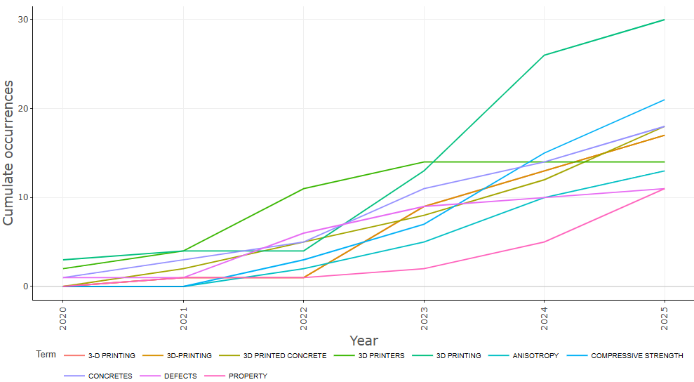

Figure 4. Publications with the highest number of works among those investigated.
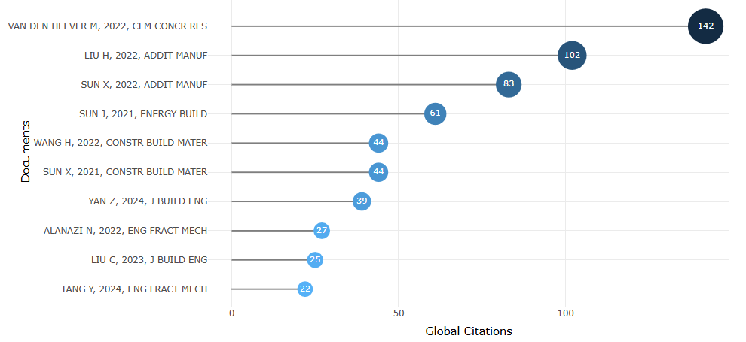
Figure 5. Journals that published the most on the study topic among the investigated papers.
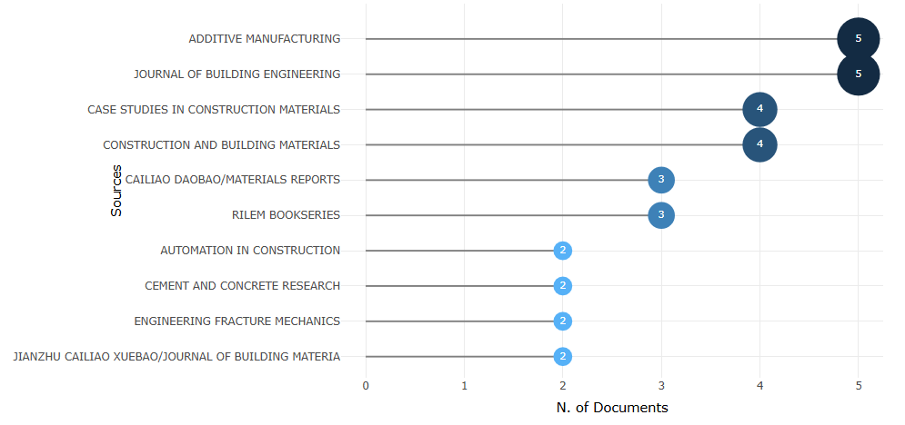
The predominance of terms like "3D printing" and "compressive strength" suggests that research is still focused on establishing and optimizing the fundamentals of the printing process and the basic performance characteristics of the material (Figure 6). However, the emergence of "anisotropy" and "defects" as relevant keywords indicates a maturation of the field, where researchers are beginning to address the more complex challenges associated with the quality and reliability of 3D printed concrete.
The concentration of publications in specific journals like Additive Manufacturing and Journal of Building Engineering reinforces the specialization and deepening of research on these platforms.
Figure 6. Biochip Reader integrated circuit (details).
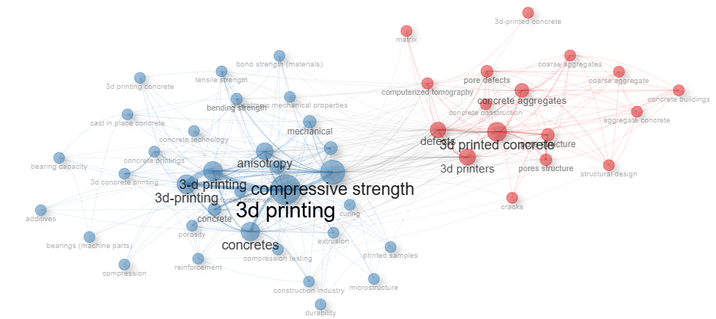

3.2 Step 2 – Failure Analysis

Defects in 3D concrete printing can arise from various causes, including problems with material rheology (its fluidity and ability to hold shape), environmental conditions (temperature and humidity), printer calibration, and the nature of the material itself. Some common problems observed in 3D printing processes in general, which can be transposed to the context of concrete, include:
- Poor layer adhesion: If layers do not bond properly, the final structure can show fragility and delamination.
- Surface and dimensional irregularities: Inconsistent material extrusion or imprecise printer movements can lead to rough surfaces, poor finish, and dimensional inaccuracies.
- Deformations and cracks: Uneven cooling of the material or internal stresses can cause warping and the appearance of cracks, compromising structural integrity.
- Under-extrusion or over-extrusion: An inadequate amount of deposited material can result in internal voids or excess material on the surface.

3.3 Step 3 – Integration of Results

- Porosity and the occurrence of defects
The analysis of the articles confirms that anomalies in 3D printed concrete (3DPC) elements are multifaceted and concentrated in specific regions of the structure. These defects not only compromise mechanical performance but also affect the durability and reliability of the construction system, requiring special attention to their characterization and mitigation [10].
Among the problems identified, interfacial issues stand out as the most critical. Located at the junctions between layers (inter-layers) and between adjacent beads of the same layer (intra-layers), these failures involve a combination of high porosity, weak adhesion—commonly referred to as "cold joints"—and micro-cracks [2]. The determination of porosity reinforces this fragility at the interfaces, where the intra-layer interface shows the highest index (4.09%), followed by the inter-layer interface (3.82%) and the concrete matrix (2.22%) [4].
The presence of these weakened interfaces also influences crack propagation in the material. Due to its high cement-to-water ratio and the absence of traditional formwork for curing control, 3DPC is particularly vulnerable to plastic and drying shrinkage cracks. These cracks appear early and tend to concentrate in regions of higher porosity, intensifying structural discontinuity [3].
In addition to internal cracks, the surface quality of the material is also compromised. The lack of finishing and the extrusion process result in surfaces with high roughness (Ra) and waviness (Wa), which are aggravated by the presence of coarse aggregates. These aggregates can temporarily obstruct the extruder nozzle, causing irregularities in material deposition and compromising surface uniformity [11]. The introduction of reinforcement bars in printed structures presents another relevant challenge. The interaction between the extruded concrete and the rebar creates an interfacial transition zone (ITZ) characterized by high porosity and low adhesion. The difficulty of compacting the material around the bars contributes to the formation of significant voids in this region, which reduces the efficiency of the steel-concrete bond and compromises the integrity of the reinforced structure [12,4].

- Porosity and mechanical performance
There is a strong correlation between porosity and mechanical performance. Studies demonstrate that an increase in porosity leads to an almost linear reduction in both compressive strength and the modulus of elasticity [2]. The relationship between increased porosity and the drop in shear strength exemplifies this trend, where voids act as stress concentrators and reduce the effective load-transfer area [4].

- Impact on durability
Interfacial defects in 3D printed elements create preferential pathways for the entry of aggressive agents like chloride ions, significantly compromising the durability of structures. Studies on the transport of these ions reveal that the chloride migration coefficient in printed samples is, on average, 10% to 30% higher than that observed in conventionally molded samples, indicating a greater susceptibility to the penetration of these agents.
Furthermore, a marked anisotropy is observed in this behavior, with intralayer interfaces—located between the printing beads—being more detrimental to ionic transport than interlayer interfaces. The direction parallel to the printing beads stands out as the most vulnerable, showing the highest rates of chloride penetration. These findings show that the print orientation relative to the exposure environment is a determining factor for a structure's service life and must be carefully considered in the design and execution of printed elements [6].

- Factors that influence, defect mitigation, and reinforcement strategies
The formation of defects in 3D printed elements is highly sensitive to printing parameters, with the width-to-height (W/H) ratio of the extruded bead being a determining factor. Wider and shorter beads, with a higher W/H ratio, promote better self-compaction between layers, which significantly reduces porosity and improves cohesion at the interfaces [2]. Furthermore, the infill pattern adopted during printing also strongly influences mechanical performance. Optimized patterns, such as the "W" shape compared to the traditional "Y," have been shown to increase load-bearing capacity by up to 80%. In these configurations, failure occurs not at the interfaces but within the filament itself, demonstrating that the part's geometric design can overcome interfacial deficiencies [13].
Despite this, the introduction of aggregates—whether coarse, recycled, or lightweight—can exacerbate defect formation, compromising structural integrity [7, 14]. However, specific treatments have proven effective in mitigating these effects. A promising example is the use of recycled coarse aggregate (RCA) subjected to a carbonation process, which works by filling the material's pores and increasing its density. 3D printed concrete using carbonated RCA showed a more compact microstructure and an increase of up to 24.7% in mechanical strength compared to using untreated RCA, proving to be a viable and sustainable alternative [8].
To overcome the challenges posed by weak interfaces, various reinforcement strategies have been explored. The addition of fibers, such as PVA or hybrid fibers, has been effective in bridging micro-cracks at interfaces, increasing both ductility and tensile and flexural strength. The extrusion process itself during printing favors the alignment of fibers in the deposition direction, enhancing performance in that orientation [1]. Another innovative solution is interlayer stapling, which involves inserting "U"-shaped metal staples between still-fresh layers. This technique ensures direct mechanical locking, improves shear transfer, and prevents delamination [15]. Complementing these local strategies, external confinement with Fiber-Reinforced Polymers (FRP) has proven effective for the component as a whole. By changing the failure mode from brittle to ductile, FRP contributes substantially to increasing the overall strength and deformation capacity of the structure [16].
However, challenges still exist regarding the anisotropic properties and fiber orientation, as in fiber-reinforced materials, the mechanical properties of 3DCP do not depend only on the fiber size but also on their arrangement [17]. Their addition rarely improves compressive strength but impacts flexural and tensile strength. Thus, it is observed that an inadequate distribution of fibers can result in unsatisfactory mechanical performance. This same problem, however, is also evident in traditional concrete. In fiber-reinforced concrete, fiber orientation is a determining factor for mechanical performance. A random or disorganized arrangement of fibers can lead to lower efficiency in stress transfer, resulting in lower strength than would be obtained with an optimized arrangement [18].

4. Conclusions

The analysis conducted demonstrates that the nature of the 3D Concrete Printing (3DCP) manufacturing process introduces a distinct typology of defects, predominantly concentrated in the interfacial zones between and within deposited layers. These anomalies, characterized by high porosity and poor adhesion, result in a markedly anisotropic mechanical behavior. This characteristic compromises structural integrity, especially shear strength at the interfaces. Additionally, these porous regions function as preferential pathways for the entry of aggressive agents, compromising the long-term durability of the structures.
Given these challenges, a rigorous control of both material and process parameters is necessary, pointing to the need to optimize cementitious mixtures and develop real-time monitoring methods. Therefore, the effective mitigation of these defects is a fundamental step to ensure the reliability and service life of printed structures, enabling the full potential of this technology in the construction industry.

References

[1] SUN, X. et al. PVA fibre reinforced high-strength cementitious composite for 3D printing: Mechanical properties and durability. Additive Manufacturing, v. 49, p. 102500, jan. 2022.
[2] VAN DEN HEEVER, M. et al. Evaluating the effects of porosity on the mechanical properties of extrusion-based 3D printed concrete. Cement and Concrete Research, v. 153, p. 106695, mar. 2022.
[3] SKRIPKIUNAS, G. et al. Durability and Cracking Defects in 3D‐Printed Concrete. Advances in Civil Engineering, v. 2025, n. 1, 4 jan. 2025.
[4] WANG, H. et al. Bond shear performances and constitutive model of interfaces between vertical and horizontal filaments of 3D printed concrete. Construction and Building Materials, v. 316, p. 125819, jan. 2022.
[5] TANG, Y. et al. Trans-layer and inter-layer fracture behavior of extrusion-based 3D printed concrete under three-point bending. Engineering Fracture Mechanics, v. 296, p. 109836, fev. 2024.
[6] SUREHALI, S. et al. Anisotropic chloride transport in 3D printed concrete and its dependence on layer height and interface types. Additive Manufacturing, v. 62, p. 103405, jan. 2023.
[7] LIU, H. et al. Influence of pore defects on the hardened properties of 3D printed concrete with coarse aggregate. Additive Manufacturing, v. 55, p. 102843, jul. 2022.
[8] TONG, J. et al. Effect of carbonated recycled coarse aggregates on the mechanical properties of 3D printed recycled concrete. Journal of Building Engineering, v. 80, p. 107959, dez. 2023.
[9] ARIA, M.; CUCCURULLO, C. bibliometrix : An R-tool for comprehensive science mapping analysis. Journal of Informetrics, v. 11, n. 4, p. 959–975, nov. 2017.
[10] LIU, K. et al. Mechanical properties of 3D printed concrete components: A review. Developments in the Built Environment, v. 16, p. 100292, dez. 2023.
[11] CHEN, Y. et al. Quantitative surface quality evaluation for 3D-printed concrete with coarse aggregate through 3D scanning. Case Studies in Construction Materials, v. 20, p. e03077, jul. 2024.
[12] LIU, C. et al. Interlayer reinforced 3D printed concrete with recycled coarse aggregate: Shear properties and enhancement methods. Additive Manufacturing, v. 94, p. 104507, ago. 2024.
[13] CHEN, Z. et al. Effect of orthotropy and printing patterns on the bending performance of 3D printed concrete grid components. Case Studies in Construction Materials, v. 22, p. e04777, jul. 2025.
[14] SUN, J. et al. 3D printed lightweight concrete containing surface pretreated coal gangue. Case Studies in Construction Materials, v. 20, p. e02906, jul. 2024.
[15] YANG, R. et al. Mechanistic insights into microstructural changes caused by stapling in extrusion-based 3D printed concrete (3DPC). Cement and Concrete Research, v. 198, p. 107998, dez. 2025.
[16] YAN, Z. et al. Compressive behavior of FRP-confined 3D printed ultra-high performance concrete cylinders. Journal of Building Engineering, v. 83, p. 108304, abr. 2024.
[17] ABREU, V. H. S.; SOUZA, G. M. A BIBLIOMETRIC REVIEW ON 3D CONCRETE PRINTING. Brazilian Journal of Production Engineering, v. 5, n. 5, p. 50–62, 2019.
[18] MEHTA, P. K.; MONTEIRO, P. J. M. Concreto: microestrutura, propriedades e materiais. IBRACON ed. São Paulo: [s.n.]. v. 3

