Bibliometric Analysis of the Use of Calcined Sewage Sludge in Mortars: Effects of Temperature on Ash Quality

Maria Eduarda Santos Leite^{1*}, Bruna Bueno Mariani², Mônica Batista Leite³, Tereza Simonne Mascarenhas Santos⁴
¹ Universidade Estadual de Feira de Santana, Departamento de Tecnologia, Feira de Santana, Bahia, Brazil
² Universidade Senai Cimatec, Departamento de Construção Civil, Salvador, Bahia, Brazil
³ Universidade Estadual de Feira de Santana, Departamento de Tecnologia, Feira de Santana, Bahia, Brazil
⁴ Universidade Estadual de Feira de Santana, Departamento de Tecnologia, Feira de Santana, Bahia, Brazil
*Corresponding author: Universidade Senai Cimatec; addresses: bruna.mariani@fieb.org.br

Abstract:
The increasing generation of sewage sludge from effluent treatment plants represents one of the main environmental challenges faced by contemporary cities. The improper disposal of this residue can cause significant impacts, such as soil and water resource contamination, toxic gas emissions, and the occupation of urban areas with landfills. In this context, the use of sewage sludge as a supplementary cementitious material (SCM), through its calcination, emerges as a technically and environmentally promising alternative. The resulting sewage sludge ash (SSA) from calcination can have relevant pozzolanic characteristics for the partial replacement of Portland cement in mortars and concretes. However, the physicochemical properties of SSA are strongly influenced by the burning conditions, especially the calcination temperature. This article presents a preliminary stage of an ongoing research, with the objective of evaluating the feasibility of incorporating SSA into cementitious matrices, focusing on the influence of calcination temperature on the ash's characteristics and the performance of mortars. For this, a bibliometric analysis was carried out based on data from the Scopus database, using the RStudio and Bibliometrix tools, in addition to a targeted literature review on calcination procedures applied to sewage sludge. The results obtained serve as a theoretical basis to guide future experimental stages, indicating recommended practices, gaps in the literature, and potential strategies for the sustainable use of this residue in civil construction.
Keywords: Sewage sludge ash. Cementitious matrices. Pozzolanic material. Calcination temperature. Sustainability.

1. Introdução

Global population growth and urban expansion intensify the generation of sewage sludge, an inevitable byproduct of Wastewater Treatment Plants (WWTPs). Its improper disposal contributes to soil and water contamination, the occupation of urban areas, and the emission of polluting gases. The search for sustainable and technologically viable alternatives for its management is urgent.
One of the most promising approaches is the use of calcined sewage sludge (Sewage Sludge Ash, SSA) as a Supplementary Cementitious Material (SCM) in mortars and concretes. Calcination converts the sludge into a potentially pozzolanic mineral residue, with a high content of silica and alumina, that can partially replace Portland cement, thereby reducing its use and associated CO₂ emissions [1].
Various studies demonstrate that calcination temperature is a critical factor. For example, dry sludge calcined at 700 °C showed an increase in mechanical strength of up to 20%, in addition to reducing equivalent CO₂ emissions by about 42% per cubic meter compared to conventional materials [2]. Meanwhile, research on thermally activated SSA shows that temperatures between 600 °C and 800 °C, with a residence time of 1 to 2 hours, promote greater pozzolanic activity and significant improvements in the compressive and flexural strength of cementitious pastes [3][4].
The compressive strength of cementitious pastes increases significantly with the rise in calcination temperature, achieving gains of up to 37% at 28 days after treatment at 800 °C for 2 hours [3]. However, higher temperatures, such as 1000 °C, caused the recrystallization of mineral phases, reducing pozzolanic reactivity. Similar results [5] highlight the balance point between the destruction of organic matter and the preservation of reactive amorphous phases.
In addition to mechanical gains, SSA shows the potential for immobilizing heavy metals, such as Cr, Pb, Cu, Ni, and Mn, thereby reducing their leaching in concrete or mortar matrices, especially when combined with accelerated CO₂ curing techniques [6].
This study aims to:
- Evaluate the technical feasibility of incorporating calcined SSA at different temperatures, focusing on the physicochemical characteristics of the ash and the mechanical performance of mortars.
- Map the state of the art through a bibliometric and bibliographic approach, with a special focus on reliable studies that have adopted variations in calcination temperature and quantified their effects.
- Provide a solid foundation to guide the next experimental stages of the research, by identifying challenges and best practices observed in the literature.

2. Method
The present study is based on a bibliometric survey, with the objective of mapping the scientific production on the use of sewage sludge ash in cementitious matrices. To carry out this analysis, the RStudio and Bibliometrix tools were used, based on data extracted from the Scopus database.
Scopus is one of the largest and most recognized databases of abstracts and citations of peer-reviewed scientific literature, covering various areas of knowledge, with a special emphasis on exact sciences, engineering, and technology. Its broad coverage and rigor in indexing make it a reliable source for bibliometric studies.
RStudio is an integrated development environment (IDE) for the R programming language, widely used in scientific research for enabling advanced statistical analysis and data visualization. Bibliometrix, on the other hand, is an R package for quantitative bibliometric analysis, capable of processing large volumes of bibliographic data extracted from databases such as Scopus, Web of Science, and Dimensions. This tool allows the extraction and analysis of information such as the most productive authors, most relevant journals, co-authorship networks, and thematic trends. It was created and developed by researchers [7] to perform a complete bibliometric analysis, following the scientific mapping workflow. Bibliometrix offers a comprehensive framework for conducting scientific bibliometric analyses in different areas of knowledge [7].
A tradução é:
The adopted search strategy involved the following main terms (keywords), which were applied to the search fields for title, abstract, and keywords:
- "sewage sludge" OR "sewage waste"
AND
- "cementitious" OR "mortar" OR "concrete"
AND
- "calcination" OR "calcined" OR "ashing" OR "temperature"
The initial search resulted in 75 publications indexed in the Scopus database. However, after an analysis of thematic relevance, it was found that the term “temperature” generated a considerable number of results not directly related to the central theme of the research. For this reason, it was decided to remove this term, which reduced the results to 18 publications. These 18 articles composed the final corpus of the bibliometric analysis, which allowed for the identification of trends, gaps, and perspectives in research on the reuse of calcined sewage sludge in cementitious materials.

3. Results
The keyword analysis was particularly insightful. As shown in Figure 1, the most recurrent keywords were "sewage sludge" (14 occurrences), followed by "calcination" (12 occurrences), and "sewage sludge ash" (9 occurrences). These data indicate a clear thematic convergence around the thermal treatment of sewage sludge and its byproduct (ash), as well as a recurring concern to explore its application in construction materials.
Figure 1. Most recurrent keywords.
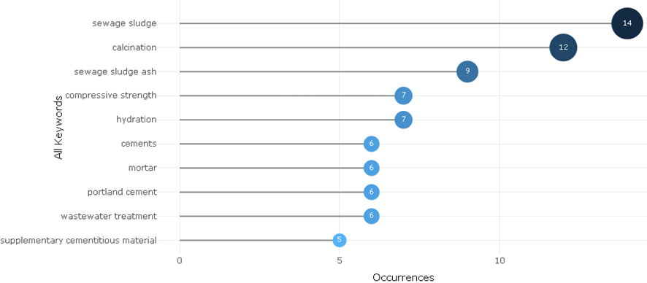
The keyword cloud (Figure 2) reinforces this perception by visually highlighting the most recurrent terms in the field of study. The identification of these most-used keywords is of great relevance for the development of this research, as it allows for conceptual alignment with the specialized literature and contributes to the definition of a more precise search strategy in future stages.
Figure 2. Keyword cloud of the most used terms in the analyzed papers.
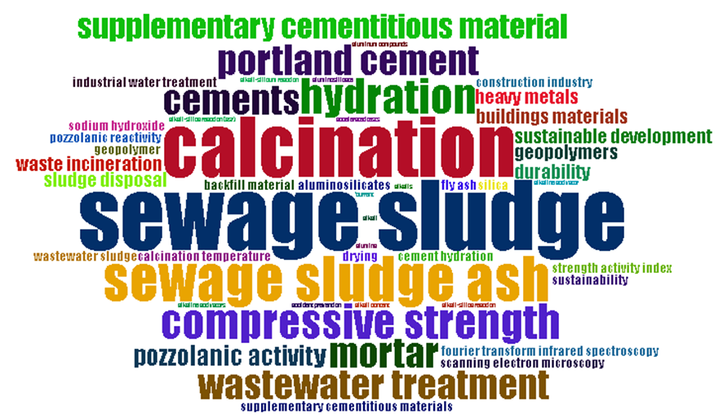Additionally, knowing these key terms facilitates the identification of robust papers, serves as a basis for formulating experimental hypotheses, and helps refine the project's terminological structure, enhancing the visibility and indexing of future results.
The keyword circuit (Figure 3) shows the relationship between the main topics addressed in the publications, allowing us to observe how concepts are interconnected within the field of study. This semantic network shows, for example, that terms such as "calcination," "ash," "mortar," "replacement," "heavy metals," and "durability" tend to coexist in studies on waste reuse, indicating the predominant thematic focuses: mechanical performance, environmental assessment, and dosage parameters.
Figure 3. Keyword circuit.
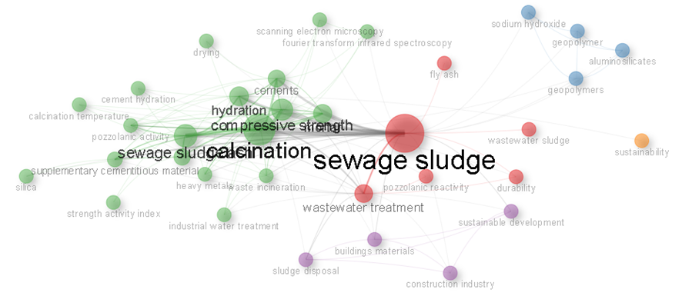
This visualization contributes to the recognition of emerging and consolidated themes, guiding technical in-depth analysis on the most relevant points and signaling potential, yet little-explored, gaps.
The analysis of scientific production by country (Figure 4) revealed that China leads the research on the topic, followed by Brazil in second place. Brazil's leading role in this area is extremely relevant, considering the national need for sustainable solutions for the destination of residues like sewage sludge. Furthermore, Brazil's position as one of the largest producers of studies on the topic highlights the country's scientific and technological capacity to contribute with innovative and sustainable solutions for the civil construction sector, especially in contexts of a circular economy and waste reuse.
Figure 4. Countries with the most citations from the papers selected in the bibliometric research.
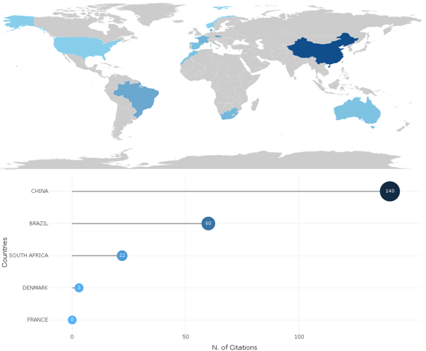
Finally, the analysis carried out provides a solid and guided basis for the next stage of the study, which involves the experimental evaluation of the technical feasibility of incorporating calcined SSA at different temperatures. The bibliometric data allowed not only for the identification of which approaches are most frequent in the literature, but also which methodologies and technical parameters have been used with greater reliability, which will be essential for the experimental design and the subsequent analysis of the results obtained.

3.1. Technical analysis of calcination conditions

The analysis of the selected studies shows that, in a large part of the research, there is a rigorous control of the pre-treatment and calcination conditions of sewage sludge. In general, the authors adopt standardized procedures to ensure the quality and reproducibility of the generated ash. Initially, the sludge is commonly dried at 100±5 °C for 24 hours to remove free moisture, followed by a milling stage, usually in a ball mill, to reduce the particle size before the calcination itself.
For example, the previously milled sludge can be calcined in a furnace at temperatures of 600, 700, 800, and 900 °C for 4 hours, with the objective of ensuring the complete oxidation of organic matter [8-9]. After the thermal treatment, the ashes are rapidly cooled in air, a common practice to prevent the formation of unwanted secondary phases.
Similarly, another study applied a controlled process, in which the sludge, after milling and sieving (75 μm mesh), was calcined at 550, 650, 750, and 850 °C for 2 hours, with a heating rate of 5 °C/min under a restricted oxygen atmosphere [10]. This approach aims to simulate more realistic burning conditions, such as in semi-controlled or industrial systems, in addition to minimizing the formation of harmful gases.
Although it was also observed that both milling and calcination are effective strategies to reduce particle size, increase the specific surface area, and, consequently, enhance the pozzolanic activity of the sludge ash [11]. However, the study also warns of possible negative effects of excessive milling, such as the adhesion of the milled sludge to cement particles and the release of compounds like phosphates, which can delay the initial hydration of the cement, impairing mechanical performance at early ages.
The same study [11] noted that the use of sludge ash as SCM, when calcined at temperatures of 600 °C and 700 °C, with increments of 100 °C, can promote compressive strengths in mortars exceeding 6 MPa, suggesting a relevant pozzolanic behavior. However, the authors observed that increasing the temperature above 700 °C did not provide additional gains in pozzolanic activity. On the contrary, high temperatures favor the crystallization of SiO₂ phases and an increase in the average particle diameter, which can compromise the reactivity of the ash.
Additionally, other studies analyzed different sludge activation methods and concluded that vibratory milling, associated with calcination at 400 °C, showed better results compared to ball milling or the use of lime. This indicates that moderate temperature conditions, combined with efficient milling techniques, may be more effective in optimizing the material's activity.
It is also important to note that excessive milling, while it can reduce the effect of particle shape and size, can introduce retarding compounds like phosphates, which hinder the initial hydration of the cement [11]. In this regard, processes such as high-temperature calcination are pointed out as effective alternatives to remove residual organic matter and reduce the retarding potential, thereby improving the residue's compatibility with cementitious matrices.
In summary, the analyzed studies highlight the importance of controlling the calcination temperature, the ash's particle size distribution, and the sludge's previous treatment as determining factors for obtaining a material with good pozzolanic activity and technical compatibility with mortars and concretes. These parameters will be fundamental for guiding the future experimental stages of the current research.
Furthermore, other studies (Table 1) also analyzed the influence of variations in the sludge's calcination time and temperature, and the percentage of cement replacement in mixtures.
Table 1. Variation in Sludge Calcination Time and Temperature in Analyzed Studies.
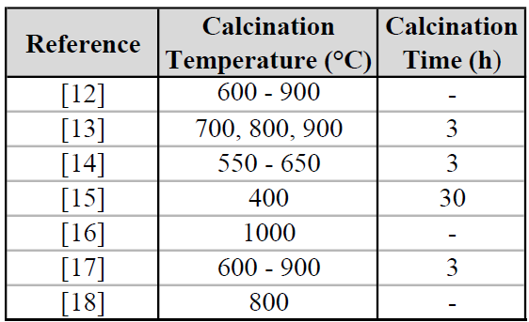
The studies presented in Table 1 evaluated the incorporation of calcined sewage sludge into cementitious matrices, considering different calcination times and temperatures and percentages of cement replacement. The methodological variations allowed for the identification of recurring trends and results regarding the technical efficiency of the application of SSA in pastes, mortars, and concretes.
Cement replacement with SSA varied between 5% and 30%, with the best technical results generally associated with contents between 10% and 20%. The temperatures used for the calcination of the sludge, on the other hand, varied between 550 °C and 1000 °C, with the most recurrent range being around 800 °C, as this temperature represents a point of balance between the elimination of organic matter and the formation of reactive mineral phases.
Research that points to temperatures below 700 °C indicated a more limited pozzolanic performance, while excessively high temperatures, such as 1000 °C [16], can promote the crystallization of phases, reducing reactivity.
In summary, most studies suggest that calcination at 800 °C, with a cement replacement of 10% to 20% and a burning time of 3 hours, provides a balance between mechanical performance, pozzolanicity, and environmental and operational viability. The ashes obtained under these conditions showed better pozzolanic activity indexes (PAI) and technical performance.
Excessively long burning times, such as 30 hours at 400 °C, tend to be unfeasible from an energy perspective, while very high temperatures, such as 1000 °C, can reduce the reactivity of the ash due to the formation of crystalline phases.

4. Conclusion
The valorization of sludge through its incorporation into civil construction, especially as an alternative resource in cementitious materials, emerges as a sustainable and economically viable alternative. This approach contributes to the circular economy, reducing the dependence on non-renewable resources and minimizing the impacts of the construction industry, one of the most polluting on the planet.
However, the analysis of the studies shows that considerable obstacles still exist for the consolidation of its use. Among the identified challenges are the heterogeneity of raw sludge, the variability in its chemical composition, and the challenge of reproducibility between different burning and characterization conditions. These factors limit the generalization of results and the transfer of advances obtained at a laboratory scale to industrial practice.
Despite these challenges, the benefits associated with the use of SSA are significant. The analyzed studies show that the ashes, when subjected to adequate burning conditions, can present relevant pozzolanic behavior, contributing to the partial replacement of Portland cement without significant harm to the mechanical properties of mortars. The comparative analysis of the research shows that the calcination temperature plays a central role in the quality of the ash. Temperatures between 700 °C and 900 °C, with burning times between 2 and 3 hours, tend to promote the best balance between the elimination of organic matter, the formation of reactive amorphous phases, and the control of energy consumption.
Finally, it is concluded that the use of SSA as a supplementary cementitious material is a worldwide expanding research line, aligned with sustainability guidelines and technological innovation in civil construction. The recurring results indicate its technical, environmental, and economic viability, provided that the appropriate burning and replacement parameters are respected. In this sense, bibliometric analysis is a strategic way to observe recurring patterns, reveal aspects little discussed in the literature, map emerging themes, and contribute to the formulation of more effective methods in subsequent studies, driving the advancement of knowledge and the consolidation of sustainable solutions in the field of construction materials.
Acknowledgement

To the Universidade Senai Cimatec and the Universidade Estadual de Feira de Santana.

References

- LYNN, C. J. et al. Sewage sludge ash characteristics and potential for use in concrete. Construction and Building Materials, v. 95, p. 767–779, 2015.
- ESPINHEIRA MARTINS, R. J. et al. Partial replacement of cement by sewage treatment plant sludge in eco-friendly cement mortar. International Journal of Engineering Research & Technology (IJERT), v. 11, n. 6, p. 77–80, 2022.
- LIU, X. et al. Utilization of sintered sludge ash with different mechanical–thermal activation parameters. Materials, v. 17, n. 16, p. 4101, 2024.
- DESSOUKY, N. et al. Influence of combustion temperature on performance of sewage sludge ash as SCM. Journal of Material Cycles and Waste Management, v. 20, p. 211–219, 2018.
- DONATELLO, S.; CHEESEMAN, C. R. Recycling and recovery routes for incinerated sewage sludge ash (ISSA): a review. Waste Management, v. 33, p. 2328–2340, 2013.
- FERNANDES, P. M. et al. The immobilisation of heavy metals from sewage sludge ash in CO₂-cured mortars. Sustainability, v. 13, n. 22, p. 12893, 2023.
- ARIA, M.; CUCCURULLO, C. Bibliometrix: An R-tool for comprehensive science mapping analysis. Journal of Informetrics, v. 11, n. 4, p. 959–975, nov. 2017.
- CHANG, Zhiyang; LONG, Guangcheng; XIE, Youjun; ZHOU, John L. Pozzolanic reactivity of aluminum-rich sewage sludge ash: influence of calcination process and effect of calcination products on cement hydration. Construction and Building Materials, v. 318, Feb. 7, 2022.
- CHANG, Zhiyang; LONG, Guangcheng; XIE, Youjun; ZHOU, John L. Chemical effect of sewage sludge ash on early cement hydration used as supplementary cementitious material. Construction and Building Materials, v. 322, Mar. 7, 2022, Art. 126116.
- MAHUTJANE, T. Charles; TCHADJIÉ, Léonel N.; SITHOLE, Thandiwe N. Feasibility of using sewage sludge as an aluminosilicate source for geopolymer cement synthesis. Journal of Materials Research and Technology, v. 25, July–Aug. 2023, p. 3314–3323.
- ZHOU, Jingfei; CHEN, Shoukai; DAS, Avik Kumar. Application of sludge as a sustainable material in construction materials: a comprehensive review. Journal of Construction Engineering, v. 111, Oct. 1, 2025, Art. 113434.
- BRENDHY, Q. (2022). Avaliação da reatividade pozolânica de cinza de lodo de esgoto calcinado. Dissertação (Mestrado em Engenharia Civil) – UFG.
- LIMA, J. (2013). Avaliação do uso de cinza de lodo de esgoto em concretos. Dissertação (Mestrado em Engenharia Civil) – UFBA.
- FONTES, C. A. (2016). Estudo da influência da cinza de lodo de esgoto em concretos de alto desempenho. Dissertação (Mestrado em Engenharia Civil) – UFAL.
- BAIOCHI, R. (2021). Avaliação do uso de cinza de lodo de esgoto em concretos. Dissertação (Mestrado em Engenharia Civil) – UNESP.
- ASSIS, Y. B. (2018). Estudo da substituição parcial da areia por cinza de lodo de esgoto em argamassas de revestimento. Anais do XVI Encontro Nacional e XII Encontro Latino-Americano de Conforto no Ambiente Construído.
- OLIVEIRA, J. V. C. (2018). Análise da atividade pozolânica da cinza de lodo de esgoto. Anais do 23º CBECiMat, 2018.
- GEYER, A. L. B. (2001). Estudo do uso da cinza de lodo de esgoto na produção de concreto. Tese (Doutorado em Engenharia) – UFRGS.

