**Skill-based Training Plan:**

**Educational Green Skills**

***(Capacity building and Strengthening Skills in Education)***

**Akbar Valadbigi, PhD.**

* **Associate Professor, General Education Department, Sanandaj, Iran**
* **Teachers' Professional Development Trainer**
* **WhatsApp:(+98) 918 287 2131**
* **E-mail:karvan74@gmail.com**

**Mariângela Monsores Furtado Capuano, PhD**

* **Instituição: Colégio Pedro II, Rio de Janeiro, Brazil**
* **Doutora em Literatura Comparada**
* [**capuanom66@gmail.com**](mailto:capuanom66@gmail.com)
* **WhatsApp:(+55) 21986776971**

Abstract

Educational systems have unlimited capacities in creating and promoting moral and citizenship skills - both at the individual level and at the social level. Green-based schools are a necessity instead of intelligence-oriented and competitive education centers.

The implementation of the educational-skills program**,** in all educational centers from kindergarten to university, can lead to "personal development", a safer and more informed society, a greener and healthier ecology, and more educated and emotional citizens. The values of the violent world, enchanted by the media, the deteriorating environment and the growing tsunami of "Loneliness" need to be rethought more and more.

***Key words:*** **Educational Challenge, Green Skills, Emotional Intelligence, Social learning**

**Skill-based Training Plan:**

**Educational Green Skills**

***(Capacity building and Strengthening Skills in Education)***

**Akbar Valadbigi, PhD.**

* **Associate Professor, General Education Department, Sanandaj, Iran**
* **Teachers' Professional Development Trainer**
* **WhatsApp:(+98) 918 287 2131**
* **E-mail:karvan74@gmail.com**

**Mariângela Monsores Furtado Capuano, PhD**

* **Instituição: Colégio Pedro II, Rio de Janeiro, Brazil**
* **Doutora em Literatura Comparada**
* [**capuanom66@gmail.com**](mailto:capuanom66@gmail.com)
* **WhatsApp:(+55) 21986776971**

**"Education and learning is a fundamental human right and a clear path to sustainable peace!"...**

**……………………………….**

**Main Contents and Key Points**

* The importance and necessity of Cultivating and Strengthening Skills
* Social-Emotional Development of the Learner, the “Missing Link” of Educational Programs
* Effective factors in the process of Learning Green Skills
* Multiple Goals and Strains of the Plan
* Key Indicators and Concepts of Green Skills
* Teaching Techniques and Methods
* Suggested Complementary Tactics (Practical Solutions)
* Achievements and Expectations of the Plan
* Suggestions and Capacities
* Conclusion
* References
* Short biography of the Author
* Appendices

**The Importance and Necessity of Cultivating and Strengthening Skills:**

Educational systems have unlimited capacities in creating and promoting moral and citizenship skills - both at the individual level and at the social level. Green-based schools are a necessity instead of intelligence-oriented and competitive schools.

Teachers can be a key factor in teaching these skills, including: Social Learning, improving Emotional Intelligence, Self-care skills, Green Skills: such as Environmental Ethics, Kindness to the earth, creatures and animals, Tolerance and Coexistence, Self-awareness Skills, Empathy, Daily Positive Habits, Problem-solving Skills and Resilience Skill against individual, family and social life challenges. Educators should be more than just teaching concepts and data.

The many challenges of today's world in all cultural, social, political and citizenship fields, along with the continuation of unbridled types of family, social and violence and deviations in educational environments, small and large wars and the spread of pandemic problems and Social insecurities such as: alcoholism, addiction, sexual and moral deviations, dropping out of school, educational decline and the alienation of teaching staff and students from major educational programs, are indicative of the claim that the content of textbooks, headings and educational programs serve teachers and managers, the need for serious changes, including the inclusion of skill-based, emotion-oriented topics, changing habits, promoting emotional intelligence instead of emphasizing elitism, environmental considerations and strengthening naturalistic intelligence, personal discipline, social relationships, and ...

**Social-emotional Development of the learner, the Missing Link of Educational Programs:**

In formal education systems and school curricula, special attention and index programs to strengthen and learn emotions and behavioral skills in order to promote individual development are missing in the midst of diverse, heavy and sometimes unnecessary educational contents.

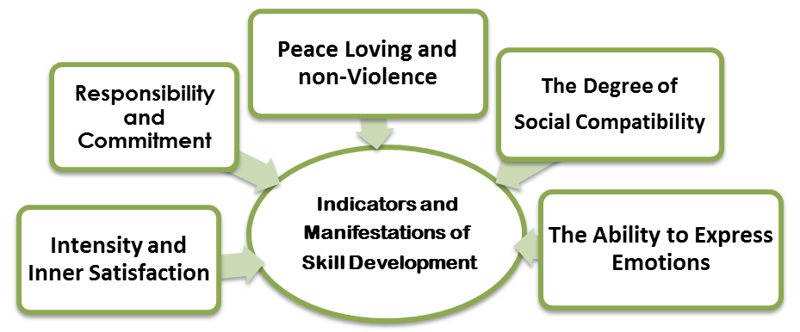

**Effective Factors in the process of Learning Green Skills:**

• Family (Parents)

• School (Curricula)

• Friends (Social Environment)

• Media

• Economic Conditions

• Gender

• Genome

• Cultural Conditions (Value and Normative System of Society)

**Purposes and multiple Strains of the Course:**

**Educational Goals:**

Such as strengthening teamwork, self-care, more educational participation……

**Cultural and Social Goals:**

Developing a culture of coexistence and order, non-violence, strengthening human interactions, improving friendship skills and emotionalism, responsibility and …..

**Environmental (Ecological) Goals:**

Taking care of nature, being kind to animals, expanding green space at home and school, growing and maintaining flowers and plants….

**Indicators and key concepts of green skills:**

**Green skills can be seen in several key concepts and major indicators such as:**

Responsibility, environmental relations, resilience, self-care, empathy and listening, stress and pressure control, daily positive habits, positive thinking, emotional intelligence, human relations and interactions, tolerance and adaptability, freedom of speech, peace-making, problem solving, social learning , participation, optimal consumption culture and...

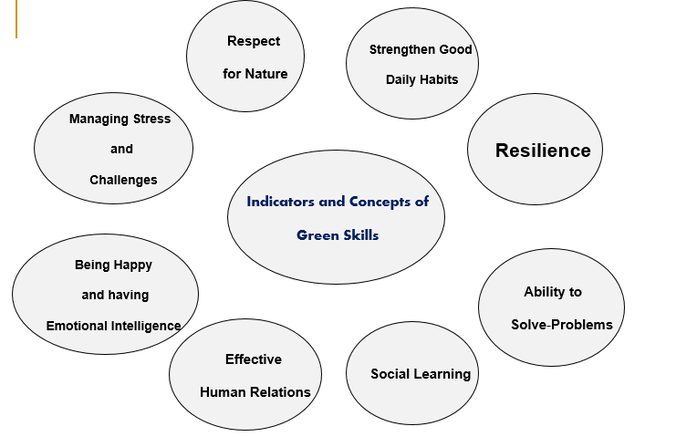

**Teaching Techniques and Methods:**

Teaching methods to teach and strengthen emotional, motivational skills and moral values to students can be: creative, decentralized, hybrid, critical, goal-based, dramatic, field-based, and based on experience and story, group activity, relationship-oriented; it should be value-based, democratic, transformative, collaborative and group, constructive and forward-looking and based on useful learnings for a sustainable future.

Skill training is dealing with unlearned and missing lessons in the process of official school education. What is more important and decisive and plays a key role in the present and future success of our individual, family and professional lives, lies in the level of happiness, inner satisfaction and success in our daily interactions and coping with and managing the many challenges of life. It seems necessary for all of us to bravely admit that we don't have enough emotional literacy and it shouldn't be a problem if we enroll in the "School of Life Skills"!

**Suggested Complementary Tactics**

**(Practical Solutions) to Develop and Strengthen Skills are:**

• Playing games and Group Activities

• Storytelling and Drama

• Group discussion (Negotiations)

• Observations (Group Camp)

• Social Modeling

• Practice Challenging Situations

• Teaching with Body Language (Non-verbal Skills)

**Achievements and Expectations from the Course:**

• Strengthening students' emotional and physical health, vitality and stress relief

• Increasing verbal and non-verbal interactions with others

• Promoting nature-loving culture and preserving plant and animal species

• Strengthening the habits of peaceful thinking, tolerance and making friends instead of all kinds of violence and loneliness

• Strengthening social learning, democratic character, free thinking and tolerance

• Respect and acceptance of diversities and contradictions in the multiracial, ethnic, religious, linguistic world etc.

**Suggestions and Capacities:**

• Formation of centers, environmental and civil organizations in educational centers with the help and experience of NGOs

• Using media specialists, psychologists, cultural and environmental activists to strengthen non-profit programs

• Teaching the "Problem-solving" method in workshops and short-term trainings with the help of visual and demonstration concepts

• Teaching self-belief, self-confidence, setting goals in life and strengthening morale in solving life's problems should be the priority of educational topics.

Expanding games, nature camps, role playing, storytelling, movies, cartoons and animations to transfer and learn skills.

• Holding seminars, classes and in-services in schools and skill training centers

**Conclusion:**

Education is the most key element in the process of modernization and development of today's societies. Escaping war, violence and achieving environmental sustainability and a healthy society requires education and learning - especially social and emotional learning- and improving the emotional intelligence of new generations and learners of educational centers.

The methods of teaching behavioral and environmental skills (Experiences of the Life School), unlike official education, are experimental, interactive, flexible, child-oriented and skill- oriented, and the character of the learner is at the center of the education cycle. Brainstorming method, waterfall method and active and present methods such as camps, games and discussions and group workshops are more important than the classroom. Undoubtedly, the personality of the coach and his professional and experimental knowledge in the field of practical training of all skills has a central and vital role.

This is part of the "Green Belief" of social responsibility and pacifism, which will result in a greener and more sustainable ecology and safer society for future generations - the owners of the globe...

Referências

**Resources for further reading:**

* Abbi, K., & Dehghan, H. (2011). Social capital among Indian and Iranian families. International Journal of Social Sciences, 1(1
* Activities among students Technical and Vocational Education Training (TVET) Elixir Social Science, 107, 47295-47297
* Aguilar Elena, Habits that Build Resilience, Onward: Cultivating Emotional Resilience in Educators
* Benavot, A. (2014). Education for Sustainable Development in Primary and Secondary Education, 43
* Bryk, A. and Schneider, B. (2002). “Trust in Schools: a Core Resource for Improvement.” New York: Russell
* Building Resilience in Schools, Research Centre for Children Schools and Families, University of Greenwich 2016
* Caplan, S. E. (2005). A Social Skill Account of Problematic Internet Use Journal of Communication. 55
* Day, C., and GU, Q. (2010). Emotional Journeys: Teacher Resilience Counts. [Pdf], Nottingham, University of Nottingham
* Fitzsimons, P. (2007). “Social Capital and Education.”Education (NZ) Ltd, Philosophy of Education Society of Australasia.
* Gary, S. (1997). Training teachers, faculty members, and staff. In B. H. Khan (Ed.), Web based. Instruction.  Englewood Cliffs,
* Golmohamad, M. (2009). Education for world citizenship: beyond national allegiance, 41 (4), 466- 486
* Hargreaves, A. (2000). Mixed emotions: Teachers’ perceptions of their interactions with students. 16, 811–826
* Hargreaves, A., & Fink, D. (2006). Sustainable leadership. San Francisco, CA: Jossey-Bass
* Insim, P. (2005). Teacher Commitment and its Effects on Student Achievement in American High Schools. 11(5), 461 – 485
* MacQuail, D. (1994). Mass communication theory. London: sage LTD, third edition.
* Mguni, N., Bacon, N. & Brown, J. F. (2012). The wellbeing and resilience paradox. London: The Yoyng Foundation
* Nagra, V., & Kaur, R. (2014). Environmental education awareness and ecological behaviour of school
* Sim, J. (2010). Social studies, citizenship and participation, Global Education, 40(2), 58-63
* Techincal and Vocational Education and Training Issues, Concern and Prospect (19), 255 - 263
* The Good New Habits Book", ABC School 2016
* 14 UNICEF Innocenti – Global Office of Research and Foresight, Accelerating Green School-to-work Transitions, UNICEF Innocenti, Florence, July 2023