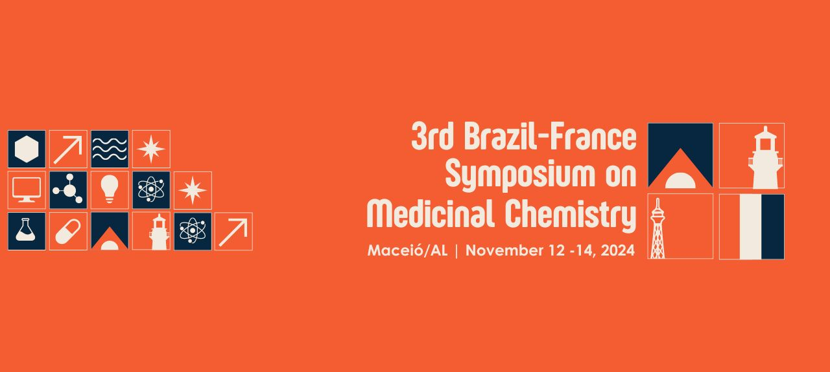
IN VITRO EFFECTS OF SB-44 AGAINST Leishmania (Leishmania) infantum AMASTIGOTES AND IMMUNE RESPONSE MODULATION
Yasmim A. A. Machado (PG),^{1*} Julyanne M. S. Sousa (PG),¹ Raiza R. L. Rodrigues (PG),¹ Franciregina S. Araújo (G),¹ Francisco J. B. M. Junior (Prof),² Klinger A. F. Rodrigues (Prof),¹.
yasmimairesmachado@gmail.com
¹ Infectious Disease Laboratory, Campus Ministro Reis Velloso, Federal University of Parnaiba Delta, 64202-020 Parnaiba, PI, Brazil; ²Molecular Synthesis and Vectorization Laboratory, Department of Biological Sciences, State University of Paraíba, 58071-160 João Pessoa, PB, Brazil.
Keywords: (2-Amino-thiophene derivative, Visceral leishmaniasis, L. infantum, Immunomodulation)
ABSTRACT

BACKGROUND: Leishmaniasis is caused by protozoa of the genus Leishmania. The visceral form of the disease, commonly known as kala-azar, primarily damages the liver, spleen, and bone marrow and can be fatal in 95% of untreated cases. Treatment relies on pentavalent antimonials, which are not only toxic but also generate increasingly resistant strains. Given these therapeutic limitations, there is an urgent need for safer and more effective treatment alternatives. Synthetic 2-amino-thiophene derivatives, compounds containing a thiophene ring, have shown various biological activities, including antileishmanial properties. Among them, compound SB-44 has shown promising activity against L. amazonensis, with an IC₅₀ of 7.37 µM in promastigotes and an EC₅₀ of 15.82 µM in amastigotes (Rodrigues et al., 2015). OBJECTIVES: The objectives of this study are to evaluate the efficacy of SB-44 against L. infantum infection in vitro, the primary causative agent of visceral leishmaniasis. Additionally, it aims to analyze the indirect mechanisms of SB-44 action, including nitric oxide (NO) levels, reactive oxygen species (ROS), and cytokine production by infected macrophages treated with the compound. METHODS: Macrophages RAW 264.7 were cultured in 24-well plates and infected with L. infantum promastigotes. After 72 hours of treatment with SB-44 (25 – 3.12 μM), the coverslips were removed, fixed, and stained using a rapid panoptic staining kit. The supernatant obtained from the infection was used to assess the indirect production of NO by measuring nitrite levels using the Griess reagent. The analysis of ROS levels in RAW 264.7 macrophages infected with L. infantum and treated with SB-44 was performed using the H2DCFDA assay with concentrations ranging from 25 to 3.12 μM. The production of Th1 cytokines (TNF-α, IL-12) and Th2 cytokines (IL-10, IL-6) was also evaluated from the infection assay supernatants using sandwich ELISA. The plates were sensitized with antibodies, incubated, washed, and detection was performed with avidin-HRP, followed by spectrophotometric reading for quantification. RESULTS AND DISCUSSION: The antileishmanial activity of compound SB-44 was evaluated in macrophages infected with L. infantum. SB-44 achieved 100% inhibition efficacy at concentrations of 12.5 µM and 25 µM, while lower concentrations of 6.25 µM and 3.12 µM reduced infection by 66.5% and 40.7%, respectively. Regarding the number of amastigotes per macrophage, there was a reduction ranging from 48.6% to 100%, with an EC₅₀ calculated at 3.08 µM, strongly indicating its selectivity against the parasite. The immunomodulatory profile of SB-44 was evidenced by a significant increase in pro-inflammatory Th1 cytokines (TNF-α and IL-12) and a reduction in anti-inflammatory Th2 cytokines (IL-10 and IL-6). This profile suggests a shift towards a Th1 response, which is essential for parasite elimination, as these cytokines are involved in macrophage activation and the production of ROS and NO. Nitric oxide and reactive oxygen species levels significantly increased after treatment, with NO production rising by up to 235.7% and ROS production increasing by 5.6-fold. These findings indicate that SB-44 not only directly reduces the parasitic load but also modulates the immune response, stimulating Th1 cytokine production and inhibiting Th2 cytokines, thus contributing favorably to parasite elimination. Also, the results obtained with SB-44 are consistent with the studies of Rodriguez et al. (2018), suggesting that thiophene ring derivatives may constitute a promising class of antileishmanial agents. SB-44 emerges as a potentially effective compound for the treatment of leishmaniasis, inducing a favorable immune response. CONCLUSION: The results of this study demonstrated that compound SB-44 is effective against amastigote forms, in addition to inducing a favorable immune response by increasing the production of Th1 cytokines (IL-12 and TNF-α) and reducing Th2 cytokines (IL-10 and IL-6), as well as elevating the levels of ROS and NO. These findings suggest that SB-44 has potential as a promising therapeutic alternative for the treatment of visceral leishmaniasis, due to both its antiparasitic efficacy and its immune response modulation.

