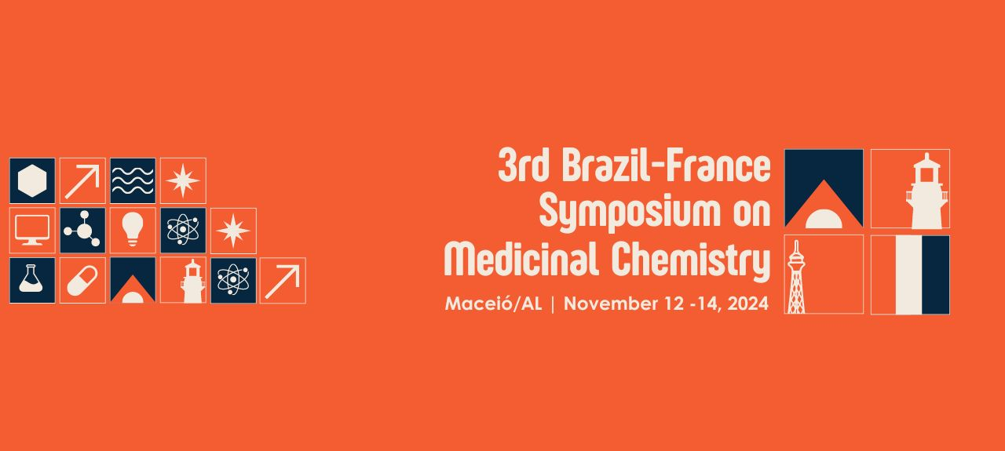
SYNTHESIS OF N-HETEROCYCLIC COMPOUNDS FROM WASTE DIPYRONE TABLETS
Letícia R. Magalhães (G),¹ Euzébio G. Barbosa (Prof),¹ Alessandro K. Jordão (Prof).¹
leticia.ribeiro.700@ufrn.edu.br;
¹ Department of Pharmacy, Federal University of Rio Grande do Norte, Natal, 59012-570, RN, Brazil
Keywords: Click Chemistry, Synthesis, Dipyrone.
ABSTRACT

Dipyrone is a very popular medicine used around the world as analgesic and antipyretic, and is one of the most consumed drugs in Brazil, where a great amount of expired medicine is discarded incorrectly, leading to environmental impact. It acts as a pro-drug, being metabolized in two molecules with the aforementioned activity: 4-methylaminoantipyrine (MAA) and 4-aminoantipyrine, among which MAA is the main responsible for the clinical effects. MAA can be easily obtained through a basic hydrolysis reaction and used as scaffolding to the synthesis of new molecules, as related already in many published papers. The hydrolysis provides the formation of a secondary amine, allowing the addition of an alkyl group containing a triple bond, which can react with a molecule containing an azide group, forming an 1,4-disubstituted 1,2,3-triazole in a Click Chemistry reaction. 1,2,3-Triazoles are known to be highly biocompatible and stable and present wide biological activity such as anti-cancer, anti-HIV, anti-tuberculosis, antifungal, antibacterial, antiviral and anti-inflammatory, being of great importance to the medicinal chemistry field. Considering this, the main objective of this work is to use waste dipyrone tablets as starting material for the synthesis of new molecules with potential biological activity. The obtention of N-heterocyclic derivatives was conducted in a three steps route: 1) hydrolysis, where the dipyrone tablets were powdered, solubilized in a KOH 10% aqueous solution, filtered and submitted to reflux; 2) alkylation, where MAA reacted with and alkyl halide, having DMF as solvent and K₂CO₃ as base, in room temperature; 3) Click Chemistry reaction, where the alkylation product reacted with 1-azido-4-nitrobenzene, having a mixture of t-Butyl alcohol and water as solvent, sodium L-ascorbate and CuSO₄$∙$5H₂O as catalytic system and being submitted to low heat. The development of the reactions was monitored by thin layer chromatography. MAA was obtained with physicochemical properties as reported in literature, yielding 20-38%, which is lower than usually presented; that indicates the need of optimization of the methods employed to obtain the hydrolysis product from tablets, since the excipients might be a source of interference to the process. The alkylation product was obtained as a yellow oil with good yield. The N-heterocyclic derivative was obtained as small orange crystals with satisfactory yield, also needing optimization of the synthesis or isolation methodology. In conclusion, it was possible to obtain new molecules using waste dipyrone tablets, although methodological improvements are needed.
