ENHANCING HYDROPHOBICITY IN POLYESTER FABRICS: THE ROLE OF PDMS AND SILICA IN SURFACE TREATMENT

Paulo Romano Correia1*, Vinícius Oliveira1, Débora Leal1, Eduardo Kerche1, Rodrigo Polkowski1
1 TRL9 Tech – Research and Development, Salvador, BA, Brazil
*Paulo Romano Correia: TRL9 Tech; Salvador, BA, Brazil; paulo.correia@trl9.tech

Abstract: Superhydrophobic fabrics play a key role in sustainable industrial applications, including oil/water separation and self-cleaning materials. This study addresses the challenge of enhancing hydrophobicity while preserving fabric functionality by modifying its surface via dip-coating with poly(dimethylsiloxane) (PDMS) and silica nanoparticles. Water contact angle (WCA) measurements were performed by depositing droplets on the fabric surface and capturing images via optical microscopy. The angles were determined using the tangent method in the ImageJ software. Eight measurements were taken per sample to ensure reproducibility. Untreated fabric exhibited a WCA of 84°, while PDMS coatings (2 wt% and 4 wt%) increased WCAs to 129.1° and 131.7°, respectively. The incorporation of silica nanoparticles further enhanced hydrophobicity (WCA: 137°), attributed to the increased roughness on the surface observed by optical microscopy (OM). However, higher PDMS concentrations (4 wt%) reduced fabric permeability, compromising the fluid flow. These results underscore the need for PDMS’s content optimization to maintain breathability while achieving robust water repellency.

Keywords: Coating. Nanoparticle. Hydrophobicity. Porosity. Filtration.

1. Introduction

Superhydrophobic behavior is observed in fabrics with a water contact angle (WCA) exceeding 150°. The surface of those fabrics integrate biomimetic principles and nanotechnological advancements to replicate hierarchical structures found in nature, such as lotus leaves (the lotus effect) and butterfly wings [1]. In addition to efficiently repelling liquids, superhydrophobic fabrics exhibit self-cleaning properties, reduced contaminant adhesion, and enhanced durability. Those characteristics are critical attributes for applications that require resistance to harsh environments, ranging from medical apparel to industrial filtration systems [2].
In a general way, the superhydrophobic effect arises from the synergy between multiscale surface roughness (micro- and nanostructures) and low-surface-energy at the liquid-solid interactions. The superhydrophobic behavior of a surface can be explained by three main theoretical models Young, Wenzel, and Cassie Baxter which describe how chemical modifications on heterogeneous surfaces affect the way water interacts with them [3].
The increasing demand for water decontamination filters is driven by pressing global challenges, such as water scarcity and aquatic ecosystem pollution. For instance, industrial activities release an estimated two million tons of oil annually into water bodies, compromising biodiversity and public health [4].
Conventional wastewater treatment technologies, such as centrifugation and chemical precipitation, are gradually being replaced by membrane-based separation techniques, due to their higher energy efficiency and scalability [5]. However, developing membranes with tunable hydrophobicity and sufficient mechanical robustness remains a critical bottleneck, particularly for oily wastewater remediation, where selective absorption of hydrophobic contaminants is essential [5].
The engineering of superhydrophobic surfaces relies on two interrelated pillars: (1) the fabrication of hierarchical micro- and nanoscale roughness, which traps air and minimizes liquid-solid contact (Cassie-Baxter regime), and (2) chemical functionalization with low-surface-energy materials, such as fluoropolymers or silanes, to repel polar molecules [3].
Silica nanoparticles (SiO₂) and polydimethylsiloxane (PDMS) have emerged as promising candidates in this context. While silica nanoparticles provide tunable surface topography, PDMS, a flexible and cost-effective polymer, exhibits intrinsic hydrophobicity and strong adhesion to fabrics substrates [6]. Recent studies demonstrated that combining those materials yields synergistic effects, elevating the WCA above 160° and improving resistance to abrasion and repeated washing cycles [1].
However, optimizing the ratio of silica to PDMS presents a multifaceted challenge. Excessive silica content may compromise fabric flexibility, whereas insufficient PDMS levels reduce coating cohesion, leading to delamination under mechanical stress [7]. Moreover, traditional fluoropolymer-based coatings, while highly effective, face criticism due to environmental persistence and bioaccumulation risks, urging the development of eco-friendly alternatives [8].
Although PDMS is not biodegradable, it is considered less toxic than perfluorinated compounds, making it a viable candidate for biomedical and environmental applications [8].
Deposition techniques such as dip-coating and electrospinning are widely employed to apply superhydrophobic coatings onto fabrics. However, achieving uniformity requires precise control over parameters such as solution viscosity, immersion speed, and temperature [9]. On the other hand, dip-coating, in particular, allows for adjustable coating thickness by varying particle concentration and the number of immersion cycles, yet inconsistencies in homogeneity can create hydrophilic regions, compromising overall performance [7].
Despite recent advancements, systematic studies on the impact of silica and PDMS concentrations on specific fabrics substrates, such as polyester, remain scarce. While Chen et al. [1] explored nature-inspired hierarchical structures, the study did not address the relationship between composition, morphology, and long-term mechanical stability, which is an essential gap for practical applications.
This study addresses challenges by engineering polyester fabrics via a dip-coating process with variable PDMS and silica nanoparticle concentrations. Optical microscopy and WCA measurements were used to correlate surface morphology with wettability, respectively. Optimal formulations were identified, maximizing hydrophobicity while preserving fabric functionality.
This research presents innovations for diverse sectors, including oil-water separation membranes, protective medical fabrics, and self-cleaning architectural materials, aligning with global sustainability objectives.
2. Methodology
Figure 1 shows commercial Telesilk polyester fabric with 150 threads. Discs measuring 6 cm in diameter were pre-cleaned in a 1% nonionic detergent solution at 100°C for 1 h. The samples were then rinsed with distilled water three times and dried at 80°C for 4 h. Five formulations (Table 1) were prepared with PDMS and silica nanoparticles.

Figure 1. 150-thread polyester fabric discs before treatment.

Table 1. Formulations.

The formulations were prepared as follows: I. First, in a beaker, a solution of 2 wt.% or 4 wt.% of PDMS resin in isopropanol was prepared and left under agitation in an ultrasonic bath for approximately 15 minutes at 65°C; II. Then, 0.1 wt.% of nanosilica was slowly added to the isopropanol solution, and the dispersion was kept under stirring in an ultrasonic bath for homogenization; III. Finally, an equivalent amount (0.2 wt.% or 0.4 wt.%) of the PDMS-curing agent was added to the mixture, which was kept in the ultrasonic bath for another 15 minutes. For the formulations containing only PDMS, the same procedure described was followed, eliminating only step II.
After preparing the formulations, the fabrics were treated using the “dip-coating” method, chosen for its simplicity and cost-effectiveness without needing expensive machinery. Thus, the fabrics were immersed in the solution with the dispersed components and left for 30 minutes in the ultrasonic bath at 65°C. Finally, the coated fabrics were cured at 120°C for 1 hour in an oven.
Optical microscopy (OM) images of the fabrics surface were carried out before and after the fabrics treatments. To evaluate the fabrics wettability after surface treatments, water contact angle (WCA) measurements were performed. For that, droplets were deposited on the fabric surface, and images of the droplets were obtained using optical microscopy. These images were analyzed using the ImageJ software, applying the tangent method to determine the contact angle value, defined between the fabric surface and the tangent line at the solid-liquid interface. Eight WCA measurements were taken in different regions of each sample to ensure data reproducibility. The average contact angle and standard deviation were calculated for statistical analysis. Filtration tests were conducted using an apparatus assembled as shown in Figure 2. A Kitasato served as a base with glassware on the top. Fabrics were positioned between the glassware and the Kitasato, and a mixture of dyed water (blue) and colorless oil was poured to evaluate separation efficiency and flux.
Figure 2. filtration system.

3. Results and discussion

Figure 3 presents the water droplets on the fabrics before (F0) and after the treatments (F1, F2, F4). The results indicate a significant increase in WCA after surface treatments, demonstrating improved water repellency. This effect was more pronounced in formulations containing silica (F2 and F4), suggesting that the incorporation of nanoparticles enhances hydrophobicity.
Figure 3. Water droplets on fabric’s surfaces before (F0) and after PDMS (F1) and PDMS+nanosilica (F2, F4) treatments.

The interaction between PDMS and nanosilica promotes the formation of hierarchical nanostructures on the fabric surface, reducing water adhesion and bringing the surface closer to a superhydrophobic state [1].
Sample F1 (2 wt% PDMS) exhibited a contact angle of 129.1° (Figure 3), which represents a significant increase compared to the untreated sample F0, which showed an WCA of 84°, indicating improved hydrophobicity. However, when PDMS concentration increased to 4% (F3) WCA improved to 131.7°, a modest gain of 1,52%. Similar findings have been reported in the literature [10]. According to Öztürk and Parvate [11-12], the concentration increase of hydrophobic agent beyond a certain threshold provided diminishing returns due to the limited surface area availability for additional coating.
Figure 4. Water contact angle (WCA) values of the fabric’s surfaces before and after surface treatments.

The incorporation of silica nanoparticles in formulations F2 and F4 demonstrated a positive effect on hydrophobicity, highlighting the role of surface roughness. While F1 and F3 (without silica) exhibited water contact angles (WCA) of 129.1° and 131.7°, respectively, F2 and F4 (with silica) achieved higher WCAs of 132.7° and 136.2°. This corresponds to an increase of approximately 61,67% in hydrophobic performance compared to the unmodified formulations. These results suggest that the synergistic combination of PDMS and silica nanoparticles enhances hydrophobicity by generating hierarchical micro- and nanostructures that reduce the effective contact area between water droplets and the membrane surface [13]. Moreover, hierarchical structures formed by silica nanoparticles may also trap air pockets, further reducing wettability and contributing to the observed increase in WCA [11-13].
The F3 and F4 samples presented a slightly higher WCA than those of F1 and F2, indicating that PDMS concentration increase beyond a certain limit does not result in proportional benefits to hydrophobicity. This behavior suggests a saturation effect, where an excess of PDMS does not significantly contribute to water repellency but may lead to undesirable structural changes in the fabric [11].
Figure 4 presents samples’ optical microscopy images. As the higher PDMS concentration, the higher is the clogging of the fabric pores, which may reduce its porosity. This phenomenon could compromise applications requiring controlled permeability, such as filtration or breathable fabrics [14].
Figure 5. Optical microscopy images of F0, F1, and F3 fabrics.

Surface treatments significantly impacted the efficiency of oil-water separation, reflecting in the filtration flux, and in the "no filtration" condition for sample F0. Besides, F0 did not have wettability alterations, which maintained a permeable structure to both fluids (water and oil), failing to create a selective barrier. This behavior also corroborates with previous studies [1-15], stating that untreated fabrics or those with unbalanced coatings (e.g., low nanoparticle concentration) usually have insufficient surface roughness, resulting in contact angles below 130° and failure in selective separation. According to Hanosh, Unnikrishnan, and Sajan (2023) [15], the absence of a hierarchical structure (micro/nano) prevented efficient water repulsion, allowing both liquids to permeate the fabric. However, the optimization of PDMS-silica concentration is critical to avoid excessive pore blockage, a challenge not addressed in scientific formulations [16-17].
The samples treated with PDMS demonstrated distinct filtration performances, clearly highlighting the critical influence of formulation on membrane functionality. F0 sample (Table 2), this sample was unable to perform oil-water separation. The absence of surface treatment resulted in non-selective wettability, allowing both oil and water to permeate freely, and therefore failing to promote effective phase separation.
Table 2. Filtration results.

Sample F1 exhibited a high flux of 275.6 L/m²·h, demonstrating that the introduction of PDMS coating successfully improved the membrane's hydrophobicity. This enhanced water repellency and allowed efficient oil passage while repelling water, enabling effective oil-water separation (99,9%) with minimal impact on permeability.
Sample F2 exhibited a permeate flux of 40.08 L/m²·h, representing a substantial decrease of 82,9% compared to sample F1. The increased surface roughness introduced by the nanoparticles likely added energy barriers to fluid transport, slowing the oil permeation. Nevertheless, the hierarchical roughness structure enhanced the hydrophobicity, promoting stronger water repellency and improved phase separation (99,9%).
Sample F3 did not permit any fluid passage, indicating that the excessive PDMS loading (4 wt.%) led to complete pore blockage. That is, increasing PDMS concentration negatively affected the membrane’s permeability. The thick polymer coating fully obstructed the porous structure (as observed in the OM images in Figure 4), eliminating fluid passage. This observation aligns with previous studies showing that overcoating or excess polymer deposition can fully clog membrane pores and severely compromise filtration functionality.
Sample F4 presented an extremely low flux of 1.061 L/m²·h, suggesting that while both hydrophobicity, surface roughness and separation efficiency (99,9%) increased, the combined effect of PDMS thick layers and silica nanoparticles drastically restricted permeability.
The significant reduction in flux indicates that pore obstruction occurred, likely due to excessive polymer coverage, further validating the importance of maintaining an optimal balance between coating thickness and nanoparticle content.
These results are consistent with previous studies, which have shown that excessive surface modification either through high polymer loading or an overabundance of nanoparticles can lead to pore blockage. This phenomenon significantly reduces permeate flux and compromises the overall filtration efficiency of the membrane system [11-12-15].

3. Conclusion

The combination of PDMS and silica nanoparticles demonstrated efficacy in obtaining hydrophobicity in fabrics, with silica nanoparticles inducing surface roughness, and PDMS acting as a binding and apolar agent, ensuring coating stability and performance. However, high concentrations of PDMS (4 wt%) compromised the permeability of the fabric, reducing its flow in oil-water separation. The results also showed that optimizing the PDMS concentration is critical to balance water repellency (contact angle of up to 137°) and material functionality. Therefore, the findings emphasize the need for carefully optimized surface treatments to achieve a synergistic balance between hydrophobicity, surface roughness, and porosity. This balance is essential to ensure effective oil-water separation while preserving sufficient permeability.

Acknowledgement

The authors are grateful to the TRL9 TECH Company and Brazilian Research Agency (CNPq) for all the technical and financial support.

References

- Chen, J., et al. Nature-inspired hierarchical protrusion structure construction for washable and wear-resistant superhydrophobic textiles with self-cleaning ability. ACS applied materials & interfaces 13.15 (2021): 18142-18151. https://doi.org/10.1021/acsami.1c03539
- Li, S., et al. A review on special wettability textiles: theoretical models, fabrication technologies and multifunctional applications. Journal of Materials Chemistry A 5.1 (2017): 31-55. DOI https://doi.org/10.1039/C6TA07984A
- Huovinen, E., et al. Micro–micro hierarchy replacing micro–nano hierarchy: a precisely controlled way to produce wear-resistant superhydrophobic polymer surfaces. Langmuir 28.41 (2012): 14747-14755. https://doi.org/10.1021/la303358h
- Onyena, A.P., and Kabari S. A review of the threat of oil exploitation to mangrove ecosystem: Insights from Niger Delta, Nigeria. Global ecology and conservation 22 (2020): e00961. https://doi.org/10.1016/j.gecco.2020.e00961
- Romero, A.S., et al. Unveiling the potential of silicon carbide as a support material and membranes for oily wastewater remediation. Separation and Purification Technology 354 (2025): 129044. https://doi.org/10.1016/j.seppur.2024.129044
- Namdari, N., et al. Advanced functional surfaces through controlled damage and instabilities. Materials Horizons 7.2 (2020): 366-396. DOI https://doi.org/10.1039/C9MH01516G
- Laad, M., and Babaji G. Fabrication techniques of superhydrophobic coatings: A comprehensive review. physica status solidi (a) 219.16 (2022): 2200109. https://doi.org/10.1002/pssa.202200109
- Sun, L., et al. Tailoring materials with specific wettability in biomedical engineering. Advanced Science 8.19 (2021): 2100126. https://doi.org/10.1002/advs.202100126
- Xu, X., et al. Assembled one-dimensional nanowires for flexible electronic devices via printing and coating: Techniques, applications, and perspectives. Advances in colloid and interface science 321 (2023): 102987. https://doi.org/10.1016/j.cis.2023.102987
- Zhou, C., Chang S., and Dan Z. Robust Superhydrophobic Flame‐Retardant Coating on Polyester Fabrics Based on Polyphosphazene Nanospheres. Journal of Applied Polymer Science 142.20 (2025): e56888. https://doi.org/10.1002/app.56888
- Öztürk, A., and Ayşe B.Y. Investigation of synergetic effect of PDMS polymer hydrophobicity and polystyrene-silica particles roughness in the content of microporous layer on water management in PEM fuel cell. Applied Surface Science 511 (2020): 145415. https://doi.org/10.1016/j.apsusc.2020.145415
- Parvate, S., Prakhar D., and Sujay C. Superhydrophobic surfaces: insights from theory and experiment. The Journal of Physical Chemistry B 124.8 (2020): 1323-1360. https://doi.org/10.1021/acs.jpcb.9b08567
- Dong, W., et al. Fabrication of superhydrophobic PET filter material with fluorinated SiO2 nanoparticles via simple sol–gel process. Journal of Sol-Gel Science and Technology 98.1 (2021): 224-237. https://doi.org/10.1007/s10971-021-05483-4
- Stucki, M.T. Internal pore functionalization for applied polymer membranes. Diss. ETH Zurich, 2017.
- Hanosh, S.. Unnikrishnan, V.K., and Sajan D.G. Fluorine-free superhydrophobic PDMS-coated silica particles for oil–water separation and liquid marbles. Journal of Materials Science 58.48 (2023): 18060-18072. https://doi.org/10.1007/s10853-023-09171-2
- Kim, S.H., et al. Superamphiphobic PDMS/silica nanoparticle surfaces with high liquid impact resistance: effect of structural hierarchy on superamphiphobicity. Macromolecular Research 33.2 (2025): 235-245. https://doi.org/10.1007/s13233-025-00374-x
- Mousa, H.M., et al. Membranes for oil/water separation: a review. Advanced materials interfaces 9.27 (2022): 2200557. https://doi.org/10.1002/admi.202200557

Figure 1.
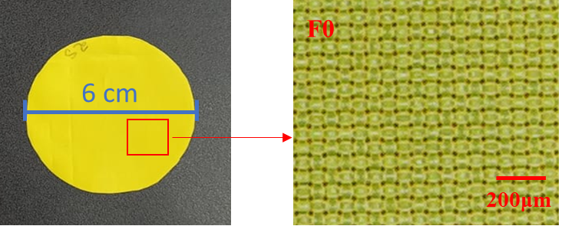
Figure 2.

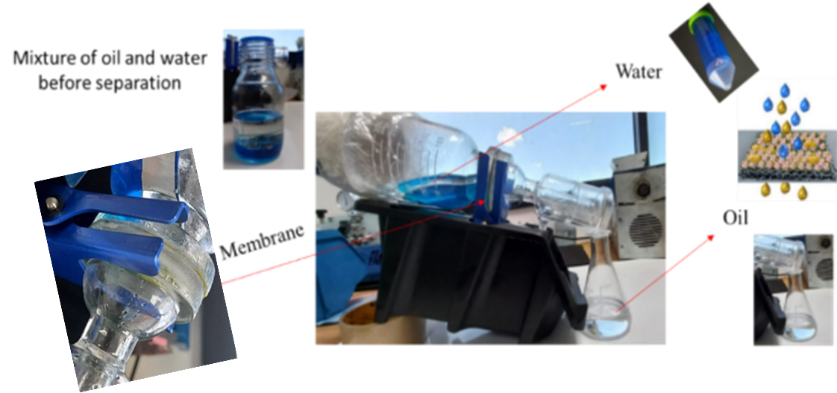

Figure 3.

Figure 4.

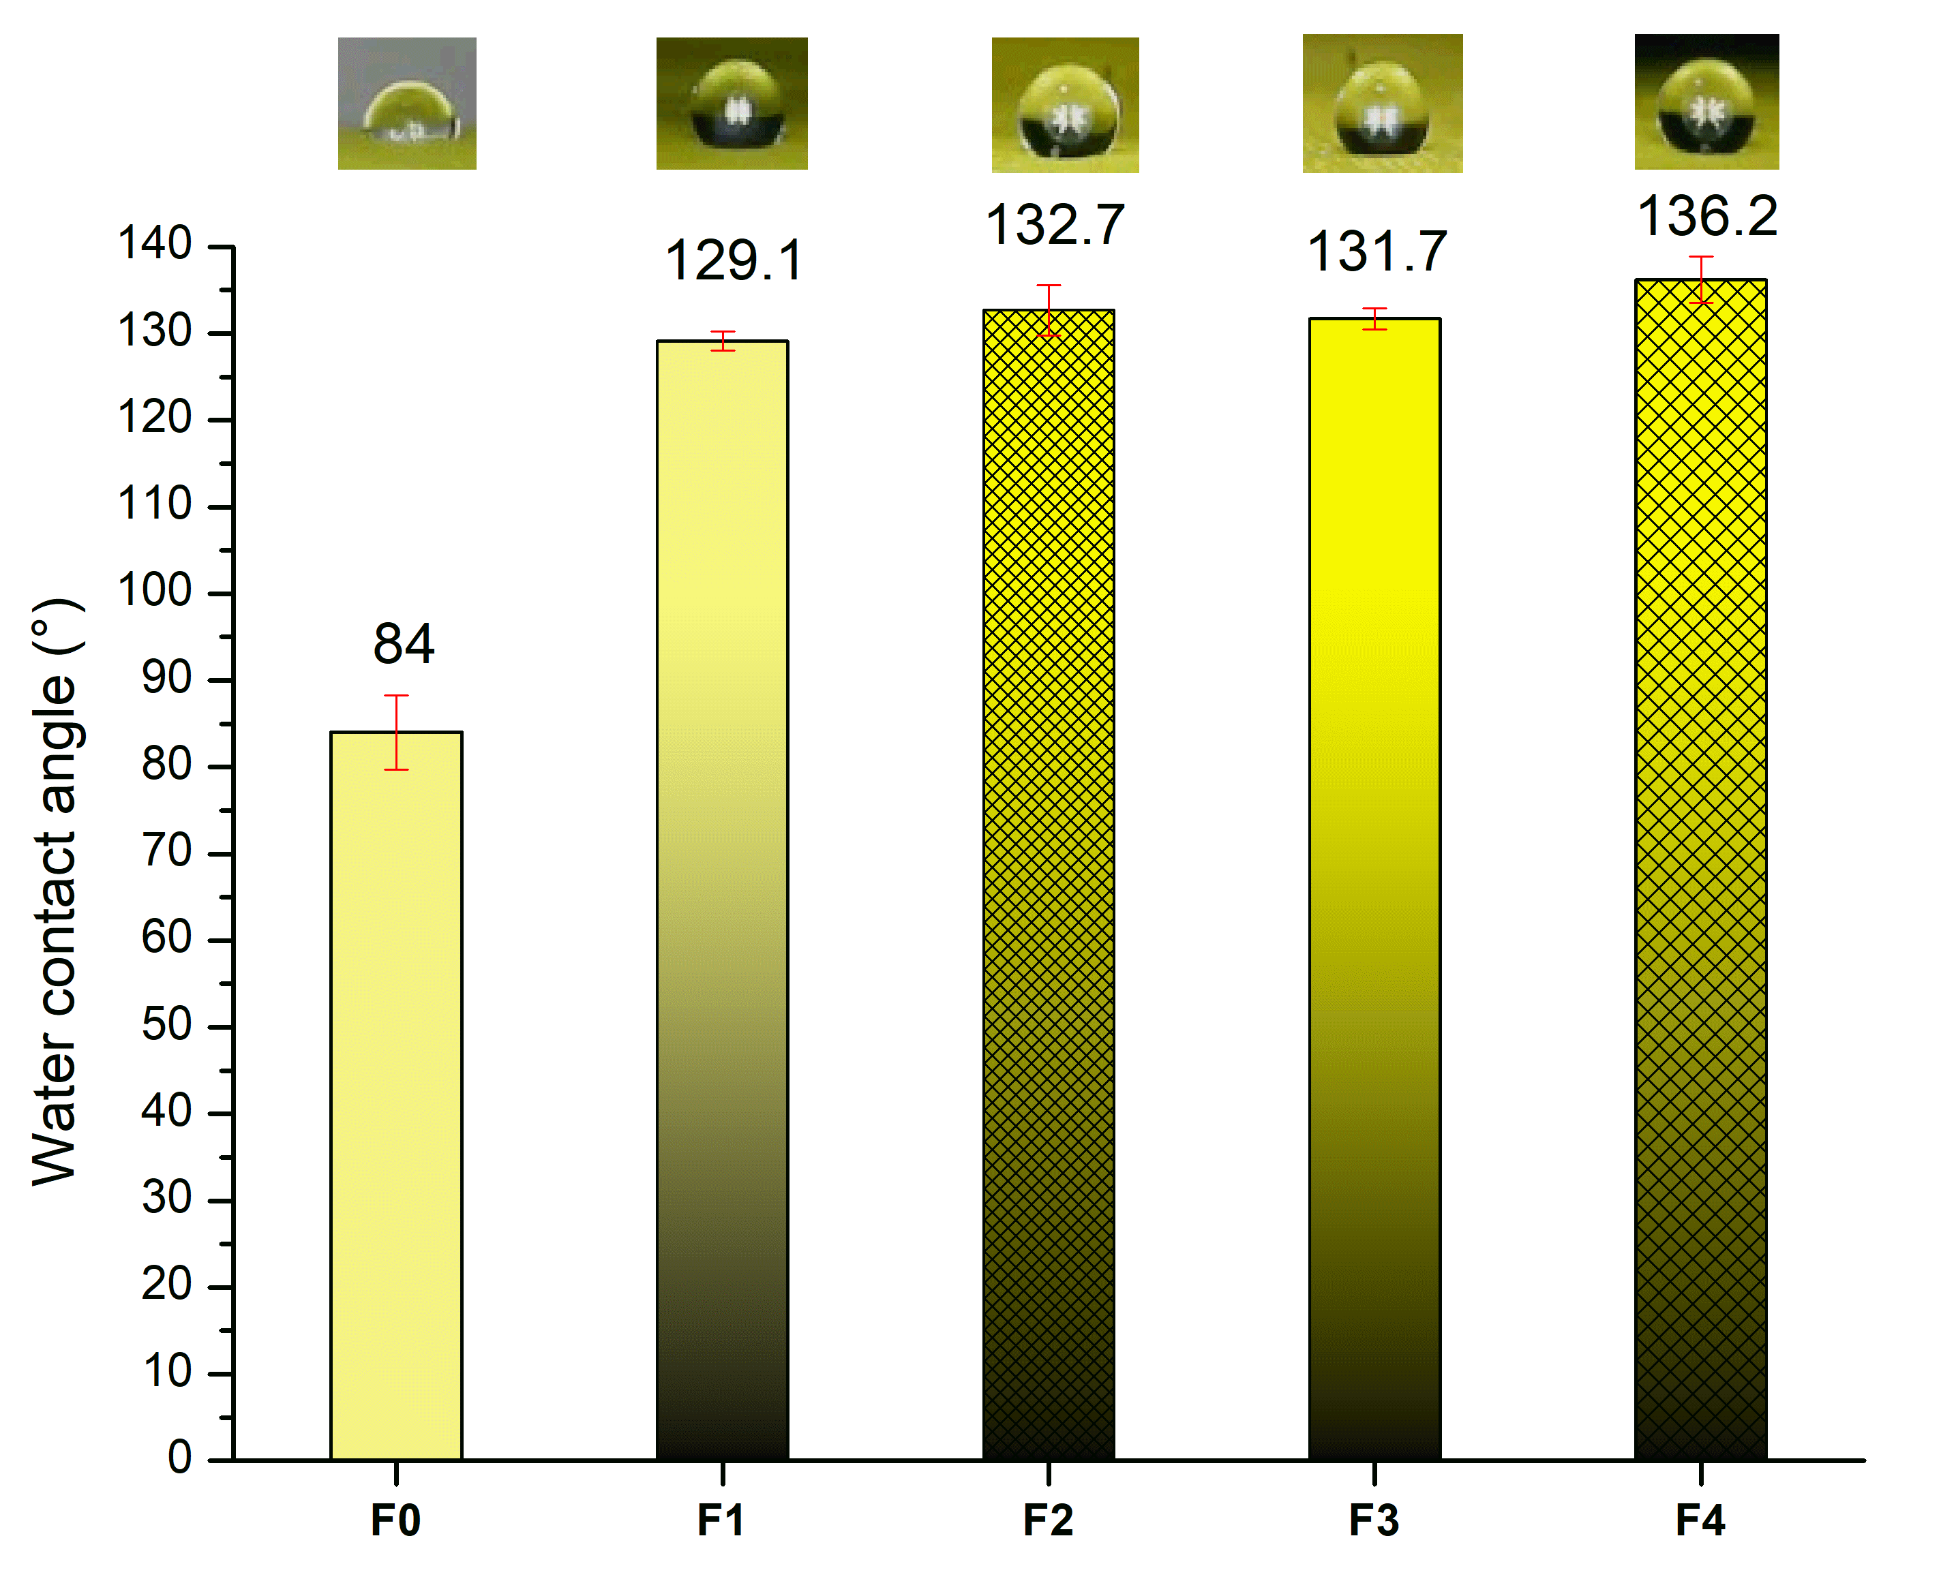
Figure 5.

Table 1

Codes | Samples
F0 | Before washing
F1 | Treatment with PDMS 2%
F2 | Treatment with PDMS 2% + Silica 0.1%
F3 | Treatment with PDMS 4%
F4 | Treatment with PDMS 4% + Silica 0.1%

Table 2.

Samples | Average | Flow | Efficiency
F0 | Does not separate | - | -
F1 | 5.55 min | 275.6 L/m²·h | 99.9%
F2 | 38.12 min | 40.08 L/m²·h | 99.9%
F3 | Does not filter | - | -
F4 | 24 h | 1.061 L/m²·h | 99.9%

