**TRILHA 4 - Tendências Emergentes**

**UMA MATRIZ ESG-IA PARA ECOSSISTEMAS DE INOVAÇÃO**

*AN ESG-AI MATRIX FOR INNOVATION ECOSYSTEMS*

**Gustavo Simas da Silva**

Doutorando em Engenharia, Gestão e Mídia do Conhecimento. Universidade Federal de Santa Catarina (UFSC) – Brasil.

gustavosimassilva@gmail.com.

**Vânia Ribas Ulbricht**

Doutora em Engenharia de Produção. Universidade Federal de Santa Catarina (UFSC) – Brasil.

vrulbricht@gmail.com.

**RESUMO**

Este artigo apresenta uma revisão sobre os desafios e oportunidades associados ao uso da Inteligência Artificial (IA) em ecossistemas de inovação, à luz dos princípios ESG (Ambiental, Social e Governança). A investigação baseia-se em literatura recente, estudos de caso e iniciativas práticas para discutir os principais obstáculos éticos, sociais, ambientais e de governança na aplicação da IA. São examinados problemas como opacidade algorítmica, pegada de carbono de modelos, vieses discriminatórios e exclusão digital, bem como avanços e experiências concretas – incluindo políticas públicas brasileiras/latino-americanas, legislações emergentes e programas de IA responsável. Apresentam-se também soluções e caminhos, abrangendo frameworks, diretrizes, princípios e métricas ESG específicas para IA, além de ferramentas e iniciativas de mitigação de impactos. Como contribuição central, o artigo propõe e discute uma matriz ESG-IA aplicável a ecossistemas, ilustrando como cada dimensão (ambiental, social e de governança) pode integrar-se à prática da inovação com IA. A intenção é apoiar profissionais, pesquisadores, empreendedores, gestores e múltiplos atores de ecossistemas de inovação na incorporação de princípios de sustentabilidade, equidade e transparência no desenvolvimento e uso de soluções de IA.

**PALAVRAS-CHAVE:** Inteligência Artificial, ESG, Ecossistemas de Inovação, Desenvolvimento Sustentável.

**ABSTRACT**

This paper presents a review of the challenges and opportunities associated with the use of Artificial Intelligence (AI) in innovation ecosystems, in light of ESG (Environmental, Social and Governance) principles. The research draws on recent literature, case studies and practical initiatives to discuss the main ethical, social, environmental and governance obstacles in the application of AI. Issues such as algorithmic opacity, carbon footprint of models, discriminatory biases and digital exclusion are examined, as well as concrete advances and experiences – including Brazilian/Latin American public policies, emerging legislation and responsible AI programs. Solutions and paths are also presented, covering frameworks, guidelines, principles and ESG metrics specific to AI, as well as impact mitigation tools and initiatives. As a central contribution, the article proposes and discusses an ESG-AI matrix applicable to ecosystems illustrating how each dimension (environmental, social and governance) can be integrated into the practice of innovation with AI. The intention is to support professionals, researchers, entrepreneurs, managers and multiple actors of innovation ecosystems in incorporating principles of sustainability, equity and transparency in the development and use of AI solutions.

**KEYWORDS:** *Artificial Intelligence, ESG, Innovation Ecosystems, Sustainable Development.*

# INTRODUCTION

The rapid diffusion of Artificial Intelligence (AI) across diverse sectors has raised questions about how to steer this technology toward the common good (Soares; Santos, 2025). In innovation ecosystems (IE) that encompass innovation habitats such as technology parks, hubs, accelerators, and incubators, where technology-based startups are born and grow, the incorporation of AI brings both promises of efficiency and new products, as well as ethical responsibilities, social challenges, environmental concerns, and governance demands (Secundo et al., 2024). In this context, the need arises to align AI development with ESG (Environmental, Social, and Governance) principles to ensure responsible innovation.

This article aims to discuss these challenges and point out practical paths to solve them. Initially, in Section 3, we identify the main challenges and barriers faced when applying AI in innovation ecosystems, categorizing them according to the ESG dimensions: environmental impacts (e.g., high energy consumption and carbon footprint), social issues (such as discriminatory biases in algorithms and digital exclusion), and governance dilemmas (including algorithmic opacity and lack of accountability). Subsequently, we highlight concrete advances and experiences being developed in Brazil and Latin America to address these problems, from public policies and legal frameworks to organizational initiatives and practical cases of ethical AI use. Further on, we explore solutions and pathways to effectively integrate the ESG pillars into the practice of AI innovation: we discuss international frameworks and guidelines for responsible AI, present impact assessment metrics and tools, and, principally, propose an ESG-AI matrix to guide technology parks, incubators, and other innovation environments in incorporating environmental, social, and governance criteria into their AI projects. This matrix constitutes the central artifact of the article, serving as a structured reference for how each ESG dimension can be integrated into the AI innovation lifecycle.

The intention is to provide robust, accessible, and relevant content for various stakeholders in IEs. It is worth noting that the sources cited throughout the text support the analysis undertaken, without claiming to exhaust the topic, but rather composing a current and multidisciplinary overview. It is hoped, therefore, to contribute to the debate and, above all, to informed action, so that AI in innovation ecosystems becomes synonymous with technological progress aligned with social, environmental, and governance responsibility.

# METHODOLOGY

This study was structured based on a scope literature review that combined indexed academic articles and grey literature documents in order to map, broadly and critically, how the ESG agenda is being integrated into artificial intelligence projects within innovation ecosystems. To ensure disciplinary breadth, the Scopus and Web of Science Core Collection databases were selected, complemented by targeted searches in Google Scholar and in repositories such as those of the OECD, UNESCO, and the European Union. The time frame covered publications from January 2010 to December 2024, a period in which the debate on responsible AI gained global traction. The searches were conducted in March 2024 with four central search strings adapted to the syntax of each database: the first combined “artificial intelligence” or “machine learning” with expressions like “responsible AI” and “ethical AI”; the second added the terms “ESG,” “sustainability,” and “carbon footprint”; the third linked AI to expressions like “innovation ecosystem,” “technology park,” and “startup hub”; and the fourth restricted the geographical scope to “Brazil,” “Latin America,” or “South America,” always associated with markers of ethics or sustainability.

The eligibility process involved two stages. In the initial screening, titles and abstracts were checked to ensure that each record explicitly addressed, in addition to AI, at least one of the ESG pillars in a context relevant to innovation habitats. Subsequently, a full-text reading was performed; studies that were strictly technical without discussion of ESG impact, duplicates between databases, and documents without full access were excluded.

The analytical stage adopted thematic coding guided by three axes (environmental, social, and governance) linking each piece of evidence to categories of barriers, advances, or solutions. Thus, metrics related to the environment (such as carbon footprint) were classified under the environmental axis; studies on algorithmic biases and digital inclusion were placed under the social axis; and discussions on transparency, accountability, or regulatory frameworks were categorized under governance.

The final synthesis of these categories underpinned the development of the ESG-AI Matrix, a propositional artifact that organizes practical recommendations along the lifecycle of AI projects in innovation ecosystems, offering stakeholders in these environments an operational roadmap to align technological innovation with socio-environmental responsibility and good governance practices.

# RESULTS AND DISCUSSION

Despite the enthusiasm for the possibilities of AI, a series of barriers and challenges hinder its responsible adoption in innovation environments. These barriers manifest on different fronts (environmental, social, and governance) which correspond to the ESG pillars. Understanding these challenges is the first step to addressing them; therefore, we delineate not only the problems but also the context in which they arise, preparing the ground for the solutions discussed in subsequent sections. It is worth noting that these three dimensions are interconnected and together form what we can call the "ESG-AI matrix": a conceptual map of AI's impacts and the critical areas to be managed.

## ENVIRONMENTAL DIMENSION: THE IMPACT ON THE CLIMATE CRISIS

In the environmental pillar, the most evident challenge posed by AI is its climate impact (Camastra; Vallejo, 2025), with issues synthesized in Figure 1. The execution and, especially, the training of complex AI models consume an enormous amount of computational energy, implying significant carbon dioxide (CO₂) emissions. The training of the GPT-3 model (a precursor to current generative AI systems) generated about 502 metric tons of carbon, an emission volume equivalent to what 112 gasoline-powered cars would produce in a year (Dora, 2024). Furthermore, the inference stage (using the trained model to make predictions or generate content) also has a significant environmental cost: it is estimated that keeping GPT-3 operational for a year emits an additional 8.4 tons of CO₂; data that illustrates the growing carbon footprint of state-of-the-art AI models.

The trend in recent years has been to develop increasingly larger models, especially LLMs (large language models), which demand proportional amounts of data and processing. Since the early 2010s, the energy requirement to train the largest AI models has increased by an impressive factor of 300000, due to the race for more powerful and accurate models (OpenAI, 2018). Unsurprisingly, projections indicate that, if this pace continues, AI could become a significant contributor to global carbon emissions in the coming decades. As early as 2024, a Gartner analysis warned that the explosion of generative AI could lead to an energy shortage for about 40% of data centers dedicated to AI by 2027, given the accelerated increase in energy consumption (Müller, 2023). In other words, there is a real concern that the unbridled advance of AI, without sustainable and regenerative counterbalances, will contradict climate goals and pressure energy infrastructures.

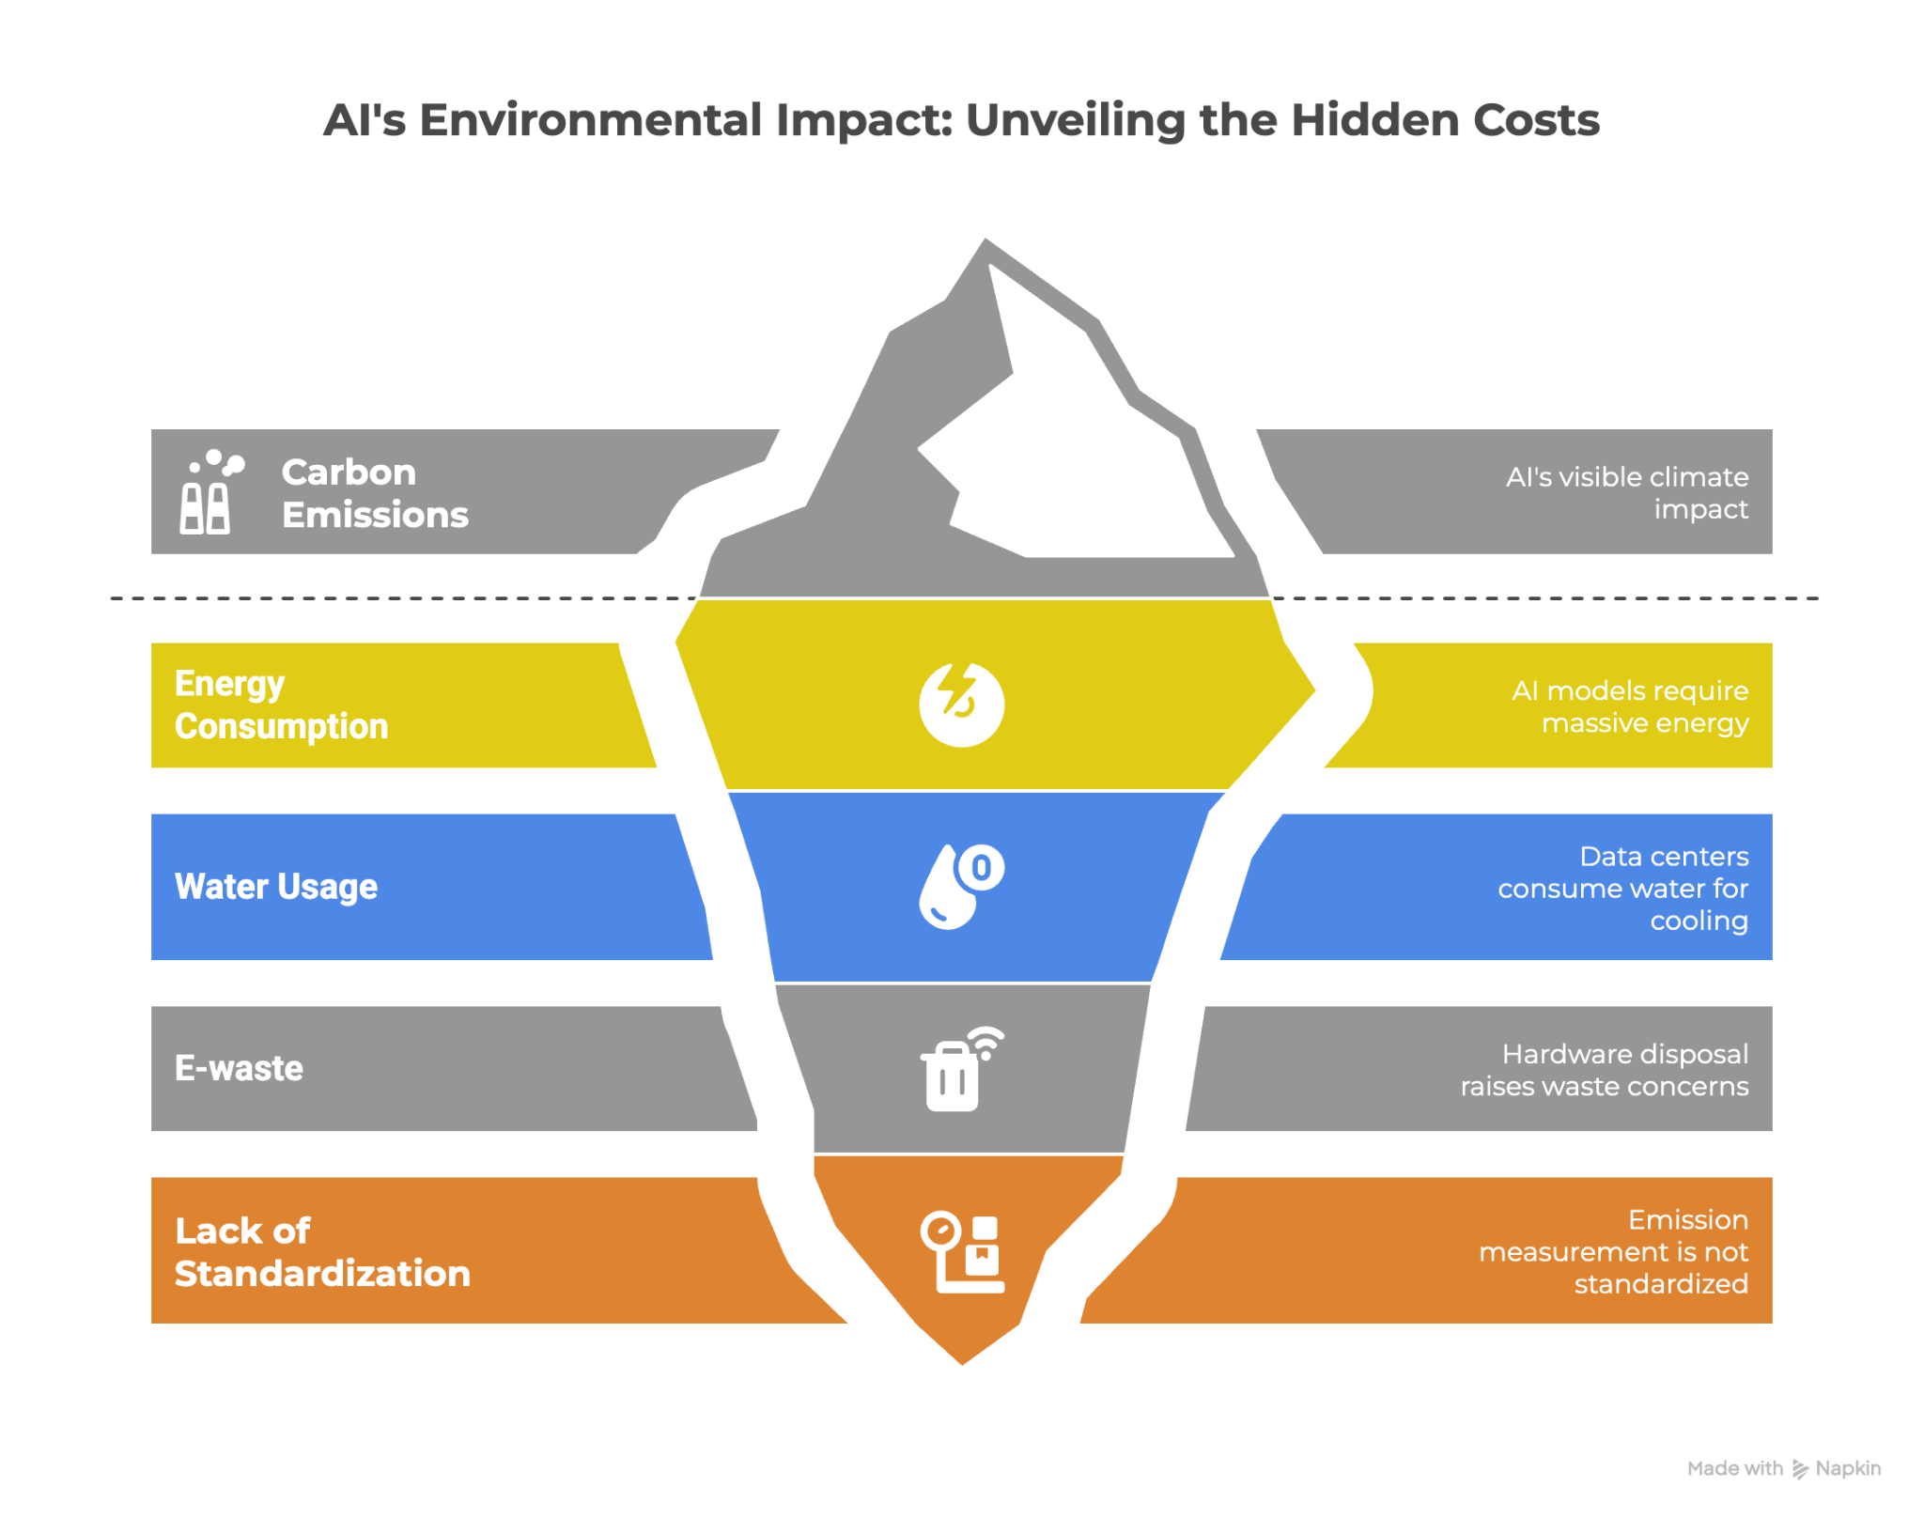

Figure 1 – AI's Environmental Impact.

Source: authors.

Another critical environmental aspect is the consumption of water and natural resources by data centers. Large processing centers consume electricity and use enormous volumes of water for server cooling. Regions already suffering from water scarcity may be impacted if they host computationally intensive AI infrastructures. And the manufacturing and disposal of specialized hardware (like GPUs and other accelerators used in AI) raise concerns about electronic waste (e-waste) and the use of rare earth metals. It is clear: the environmental impacts of AI go beyond carbon, encompassing the entire ecological footprint of the technological supply chain.

The challenge, therefore, lies in reconciling AI innovation with environmental sustainability. Currently, sustainable practices are still incipient in the face of the AI boom. The very measurement of AI system emissions is not standardized, leading to an underestimation of the real footprint (Dora, 2024). Without clear metrics and transparency, it becomes difficult for incubators, startups, or investors to understand the environmental cost of their AI projects. This scenario creates an important gap that demands action; for example, by integrating environmental indicators into technological development (an element that will be included in our ESG-AI matrix).

Before moving on to solutions, it is worth reinforcing that the problem is not insoluble: there are already ways to reduce AI's carbon footprint, which will be explored in Section 3. For now, recognizing the scale of the impact is fundamental: training a single large-scale AI model can emit up to 284 tons of CO₂, according to a 2019 UMass study; a volume almost five times greater than the emissions of an average car over its entire lifespan, including manufacturing. This disparity has led experts to question why ways to reduce this footprint are not discussed more emphatically. AI-driven innovation has an alarming ecological cost, which requires innovative countermeasures so that technological progress does not come at the planet's expense.

## 

## SOCIAL DIMENSION: BIASES, EQUITY, AND INCLUSION

In the social dimension, the challenges of AI in ecosystems primarily concern the fairness and equity of systems, as well as impacts on social cohesion and inequalities, as synthesized in Figure 2. One of the most discussed problems is algorithmic bias; the tendency of AI systems to reproduce prejudices present in training data or design choices (Silva, 2024; Cozman; Kaufman, 2022). We know that in innovation contexts, where startups experiment with AI in various applications (human resources, finance, health, security, etc.), there is a risk of scaling biased solutions if the issue is not addressed from the outset.

Emblematic examples abound. A notorious case occurred in 2018 when Amazon developed an AI system for screening resumes and it was discovered that the algorithm discriminated against women in hiring, as it was trained on historical data dominated by men in the tech field (Dastin, 2022). The result was the assignment of lower scores to female candidates, violating basic principles of equal opportunity. Another frequently cited incident is that of the COMPAS system in the US: an AI used in courts to predict recidivism risk that was found to be more likely to label Black defendants as high-risk compared to white defendants, contributing to racial disparities in the judicial system (Engel; Linhardt; Schubert, 2024).

Although these cases occurred abroad, they illustrate universal problems of bias that can be replicated anywhere, including Latin America, if caution is not exercised. In Brazil, we have already faced practical examples of algorithmic racism: facial recognition systems used by the police in cities like Rio de Janeiro have disproportionately erred with Black people. In 2024, for example, a Black female public servant was mistakenly identified as a fugitive by a facial recognition software during an event; a clear case where the technology failed and caused embarrassment, raising criticism that such systems "do not adequately recognize the Black phenotype," perpetuating racial biases (Dutra, 2024). This episode highlights how the lack of diversity in data and AI testing can turn public safety tools into instruments of injustice and discrimination.

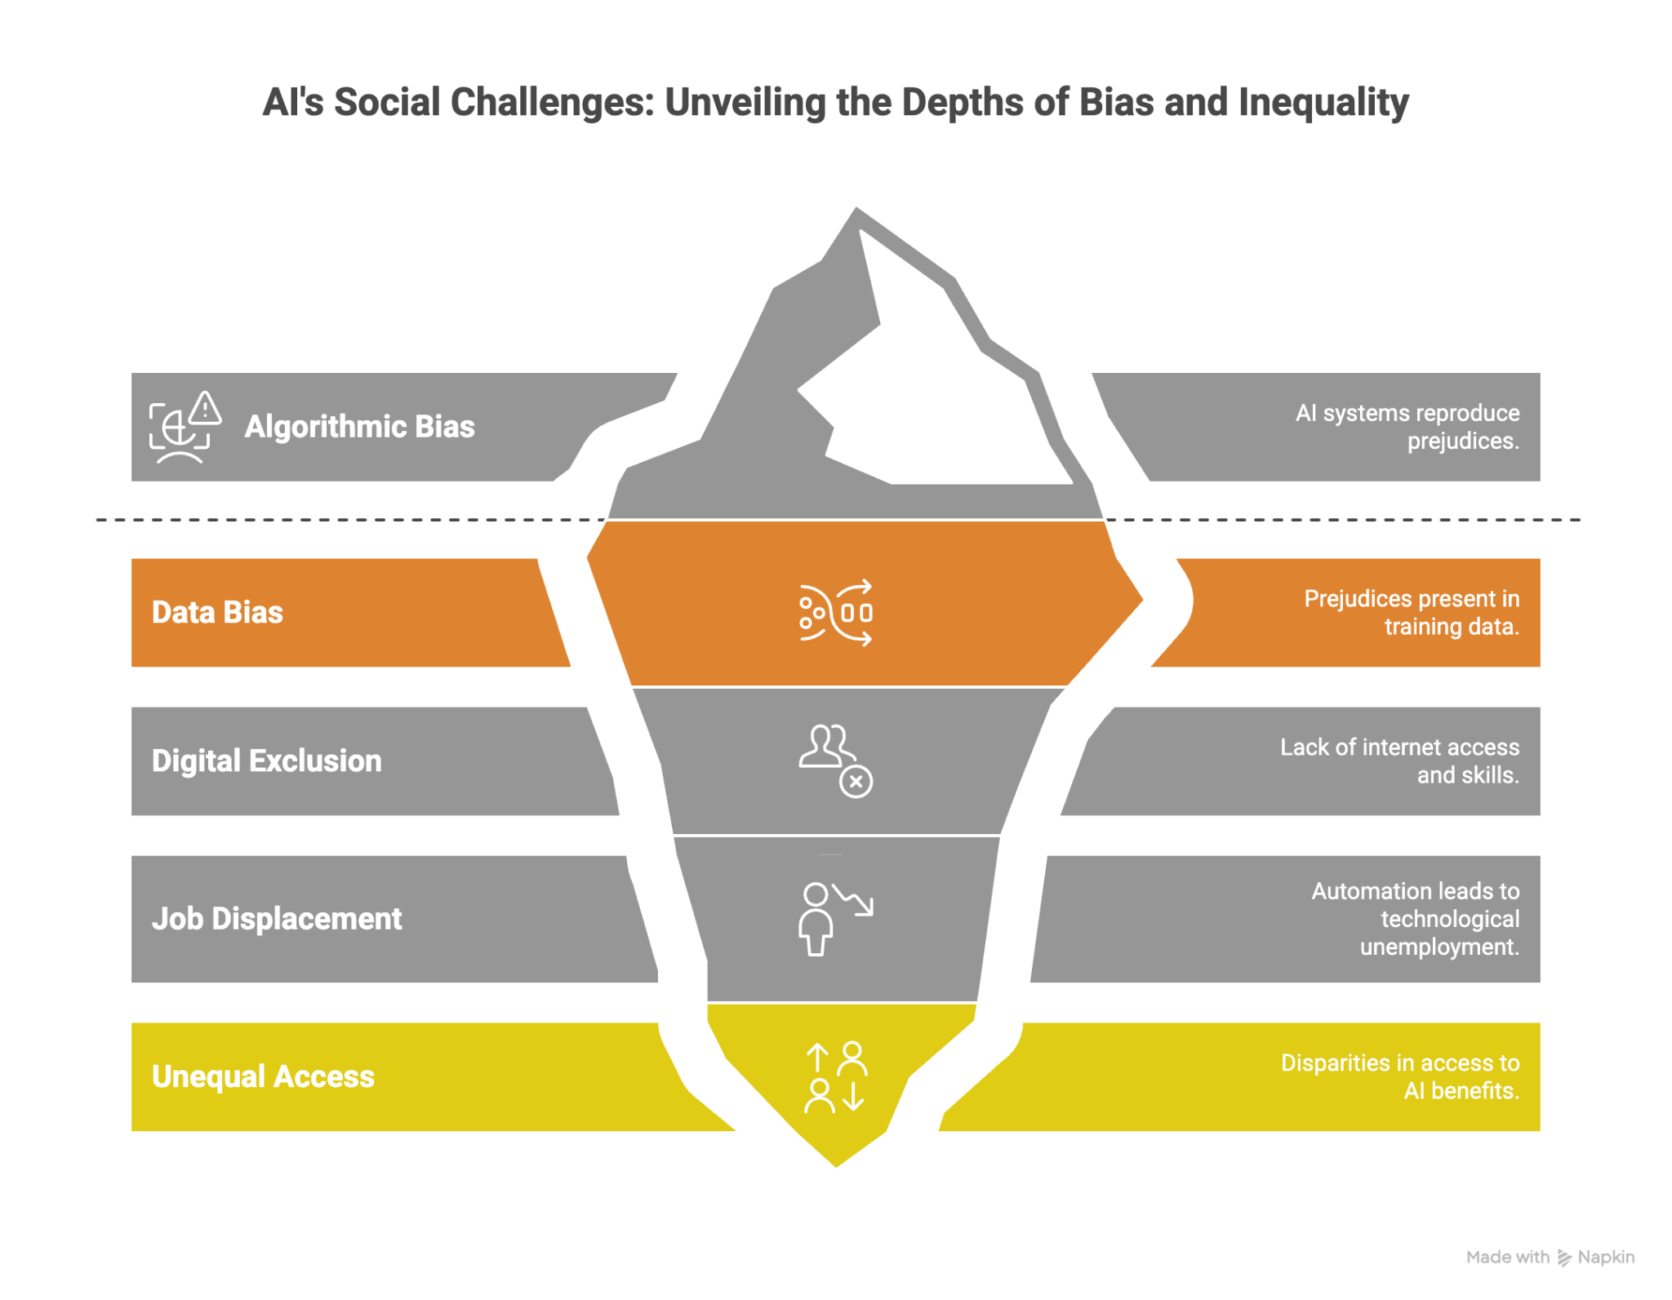

Figure 2 – AI's Social Impact.

Source: authors.

In addition to biases related to race or gender, AI can amplify other social inequalities. Credit algorithms, if trained on historical data, may deny loans to certain minority groups more frequently, even if they have financial profiles similar to majority groups, by reflecting pre-existing disparities (De Castro Vieira et al., 2025). Similarly, selection or dynamic pricing systems can harm residents of certain regions, reinforce stereotypes, or even spread disinformation, undermining social cohesion. In other words: without safeguards, AI can perpetuate and scale prejudices, rather than promoting inclusion.

Another critical social component is digital exclusion and its implications in the face of AI's advancement. Brazil and other Latin American countries still live with a significant digital divide: according to a 2022 survey, about 36 million Brazilians do not have internet access, with the most excluded groups being Black people, the elderly (60+), and low-income individuals from classes D/E (Rodrigues, 2023). This means that a huge portion of the population does not even enjoy basic digital services (let alone existing innovations). Even among those who are connected, there are disparities: the majority (62%) access the internet only by cell phone, often with limited mobile connections. This scenario implies that AI solutions (often developed for broadband environments and multiple devices) may not reach or be suitable for the most vulnerable segments. There is a risk of creating a cycle where communities without digital access are left on the sidelines of benefits (e.g., they cannot use an AI assistant for education or employment) and, at the same time, are disproportionately affected negatively (such as by automated decisions made without their knowledge or ability to contest) (De Moura et al., 2020).

Another example is the adoption of these systems in public services. If governments implement exclusively automated service systems or intelligent medical appointment scheduling, citizens without digital access or technological literacy may be left behind in accessing basic rights. In this, digital inclusion becomes an integral part of the social challenge we face: it is not enough for the technology to be equitable in its internal functioning; its access and benefits must be distributed fairly.

In terms of innovation ecosystems, this means that hubs and accelerators need to consider for whom solutions are created and who can use them, encouraging innovations that also meet the needs of marginalized populations.

Finally, another emerging social topic is the impact of AI on work and labor relations. The intelligent automation that promises productivity gains also generates fears of technological unemployment in many sectors (Monteiro, 2023). Global estimates (such as those from the World Economic Forum) suggest that while AI is expected to create millions of new jobs, it will also transform or eliminate traditional occupations, requiring large-scale reskilling of workers. In Brazil, a Deloitte study pointed out that repetitive and manual functions (from machine operators to back-office analysts) will face significant challenges with the diffusion of AI by the current year (2025) (Deloitte, 2024). This is a social and economic challenge that demands from innovation ecosystems a deep and systemic awareness of the effects (on the workforce) of the AI products and services they incubate, invest in, or accelerate. The transition must be accompanied by education and training strategies so that the technological revolution does not deepen unemployment or precarity, but rather paves the way for more qualified jobs and a fair redistribution of productivity gains.

## 

## GOVERNANCE DIMENSION: OPACITY, PRIVACY, AND ACCOUNTABILITY

The third strand of challenges corresponds to the governance of AI, encompassing ethical, legal, and management aspects that must be addressed for responsible use (Dafoe, 2018), as synthesized in Figure 3. In innovation ecosystems, which are dynamic environments with companies experimenting with new business models, governance issues can be overlooked in the rush to scale technologies quickly. However, ignoring them can lead to serious risks, both for users and for the organizations themselves (Ribeiro; Eloi; Rodrigues, 2025). Three major themes emerge in this pillar: algorithmic transparency (or its lack, opacity); privacy and data protection; and accountability for automated decisions.

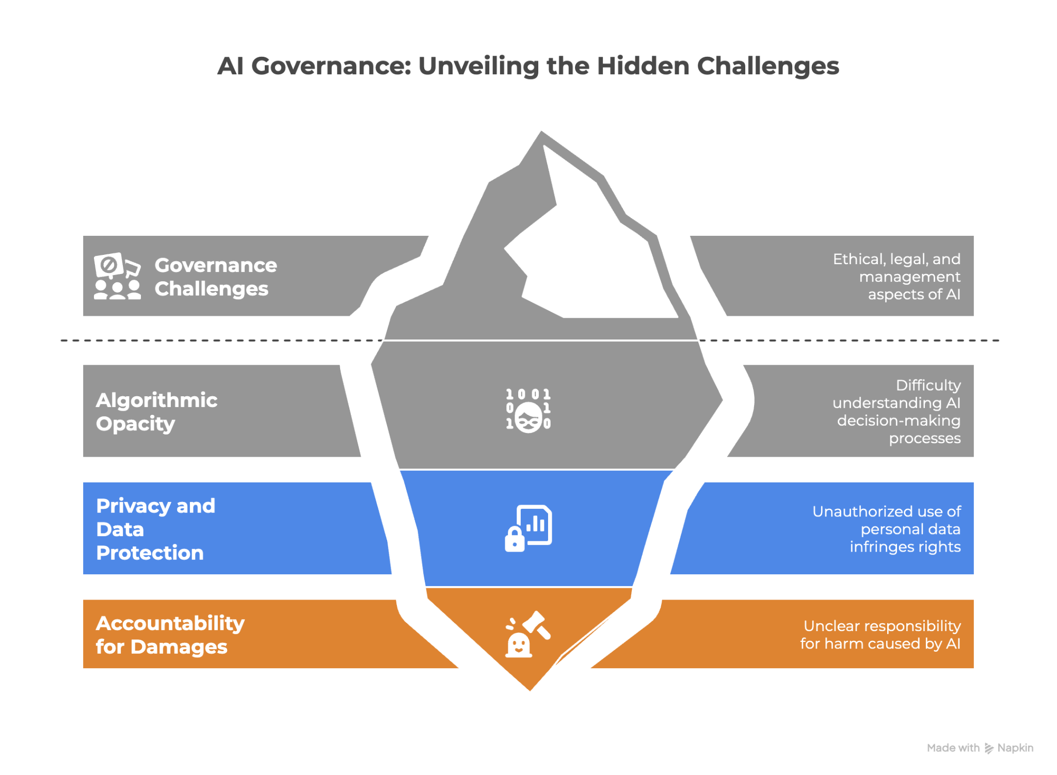

Figure 2 – AI's Governance issues.

Source: authors.

Algorithmic opacity refers to the difficulty (sometimes impossibility) of understanding how AI systems, especially those based on machine learning (ML) and deep neural networks, reach their conclusions (Argôlo dos Santos; Almeida Santos, 2024). Unlike traditional software programmed line by line, ML models learn complex patterns from data, often resulting in a kind of "black box" whose internal logic is not easily explainable even by the developers. This lack of explainability becomes problematic when AI is used in sensitive applications; for example, to decide on a bank loan, diagnose a disease, or even moderate online content. Users and affected parties have the right to know the reasons behind automated decisions, but if the system is opaque, how can this right be ensured? Opacity undermines trust and hinders the identification of errors or internal biases. In innovation, it can also disrupt collaborations: imagine a startup (that uses AI in its services) wanting to sell its solution to a large corporate client that demands transparency in its algorithms; if the startup cannot provide clear explanations, the deal may not succeed.

Not surprisingly, transparency and explainability are principles advocated in regulation proposals worldwide. The European Union, in the draft of its AI Act, provides that high-risk systems must have some level of explainability and documentation of how they work (Wagner; Borg; Runeson, 2023). In Brazil, recent bills also emphasize this point (Mourão; Resende, 2022). The lack of transparency is closely linked to the biases discussed in the social section: without access to the databases and criteria, it is difficult to audit an AI to check for discrimination. Therefore, regulatory proposals tend to require the right to an explanation and the possibility of independent auditing of algorithms.

However, implementing transparency is not trivial, especially in complex technologies like deep neural networks, where making every calculation traceable and intelligible is a scientific and technical challenge. Herein lies a dilemma between innovation vs. explanation: does requiring full transparency slow down development? Or, on the contrary, does it stimulate it to be better and more reliable? This tension appears, for example, in discussions about trade secrets: companies sometimes claim that detailing the functioning of their algorithms infringes on intellectual property, which conflicts with the social demand for auditable algorithms.

Another component of utmost importance for governance is privacy and personal data protection. Much of current AI depends on big data: enormous datasets often derived from people's information (online behaviors, medical histories, images, etc.). The unauthorized or irresponsible use of this data infringes on fundamental rights. Brazilian legislation has already taken important steps in this field with the General Data Protection Law (LGPD), in effect since 2020, which establishes principles for the collection and processing of data (Brasil, 2018). The LGPD and similar regulations (like the European GDPR) directly address the use of automated decisions, requiring companies to inform individuals when an algorithm is used and offering citizens the right to contest decisions made exclusively by AI. This has practical implications: a fintech incubated in an innovation hub, for example, cannot simply deny credit via an automated model without informing the customer and without providing channels for human review, under penalty of violating the law. Privacy also involves data security: AI systems must protect sensitive information against leaks and malicious uses. Cases of privacy breaches involving AI (such as virtual assistants that inadvertently record conversations, or facial recognition systems accessing images without consent) receive wide negative attention and shake public trust (Silva; Malta; Vasconcelos, 2022). Therefore, legal and ethical compliance in data handling is not optional: it is a survival requirement for any business that uses artificial intelligence and intends to scale in markets that value privacy.

The third piece of governance is accountability for results and damages caused. This theme boils down to the question: if an AI system causes harm or violates someone's rights, who is responsible? In traditional software, if there is a code error, responsibility typically falls on who provided/operated the system. However, with artificial intelligence systems, especially if they have a high level of autonomy or learn unexpected behaviors, there are complex debates (Novelli; Taddeo; Floridi, 2024). Developers, corporate users, and even the AI itself (within the limits of legal possibilities) could be held responsible. This lack of definition creates legal risks and a brake on innovation: companies may hesitate to adopt AI fearing future litigation.

On the other hand, not defining responsibility leaves victims unprotected. Bills in Brazil and other countries are already facing this difficulty (Pinto, 2020). Many proposals lean towards making it clear that responsibility is always human, whether it be the developer (for creating a faulty system) or the operator (for using it in an inappropriate context). But determining in practice who, specifically, is responsible can be difficult; imagine a consortium that develops an AI, a startup that adapts it, and an end client that implements it incorrectly: the attribution of blame can lie at different layers and turn into an intense legal battle.

Linked to this is the need for accountability mechanisms adapted to AI: independent audits, certifications, specialized regulatory bodies. The opacity mentioned earlier complicates the attribution of responsibility: if we do not understand the cause of a system's decision, how can we prove the causal link of a harm? Hence the importance of records and logs, and of tools that allow "opening the black box" when necessary. This is an evolving field, with concepts like accountable AI and algorithmic auditing gaining ground.

In the Brazilian public sector, bodies like the TCU (Federal Court of Accounts) are already signaling concerns and the need for oversight (TCU, 2024a). In 2024, the TCU evaluated AI law proposals and warned that excessively burdensome governance measures could make startups unviable, but at the same time acknowledged that it is fundamental to guide the responsible development of the technology and strengthen the Brazilian AI Strategy (Ebia) with effective guidelines (Conselho Digital, 2024; TCU, 2024b). This TCU analysis highlights the delicate balance that must permeate governance: protecting society and rights, without stifling innovation in emerging ecosystems.

After mapping the challenges, we now turn to examining how Brazil and neighboring countries have responded to them, and what advances already exist to inspire us.

## 

## PUBLIC POLICIES FOR AI IN BRAZIL AND LATIN AMERICA

Although the challenges listed are significant, in recent years various advances, policies, and practices have emerged aimed at making AI more ethical, inclusive, and sustainable. In this section, we analyze concrete experiences, with an emphasis on the Brazilian and Latin American context, that signal how governments, companies, and institutions are addressing the ESG issues related to AI.

First, we will address the landscape of public policies and legislation, from national AI strategies to pending bills, showing how the regulatory agenda has incorporated debates on ethics and ESG.

Next, we highlight practical initiatives and programs focused on responsible AI, whether conducted by public bodies, academia, civil society, or the private sector.

Finally, we present applied examples in innovation ecosystems: cases of startups or hubs that integrate ESG concerns into their projects involving artificial intelligence, illustrating that, in practice, paths are already being forged to align innovation and responsibility.

Let's start with Brazil: an important milestone was the publication of the Brazilian Artificial Intelligence Strategy (EBIA), established in April 2021 by the Ministry of Science, Technology, and Innovations (de Souza Mello Filho, de Souza Vieira, 2024). The EBIA established general guidelines to promote the use of artificial intelligence in the country in alignment with ethical values and socioeconomic development. Among its thematic axes, those focused on Legislation, Regulation, and Ethical Use of AI, Data Governance, and Public Security, among others, stand out (MCTI, 2021). That is, from its conception, the national strategy recognized that it is not enough to invest in research and innovation; it is also necessary to take care of aspects such as transparency, rights, and security. Working groups were formed to implement the EBIA, including representatives from government, academia, and civil society; for example, professionals dedicated to algorithmic transparency and members of the National Data Protection Authority (ANPD) contributing to the ethical and legal axes. It is a multi-sectoral approach that indicates an understanding that AI governance must be built collectively.

In addition to the national strategy, the Brazilian legislative debate on AI has recently gained traction. In October 2023, the Federal Senate approved Bill 2.338/2023, which establishes a regulatory framework for the use of AI in the country (Senado Federal, 2023). Bill 2338 (a substitute bill that consolidated several previous projects, including Bill 21/2020) establishes principles, rights, and duties for the development and application of AI, even proposing the creation of a National System for Regulation and Governance of AI (Agência Senado, 2024). Among the principles listed in the text are respect for human rights, non-discrimination, transparency, and the promotion of innovation, in line with international best practices. As of the closing of this article, the project was proceeding to discussion in the Chamber of Deputies, indicating that Brazil may soon have a specific AI law. Such legislation should complement the LGPD, focusing not only on personal data but on AI more broadly. The approval in the Senate was seen as a step aligned with global trends, as several countries and blocs (European Union, USA, Canada) are defining their AI frameworks.

However, there are open debates: the TCU itself, in a 2024 report, considered that the version of Bill 2338 approved was perhaps excessively restrictive, emphasizing the risks of AI over incentives for responsible innovation (Conselho Digital, 2024). This is feedback that suggests that the Brazilian legislature is still seeking to calibrate the law to balance technological promotion and protection of rights.

In the field of digital rights and transparency, it is worth remembering that Brazil already has the LGPD and the Civil Rights Framework for the Internet (Law 12.965/2014), which establish important foundations for the AI era. The LGPD, as mentioned, gives citizens rights against opaque automated decisions. And the Civil Rights Framework provides for principles such as freedom of expression, privacy, and net neutrality, which create a favorable legal environment for the ethical discussion of online AI applications. In addition, the National Data Protection Authority (ANPD), created to oversee the LGPD, may also come to have a supervisory role over AI applications that process personal data, possibly by issuing specific norms, as is already the case in Europe (here, inspired by the GDPR, the European Commission has created guides on AI and data protection).

Expanding the view to Latin America, several countries have been developing their national AI strategies and addressing AI ethics. Chile, for example, launched its National Artificial Intelligence Policy in 2021 (Arancibia et al., 2022), including pillars of ethics, regulatory aspects, and social impact. Uruguay, Colombia, and Mexico also have strategic documents discussing trustworthy AI (Benítez; Ruvalcaba-Gómez, 2023; Lawgorithm, 2025). A relevant supranational milestone was the UNESCO Recommendation on the Ethics of AI, adopted in November 2021 and endorsed by 193 countries, including virtually all of Latin America (Unesco, 2022). This international document defines ethical standards for AI and has served as a reference for national legislation and policies; it addresses current dilemmas such as transparency, data privacy, and unequal access to the benefits of AI, and recommends specific actions: assessing the environmental impact of AI systems, ensuring inclusive mechanisms for algorithmic governance, promoting gender equality and diversity in technology, among others.

In other words, the ESG agenda is embedded in this global agreement: environmental (climate impact), social (equitable access, non-discrimination by gender), and governance (transparency, participation). Brazil, as a signatory, has committed to internalizing these principles, which is already partly reflected in the aforementioned initiatives.

Another normative development in the region is the discussion of responsible AI guidelines in local governments; for example, some Latin American cities have joined the Cities for Digital Rights initiative and have sought to establish guides for the ethical use of AI in municipal services (such as surveillance with smart cameras, social scoring systems, etc.), avoiding abuses. In the Justice sector, the Brazilian Federal Supreme Court (STF) implemented an AI system called VICTOR for screening cases, but with a limited scope and under human supervision, following recommendations from the National Council of Justice to ensure that algorithms do not violate legal guarantees (De Jesus Dias et al., 2023). These precautions demonstrate a gradual awareness.

It is clear: there is a consistent movement to build a framework for responsible AI, with Brazil on the path to having a legal framework and already counting on strategies and related laws; while Latin America, more broadly, participates in global discussions and adopts ethical principles. This evolving normative environment will directly influence innovation ecosystems: actors will have to operate within these parameters, and may even benefit from government support initiatives (calls for proposals, funding) that prioritize projects involving artificial intelligence with socio-environmental impact. Next, we will look at some initiatives and programs that are already underway to foster this ESG-aligned AI in practice.

## FRAMEWORKS, GUIDELINES, AND ETHICAL PRINCIPLES OF AI

Having identified the challenges (Sections 3.1, 3.2 and 3.3) and being aware of public policies and promising initiatives (Section 3.4), we now focus the discussion on solutions and pathways to systematically align AI with ESG criteria. There are several possible fronts for action: from adopting existing ethical frameworks to developing customized metrics to assess the environmental and social impacts of AI systems. We have structured this section into three parts: first, we present consolidated frameworks, guidelines, and ethical principles that can serve as a reference for organizations and innovators to guide their responsible AI practices (Section 3.5, i.e., this section); next, we explore specific ESG metrics and technical tools that help measure and mitigate impacts (Section 3.6); and finally, we synthesize all of this into our proposed ESG-AI Matrix (Section 3.7), aimed at innovation ecosystems and their stakeholders, concretely outlining how to integrate each ESG dimension into the lifecycle of projects involving artificial intelligence. The intention is to provide a cohesive guide (both theoretical and practical) so that innovation with AI can flourish without neglecting environmental sustainability, social justice, and good governance.

In recent years, a large number of international organizations, multi-stakeholder committees, and technology companies have developed guiding principles for responsible AI. These are frameworks that serve as an ethical compass and pave the way for future standardizations (including regulatory ones).

At the international level, the OECD's Principles on AI (2019) establish five core tenets: inclusive growth, human-centered values, transparency, robustness, and accountability; which can be translated into practical checklists for startups to demonstrate social benefit and ensure user explainability. Complementing this, the UNESCO Recommendation on the Ethics of AI (2021) advocates for universal values and actionable plans, such as requiring pre-launch ethical impact assessments and fostering inclusive governance through dialogue with diverse stakeholders.

National policies are also maturing, exemplified by Canada's 2024 Directive on Automated Decision-Making, which introduces a risk-based "Algorithmic Impact Assessment Index" to impose graded obligations (Government of Canada, 2024), and Brazil's Bill 21/2020, which outlines voluntary principles like human dignity and human oversight. This ethical architecture is further reinforced by corporate frameworks from technology leaders like IBM, Google, and Microsoft, which consistently emphasize explainability, fairness, and privacy. These principles are operationalized through external instruments like the Ethical OS Toolkit for risk mapping and IEEE standards for transparency (7001) and algorithmic well-being (7003), collectively offering a multi-layered guide for actors within innovation ecosystems to embed responsibility into their AI projects.

It is possible to see that many frameworks converge on a few key components. We can list them to facilitate understanding (already connecting with ESG), as shown in Table 1.

Table 1 - Key components for responsible AI and their ESG links

| Key Component | Description (what it involves in practice) | Related ESG Aspects |
| --- | --- | --- |
| Transparency | Understandable and communicable AI systems; documentation of data and algorithms (e.g., datasheets for datasets, model cards for models). | Governance |
| Fairness and Equity | Bias mitigation; discrimination assessments; diversity in teams and data so that AI benefits different groups in a balanced way. | Social |
| Accountability | Clearly designated responsible parties, possibility of audit and contestation; ethics committees, ombudsman channels, records of algorithmic decisions. | Governance |
| Privacy and Security | Protection of personal data (LGPD/GDPR), cybersecurity, privacy by design, anonymization, and encryption. | Governance / Social |
| Social Benefit | Prioritization of positive impacts; analysis of how AI improves quality of life or reduces inequalities. | Social |
| Sustainability | Measurement and mitigation of environmental footprint (energy, hardware); adoption of green computing; balancing AI gains with ecological costs. | Environmental |
| Inclusion and Accessibility | Usability for people with disabilities, support for linguistic minorities, assistive technology; broad availability of AI services. | Social |

Source: authors.

These principles, of course, are general guidelines. Practical implementation requires transforming them into processes and tools, which leads us to the next topic: concrete metrics and instruments to put ESG into action in AI development.

## 

## ESG METRICS AND IMPACT MITIGATION TOOLS

To operationalize ESG principles in AI, innovation ecosystems can adopt a toolkit of practical measures across all three dimensions. On the environmental front, this involves leveraging carbon metrics through trackers like Carbontracker and CodeCarbon to estimate and optimize energy consumption, embracing Green AI design principles such as TinyML and neuromorphic hardware to build inherently efficient models, and committing to sustainable infrastructure by hosting workloads in data centers powered by renewable energy. Socially, the focus shifts to ensuring equity and inclusion through rigorous bias auditing using open-source packages like AI Fairness 360 and Fairlearn, proactively building diverse datasets and inclusive teams, designing accessible user experiences according to WCAG guidelines, and empowering underrepresented communities through digital and AI literacy programs. Finally, robust governance is established by implementing auditable algorithms with decision logs and interpretability tools like Captum, adopting responsible MLOps for traceability, creating corporate AI governance structures such as ethics committees and Chief AI Ethics Officers, fostering social participation via citizen panels and public consultations, and utilizing automated tools to ensure continuous legal compliance with regulations like the LGPD.

In all these points, we see that measuring (via metrics and tests) and acting (with tools and processes) are two sides of the same coin to make ESG effective in the use of AI. However, a challenge is not to fragment initiatives, it is necessary to see the whole picture. This is where the ESG-AI matrix comes in as an integrative proposal, which we will address next.

## AN ESG-AI MATRIX FOR INNOVATION ECOSYSTEMS

Based on everything discussed, we propose an ESG-AI Matrix as a framework to guide stakeholders (technology parks, hubs, accelerators, incubators, among other innovation habitats) in integrating the Environmental, Social, and Governance dimensions into their activities involving AI.

This matrix, as indicated in Table 2 below, is essentially a table that cross-references each ESG pillar with the main areas of application or action within an innovation ecosystem. The goal is to highlight what should be considered and done in each dimension so that AI innovation is responsible and aligned with sustainable values.

Table 2 - An ESG-AI Matrix For Innovation Ecosystems

| **Lifecycle Phase** | **Environmental (E)** | **Social (S)** | **Governance (G)** |
| --- | --- | --- | --- |
| Planning & Policies | • Green IT policies (renewable energy, CO₂ offsetting)  • Mandatory emission reduction targets for stakeholders  • Incentives (discounted cloud/infra) for those adopting sustainable practices. | • Charter of responsible AI principles based on human rights  • Anti-discrimination contractual clauses; programs to attract diverse entrepreneurs. | • Code of techno-ethical conduct  • Transdisciplinary AI Ethics Committee  • Systematic monitoring of LGPD and regulatory frameworks. |
| AI Project Development | • Energy benchmarking before model selection  • Efficient AI frameworks, use of optimized servers. | • Representative databases; mandatory bias testing with open-source tools  • User-centered design with participation from multiple profiles. | • Mandatory documentation (datasheets, model cards) and ethical risk analysis  • Privacy by design and an "ethical checklist" before go-live. |
| Operation & Monitoring | • Continuous measurement of energy and CO₂ emitted per workload• Annual carbon footprint reports for the ecosystem; circular economy for hardware. | • Feedback and bias reporting channels; satisfaction and error indicators by demographic group• Rapid correction when metrics deviate. | • Auditable logs and basic explainability for users  • Compliance indicators (no. of audits, active policies) and violation response plans. |
| Culture & Education | • "Green AI" workshops; carbon-neutral events  • Integration of UN SDGs as values. | • Training on ethics and bias for teams  • Social hackathons, public recognition for high-impact projects. | • Legal/ethical mentoring; dissemination of internal case studies (successes and failures)  • Annual ESG-AI report from the stakeholder for accountability. |

Source: authors.

The categories defined as "Lifecycle Phases", namely Planning & Policies, AI Project Development, Operation & Monitoring, and Culture & Education, were observed and identified as essential stages for innovation ecosystems during the literature review.

It is important to note that this matrix does not pretend to be exhaustive or to cover all necessary elements for responsible AI. Instead, it serves as an initial artifact designed to provide a cohesive starting point for building more assertive approaches to AI governance within innovation ecosystems and for shaping effective public policies. Its purpose is to foster a practical and systematic alignment of technological innovation with environmental, social, and governance imperatives.

# CONCLUSIONS AND IMPLICATIONS

This paper addressed the urgent need to align the rapid advancement of Artificial Intelligence with sustainable development principles within innovation ecosystems, using the ESG approach. Faced with significant environmental, social, and governance challenges: from the carbon footprint of large models to algorithmic bias and regulatory opacity; the development of responsible AI is no longer optional but a requirement for sustainable technological progress. The central contribution of this work is the ESG-AI Matrix, a propositional artifact designed to bridge the gap between abstract ethical principles and concrete operational practices.

## THEORETICAL AND PRACTICAL IMPLICATIONS

Theoretically, this study contributes by providing a structured framework that systematically links the often-siloed discussions of AI ethics with the established, measurable pillars of ESG. The matrix offers a unified conceptual language for analyzing and managing the various impacts of AI. Practically, its primary implication is providing a tangible, actionable roadmap for stakeholders within innovation ecosystems. For startups, accelerators, and tech parks, the matrix serves as an operational guide to integrate environmental, social, and governance criteria throughout the entire AI project lifecycle, from planning and development to monitoring and education.

## MANAGERIAL IMPLICATIONS

For managers and ecosystem leaders, the ESG-AI Matrix is a strategic tool for de-risking innovation. By proactively addressing ESG concerns, organizations can mitigate regulatory and reputational risks, enhance their appeal to socially conscious investors, and build greater trust with users and society.

Adopting this framework helps position the multiple actors (universities, government, startups, innovation hubs, etc.) at the forefront of a society that increasingly demands technology that is not only intelligent but also ethical, equitable, and sustainable. It transforms ESG from a compliance burden into a source of competitive advantage and long-term value creation.

## LIMITATIONS AND FUTURE RESEARCH

This study's primary limitation is that the ESG-AI Matrix is a conceptual artifact derived from a comprehensive literature review. While grounded in existing frameworks and identified challenges, it has not yet been empirically validated in a real-world innovation ecosystem.

Future research should, therefore, focus on the practical application and testing of the matrix through case studies in different innovation habitats (e.g., accelerators, technology parks). This would allow for the refinement of the matrix and the development of quantitative metrics to assess its effectiveness in improving the ESG performance of AI projects. Further studies could also adapt the matrix for specific high-impact sectors, such as fintech or healthtech, creating specialized versions to address their unique ethical and regulatory landscapes.

# REFERENCES

AGÊNCIA SENADO. Senado aprova regulamentação da inteligência artificial; texto vai à Câmara. 10 dez. 2024. Disponível em: https://www12.senado.leg.br/noticias/materias/2024/12/10/senado-aprova-regulamentacao-da-inteligencia-artificial-texto-vai-a-camara. Acesso em: 27 jul. 2025.

ARANCIBIA, D. et al. Política Nacional de Inteligencia Artificial. Santiago, Chile: Ministerio de Ciencia, Tecnología, Conocimiento e Innovación, 2022.

ARGÔLO DOS SANTOS, P.; ALMEIDA SANTOS, J. Os Desafios da Regulamentação da Inteligência Artificial (IA) no Brasil em Relação a Alguns Países Desenvolvidos. Revista FSA, v. 21, n. 6, 2024.

BENÍTEZ, V. H. G.; RUVALCABA-GÓMEZ, E. A. Análise das estratégias nacionais de inteligência artificial na América Latina: estudo das abordagens ética e direitos humanos. Revista Brasileira de Direitos Fundamentais & Justiça, v. 20, n. 50, 2023.

BRASIL. Lei nº 13.709, de 14 de agosto de 2018. Lei Geral de Proteção de Dados Pessoais (LGPD). Diário Oficial da União: Brasília, DF, 15 ago. 2018. Disponível em: https://www.planalto.gov.br/ccivil_03/_ato2015-2018/2018/lei/l13709.htm. Acesso em: 27 jul. 2025.

CAMASTRA, F. D.; VALLEJO, R. G. Inteligencia artificial, sostenibilidad e impacto ambiental. Un estudio narrativo y bibliométrico. Región Científica, v. 4, n. 1, p. 1, 2025.

CONSELHO DIGITAL. TCU publica relatório sobre os riscos da regulação da Inteligência Artificial no Brasil. 25 abr. 2024. Disponível em: https://conselhodigital.org.br/2024/04/tcu-publica-relatorio-sobre-os-riscos-da-regulacao-da-inteligencia-artificial-no-brasil/. Acesso em: 27 jul. 2025.

COZMAN, F. G.; KAUFMAN, D. Viés no aprendizado de máquina em sistemas de inteligência artificial: a diversidade de origens e os caminhos de mitigação. Revista USP, n. 135, p. 195-210, 2022.

DAFOE, A. AI governance: a research agenda. Oxford, UK: Governance of AI Program, Future of Humanity Institute, University of Oxford, 2018.

DASTIN, J. Amazon scraps secret AI recruiting tool that showed bias against women. In: Ethics of data and analytics. Auerbach Publications, 2022. p. 296-299.

DE CASTRO VIEIRA, J. R. et al. Towards Fair AI: Mitigating Bias in Credit Decisions—A Systematic Literature Review. Journal of Risk and Financial Management, v. 18, n. 5, p. 228, 2025.

DE JESUS DIAS, S. A. et al. Inteligência artificial e redes de colaboração: O caso Victor, IA do Supremo Tribunal Federal. Revista Contemporânea, v. 3, n. 7, p. 7608-7635, 2023.

DE MOURA, L. M. F. et al. Exclusão Digital em processos de Transformação Digital: uma revisão sistemática de literatura. Gestão.Org, v. 18, n. 2, p. 198-213, 2020.

DE SOUZA MELLO FILHO, R.; DE SOUZA VIEIRA, R. Estratégia brasileira de inteligência artificial (EBIA): avanços na cidadania a partir das aplicações no poder público. In: SEMINÁRIO INTERNACIONAL EM DIREITOS HUMANOS E SOCIEDADE, 6., 2024, Anais [...]. 2024.

DELOITTE. G20 2024 Readiness Report: AI Powered Transformation. Jul. 2024. Disponível em: https://www.ioe-emp.org/fileadmin/ioe_documents/publications/Other%20International%20Organisations/G20/EN/20240715_FINAL_G20_2024_Readiness_Report__AI_Powered_Transformation.pdf. Acesso em: 27 jul. 2025.

DORA, S. AI has a large and growing carbon footprint, but there are potential solutions on the horizon. The Conversation, 2024.

DUTRA, D. Mulher é confundida com foragida por sistema facial da PM: 'Racismo'. UOL Notícias, 11 jul. 2024. Disponível em: https://noticias.uol.com.br/cotidiano/ultimas-noticias/2024/07/11/reconhecimento-facial-confunde-servidora-publica-com-foragida.htm. Acesso em: 27 jul. 2025.

ENGEL, C.; LINHARDT, L.; SCHUBERT, M. Code is law: how COMPAS affects the way the judiciary handles the risk of recidivism. Artificial Intelligence and Law, p. 1-22, 2024.

GOVERNMENT OF CANADA. Algorithmic Impact Assessment tool. 2024. Disponível em: https://www.canada.ca/en/government/system/digital-government/digital-government-innovations/responsible-use-ai/algorithmic-impact-assessment.html. Acesso em: 27 jul. 2025.

LAWGORITHM. Atos regulatórios – Inteligência Artificial. 2025. Disponível em: https://www.lawgorithm.org.br/atos-regulatorios-de-inteligencia-artificial. Acesso em: 27 jul. 2025.

MCTI - MINISTÉRIO DA CIÊNCIA, TECNOLOGIA E INOVAÇÕES. Estratégia Brasileira de Inteligência Artificial (EBIA). Secretaria de Empreendedorismo e Inovação, 2021. Disponível em: https://www.gov.br/mcti/pt-br/acompanhe-o-mcti/transformacaodigital/arquivosinteligenciaartificial/ebia-documento_referencia_4-979_2021.pdf. Acesso em: 27 jul. 2025.

MONTEIRO, M. A. O impacto dos algoritmos nas relações laborais: Uma nova fonte de discriminação. 2023. Dissertação (Mestrado) – Iscte - Instituto Universitário de Lisboa, Lisboa, 2023. Disponível em: http://hdl.handle.net/10071/29898. Acesso em: 27 jul. 2025.

MOURÃO, L.; RESENDE, M. B. Regulação da Inteligência Artificial no Brasil. NOVAS LEIS, p. 185, 2022.

MÜLLER, N. Como a inteligência artificial prejudica o meio ambiente. DW, 8 ago. 2023. Disponível em: https://www.dw.com/pt-br/como-a-intelig%C3%AAncia-artificial-prejudica-o-meio-ambiente/a-66475717. Acesso em: 27 jul. 2025.

NOVELLI, C.; TADDEO, M.; FLORIDI, L. Accountability in artificial intelligence: what it is and how it works. AI & Society, v. 39, n. 4, p. 1871-1882, 2024.

OECD - ORGANISATION FOR ECONOMIC CO-OPERATION AND DEVELOPMENT. AI principles. 2019. Disponível em: https://www.oecd.org/en/topics/ai-principles.html. Acesso em: 27 jul. 2025.

OPENAI. AI and compute. OpenAI, 16 maio 2018. Disponível em: https://openai.com/index/ai-and-compute/. Acesso em: 27 jul. 2025.

PINTO, H. A. A utilização da inteligência artificial no processo de tomada de decisões: por uma necessária accountability. Revista de Informação Legislativa, v. 57, n. 225, p. 43-60, 2020.

RIBEIRO, A.; ELOI, D. L. C.; RODRIGUES, R. V. M. Transparência e ética no uso de IA generativa. Revista Base Científica, v. 3, 2025.

RODRIGUES, J. Desconectados: 36 milhões de pessoas sem internet refletem a desigualdade no Brasil. Brasil de Fato, 1 set. 2023. Disponível em: https://www.brasildefato.com.br/2023/09/01/desconectados-36-milhoes-de-pessoas-sem-internet-refletem-a-desigualdade-no-brasil/. Acesso em: 27 jul. 2025.

SECUNDO, G. et al. The transformative power of artificial intelligence within innovation ecosystems: a review and a conceptual framework. Review of Managerial Science, p. 1-32, 2024.

SENADO FEDERAL. Projeto de Lei nº 2338, de 2023. Dispõe sobre o uso da Inteligência Artificial. Brasília, DF: Senado Federal, 2023. Disponível em: https://www25.senado.leg.br/web/atividade/materias/-/materia/157233. Acesso em: 27 jul. 2025.

SILVA, A. A. D. Vieses em Modelos de Redes Neurais do Setor Financeiro: uma análise comparativa entre sistemas de IA no Brasil e de Portugal. 2024. Tese (Doutorado) – Universidade de Coimbra, 2024.

SILVA, D.; MALTA, M. C.; DE VASCONCELOS, P. A. D. S. Desafios da Privacidade nos Assistentes Virtuais Pessoais. Cadernos de Investigação do Mestrado em Negócio Eletrónico, v. 2, 2022.

SOARES, T. T. N. G.; SANTOS, I. M. R. A Governança da Inteligência Artificial: Regulamentações e Práticas Éticas. Caderno Virtual, v. 1, n. 62, 2025.

TCU - TRIBUNAL DE CONTAS DA UNIÃO. Acórdão nº 616/2024 – Plenário. Processo nº 033.638/2023-3. Relator: Ministro Aroldo Cedraz. 3 abr. 2024a. Disponível em: https://pesquisa.apps.tcu.gov.br/documento/acordao-completo/*/KEY%253AACORDAO-COMPLETO-2648855/DTRELEVANCIA%2520desc%252C%2520NUMACORDAOINT%2520desc/0. Acesso em: 27 jul. 2025.

TRIBUNAL DE CONTAS DA UNIÃO. Riscos da regulação da Inteligência Artificial no Brasil: Possíveis impactos na Estratégia Brasileira de Inteligência Artificial (Ebia). 24 abr. 2024b. Disponível em: https://portal.tcu.gov.br/data/files/3A/54/45/60/128CE810943E72C8E18818A8/Sumario%20executivo%20-%20Riscos%20da%20regulacao%20da%20IA%20no%20Brasil.pdf. Acesso em: 27 jul. 2025.

UNESCO - ORGANIZAÇÃO DAS NAÇÕES UNIDAS PARA A EDUCAÇÃO, A CIÊNCIA E A CULTURA. Recomendação sobre a Ética da Inteligência Artificial. Documento SHS/BIO/PI/2021/1, 2022.

WAGNER, M.; BORG, M.; RUNESON, P. Navigating the upcoming European Union AI act. IEEE Software, v. 41, n. 1, p. 19-24, 2023.