

in silico EVALUATION OF PROMISING N-ACRIDINE ACYL HYDRAZIDE DERIVATIVES AGAINST DENGUE PROTEASE
Arthur Gabriel Corrêa de Farias (G),^{1*} Misael de Azevedo Teotônio Cavalcanti (PG),¹ Fernanda de França Genuíno Ramos Campos (G),¹ Wallyson Junio Santos de Araújo (G),¹ Ricardo Olimpio de Moura (Prof),¹.
arthurgabrielcf2002@gmail.com;
¹ State University of Paraíba, Campina Grande, Paraíba, Brazil;
Keywords: dengue, antiviral activity, molecular docking, NS2B-NS3.
ABSTRACT

BACKGROUND
Dengue is a disease caused by the dengue virus (DENV), transmitted by infected mosquitoes of the genus Aedes. NS2B-NS3 is a protease responsible for the proteolytic cleavage and assembly of pivotal proteins to the viral replication process, thus being an interesting target for the design of new antiviral drugs to treat dengue. The compound N'-(6-chloro-2-methoxyacridine-9-yl)-2-cyanoacetohydrazide (ACS-AZ) and its derivatives (Fig. 1A) demonstrated in vitro and in vivo antitumoral and antimalarial activity, showing a chemotherapeutic profile.

OBJECTIVES
Therefore, the aim of this study was to evaluate if these compounds could interact with NS2B-NS3 DENV protease through molecular docking and to predict pharmacokinetic properties by using virtual tools.

METHODS
The target was obtained from the Protein Data Bank (PDB id: 2FOM). Molecular docking was performed using Gold software and the allosteric site coordinates, and each ligand-protein complex was loaded in BIOVIA Discovery Studio. To validate the docking the values of fitness score of the molecules were compared with the score of a promising allosteric inhibitor previously reported by Júnior and colleagues (compound 1, Fig. 1B).

RESULTS AND DISCUSSION
The compound 2 (Fig. 1B) presented the higher value of score similar to that of the compound 1. It also interacted with similar residues in the protease (Fig. 1C). SwissADME website revealed a promising pharmacokinetic profile, with a high predicted gastrointestinal absorption, no permeability through the blood-brain barrier, and no violation of the druglikeness rules of Lipinski, Veber and Egan.

(A)
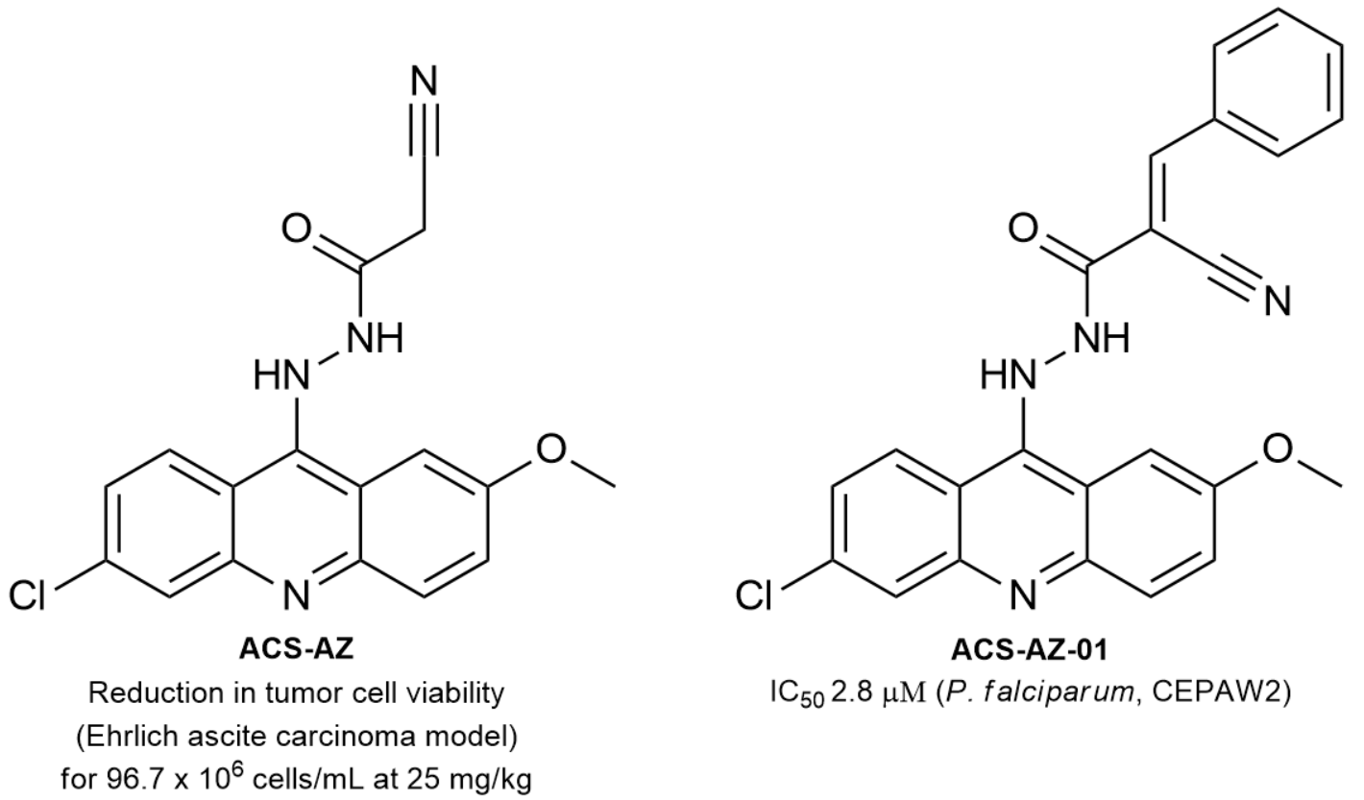
(B)
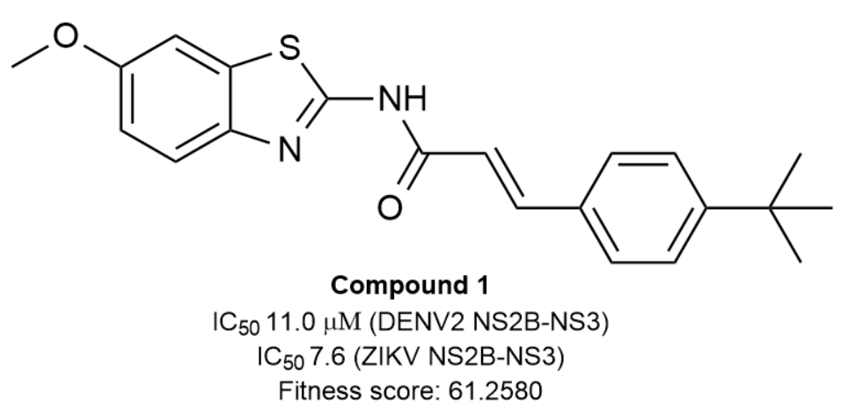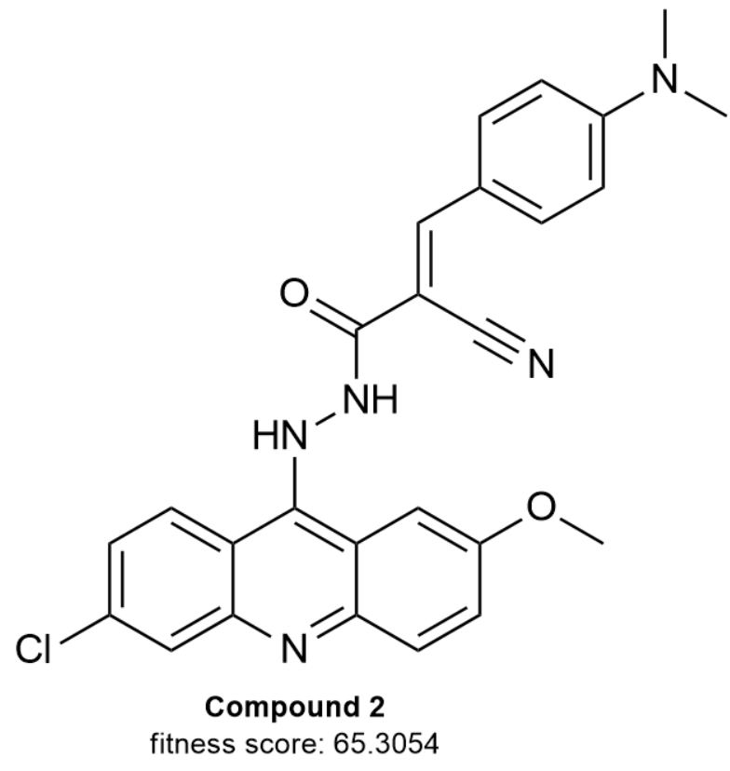

(C)
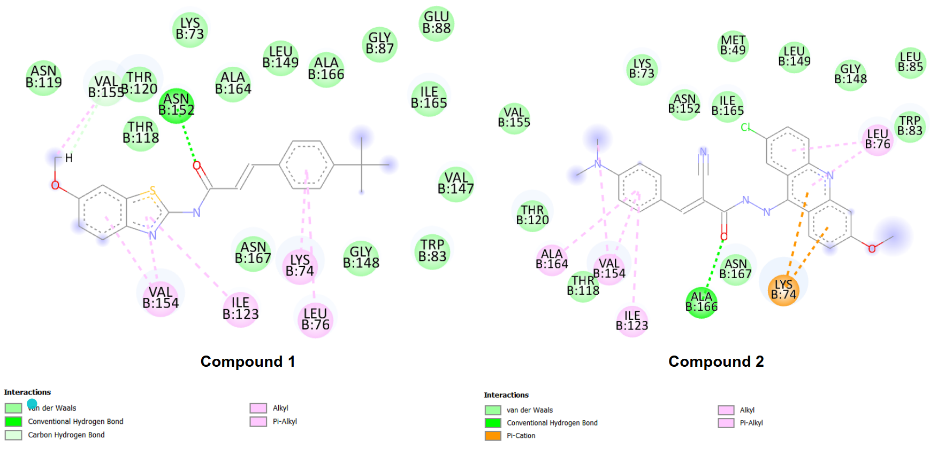
Figure 1 – (A) ACS-AZ and its derivative ACS-AZ-01; (B) compound 1 and compound 2 and their respective fitness score; (C) complexes of compound 1 and compound 2 with the NS2B-NS3 protease.

CONCLUSION
The ACS-AZ derivative, compound 2, presented a good pharmacodynamic and pharmacokinetic in silico profile, thus being a promising molecule for further studies in order to proof its antiviral activity.

