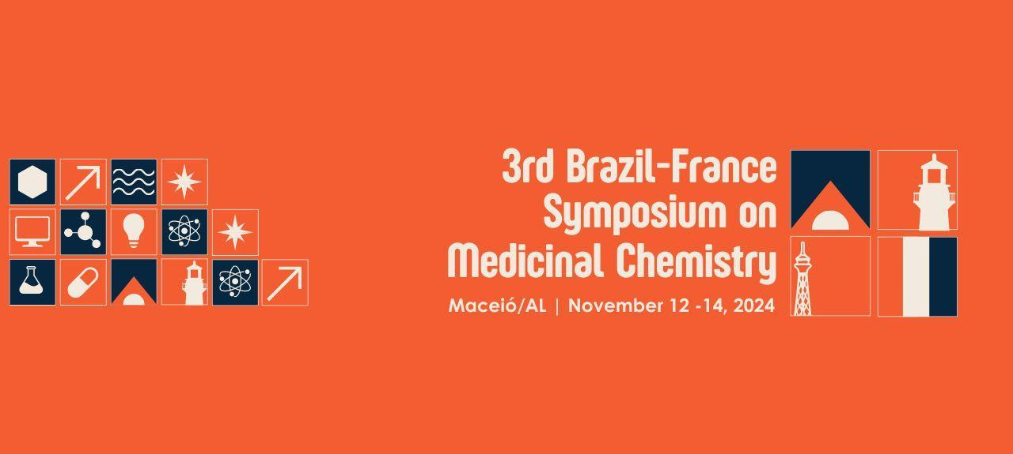

CHARACTERIZATION OF THE INTERACTION OF THE FLAVONOIDS NARINGENIN AND FORMONONETIN WITH β-CYCLODEXTRIN
Kathylen V. Ferreira Santos (G)¹, Nataly C. Soares Gama (PG)³, Salvana P. Manso Costa (Res)³; Arthur Luy Tavares F. Borges (PG)⁴, Monique A. Vila Nova (PG)³, Nathalia M. Lins Freire (PG)⁵, Fernanda Geny C. Silva (PG)⁴, Shirley V. Amorim (PG)⁴, Emanoel G. da Silva Junior (PG)³, Jeniffer C. Freitas dos Santos (G)¹, João Victor L. de Oliveira (PG)⁶, Edson de Souza Bento (Prof)², Thiago M. de Aquino (Prof)², Ticiano G. do Nascimento (Prof)¹.
¹Institute of Pharmaceutical Sciences, Federal University of Alagoas
²Institute of Chemistry and Biotechnology, Federal University of Alagoas
³Postgraduate program in Pharmaceutical Science, Federal University of Alagoas
⁴Postgraduate program in Materials, Federal University of Alagoas
⁵Postgraduate Program in Chemistry and Biotechnology, Federal University of Alagoas
⁶Postgraduate program in Health Sciences, Federal University of Alagoas
kathylen.santos@icf.ufal.br
Keywords: Red propolis, cyclodextrin, RMN-H , molecular docking.ABSTRACT

Introduction: Propolis is a natural product with a worldwide research focus, which, due to its chemical composition, especially flavonoids and phenolic acids, is responsible for various biological activities. However, like other flavonoids, naringenin (NAG) and formononetin (FMT) have low water solubility, which will directly affect their oral bioavailability, limiting their pharmacological effects. To improve their physicochemical characteristics, a viable alternative is to complex them with cyclodextrins (CDs). Among the CDs, β-CD stands out due to its greater volume compatibility with most substrates. Objective: In view of the above, the present work consisted of studying the interactions of β-CD with the main flavonoids present in red propolis from Alagoas (PVA) (NAG and FMT) using the H ^{NMR}spectroscopic technique in association with computational molecular docking tools. Methodology: PVA was extracted to obtain the crude extract and then the biomarkers of PVA were identified using High Performance Liquid Chromatography (HPLC-DAD). One-dimensional ^{1H}NMR spectra were acquired on a Varian Unity 300 MHz spectrometer at 25 °C using a simple pulse-acquisition sequence with pre-saturation in deuterated organic solvent. The docking tests of the compounds were carried out in the GOLD 2020 v.1.10.5®️ software, using the ChemPLP algorithm. The best poses were analyzed in the Discovery Studio 2017 R2 Client® program. Results and discussion: The chromatographic profile identified flavonoids such as formononetin, isoliquiritigenin, liquiritigenin, pinocembrin, pinobanksin and biochanin A in comparison with analytical standards. The NMR analyses were compatible with the proposed structures. The spectra of the two flavonoids revealed sharp singlets at 5ppm corresponding to the phenol groups present in the molecules. For FMT there was a signal at 3pmm referring to O-CH3 and for NAG to the other OH of the phenol. These data corroborate the literature. The approach revealed that the insertion of the B ring of NAG and the A ring of FMT into the β-CD cavity by the edge of the secondary OHs is the most likely conformation. This result suggests a stronger bond due to the lower affinity energy. Molecular docking also made it possible to verify that the 1:1 molar ratio proved to be the most stable structure of the complex. Conclusion: Therefore, in order to investigate the possible formation of such complexes between NAG and FMT, i.e. the main flavonoids in PVA and β-CD, it is of the utmost importance to understand the profile of the NMR-H spectra and subsequently compare the possible variations in chemical shifts after the formation of the complexes. In this sense, the docking results are in great agreement, corroborating the possibility of complex formation.

