
DESIGN, SYNTHESIS, IN SILICO AND IN VITRO EVALUTION ANTIMALARIAL ACTIVITY OF SPIRO-ACRIDINIC DERIVATIVES
Wallyson J. S. Araújo (G)*,¹ Arthur G. C. Farias (G),¹ Maria V. B. Nascimento (G),¹ Misael A. T. Cavalcanti (PG),¹ Ricardo O. Mora (Prof).¹*
wallyson.araujo@aluno.uepb.edu.br;
¹ State University of Paraíba;
Keywords: Acridines, Computer Simulation, In Vitro Techniques, Plasmodium falciparum.
ABSTRACT

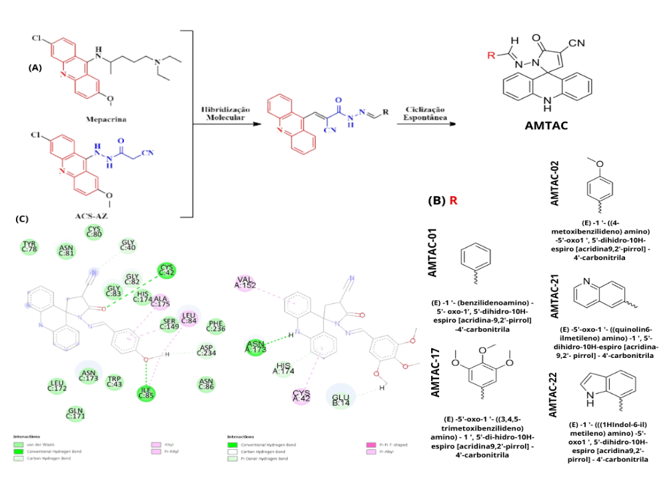
In the Americas, Brazil, Colombia, and Venezuela accounted for about 80% of South American malaria cases in 2021, with Plasmodium falciparum infecting 247 million people worldwide. Given the parasite's resistance to antimalarial therapy, new therapeutic approaches are essential to reverse this trend. Among these new strategies, inhibiting hemoglobinases has shown promise, as these enzymes are critical during the parasite's most virulent stage. This study aims to develop and evaluate the antimalarial activity of spiro-acridine derivatives AMTAC-01, 02, 17, 21, and 22 through in silico and in vitro analyses (Figures 1A and 1B). The molecules were designed in ChemDraw Ultra 12.0 and minimized in Chem3D using MM23 force field mechanics. The falcipain-2 structure was obtained from the Protein Data Bank (PDB: 3BPF) and prepared in GOLD. In Discovery Studio 4, binding regions, interaction types, and active site amino acids were identified. Molecular redocking validated the methodology with a root-mean-square deviation (RMSD) under 2.0 Å, confirming accurate positioning. The derivatives were then tested at fixed concentrations (1 and 10 µM) for their ability to inhibit the growth of P. falciparum 3D7 expressing green fluorescent protein (3D7-GFP, MRA-1029). Fluorescent events (parasitized erythrocytes) detected by flow cytometry indicated the percentage of surviving parasites. The design involved the molecular hybridization of ACS-AZ and Mepacrine, yielding an intermediate compound that underwent intramolecular cyclization to form the AMTAC structures (Figure 1A). Among the compounds, AMTAC-17 showed the highest fit score in subcavity A (61.54), while AMTAC-22 scored best in subcavity D (56.07), with AMTAC-21 and AMTAC-17 also showing relatively high fit scores in subcavity D. AMTAC-17 can form pi-alkyl interactions with Cys-42, a residue that forms covalent bonds with inhibitors resulting in a hemithioacetal, and hydrogen bonds with His174, another catalytic residue essential for enzymatic activity and inhibitor binding (Figure 1C). Additionally, it interacts with Ser149, a residue capable of forming hydrogen bonds, contributing to binding stability. At a 10 µM concentration, AMTAC-17 and AMTAC-02 showed the best activity values, 97.43 ± 0.05 and 97.64 ± 0.14, respectively, followed by AMTAC-01 (96.78 ± 0.07), AMTAC-22 (95.31 ± 0.12), and AMTAC-21 (91.14 ± 0.14). AMTAC-02 and AMTAC-21 showed no activity at 1 µM, while AMTAC-22 demonstrated 12.28 ± 1.43 activity, followed by AMTAC-01 (10.48 ± 1.57) and AMTAC-17 (6.02 ± 5.75). As the parasite develops, GFP protein production increases, as does green fluorescence. While the in silico and in vitro assessments of AMTACs do not entirely align, the potential of these acridine derivatives against P. falciparum remains evident. Despite the enzyme-inhibitory activity, other mechanisms may contribute to their in vitro inhibitory potential, suggesting that additional targets should be evaluated in future studies.

