
PS: After to fill all requirements for this abstract, please remove all the instructions.
STUDY AND CHARACTERIZATION OF THE ENCAPSULATION OF THE DRUG DOCETAXEL WITH PAMAM 3G DENDRIMER.
Ana L. A. Costa (PG),¹* Gleidson P. O. Silva (PG),¹ Jeniffer M. D. Freitas (PG),¹ Jailson V. Silva (PG),¹ Islane G. M. Araujo (G),¹ Edla I. V. Nascimento (G),¹ Max L. M. Bezerra (G),¹ Marilia P. M. Silva (G),¹ Mauro C. S. Santos Filho (G),¹ Fabiane C. Abreu (Prof).¹
analaisdearaujo@gmail.com;
¹ Universidade Federal de Alagoas (UFAL)
Keywords: PAMAM, Docetaxel, Nanocarrier, Cancer;
ABSTRACT
The use of natural compounds and their derivatives has been a crucial source for the development of new drugs throughout history. Taxanes, a class of antineoplastic drugs derived from plants, have gained prominence, especially paclitaxel (PTX) and its derivative docetaxel (DTX), which marked a new era in the treatment of breast cancer. In parallel, dendrimers, branched molecules with diverse applications, have been explored as drug delivery agents, with emphasis on polyamidoamine dendrimers (PAMAM). The combination of these two research fields opens new possibilities in anticancer therapy. This work aimed to investigate the efficacy of docetaxel (DTX) encapsulation by PAMAM dendrimers to enhance anticancer therapy, aiming to reduce side effects and increase treatment efficacy. The research involved the synthesis of the DTX-PAMAM complex and its characterization using several analytical techniques, including UV-vis spectrophotometry, high-performance liquid chromatography (HPLC), scanning electron microscopy (SEM), thermogravimetric analysis (TGA) and Fourier transform infrared spectroscopy (FTIR). The TGA, SEM, HPLC and FTIR results confirmed the formation of the complex and greater thermal stability compared to the individual components. UV-vis analyses demonstrated its increased solubility and indicated a complexation limit of 22 drug molecules to 1 dendrimer in aqueous medium with 20% ethanol. Drug release was tested with dialysis membrane in PBS as the release medium. The efficacy of the complexed drug was tested in breast cancer cells. The encapsulation of DTX by the PAMAM dendrimer proved to be effective, offering a promising strategy to improve anticancer therapy. Increasing the solubility of DTX and reducing the side effects associated with the eluents used in the treatment are significant advances. These results provide important insights for the development of novel anticancer therapies based on encapsulating dendrimers.
Figure 1 - SEM analyses of the pure compound and the complex
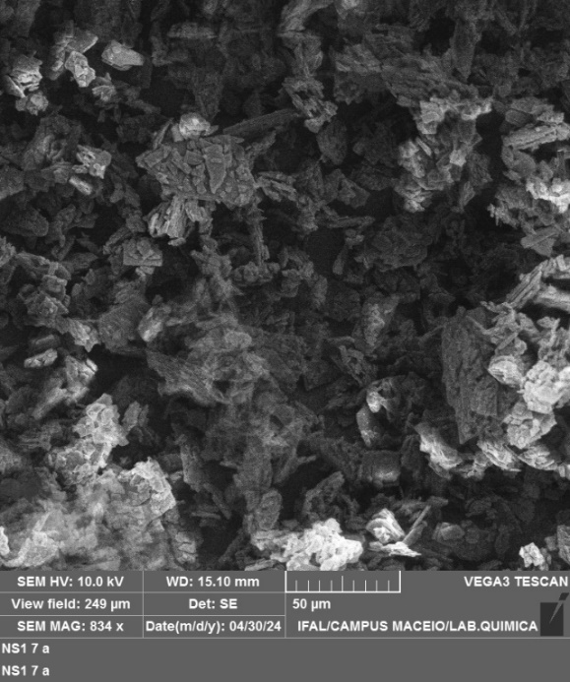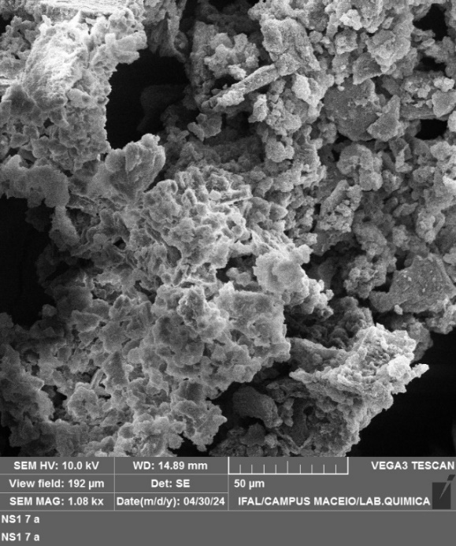
DTX DTX-PAMAM

