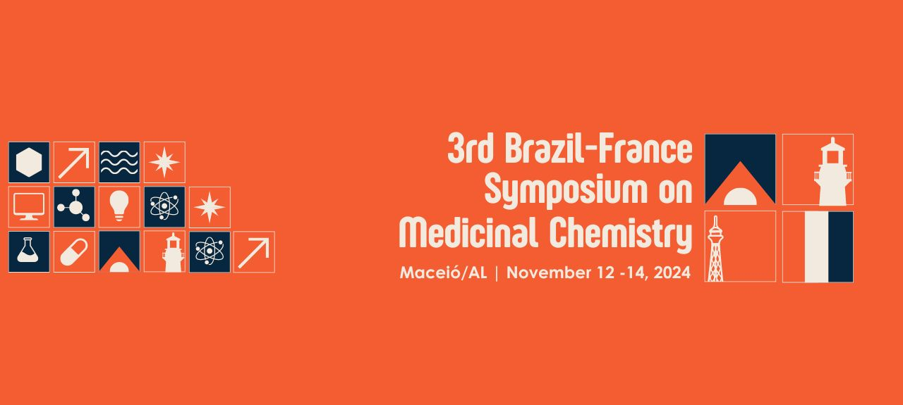
2-AMINO-THIOPHENE DERIVATIVE SB-44: ANTILEISHMANIAL ACTIVITY WITH LOW TOXICITY in vitro and in vivo
Julyanne M. S. Sousa (PG)*,¹ Yasmim A. A. Machado (PG),¹ Paulline P. M. S. Leal (PG),² Bianca S. Anjos (G),² Michel M. M. Alves (Prof),² Marcus V. Silva (Prof),² Alyne R. Araújo (Prof),² Francisco J. B. Mendonça-Junior (Prof),¹ Klinger A. F. Rodrigues (Prof).¹
julyannesaraiva@gmail.com.
¹ Laboratory of Infectious Diseases, Campus Ministro Reis Velloso, Federal University of Parnaíba Delta, Parnaíba 64202-020, PI, Brazil; ² Laboratory of Antileishmania Activity, Medicinal Plants Research Center, Federal University of Piauí, Teresina 64049-550, Brazil; ³ Laboratory of Immunology and Parasitology, Institute of Biological and Natural Sciences, Federal University of Triângulo Mineiro, Uberaba 38025-180, MG, Brazil; ⁴ Research Center in Biodiversity and Biotechnology, Campus Ministro Reis Velloso, Federal University of Parnaíba Delta, Parnaíba 64202-020, PI, Brazil; ⁵ Molecular Synthesis and Vectorization Laboratory, Department of Biological Sciences, State University of Paraíba, 58071-160 João Pessoa, PB, Brazil.
Keywords: (2-Amino-thiophene, antileishmanial, Leishmania infantum)
ABSTRACT

BACKGROUND: Leishmaniasis is a spectrum of diseases caused by dimorphic trypanosomatids of the genus Leishmania that manifest in the form of visceral leishmaniasis and different types of cutaneous leishmaniasis. Despite their epidemiological relevance, the treatments available for these diseases are expensive, highly toxic and, in some cases, parasite resistant. Therefore, there is a need to search alternative treatments for these diseases. SB-44 is a 2-amino-thiophene derivative that has shown promising anti-Leishmania (Leishmania) amazonensis activity in a previously published study. OBJECTIVES: The aim of this study was to evaluate the antileishmanial activity of SB-44 against Leishmania (Leishmania) infantum by investigating morphological damage, cell death profile, cytotoxicity and acute toxicity in vivo in Zophobas morio larvae. METHODS: The evaluation of antileishmanial activity was performed through the MTT assay. Promastigotes of L. infantum in logarithmic phase (1x10⁶) were cultured in 96-well plates with Schneider medium and treated with SB-44 (100 µM – 3.12 µM) for 72 h at 26ºC. After this period, MTT was added to the wells and after 4 h the plate was read at 540 nm. After treatment, morphological and structural damage was analyzed by Atomic Force Microscopy (AFM). To investigate the cell death profile, treated promastigotes were double labeled with Annexin V-FITC/Propidium Iodide (PI) and analyzed by flow cytometry. To evaluate cytotoxicity, RAW 264.7 macrophages and VERO cells (10⁵) were cultured in DMEM medium in a 96-well plate containing SB-44 (200 µM – 3.12 µM) for 72 h at 37 ºC and 5% CO₂. After this period, MTT was added to the wells and after 4 h the plate was read at 540 nm. Furthermore, in vivo toxicity assessment was performed on Zophobas morio larvae. Doses of SB-44 (3000 mg/kg – 3 mg/kg) (negative control – saline solution; negative control – pure DMSO) were administered to the larvae and kept at room temperature in a petri dish containing substrate. After 48 h, all larvae were macerated with PBS, the contents were centrifuged and read in a 96-well plate at 540 nm. RESULTS AND DISCUSSION: SB-44 presented an IC₅₀ of 3.88 µM, demonstrating effective activity against the species that causes visceral leishmaniasis. Through ultrastructural analysis using MFA, loss of fusiform shape and reduction in cell size were observed, as well as the formation of globules, cytoplasmic disorganization, apparent membrane rupture and appearance of cellular debris. These morphological changes suggest that SB-44 produces a leishmanicidal effect on promastigote forms. When evaluating the cell death profile, SB-44 at concentrations of 2x and 4xIC₅₀ induced death by late apoptosis and necrosis in promastigotes, corroborating a previously described killing pattern for this compound in Leishmania amazonensis. When evaluating cytotoxicity, SB-44 showed toxicity to cells at concentrations higher than the toxic concentration for parasites, presenting a CC₅₀ of 53.41 µM and 33.9 µM for RAW 264.7 macrophages and VERO cells, respectively. The IS demonstrated that the compound was 13.76 and 8.75 times more selective for parasites when compared to macrophages and VERO cells, respectively. Furthermore, it was 16.58 times more selective to parasites than the reference drug amphotericin B. In the in vivo toxicity assessment, SB-44 did not induce increased melanization and death in invertebrates, indicating low acute toxicity and making it a promising candidate for study in a murine model. CONCLUSION: The results of this study demonstrated potential in vitro antileishmanial activity of SB-44. The compound induced structural damage and late apoptosis and necrosis in the parasite. In addition, it showed low toxicity in vitro and in an alternative in vivo model, making it a promising candidate for studies in the research of alternative treatment for visceral leishmaniasis.

