quali-quantitative multimethodology to support government procurement

Luiz Fernando do Nascimento^{a,b}, Marcos Pereira Estellita Lins^{a,c}, José H. Dulá^{d}

ª Production Engineering Program, COPPE, Federal University of Rio de Janeiro, Brazil Av Athos da Silveira 149, Bloco F sala 103, Rio de Janeiro, Brazil
^{b} Centro de Análises de Sistemas Navais (CASNAV), Praça Barão de Ladário, s/n° – lha das Cobras, Rua da Ponte, Ed. n° 23 do AMRJ, Centro – Rio de Janeiro, Brazil
^{c} Production Engineering Department, CCET, Federal University of the State of Rio de Janeiro, Brazil Rua Soares Cabral 80/1301, Rio de Janeiro, Brazil
^{d}Department of Information Systems, Statistics and Management Science, The University of Alabama. Tuscaloosa, AL, USA

Abstract. This paper uses multimethodology for evaluating proposals in public procurement by integrating the Complex Holographic Assessment of Paradoxical Problems (CHAP²) with Data Envelopment Analysis (DEA), focusing on Full Dimensional Efficient Faces (FDEFs) and Enhanced Russell Graph Measure (ERGM). Grounded in Systems Thinking, CHAP² structures the decision problem through conceptual mapping, capturing paradoxes, divergences, and contextual specificities before moving to quantitative modeling. DEA then constructs efficiency frontiers supported by reference decision-making units (DMUs) and evaluate proposals, ensuring transparent and strictly positive trade-offs among technical and economic attributes. The methodology was validated with the Brazilian Navy during the structuring phase and applied in a simulated tender using secondary vessel data. Results demonstrate that the approach enhances transparency, avoids distortions from zero-weight solutions, and strengthens compliance with the Most Economically Advantageous Tender (MEAT) principle. The study contributes by showing how Systems Thinking facilitates problem structuring and enables the design of robust multimethodological frameworks for complex procurement environments.

1. Introduction
Open democratic societies require transparent and accountable bidding processes in government procurement. Transparency reduces corruption risks, promotes competitiveness, and ensures greater efficiency in the use of public resources. Within this context, the European Union Directive 2014/24/EU establishes that evaluation criteria and their respective weights must be defined a priori in every public bid announcement (EUROPEAN UNION, 2014).
A procurement auction begins with the release of a Request for Proposal (RFP), which specifies the selection procedure, technical requirements, and evaluation criteria. Interested parties then submit proposals consistent with these requirements, which are evaluated according to objective and pre-established rules. In line with the Most Economically Advantageous Tender (MEAT) principle, the evaluation aims to achieve the best balance between price and non-monetary attributes such as quality, innovation, and sustainability. The winning bid is not necessarily the lowest-priced option but the one offering the most advantageous trade-off between cost and technical performance.
A major challenge in this process lies in defining and justifying the weights used to aggregate multiple criteria. Weighted sums of incommensurate attributes often create confusion among bidders and may be perceived as biased or as favoring particular proponents. To overcome this issue, this study emphasizes problem structuring as a necessary step before applying quantitative models.
The Complex Holographic Assessment of Paradoxical Problems (CHAP²) provides such structuring. Grounded in systems thinking, theory of mind, and metacognition (LINS, 2018) e (LINS et al. 2021), CHAP² enables experts and stakeholders to identify paradoxes, map perspectives, and represent knowledge through conceptual and metacognitive maps. This approach ensures that contextual and qualitative issues are explicitly addressed before formal evaluation, providing a holographic representation of the problem and integrating multiple perspectives into the decision-making framework.
Once conceptual and paradoxical models are established through CHAP², experts conduct market research and database analysis to identify comparable products that form a realistic reference set of best practices. DEA is then employed to formalize and calculate a production possibility set (PPS), whose frontier is characterized by the existence of Full Dimensional Efficient Faces (FDEFs), also called facets. The supporting hyperplanes of these facets provide well-defined marginal rates of substitution among attributes, thereby establishing transparent operational possibilities for bidders.
In this multimethodology, DEA does not replace problem structuring but rather builds upon the foundation established by CHAP². The integration ensures consistency in assigning weights, improves the interpretability of trade-offs, and enables objective comparison of proposals.
Thus, the proposed methodology integrates CHAP² for qualitative structuring with DEA for quantitative evaluation, ensuring that contextual, qualitative, and strategic dimensions are addressed before numerical optimization. This enhances transparency, robustness, and fairness in government procurement, aligning practice with international standards and responding to the complex challenges of public decision-making.

2. Theoretical Framework

2.1 Complex Holographic Assessment of Paradoxical Problems (CHAP²)
The Complex Holographic Assessment of Paradoxical Problems (CHAP²) is a problem structuring method based on systems thinking, theory of mind, and metacognition (LINS, 2018) e (LINS et al. 2021). It aims to address complex decision contexts by explicitly identifying paradoxes and divergences that cannot be eliminated but must be managed constructively.
Its central tool is the use of conceptual and metacognitive maps, which serve as holographic representations of the problem, integrating diverse stakeholder perspectives and ensuring contextual validity.
Figure 1 illustrates the six operational phases of the CHAP² methodology, each of which plays a specific role in structuring paradoxical problems.
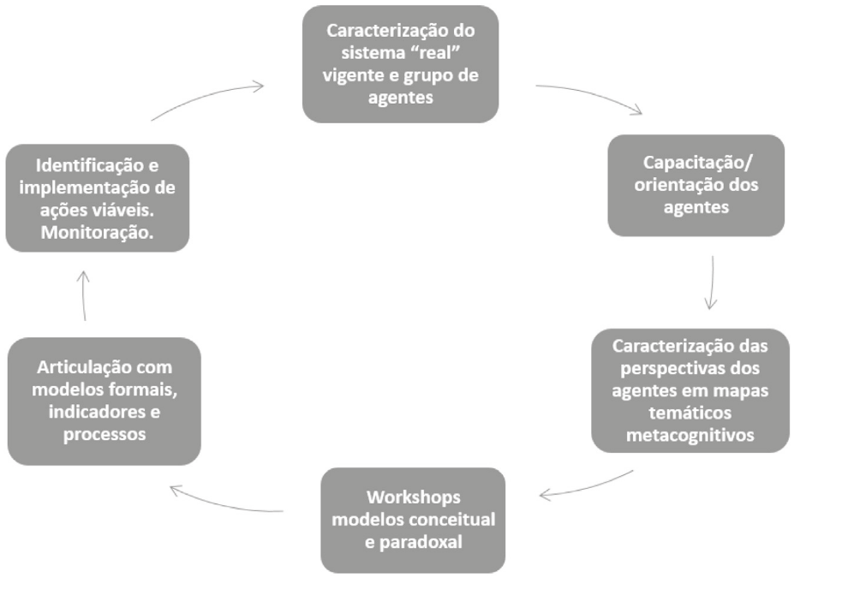
Figure 1. Phases of the CHAP² methodology
(Source: Lins (2018))
The phases are described as follows:
- Characterization of the real system and group of agents – Knowledge maps are created through expert interviews and literature review. These maps represent the initial perception of the problem, capturing divergent viewpoints.

- Orientation and capacitation of agents – Stakeholders are introduced to the method through workshops and exercises designed to foster metacognition and ensure holographic representation of different perspectives.
- Characterization of perspectives in thematic metacognitive maps – Perceptions of each stakeholder are documented, validated, and consolidated into thematic maps, explicitly preserving divergences.
- Workshops for conceptual and paradoxical models – Using a constructivist dialogical process, two models are developed: a conceptual model, capturing convergences, and a paradoxical model, highlighting divergences and trade-offs.
- Articulation with formal models, indicators, and processes – The conceptual model provides the foundation for quantitative modeling, including multicriteria and DEA based methods. Relevant indicators are defined to guide both internal and external regulation.
- Identification, implementation, and monitoring of feasible actions – Actions identified as viable are implemented and monitored, while the paradoxical model identifies barriers to change and contextual risks.
By explicitly addressing paradoxes and validating contextual insights, CHAP² ensures that the transition from qualitative deliberation to quantitative evaluation is consistent and legitimate. This makes it particularly suitable for procurement contexts, where multiple stakeholders with conflicting goals must reach consensus.

2.2 Data Envelopment Analysis and Full Dimensional Efficient Faces
Data Envelopment Analysis (DEA) is a widely used methodology for evaluating and comparing the efficiency of organizations and productive units since its introduction by CHARNES et al. (1978). Its objective is to measure the relative efficiency of a set of productive units, called Decision Making Units (DMUs), considering multiple inputs and outputs.
The original model, proposed by Charnes, Cooper, and Rhodes, known as the CCR model, assumes constant returns to scale in the transformation process between inputs and outputs, defining efficiency as the ratio between the weighted sum of outputs and the weighted sum of inputs. Subsequently, Banker, Charnes, and Cooper proposed an extension for variable returns to scale, called the BCC model (Banker et al., 1984), whose multiplier formulation can be expressed as follows:

$E_{o}={max u}^{t}y_{o}+u_{o}$ (1)
$$s.t. v^{t}x_{o}=1, u^{t}y_{j}-v^{t}x_{j}+u_{o} ≤0, j=1,…,n. u, v ≥0, u_{o}∈R$$
Where $E_{o}$​ is the efficiency of the DMU under evaluation, $j = 1,..., n$. $x_{j }≠0$ e $y_{j}≠0$ are the vectors of inputs and outputs denoted by $x_{j}=\left(x_{1j}, …,x_{mj}\right)$ e $y_{j}=\left(y_{1j}, …,x_{sj}\right)$. $u$ e $v$ are vectors of decision variables, also known as weights, which represent the multipliers assigned to the m inputs e s outputs, respectively. An additional decision variable $u_{o}$ is interpreted as a scale factor, necessary for the assumption of variable returns to scale in the transformation process. The solution to the linear programming problem (LP) in (1) maximizes the efficiency of the DMU being evaluated subject to normalization constraints, which ensure that the efficiency of each DMU does not exceed 1.
A DMU is deemed BCC-efficient if there exists an optimal solution $\left(u^{*}, v^{*}, u_{o}^{*}\right)$to the linear program in expression (1), where $\left(u^{*}, v^{*}\right)>0$e $u^{*}y_{o}+u_{o}^{*}=1$. Otherwise, the DMU is regarded as inefficient.
A critical challenge in DEA is the occurrence of zero weights in optimal solutions, implying that certain inputs or outputs are disregarded in the evaluation. This weakens interpretability and prevents meaningful trade-off analysis (BOUGNOL and DULÁ, 2009). Restricting weights has been proposed as a solution, but these constraints often lead to infeasibility or arbitrariness.
To address this, researchers introduced the concept of Full Dimensional Efficient Faces (FDEFs) (OLESEN and PETERSEN, 1996). A facet is defined as the intersection of the supporting hyperplane and the Production Possibility Set, supported by a sufficient number of extreme-efficient DMUs. FDEFs provide:
- Complete marginal rates of substitution, ensuring trade-offs are well-defined across all attributes.
- Transparency, since facet equations can be disclosed as evaluation criteria.
- Robustness, as FDEFs are supported by observed efficient DMUs rather than arbitrary weights.
To identify the FDEFs, we employ the variable returns to scale (VRS) mixed-integer programming (MILP) formulation of OLESEN and PETERSEN (2015). Let E be the set of indices for all the extreme-efficient DMUs in a sample. The following MILP provides a test for the existence of at least one FDEF:

$Min\sum_{j ∈ E}{b_{j}}$ (2)
$$s.t. u^{t}y_{j}-v^{t}x_{j}+v_{0}+s_{j}=0 \left(j∈E\right),$$
$$e^{t}v=1,$$
$$s_{j}-b_{j}M≤0 \left(j∈E^{BCC}\right)$$
$$b_{j }binary, s_{j}≤0, ∀j ∈E^{BCC}, u≥εe,v≥εe u ∈R^{s}, v ∈R^{m}$$

Where $ε$ is a non-Archimedean, $M=\frac{1}{ε}$, and e is a vector ${\left(1,…,1\right)}^{T}$ of an appropriate length. Let $J_{k}$ $be a subset$of $E$ such that $\left|J_{k}\right|$ = (m+s) and (2) has a feasible solution with $s_{j}=0$, j ∈ $J_{k}$. An FDEF exists if the condition in expression (3) is satisfied:

$\sum_{j ∈ E}{b_{j}^{*}}≤\left|E\right|-\left(s+m\right)$ (4)

The original Russell Measure of Technical Efficiency was defined by FÄRE et al. (1985) as a combination of the input and output Russell measures. However, its computational implementation posed challenges, since it is a non-linear program that optimizes a product of arithmetic and harmonic weighted averages (Sueyoshi w Sekitani, 2007). Pastor et al. (1999) proposed an adaptation known as the Enhanced Russell Graph Measure (ERGM), which addresses these limitations. ERGM can be interpreted as the ratio between the average efficiency of inputs and the average efficiency of outputs, thus offering a more balanced view of performance across dimensions. Moreover, in line with evolution of the Slacks-Based Measure (Tone, 2001) to variation II SBM (TONE, 2010), ERGM has been reformulated to allow for maximization, enabling the projection of decision-making units onto proximal facets of the efficient frontier and obtaining efficiency scores that reflect the best possible performance on each facet.
The non-radial maximizing version of ERGM represents an important advancement in efficiency analysis, as it overcomes the limitations of traditional radial approaches. Unlike radial models, which assume proportional expansion of outputs or contraction of inputs, the non-radial ERGM allows for non-proportional adjustments, providing a more realistic representation of production technologies maximizing efficiency over a FDEF.

$$Max$$ | $$\frac{1}{m} \sum_{i=1}^{m}{{\left(X_{\hat{f}i}\right)}^{T}{λ^{'}}_{\hat{f}}}$$
s.t. | $$\frac{1}{s}\sum_{k=1}^{s}{{{\left(Y_{\hat{f}k}\right)}^{T}λ'}_{\hat{f}}}$$ | = | 1
 | $$e^{T}{λ'}_{\hat{f}}$$ | = | $$δ$$ |  | (5)  (8)
 | $${\left(X_{\hat{f}i}\right)}^{T}{λ'}_{\hat{f}}$$ | ≥ | 0 | $$i=1,…,m$$
 | $${{\left(Y_{\hat{f}k}\right)}^{T}λ'}_{\hat{f}}$$ | ≥ | 0 | $$k=1,…,s$$
 | $${λ'}_{\hat{f}}∈ R_{+}^{m+s}$$
 | $$δ≥0$$

Model (5) evaluates each proposal by maximizing its efficiency. The matrices $\hat{f}$ : $\left[\begin{matrix}X_{f} \\ Y_{f}\end{matrix}\right]$​​ contain, respectively, the input and output vectors of the extreme-efficient DMUs that span facet $\hat{f}$​. The decision vector $λ_{\hat{f}}$ assigns nonnegative weights to these extreme points, thereby selecting the convex combination that defines the projection of the proposal on the facet. The vector e is composed of ones and is used in the normalization condition to ensure convexity under variable returns to scale. Finally, the auxiliary variable δ is introduced as a strictly positive scalar that linearizes the fractional structure of the ERGM, making the problem computationally tractable while preserving the maximizing orientation.

3. A New Methodology for Ranking Proposals
The methodology proposed in this work is grounded in the multimetodological framework presented in Chapter 2, which combines qualitative and quantitative procedures in a sequential and complementary way. The essence of this approach lies in the articulation between the first four stages of Chapter 2 — predominantly qualitative — and the subsequent stages 5 and 6, which provide the quantitative backbone of the model. Accordingly, the process is divided into two main phases: a qualitative stage that frames the problem and structures the evaluation model, and a quantitative stage that constructs the efficient frontier and evaluates the proposals using DEA. The quantitative phase itself is subdivided into two complementary components: internal, focused on the generation of the frontier and FDEFs from a reference dataset, and external, dedicated to the evaluation of actual proposals projected onto those facets.

3.1 Qualitative phase: integrating insights from Chap. 2
The qualitative phase of the methodology draws inspiration from the initial stages of CHAP², which emphasize the importance of capturing perceptions, consolidating diverse viewpoints, and building conceptual clarity before moving into quantitative analysis. In the procurement context, this phase begins with the framing of the problem under the MEAT (Most Economically Advantageous Tender) principle. Here, the system and its agents are characterized with the help of experts, and the multiple perspectives regarding the balance between price and technical quality are acknowledged. This ensures that governance mechanisms and transparency requirements are not only defined but also rooted in a broader understanding of the decision environment.
The next step involves the definition of attributes. The technical specifications of the good or service are translated into outputs, while cost is set as the single input. In this process, elements reminiscent of thematic maps are present: expert knowledge is structured into a coherent framework, but divergences are not suppressed. Instead, issues such as the treatment of undesirable outputs are explicitly addressed, maintaining both technical soundness and openness to different perspectives.
The construction of the reference set follows, supported by the contributions of specialists. Exemplary or archetypal units (special DMUs) are identified to span the feasible space of input–output combinations. This step resonates with the idea of consolidating thematic perspectives: the chosen DMUs embody both convergences and divergences in expert judgment, serving simultaneously as benchmarks and as a representation of the diversity of feasible alternatives.
Finally, the model is formalized and prepared for disclosure. At this point, a conceptual representation is consolidated, and commitments to transparency are embedded in the RFP. The evaluation criteria are clearly stated, while the assurance that weights will emerge strictly from the data through the identification of FDEFs reflects a constructivist orientation. This guarantees that the tendering process is not only transparent and fair but also informed by a multimetodological foundation that values both consensus and divergence in the early stages of model design.

3.2 Quantitative phase: internal and external components

3.2.1 Internal component: DEA frontier and FDEF generation
The internal component consolidates the dataset that will serve as the foundation of the DEA model. This includes compiling all identified technical attributes as outputs, with price as the single input, standardizing measurement units, and applying proper transformations to handle undesirable outputs. Data validation is also carried out to ensure consistency and feasibility.
Once the dataset is established, the BCC (VRS) model is applied to identify the extreme-efficient DMUs that span the production possibility set (PPS). These units form the basis for constructing the efficient frontier. The Full Dimensional Efficient Faces (FDEFs) are then determined by applying the VRS MILP formulation of Olesen and Petersen (2015). Each FDEF is represented by a supporting hyperplane whose normal vector has strictly positive coefficients, thereby guaranteeing well-defined marginal rates of substitution across all attributes. The outcome of this step is a set of hyperplane equations and supporting DMUs that provide the structural backbone for the subsequent evaluation.

3.2.2 External component: proposal evaluation and decision-making
The external component begins with the publication of the RFP, which now includes the facet equations and the set of supporting DMUs identified in the internal phase. This ensures that bidders are fully informed of the evaluation framework and the criteria that will be applied.
Each proposal submitted in response to the RFP is treated as a new DMU to be evaluated. Proposals are projected onto every identified FDEF using the non-radial maximization version of the Enhanced Russell Graph Measure (ERGM). This ensures that all attributes are assigned strictly positive weights, avoiding the common DEA problem of zero-weight variables, and producing more robust efficiency measures.
For each proposal, the most favorable projection is selected according to the benevolent principle of DEA, yielding the maximum efficiency score achievable on the frontier. The peer group and supporting hyperplane associated with this projection are recorded, ensuring transparency in the evaluation. Proposals are then ranked based on their maximum efficiency, and the highest-scoring proposal is declared the winner. In the case of ties, additional pre-defined rules, such as distance to the target or cost dominance, may be applied.
Finally, robustness and sensitivity analyses may be conducted to validate the results. These analyses test how changes in the reference set or facets affect the evaluation outcomes, strengthening the credibility of the methodology and providing insights for future procurement processes.

3.3 Simplified step-by-step summary
Qualitative Phase (CHAP2: Stages 1–4)
- Problem framing → Define MEAT objectives, governance, and transparency rules.
- Attributes definition → Set technical outputs and price (input); specify treatment of undesirable outputs.
- Reference set construction → Experts select exemplary DMUs to span the feasible space.
- Disclosure plan → Prepare the RFP explaining criteria and data-driven weighting via facets.
Quantitative Phase — Internal component (CHAP2: Stages 5–6)
5. Dataset consolidation → Organize input/output data, transform undesirable outputs, check consistency.
6. Extreme-efficient DMUs → Apply BCC-VRS to identify frontier DMUs.
7. FDEF identification → Use VRS MILP to determine facets and supporting hyperplanes (positive normals).
8. Publication prep → Finalize facet equations and supporting DMUs for inclusion in the RFP.
Quantitative Phase — External component (CHAP2: Stages 5–6)
9. Proposal projection → Apply maximizing ERGM to project each proposal on all FDEFs.
10. Best target selection → Keep, for each proposal, the most favorable projection (benevolent selection).
11. Ranking & award → Rank proposals by maximum efficiency; the highest wins per tender rules.
12. Robustness (optional) → Sensitivity checks on reference set/facets to support credibility and insights.

4. Results

4.1 Introduction
The results presented in this chapter stem from the application of the multimetodological framework introduced in Chapter 3. In the first stage, the CHAP² approach was employed as a problem-structuring method to understand the complexity of a government procurement auction. This process was carried out with the participation of experts from the Brazilian Navy, who contributed to characterizing the procurement system, identifying relevant attributes, and highlighting paradoxical tensions such as the trade-off between cost and performance.
From this real problem-structuring, the initial conceptual maps Fig. 2 was generated, serving as the foundation for the design of a quantitative evaluation. The proposed evaluation model was then presented back to Navy representatives, who validated its logic and confirmed that it is a valid and adherent method for use in the assessment of proposals under the MEAT (Most Economically Advantageous Tender) principle.
It should be emphasized, however, that while the problem-structuring phase was real, the subsequent tender simulation was carried out with secondary data obtained from publicly available sources on comparable vessels. In this sense, the results illustrate a simulated auction scenario: the structuring and validation steps were anchored in real practice, whereas the quantitative application used real data to emulate a bidding process.

4.2 Qualitative phase: conceptual problem structuring with CHAP²

A concept map representing the general problem of a government procurement auction is presented in Figure 2.

Cluster A shows the principles of public procurement, where transparency, equality, and negotiation are key issues. Cluster B addresses the object of procurement and its specifications, consolidating the requirements that define the tender. Clusters C, D, and E give an overview of the selection criteria, which are organized into an elimination round and two classification rounds.

The elimination round is represented in Cluster C and establishes the qualitative grounds for exclusion. Examples include judicial rulings related to participation in a criminal organization, corruption, child labor, fraud, or money laundering. Disqualification also applies when a tenderer is deemed incapable of fulfilling contractual obligations due to economic, financial, technical, or professional incapacity.

The classification rounds are represented in Clusters D and E. Cluster D focuses on risk analysis, dealing with potential supervening events between the contract signature and its execution that could affect either the economic-financial balance of the agreement or the technical feasibility of the solutions presented. The purpose of this round is to anticipate and prevent conditions that could lead to a poor procurement decision.

The technical-economic evaluation of tenders is based on the Most Economically Advantageous Tender (MEAT) principle, which seeks to balance cost and quality. Beyond simply meeting the requirements of the request for proposal, this balance aims to achieve the best quality for a fair price, reflecting the trade-offs inherent to the procurement of complex assets. In addition to the characteristics of the object and its price, other factors may also be incorporated into this evaluation. For example, in defense-related contracts, offset agreements such as technology transfer and on-the-job training are often critical components.

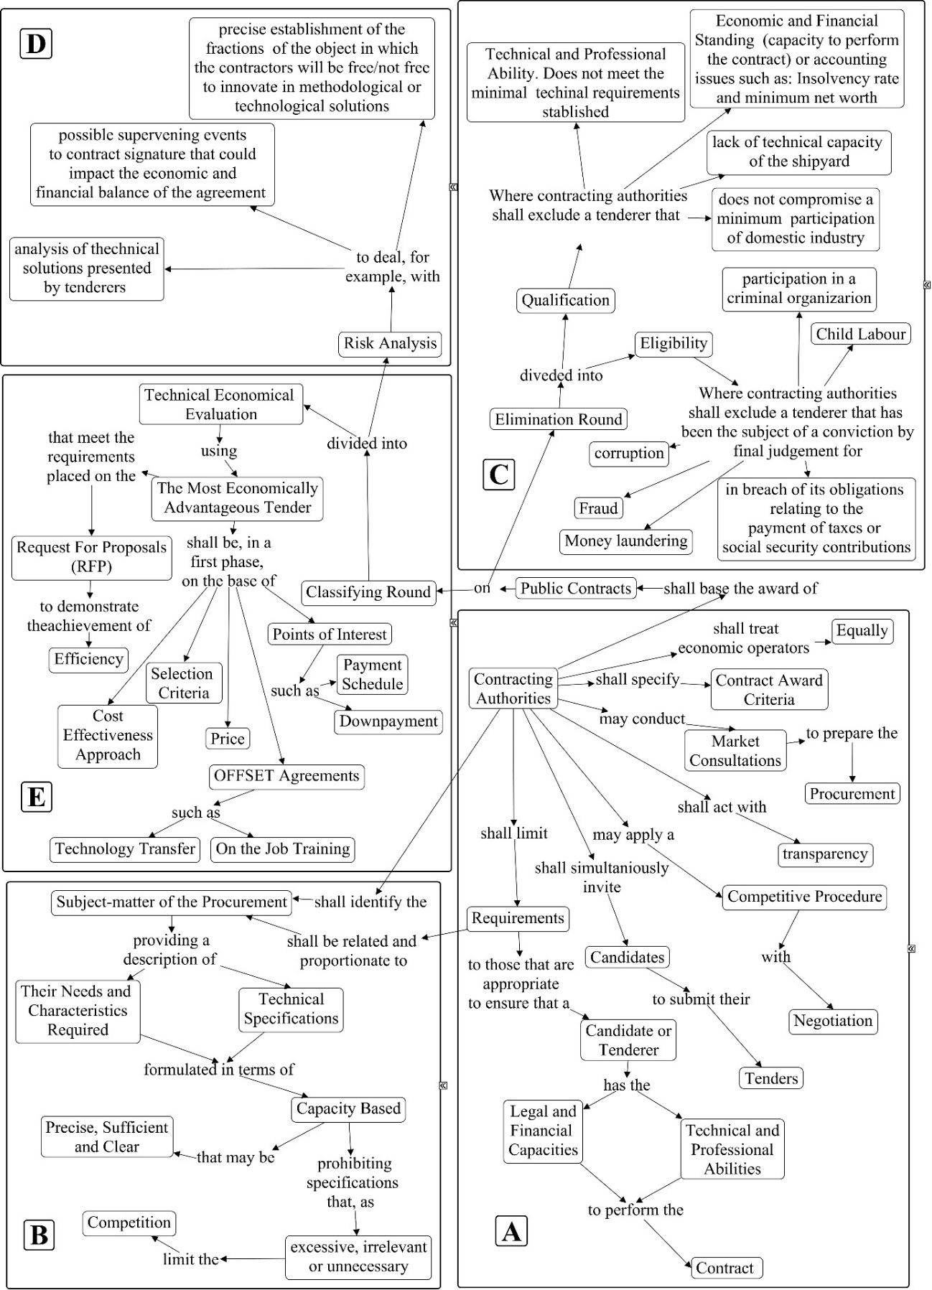

Figure 1 – Concept map of a government procurement auction
(Source: Authors)

Cluster E, detailed in Figure 3, is where this research makes its main contribution.

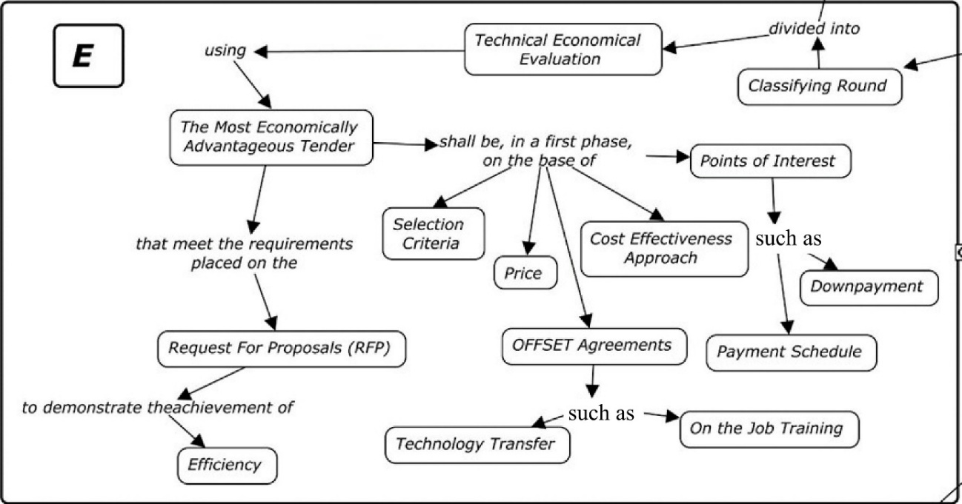

Figure 3 – Detail of Cluster E: Technical-economic evaluation
(Source: Authors, based on CHAP² application)

Taken together, these conceptual maps show how CHAP² provides a structured and transparent understanding of the procurement process. Clusters A–C capture the legal and regulatory framework, while Clusters D–E reveal the decision-making complexity of evaluating tenders under paradoxical pressures—such as minimizing cost while maximizing performance. The criteria emerging from this structuring directly informed the quantitative phase of the methodology.

From this structuring, the Navy defined the initial requirements for an Offshore Patrol Vessel (OPV): displacement of 1,800 tons; draught of 5 meters; crew of 62; maximum speed of 20 knots; autonomy of 20 days; radius of action of 4,000 NM; capacity to operate a 5-ton helicopter; and an estimated cost of BRL 250 million. Displacement and draught were modeled as undesirable outputs. We deal with these undesirable outputs using the multiplicative inverse (LOVEL et al., 1995): f (U)=1/U, 100.000/displacement and 100/draught, according Table 1.
Table 1 – Requirements of the Brazilian Government
Requirements | DISPL (ton) | DRA (m) | CREW (un) | MS (knots) | AUT (days) | RA (1000 NM) | AIR (tons) | PRICE (million BRL)
Original | 1800 | 5 | 62 | 20 | 20 | 4 | 5 | 250
Adjusted | 55.6 | 0.20 | 62 | 20 | 20 | 4 | 5 | 250

The qualitative phase therefore concluded with a validated set of evaluation criteria—price as the input, technical specifications as outputs, and the treatment of undesirable attributes—directly linked to the insights of the CHAP² structuring workshops.

4.3 Quantitative phase: internal component – finding FDEFs

Based on the results of the problem-structuring stage, the quantitative phase began with the definition of the evaluation attributes. These criteria capture the technical and operational characteristics of Offshore Patrol Vessels (OPVs), together with their acquisition cost:

Displacement (DISPL) - the vessel’s weight, measured by the volume of water displaced by the hull, which varies according to load.

Draught (DRA) - the vertical distance between the waterline and the keel, determining the minimum depth required for navigation.

Crew (CREW): the number of individuals required to operate the vessel.

Maximum Speed (MS): the maximum sustainable speed of the ship, limited by fuel capacity.

Autonomy (AUT) - the maximum number of days the vessel can remain at sea without resupply of provisions or fuel.

Radius of Action (RA) - the maximum distance the ship can sail without refueling.

Aircraft Capacity (AIR) - the ability to operate onboard aircraft, which increases mobility, autonomy, and operational reach; larger helicopters provide greater capacity.

Price - the only input of the model, representing acquisition cost.

The reference dataset was constructed from real technical specifications of comparable vessels obtained in specialized sources, as shown in Table 2.

Applying the MILP formulation described in Section 3.3.1, the analysis identified 11 FDEFs. The coefficients of the normal vectors for each facet are shown in Table 3, while Table 4 lists the supporting DMUs that define each hyperplane.

Table 2 – Data to produce the FDEF set
REQUIREMENT
DMU | DISPL | DRA | CREW | MS | AUT | RA | AIR | PRICE
A | 80 | 34 | 149 | 39 | 30 | 13.193 | 14 | 43
B | 81 | 36 | 121 | 44 | 35 | 12.000 | 14 | 51
C | 74 | 38 | 132 | 31 | 41 | 18.644 | 11 | 53
D | 85 | 35 | 139 | 38 | 32 | 19.254 | 11 | 56
E | 67 | 37 | 121 | 40 | 31 | 17.123 | 13 | 41
F | 75 | 33 | 134 | 30 | 36 | 17.527 | 12 | 32
G | 83 | 29 | 141 | 45 | 36 | 17.993 | 10 | 58
H | 99 | 36 | 123 | 39 | 33 | 16.769 | 10 | 53
I | 68 | 36 | 132 | 45 | 33 | 14.996 | 12 | 42
J | 77 | 37 | 132 | 38 | 38 | 15.284 | 13 | 62

Table 3 – Normal vectors of hyperplanes (H1–H11)
 |  |  |  |  |  | HYPERPLANE
 | $$H_{1}$$ | $$H_{2}$$ | $$H_{3}$$ | $$H_{4}$$ | $$H_{5}$$ | $$H_{6}$$ | $$H_{7}$$ | $$H_{8}$$ | $$H_{9}$$ | $$H_{10}$$ | $$H_{11}$$
DISPL | 0.7367 | 0.8835 | 0.9301 | 0.8714 | 1.4156 | 1.4589 | 2.1272 | 0.9353 | 0.9389 | 1,0092 | 0.9405
DRA | 1.3101 | 1.7687 | 1.4261 | 1.5757 | 9.3747 | 4.1975 | 1.0976 | 1.5829 | 0.9247 | 1.8378 | 2.5075
CREW | 0.6487 | 0.6731 | 0.6227 | 0.5839 | 0.9896 | 1.1673 | 0.7489 | 0.2318 | 0.2601 | 0.5250 | 0.4048
MS | 2.6969 | 2.8255 | 2.6906 | 2.5314 | 2.7722 | 3.3358 | 1.9936 | 2.1820 | 1.9886 | 2.0168 | 1.7321
AUT | 3.5059 | 3.3615 | 3.4070 | 3.0644 | 1.5394 | 3.8398 | 4.4695 | 2.5063 | 1.5375 | 2.5337 | 1.9196
RA | 0.0069 | 0.0071 | 0.0074 | 0.0064 | 0.0050 | 0.0042 | 0.0064 | 0.0051 | 0.0043 | 0.0040 | 0.0041
AIR | 11.4268 | 11.1963 | 11.9526 | 9.8586 | 8.1413 | 5.6049 | 12.3846 | 5.9436 | 5.7345 | 5.2503 | 5.6862
PRICE | 1 | 1 | 1 | 1 | 1 | 1 | 1 | 1 | 1 | 1 | 1
v_{o} | 618.2277 | 650.0056 | 644.8590 | 580.6006 | 871.2289 | 769.9469 | 746.1065 | 438.1265 | 363.0799 | 459.0091 | 436.5219

Table 4 – Supporting DMUs of FDEFs
HYPERPLANE | DMU
HYPERPLANE | A | B | C | D | E | F | G | H | I | J
$$H_{1}$$ | X | X | X |  | X | X | X |  | X | X
$$H_{2}$$ | X | X | X | X | X |  | X |  | X | X
$$H_{3}$$ | X | X | X | X | X | X | X |  |  | X
$$H_{4}$$ | X | X | X | X | X | X | X |  | X
$$H_{5}$$ | X | X | X | X | X |  |  | X | X | X
$$H_{6}$$ | X | X | X | X |  |  | X | X | X | X
$$H_{7}$$ | X | X | X | X |  | X | X | X |  | X
$$H_{8}$$ |  | X | X | X | X | X | X | X | X
$$H_{9}$$ | X | X |  | X | X | X | X | X | X
$$H_{10}$$ | X | X | X | X |  | X | X | X | X
$$H_{11}$$ | X | X | X | X | X | X |  | X | X

The results demonstrate that the reference dataset displayed sufficient variability to generate a well-defined PPS. The presence of strictly positive weights in the normal vectors confirmed that all attributes were effectively incorporated, ensuring consistent marginal rates of substitution. This condition validates the PPS as well-suited for DEA analysis.

4.4 Quantitative phase: external component – evaluating proposals

After the FDEFs were determined, their equations were disclosed in the Request for Proposal (RFP). Candidate proposals were then considered in the simulated auction. The technical and economic characteristics of these vessels are presented in Table 5.

Table 5 – Data from bidding vessels to be evaluated
REQUIREMENT
PROPOSALS | DISPL | DRA | CREW | MS | AUTON | RA | AIRC | PRICE
OPV 80 | 55.6 | 26.3 | 60 | 20 | 30 | 12 | 5.6 | 44
V. Castelo | 56.8 | 27.1 | 67 | 21 | 30 | 5 | 5 | 57
MEKO 100 | 54.1 | 29.4 | 93 | 22 | 21 | 6 | 10 | 55
AKER PV 85 | 55.6 | 27.7 | 80 | 23 | 21 | 6 | 6 | 48
AVANTE1400 | 66.7 | 26.3 | 81 | 21 | 20 | 6 | 5 | 61
GOWIND 170 | 58.8 | 22.2 | 80 | 30 | 20 | 3 | 5 | 59
SIRIO | 62.5 | 29.4 | 70 | 22 | 20 | 3 | 9 | 69
OPV 8313 | 55.2 | 26.6 | 50 | 20 | 30 | 7.5 | 5 | 44
OAXACA | 53.9 | 21.8 | 121 | 20 | 30 | 9 | 5 | 63
CLYDE | 54.1 | 26.3 | 56 | 20 | 21 | 7.8 | 5 | 57
NVC-810 | 58.1 | 23.2 | 43 | 17 | 19 | 3 | 5 | 56

The maximizing version of the Enhanced Russell Graph Measure (ERGM), linearized according to Section 3.2.2, was then applied to each proposal. Proposals were projected onto all FDEFs, and in line with the benevolent DEA principle, the most favorable projection was retained. The results of this analysis are presented in Table 6 and Table 10.

Table 6 – Highest optimal efficiency of proposals
 | PROPOSAL
 | OPV 80 | Vianna Castelo | Meko 100 | AKER PV 85 | Avante 1400 | Gowind  170 | Sirio | OPV 8313 | Oaxaca | Clyde | NVC 810
Efficiency | 0.839 | 0.567 | 0.687 | 0.720 | 0.545 | 0.608 | 0.434 | 0.746 | 0.590 | 0.566 | 0.432

Table 7 – Ranking and max efficiency FDEFs of proposals
PROPOSAL | MAX EFFICIENCY | RANKING
MEKO 100 | 0.687 | 4
OPV 80 | 0.839 | 1
GOWIND | 0.475 | 5
OAXACA | 0.590 | 6
AKER PV 85 | 0.721 | 3
OPV 8313 | 0.746 | 2
AVANTE 1400 | 0.545 | 8
CLYDE | 0.529 | 9
V. CASTELO | 0.567 | 7
SIRIO | 0.434 | 10
NVC 810 | 0.432 | 11

The results highlight how the performance of vessels depends on the facet of the efficient frontier onto which they are projected. For example, MEKO 100 and Sirio benefit from projections onto H2, which attributes greater weight to aircraft capacity, a feature that distinguishes these ships due to their ability to operate larger helicopters. In contrast, facets such as H5, H6, and H11 assign higher weights to draught, favoring vessels like Gowind and Oaxaca, which present the lowest draught values. Under facet H11, these ships achieve better results thanks to this relative advantage. These cases illustrate how the methodology makes explicit the trade-offs among evaluation criteria, allowing different proposals to emerge as efficient under distinct supporting hyperplanes.

Another important feature of the methodology lies in the fact that it operates on both sides of the dual linear program. On the multiplier side, it guarantees strictly positive weights for all attributes, thereby avoiding the zero-weight problem that undermines the interpretation of efficiency scores. On the envelopment side, the model provides reference sets and target values associated with each efficient facet. This allows bidders to check the consistency of the weights, identify their peers, and, if desired, adjust their proposals to move closer to the efficient frontier. This dual formulation reinforces robustness and transparency in the evaluation, ensuring that all technical and economic attributes play an active role in the decision-making process.

5. Conclusion
This paper illustrates how Systems Thinking can enhance the design of methodologies for complex procurement processes. By applying CHAP² as a problem structuring method, it was possible to engage multiple stakeholders, capture paradoxical tensions, and represent divergent perspectives through conceptual maps. This structuring process clarified the systemic nature of government procurement, where legal, technical, and strategic dimensions must be reconciled under principles of transparency and fairness. The resulting knowledge maps demonstrated the capacity of CHAP² to support collective sensemaking and to frame procurement as a complex adaptive system rather than a purely technical optimization exercise.
Building on this structured understanding, a multimethodology was developed by integrating the qualitative insights from CHAP² with the quantitative rigor of DEA. The role of CHAP² was pivotal: without an explicit representation of the system, attributes, and paradoxical tensions, the quantitative phase would have lacked validity and contextual grounding. The simulation with vessel data showed that DEA can operationalize the trade-offs identified in the qualitative stage, ensuring that all attributes are incorporated with positive weights and that efficiency comparisons are transparent and robust.
By combining a constructivist problem-structuring approach with a rigorous quantitative model, the proposed methodology addresses key challenges in public procurement: it enhances transparency, prevents manipulation through arbitrary weight assignments, and ensures that all relevant attributes are considered in decision-making. Although the tender process presented here was simulated, the structuring and validation phases conducted with the Brazilian Navy demonstrate the practical relevance of the framework. This work contributes to the field by offering a robust, transparent, and replicable methodology for identifying the Most Economically Advantageous Tender (MEAT) in complex procurement scenarios.

6. References
Banker, R.D., Charnes, A., Cooper, W., 1984. Some Models for Estimating Technical and Scale Inefficiencies in Data Envelopment Analysis. Management Science. v.30, n.9, p. 1031-1142.
Bougnol, M.L., Dulá, J.H., 2009. Anchor points in DEA. European Journal of Operational Research. v. 192, n.2, p.668–76.
Charnes, A., Cooper, W., Rhodes, E., 1978. Measuring the efficiency of decision making units. European Journal of Operational Research. v. 2, p. 429-444.
European Union Directive on public procurement 2014/24/EU regulations, 2014. European Parliament, Council of the European Union. https://eur-lex.europa.eu/eli/dir/2014/24/oj/eng
Färe, R., Grosskopf, S., Lovell, C.A.K., 1985. The measurement of efficiency of production. Springer, New York.
Lins, M. P. E. Avaliação Complexa Holográfica de Problemas Paradoxais (CHAP²). In: Lins, M.P.E., Antoun Netto, S.O., Estruturação de Problemas Sociais Complexos: Teoria da Mente, Mapas Metacognitivos e Modelos de Apoio a Decisão, chapter 8, Rio de Janeiro. Interciência. 2018.
Lins, M.P.E., Pamplona, L., Lins, A.E., Lyra, K., 2021. Metacognitive attitude for decision making at a university hospital. International Transactions in Operational Research. v.30, n.3, p. 1366-1386.
Lovell, C.A.K., Pastor, J.T., Turner, J.A., 1995. Measuring macroeconomic performance in the OECD: A comparison of European and non-European countries. European Journal of Operational Research. v.87, n.3, p. 507-518.
Olesen, O.B., Petersen, N.C., 1996. Indicators of Ill-Conditioned Data Sets and Model Misspecification in Data Envelopment Analysis: An Extended Facet Approach. Management Science. v.42, n.2, p.157-306.
Olesen, O.B., Petersen, N.C., 2015. Facet analysis in data envelopment analysis. In Data Envelopment Analysis. International Series in Operations Research and Management Science, vol. 221. Springer, New York, pp. 145–90.
Pastor, J.T., Ruiz, J.L., Sirvent, I., 1999. An enhanced DEA Russell graph efficiency measure. European Journal of Operational Research. v. 115, n.3, p. 596-607.
Sueyoshi, T., Sekitani, K., 2007. Measurement of returns to scale using a non-radial DEA model: A range-adjusted measure approach. European Journal of Operational Research. v.176, n. 3, p. 1918-1946.
Tone, K., 2001. A slacks-based measure of efficiency in data envelopment analysis. European Journal of Operational Research. v.130, n. 3, p. 498-509.
Tone, K. 2010. Variations on the theme of slacks-based measure of efficiency in DEA. European Journal of Operational Research. v.200, n. 3, p. 901-907.

