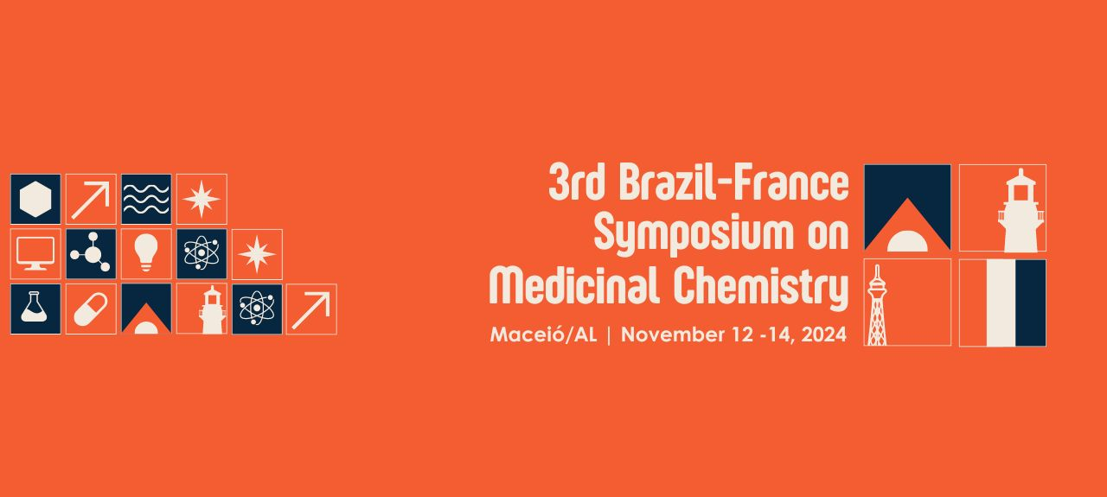
PS: After to fill all requirements for this abstract, please remove all the instructions.
BIOFILMS BASED ON CHITOSAN AND POLYETHYLENE GLYCOL FUNCTIONALIZED WITH ZINC-DERIVED NANOPARTICLES FOR THE PREVENTION OF FOOD CONTAMINATION FOCUSING ON Staphylococcus aureus.
Edla I. V. Nascimento (G),¹ Ana L. A. Costa (PG),¹* Gleidson P. O. Silva (PG),¹ Jeniffer M. D. Freitas (PG),¹ Jailson V. Silva (PG),¹ Islane G. M. Araujo (G),¹ Max L. M. Bezerra (G),¹ Marilia P. M. Silva (G),¹ Mauro C. S. Santos Filho (G),¹ Fabiane C. Abreu (Prof).¹
edla.nascimento@iqb.ufal.br;
¹ Universidade Federal de Alagoas (UFAL)
Keywords: nanoparticle, zinc, chitosan, bactericide;
ABSTRACT
According to the Center for Disease Control and Prevention, there are more than 250 types of diseases caused by bacteria, fungi, parasites and viruses through contamination of food still on the shelf. These infectious agents contaminate people who consume contaminated food while it is still on sale, causing various consequences and symptoms such as diarrhea, vomiting, nausea and fever. According to the Ministry of Health, the main causes of foodborne diseases are: Salmonella, Escherichia coli, Staphylococcus aureus, Coliforms, Bacillus cereus, Rotavirus and Norovirus. Studies show that some metals have great antimicrobial activity, so with the evolution of science new tools have been created, such as nanoparticles, which are materials with a reduced size (between 1-100nm) that can be used for various purposes. Aiming at antimicrobial action, we use non-toxic nanoparticles derived from zinc corrosion. This mineral has oxygen vacancies on its surface that help fight bacterial, viral and fungal infections. The purpose of functionalizing the biofilms with these nanomaterials was to produce a membrane that acts as a biocide in fighting the bacteria Staphylococcus aureus, aiming to extend the shelf life of foods and protect them from pathogens that can cause harm to human health. This biofilm was produced using chitosan, a polymer derived from chitin found in the exoskeleton of crustaceans, and which has several advantages due to being non-toxic, low-cost and biodegradable. The plasticizing agent polyethylene glycol was also used to improve the physicochemical properties of the membrane, giving it greater elasticity and mechanical resistance. The antimicrobial efficacy of these membranes, as well as their physicochemical and structural properties, were evaluated. The biofilms were characterized by scanning electron microscopy (SEM) and energy dispersive X-ray spectroscopy (EDX). The antibacterial activity was tested against Staphylococcus aureus ATCC 25923, showing inhibition of over 70% with the incorporation of nanoparticles. Thermogravimetric and spectroscopic (FTIR) analyses indicated that functionalization with nanoparticles improved the thermal and structural properties of chitosan biofilms, giving them greater stability and antibacterial activity.
Figure 1 - TGA of the chitosan film, Nanoparticles, and chitosan film functionalized with nanoparticle.

