Technical and Economic Feasibility Study of Castor Bean Biorefinery
Pedro Henrique Cruz de Souza^{1*}, Julia Gimenez Iervolino¹, Luiza Vasconcelos Santos¹, Artur Santos Bispo¹, Gustavo de Souza dos Santos¹, Leonardo Oliveira Santos de Santana¹, Fernando Luiz Pellegrini Pessoa¹

¹University SENAI CIMATEC, Department of chemical engineering, Salvador, Bahia, Brazil
*University SENAI CIMATEC; Salvador, Bahia, Brazil; pedro.souza@aln.senaicimatec.edu.br

This study presents a technical and economic feasibility analysis for the implementation of a biorefinery for the extraction and processing of castor oil (Ricinus communis L.) in Bahia, Brazil. Castor oil is an oilseed of great industrial importance, known for its resilience to adverse climatic conditions and its wide range of applications in the chemical, pharmaceutical, cosmetic, and energy sectors, particularly due to the presence of castor oil. Accordingly, this work is based on its potential as a sustainable alternative to fossil sources, the valorization of regional production chains, and the promotion of socioeconomic development in Brazil's semi-arid Northeast. Furthermore, the high added value of castor oil and the potential for full biomass utilization justify investments in well-structured biorefinery projects. Both qualitative and quantitative methods were used to determine the optimal location, with Irecê (Bahia) identified as a strategic site. The hot pressing technology was selected for its high yield and simplicity. Two production capacity scenarios were evaluated: a high-capacity scenario (150 t/day), which demonstrated excellent economic viability (NPV of R$ 148 million, IRR of 38%, and a payback period of 3 years), and a medium-capacity scenario (50 t/day), which yielded negative results (NPV of -R$ 19 million, IRR of 6%). It is concluded that the implementation of a large-scale biorefinery is viable and promising, provided it is supported by strategies to reduce market volatility and optimize operational costs, thereby contributing to the strengthening of the castor production chain and the sustainable development of the region.
Keywords: Castor bean; Northeast; Oil; Feasibility; Biomass.
1. INTRODUCTION
The search for renewable and sustainable energy sources has intensified in recent decades, driven by climate change, oil price volatility, and the need to diversify the global energy matrix. In this context, plant biomass stands out as a promising alternative, produced by plants in the form of lignocellulosic material, sugars, starches, and oils. Brazil, favored by natural conditions such as a tropical climate, fertile soils, and abundant water resources, is one of the world’s largest producers of biomass. Among all culture energies sources, sugarcane has held a prominent position since the 15th century, contributing significantly to ethanol production and electricity cogeneration from bagasse [1].
Castor bean (Ricinus communis L.), although less exploited, is an oilseed with high industrial potential, with applications in the chemical, pharmaceutical, cosmetic, and biofuel sectors due to the extraction of castor oil. Traditionally cultivated by small and medium-sized farmers, it holds social relevance and potential for income generation in rural areas [2]. Historically, Brazil led global production of castor seeds and castor oil, but in recent decades has lost this position to countries such as India and China [3]. Despite its presence in several regions, castor bean cultivation still lacks technological advances, agronomic studies, genetic improvement, and the development of large-scale processing technologies. In addition, a major challenge is the presence of ricin, a highly toxic protein found in the seeds that inhibits protein synthesis in eukaryotic cells. This toxicity limits the use of the residual cake, a by-product of oil extraction, particularly for animal feed due to toxicological risks. Research efforts have been made to develop varieties with lower ricin content and detoxification processes, aiming to expand the safe use of this by-product.
Given this scenario, the present study aims to conduct a Technical and Economic Feasibility Study (TEFS) for the implementation of a biorefinery dedicated to castor bean processing in the state of Bahia, considering the region's agricultural potential and the full utilization of biomass. In addition to oil extraction, the study seeks to evaluate the use of the residual cake as a value-added by-product, contributing to the strengthening of the castor bean value chain and the sustainable development of the semi-arid Northeast region of Brazil.
2. METHODOLOGY
To carry out the economic feasibility study for the implementation of a castor bean biorefinery, methodological steps were followed to ensure a comprehensive analysis from market characterization to the definition of production capacity and cost estimation, using literature review, secondary data, and both quantitative and qualitative analyses.
2.1 MARKET CHARACTERIZATION
To characterize the current market, research was conducted using scientific articles, government and institutional databases such as Embrapa and the National Supply Company (Conab), along with a demand projection through 2027 based on data from the Our World in Data platform. The objective was to understand the status of the castor bean value chain in Brazil and globally, as well as to obtain relevant statistical data for the study. It was observed that the Brazilian market shows a slight downward trend in production, although it remains relatively stable.
2.2 TECHNOLOGICAL ROUTE DEFINITION AND PLANT LOCATION
Subsequently, technological routes for oil extraction and the utilization of castor cake were evaluated. Based on technical and economic criteria, the process selected was hot pressing followed by solvent extraction, due to its high yield and feasibility at the proposed scale. From this definition, a process flow diagram was developed, and the main utility requirements such as thermal and electrical energy and process water were identified.
Following the definition of the production process, it was necessary to identify the most efficient location for establishing the biorefinery. Considering Bahia’s relevance in Brazil’s castor bean production, three municipalities were selected as potential locations: Luís Eduardo Magalhães, Barreiras, and Irecê. Initially, the The Gravity Center method was applied, based on the geographical distribution of the main castor-producing regions and the consumer centers for its by-products (oil and cake), following the approach used in [4]. This method enabled the estimation of the optimal logistical location, aiming to streamline product distribution and minimize transportation costs by considering weighted distances.
In addition to the quantitative approach, a qualitative weighting matrix was employed using strategic criteria such as proximity to production areas, logistical infrastructure (roads, railways, and distribution centers), and the availability of resources (water, energy, and labor). This multicriteria assessment allowed for a broader comparison of the alternatives, taking into account not only logistical aspects but also operational and socioeconomic factors.
2.3 MASS BALANCE
For the mass balance stage, it was assumed that the raw material used consists of 100% clean, dehulled castor seeds that is the pretreatment stage (cleaning and dehulling) was carried out beforehand and is not included in the following calculations. The calculations were based on the assumptions presented in Table 1 below:
Table 1. Base data for mass balance
Base Data
Acidity level (%) | 2%
Pressing (%) | 48%
Oil in Cake | 6%
Oil in Centrifuge | 97%
Neutralization | 0.00199
Water input | 10%

An empirical factor (0.00199) was used, based on the stoichiometry of the saponification reaction between free fatty acids (FFA) and sodium hydroxide, to estimate the required amount of base. This value, widely accepted in technical and industrial literature, relates the acidity level of the oil to the processed mass, taking into account the average molar mass of the main fatty acids and the molar ratio of the reaction [5].
2.4 ECONOMIC ANALYSIS
For the economic analysis, two plant production capacity scenarios were considered: 150 t/day and 50 t/day. The 150 t/day capacity was intentionally overestimated, representing an optimistic large-scale operation scenario aimed at evaluating the maximum economic potential of the process under ideal continuous production conditions. On the other hand, the 50 t/day capacity reflects a more conservative and realistic estimate, compatible with a medium-scale processing unit feasible for regional implementation. This comparison allowed for assessing the sensitivity of economic indicators to project scale and helped define a model better suited to the socioeconomic reality of the region.
Equipment costs were estimated based on 1990 data from [6], updated to 2024 using the Chemical Engineering Plant Cost Index (CEPCI) and converted to Brazilian reais using a nationalization factor (1.2), due to the lack of specific data on individual costs and energy consumption. The annual net revenue was calculated from the estimated production of castor oil and cake, considering average market prices and applying a 30% tax burden. Fixed plant costs were estimated, including investments in ISBL (Inside Battery Limits) and OSBL (Outside Battery Limits), startup investment (10% of fixed investment), and working capital. The sum of these values resulted in the total project investment. The annual operating cost (OPEX) was obtained by summing fixed and variable costs.
Based on these data, the annual cash flow was projected over a 10-year horizon, considering straight-line depreciation of fixed investment, operational costs, tax burden, and estimated revenue. The economic feasibility analysis was conducted through the calculation of the Net Present Value (NPV), using a Minimum Attractive Rate of Return (MARR) of 14.75%, corresponding to the SELIC rate as of May 2025 (Eq. 3).
In addition to NPV, the Internal Rate of Return (IRR), breakeven point, payback period, and profitability index (PI) defined as the ratio between the accumulated NPV and the initial investment (Eq. 4) were calculated. Finally, a sensitivity analysis was performed to evaluate the effects of variations in selling prices and operational costs on project feasibility.
The following equations were used for the calculations:
$I_{1}=I_{2}(\frac{C_{1}}{C_{2}})^{f}$ (1)
Where I1 is the cost in 2024, I2 is the cost 1990; f=0,6; C1=798,8 ; C2 =100
$I_{Brazil }= F*I_{EUA }$ (2)
$NPV = \sum_{j=0}^{n}{\frac{FC_{j}}{(1+i)^{J}}}$ (3)
$PI =\sum_{j=0}^{n}{\frac{FC_{j}}{(1+i)^{J}} / FC_{0}}$ (4)
3.RESULTS
3.1 MARKET POTENTIAL AND LOCATION
The analysis of global availability of the raw material castor bean (Ricinus communis L.) revealed that the largest producers are mainly located in Brazil, China, and India, the latter responsible for approximately 1.98 million tons in 2023 (Our World in Data). By applying plant location selection methodologies highlighting qualitative weighting and geolocation of production capacity the region near Irecê was identified as the most suitable for establishing the castor oil extraction and processing unit,due to logistical advantages and the availability of raw material in the area.
3.2 RESULTS OF MASS BALANCE
The castor oil extraction process and utilization of the cake were structured in stages integrating thermal, mechanical, and chemical operations to optimize yield and quality, as well as to ensure the safe reuse of the residual cake, based on [7]. Initially, the seeds underwent cooking with saturated steam to facilitate mechanical extraction by hot pressing, which also helps denature the ricin present in the cake. The extracted oil was centrifuged to separate impurities and subsequently subjected to chemical neutralization to remove free fatty acids, thereby improving its stability. To recover residual oil from the cake, solvent extraction with hexane was performed, followed by distillation to separate the solvent from the pure oil. The residual cake underwent thermal and chemical detoxification to neutralize ricin, making it safe for use, and was then dried to reduce moisture content, facilitating storage and transportation, as illustrated in Figure 1.
3.3 TECHNICAL AND ECONOMIC FEASIBILITY STUDY
To evaluate the economic feasibility of the project under different production scales, a sensitivity study was conducted considering two operational capacity scenarios for the castor processing plant. Variations in plant capacity implied proportional adjustments in revenue, fixed costs, and variable costs. Elements such as utility consumption (water, steam, electricity) and logistics costs were scaled according to the size of each scenario.

Figure 1. Process Flowsheet
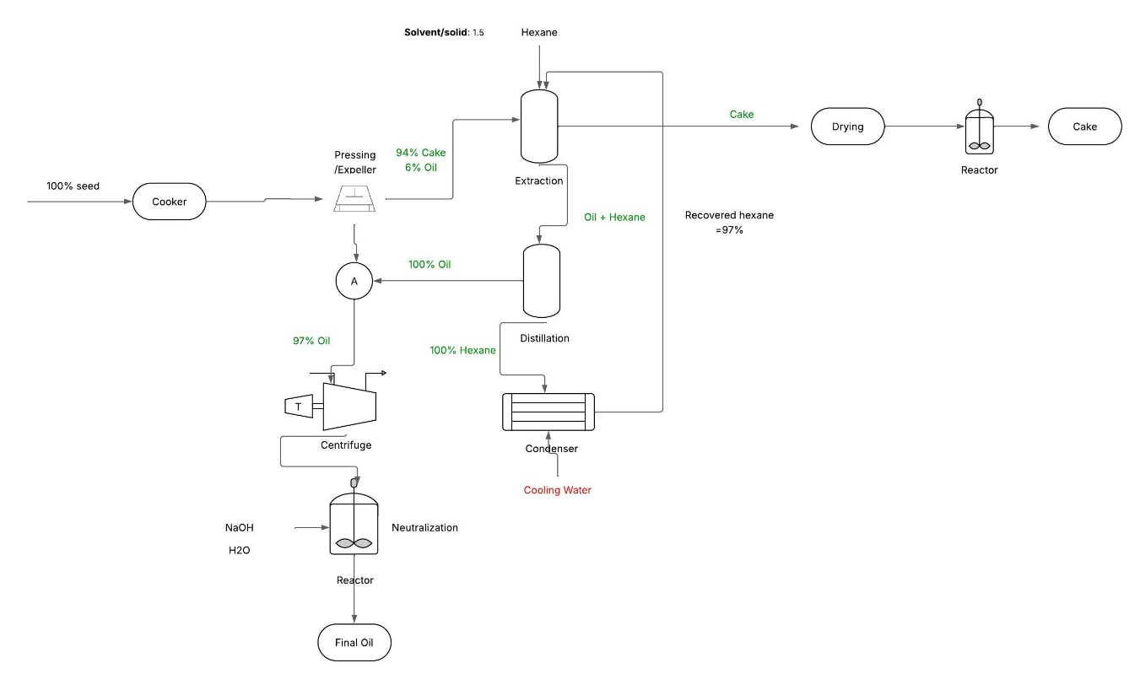

Scenario 1 – Overestimated Plant Capacity
In the first scenario, a plant with a processing capacity of 150 tons per day was considered, exceeding the average reported in the literature. The estimated annual oil production was approximately 27.2 million kg, assuming 8,000 effective operating hours per year, including downtime for maintenance and other interruptions.
Based on the quantities of oil and cake produced, with prices set at BRL 45.00/kg and BRL 19.40/kg, respectively, the plant’s annual net revenue was calculated. After applying a 30% tax rate, the resulting amount was BRL 1,189 million.
For the calculation of fixed investments, direct and indirect labor costs were estimated based on the number of required positions and employees, in addition to construction costs for an estimated area of 1,000 m². Accordingly, the total ISBL costs amounted to BRL 11.44 million, and OSBL costs to BRL 90.61 million, resulting in a total fixed investment of BRL BRL 102.02 million
Considering the unit prices of castor seeds, solvents, and NaOH, the process variable costs were estimated based on the quantities calculated in the mass balance, totaling BRL 138.87 million, as shown in Table 2.
The OPEX value was obtained by summing the fixed and variable costs, resulting in BRL BRL 240.84 million
Table 2. Total Variable Costs – Scenario 1
Item | Cost
Castor Seeds | BRL 7,200,000.00
Hexane Solvent | BRL 58,500.00
Sodium Hydroxide (NaOH) | BRL 7,477.29
Utilities | BRL 118,943,892.77
Supplies | BRL 37,573.93
Transportation | BRL 12,624,744.40
TOTAL | BRL 138,872,188.38

Scenario 2 – Plant Capacity Based on the Average
As in the first scenario, the same calculations were performed; however, for a plant capacity of 50 tons per day, which reflects typical medium-scale industrial plants. This capacity resulted in an annual production of approximately 9,074,536.80 kg of castor oil and 8,146,666.67 kg of castor cake. Due to this change, there was a variation in revenue, variable costs, and logistics costs, resulting in an annual net revenue of BRL 396.48 million. Regarding the fixed costs for the plant operating at average capacity, only logistics costs were altered, decreasing significantly since they correspond to 7.6% of the revenue value, according to the assumption made. The total ISBL costs amounted to BRL 11.44 million and OSBL costs to BRL 30.35 million, demonstrating a total fixed investment of BRL 41.79 million, a considerably lower amount than in Scenario 1.
With the change in plant capacity, variable costs were the most impacted, as shown in Table 3.
Table 3. Total Variable Costs – Scenario 2
Item | Cost
Castor Seeds | BRL 2,400,000.00
Hexane Solvent | BRL 19,500.00
Sodium Hydroxide (NaOH | BRL 2,492.43
Utilities | BRL 39,647,964.26
Supplies | BRL 37,573.93
Transportation | BRL 4,210,753.06
TOTAL | BRL 46,318,283.68

The OPEX value was obtained by summing the fixed and variable costs, resulting in BRL 88.11 million.
3.4 SENSITIVITY ANALYSIS
For this analysis, a significant difference in operational costs (OPEX) is initially observed, which directly influences the Net Present Value (NPV), as illustrated in Graphic 1 below:
Graphic 1. Comparison of NPV and OPEX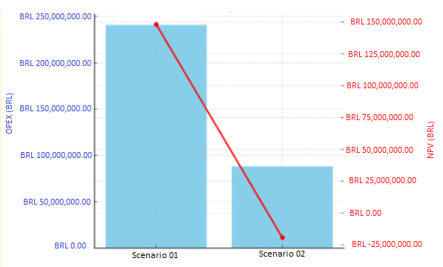
Although it presents higher operational costs, the overestimated scenario achieved a positive Net Present Value (NPV) of BRL 148 million, demonstrating economic feasibility. In contrast, the medium-scale plant, despite its lower cost, showed a negative NPV of approximately BRL 19 million.
Regarding the payback period, it was observed that the plant in Scenario 1 achieves return in 3 years, while the medium-scale plant has a payback period of approximately 8 years.
The results indicate that the overestimated scenario (Scenario 1) is significantly more advantageous from a financial perspective. It presents a shorter payback time and greater cash generation over time, accumulating substantial profit. In this scenario, the Internal Rate of Return (IRR) was 38%, a value substantially higher than the adopted Minimum Attractive Rate of Return (MARR) of 14.75% (SELIC), highlighting the high economic viability of the project. This means that, beyond recovering the initial investment, the project generates an attractive profit margin, justifying the higher capital outlay.
On the other hand, the medium-scale scenario (Scenario 2) presented an IRR of only 6%, well below the MARR. Although the investment may be recovered over the years, the financial risk is higher and the profit potential is limited, making the project less competitive.
Additionally, the cash flow analysis reveals that both scenarios operate profitably from the start of production. Scenario 2 shows that sales revenue exceeds total costs (fixed and variable) across the entire operating range (0% to 100% of capacity), indicating that there is no apparent breakeven point, as the operation remains profitable even at low utilization levels.
The Profitability Index (PI) analysis further reinforces the superiority of the overestimated scenario, which achieved a positive value of 1.01, indicating that for every real in revenue, BRL 0.01 in profit is generated. In contrast, the medium-scale scenario presented a negative PI of -0.32, indicating an operational loss.
Despite its overall inferior performance, the second scenario demonstrated that reducing operational costs, especially variable costs, has a positive impact on the NPV, highlighting the importance of efficient management of inputs such as raw materials, energy, and labor.
4. CONCLUSION
The use of castor beans for oil extraction represents a strategic opportunity, given the high value of the product and its broad industrial applications. However, price volatility introduces uncertainty into the supply chain, making the proper sizing of processing plants essential for the project's viability.
Based on the results, it is concluded that the overestimated scenario, despite its higher costs and deviation from current market conditions, shows superior economic performance. The positive NPV, high IRR, quick payback period, and overall profitability indicate that the higher initial investment is compensated by better operational results. In contrast, the medium-scale plant is financially unfeasible, with a slow return, IRR below the MARR, and operating at a loss.
Given the sector’s instability, it is recommended to conduct broader sensitivity analyses, varying parameters such as prices, operational costs, production capacity, and discount rates. This approach will help assess the robustness of the project and ensure the economic sustainability of the castor oil production chain in the face of market uncertainties.
Acknowledgement
We thank SENAI CIMATEC for the essential support, technical assistance, and the infrastructure provided for the development of this work. We also express our sincere gratitude to our advisors for their guidance, patience, and dedication throughout all stages of the study
REFERENCES

- Pinho M, Toneto Jr R, organizadores. Economia de baixo carbono: impactos de novos marcos regulatórios e tecnologias sobre a economia brasileira. Ribeirão Preto: FUNPEC Editora; 2015. p. 394
- Parrella NNL de, Carvalho MLM de, Parrella RAC da C, Resende JCF de, Reis JBR da S. Caracterização fisiológica e sanitária de sementes de mamona utilizadas na safra 2006 no estado de Minas Gerais. Sete Lagoas: Embrapa Milho e Sorgo; 2009. 23 p.
- Sausen TL. Respostas fisiológicas de Ricinus communis à redução na disponibilidade de água no solo [dissertação]. Porto Alegre: Faculdade de Agronomia, Universidade Federal do Rio Grande do Sul; 2007. 105 f.
- Oliveira BF, Neto JO, Silva JK, Santoro PPC. Uso do centro de gravidade para localizar a base operacional da TPG do Brasil. In: Anais do XIII Simpósio de Excelência em Gestão e Tecnologia – SEGeT; 2015 Oct 28–30; Resende, Brazil. Resende: AEDB; 2015. Available from: https://www.aedb.br/seget/arquivos/artigos15/24722311.pdf
- American Oil Chemists' Society. Official methods and recommended practices of the AOCS. 6th ed. Urbana: AOCS Press; 2009.
- Lima PF. Análise da viabilidade econômica da produção de óleo de mamona de primeira geração no Rio Grande do Sul .Porto Alegre: Universidade Federal do Rio Grande do Sul, Programa de Pós-Graduação em Agronegócios; 2002. Available from: http://hdl.handle.net/10183/5294
- Kaur R, Bhaskar T. Potential of castor plant (Ricinus communis) for production of biofuels, chemicals, and value-added products. In: Moser BR, editor. Handbook of Biofuels Production. 2nd ed. Cambridge: Woodhead Publishing; 2020. p. 211–223. doi:10.1016/B9780128182284000113

