Comparison of the value chain of steel inserts for multi-cavity tools manufactured additively and conventionally using Flexsim

Letícia Gabriely Witt¹, Camille Grajauskas Gonçalves¹, Lucas Xisto Travassos Junior¹, Cristiano Vasconcellos Ferreira¹, Valter Estevão Beal², Armando Sá Ribeiro Junior³ e Silvia Lopes de Sena Taglialenha¹
¹ Universidade Federal de Santa Catarina, Joinville, SC
² Centro Universitário SENAI CIMATEC, Salvador, BA
³ Universidade Federal da Bahia, Salvador, BA

Abstract: The tooling sector is essential for industrial development, providing tools and molds that directly influence the efficiency and competitiveness of industries. In Brazil, low productivity meets only 50% of domestic demand, requiring imports. The main obstacles include lack of modernization, shortage of professionals, inadequate management, and inefficient use of resources. The development of injection molding tools is expensive, time-consuming, and resource-intensive; additive manufacturing emerges as an alternative for faster production. However, there is a lack of effective methods for choosing the ideal technology for each project. Computer simulation allows the emulation of production chains with additive and conventional technologies, enabling economic analysis and the identification of bottlenecks. In this article, FlexSim was used to model a 32-cavity mold and compare the results with those obtained in Tecnomatix Plant Simulation. The systematic review supported the simulation methodology, and the results indicated that conventional manufacturing had higher productivity and lower manufacturing costs.
Keywords: simulation with FlexSim, decision support tool, metal plastic injection molds, additive manufacturing, conventional manufacturing.
Abbreviations: AM, Additive Manufacturing. CM, Conventional Manufacturing.

1. Introduction

In the tooling sector, the use of technologies such as artificial intelligence, interconnectivity, machine learning, and, above all, customization in production is growing. With a focus on productivity, flexibility, and rapid tool development, the expansion of additive manufacturing (AM) stands out.
This process forms the final product by depositing successive layers, allowing for rapid prototyping and customized parts with minimal waste. Despite its advantages, conventional manufacturing (CM) still predominates due to its stability, consolidated processes, and high production capacity.
The evolution of AM equipment suggests a possible replacement of conventional methods, requiring careful analysis to identify the most advantageous approach, considering the pros and cons and their implications for the transformation of raw materials [16].
In Brazil, about 90% of tool shops have fewer than 20 employees, which makes it difficult to adopt complex and expensive technologies such as AM. In addition, strong competition from Asian tool shops requires innovation and greater efficiency [15]. This study aims to compare AM and CM to assist managers in making the most appropriate choice, using computer simulation as a decision support tool, evaluating time, process optimization, bottlenecks, automation, and digital twins, contributing to operational, administrative, and financial management [3]. With FlexSim, technical parameters, limitations, and impacts on reliability will be simulated, providing input for strategic decisions and strengthening the competitiveness and sustainability of the sector.

2. Theoretical Foundations
The manufacturing process in tool shops began during the Industrial Revolution, with the aim of producing standardized parts and molds that would optimize craftsmanship or enable large-scale production. Milling, turning, and grinding became commonplace with the advancement of automation in the 19th century, increasing precision [2]. In the following century, CNC machines made it possible to manufacture complex geometries with high quality, establishing themselves as essential technology for molds and dies [6].
Additive manufacturing brought greater flexibility, reduced waste, and made complex parts feasible [9]. Conventional manufacturing, on the other hand, removes material by machining and grinding until the desired geometry is achieved [23].
The PRISMA (Preferred Reporting Items for Systematic Reviews and Meta-Analyses) methodology was applied to the literature review to enhance understanding of the problem addressed in this study and provides a structured framework that ensures transparency and reproducibility in systematic reviews. In this research, it guided the identification of relevant databases, the definition of inclusion and exclusion criteria, and the screening and selection of sources, guaranteeing that only high-quality and contextually appropriate references were considered. For comparison purposes, the data used in the FlexSim simulation model were the same as those adopted in the TecnoMatix Plant Simulation case study [17], which was identified through the PRISMA-based review. Sixty-three studies were initially retrieved from SCOPUS, but [17] was selected for its direct comparison of AM and CM in an industrial multi-cavity molding case. Reference [17] used Tecnomatix, a Siemens software based on digital twins, to optimize manufacturing and identify bottlenecks [22], presenting an annual economic comparison to support decision-making. To complement these findings, this study applies FlexSim—an OpenGL-based simulation platform capable of real-time scenario analysis and bottleneck identification—to evaluate time, inventory, and cost variables.

3. Methodology
Following the literature review, the research progressed through several stages: defining the problem situation and objectives for process improvement; establishing the study scope to compare AM and CM; and collecting and processing data, including selecting tools and detailing the procedures for using FlexSim. The production processes for both CM and AM were thoroughly mapped, identifying setup times, operation durations, post-processing requirements, resource use, and potential bottlenecks. Based on this mapping, a conceptual model representing the logic and flow of operations was developed and implemented in FlexSim for computational simulation. The model was validated and calibrated to ensure the simulated behavior accurately reflected industrial performance. Sensitivity analyses and parameter variations were conducted to evaluate the impact of machine configurations, labor allocation, and production volumes. Finally, performance indicators such as productivity, cycle time, resource utilization, and operational costs were monitored to systematically compare CM and AM.

3.1 Problem Situation
Toolmakers need to optimize production efficiency, costs, and quality. This study compares additive and conventional manufacturing, evaluating production time, cost, raw material consumption, customization, geometric complexity, post-processing, and skilled labor, considering a company that manufactures a specific type of tooling on a large scale.

3.2 Scope Definition
Through a production analysis, this article seeks to identify which manufacturing method is most efficient and viable for industries and toolmakers, with a view to improving the production process. Comparing the total manufacturing time for inserts using both techniques allows for an assessment of productivity and costs related to raw materials, machinery, and operation, determining the economic impact of each approach.
In addition, it considers how each method influences the accuracy of the inserts in terms of tolerances and surface quality, an essential factor in industrial applications, especially on a large scale. The need for skilled labor is also evaluated, analyzing both the cost of hiring specialized professionals and the availability of this profile in the market.

3.3 Data Collection
Considering the variables influencing technological choice and based on [17], the FlexSim software was used for simulation, applied to an industrial case study of a 32-cavity plastic injection mold (Figure 1).
Figure 1. 32-cavity mold for plastic injection molding. [17].
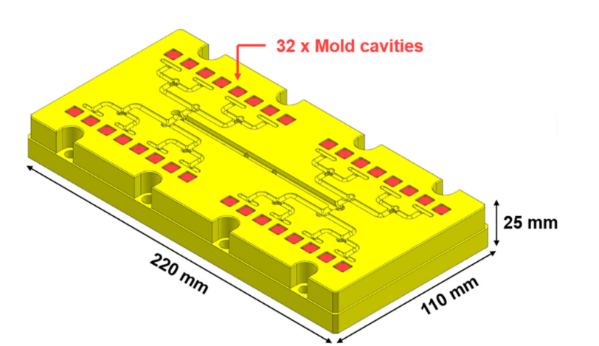
According to [1], discrete-event simulation was employed to compare CM and AM process chains, analyzing delivery deadlines, bottlenecks, and critical points. For comparison purposes, the same data from the case study with TecnoMatix Plant Simulation [17] were used, allowing the acquisition of real machine data
In the CM chain, the process includes drilling, milling (rough, semi-finish, and finish), EDM or manual polishing, laser engraving, ultrasonic cleaning (UC), and quality control (QC), with times presented in Table 1 [17].
Table 1. Time data for CM manufacturing flow obtained from the base article; if N/A – not applicable. [17].
Step | Machines | Process Time | Setup Time
DC drilling/ejectors | CC (Cooling Channels) | 180 min | 60 min
Plugging | CC (Cooling Channels) | 60 min | N/A
RMB (Rough Milling Back) | 3-axis milling machine | 180 min | 30 min
RMF (Rough Milling Front) | 3-axis milling machine | 180 min | 90 min
Grinding | AM grinding machine | 30 min | 30 min
FMB (Finish Mill backside) | 5-axis milling machine | 105 min | 75 min
SFF (Semi-finish front) | 5-axis milling machine | 540 min | 60 min
FF (Finish front) | 5-axis milling machine | 540 min | 60 min
EDM | EDM + Wire cutter | 480 min | 60 min
Laser engraving | Laser cutter | 60 min | 15 min
Ultrasonic cleaning | UC | 40 min | N/A
Quality control | QC | 22 min | 5 min

In the AM chain, the process starts with metal additive manufacturing (LPBF), followed by post-processing, heat treatment, and steps similar to those in CM, with adjustments for the specific characteristics of printed parts, as shown in Table 2 [17].
Table 2. Time data for AM manufacturing flow obtained from the base article; if N/A – not applicable. [17].
Step | Machines | Process Time | Setup Time
MAM (LPBF) process | LPBF laser | 3240 min | 120 min
AM post-processing | LPBF laser | 130 min | N/A
Heat treatment | Furnace | 2880 min | N/A
Grinding | AM grinding machine | 180 min | 180 min
FMB (Finish Mill Backside) | 5-axis milling machine | 180 min | 120 min
SFF (Semi-finish Front) | 5-axis milling machine | 540 min | 60 min
FF (Finish Front) | 5-axis milling machine | 540 min | 60 min
EDM | EDM + Wire cutter | 480 min | 60 min
Laser engraving | Laser cutter | 60 min | 15 min
Ultrasonic cleaning | UC | 40 min | N/A
Quality control | QC | 22 min | 5 min

The analysis with FlexSim incorporated cycle times, production capacity, and rejection rates into the model, accurately representing the behavior of the physical system. Statistical tools enabled the monitoring of metrics such as waiting times, utilization rates, OEE, and productivity, facilitating the identification of bottlenecks and a detailed comparison between AM and CM. FlexSim also enabled the creation of realistic scenarios, layout analysis, and proposals for changes in process flows, operators, and machinery, considering cost, production time, and material consumption, thus supporting decision-making on the most suitable technology for the project.
3.4 Simulation Model
Based on the machine data and their distribution in the respective analysis sections, it was possible to map and simulate the process flows, resulting in the sequence for conventional manufacturing: CC, followed by 3-axis milling, grinding, 5-axis milling, EDM, laser, UC, and finally QC; and for additive manufacturing: LPBF, followed by furnace, grinding, 5-axis milling, EDM, laser, UC, and finally QC.
The simulation shown in Figure 2, based on the data presented, enabled the optimization of machine placement and operation, taking into account the performance of both conventional and additive manufacturing processes.
Figure 2. Simulation model in FlexSim.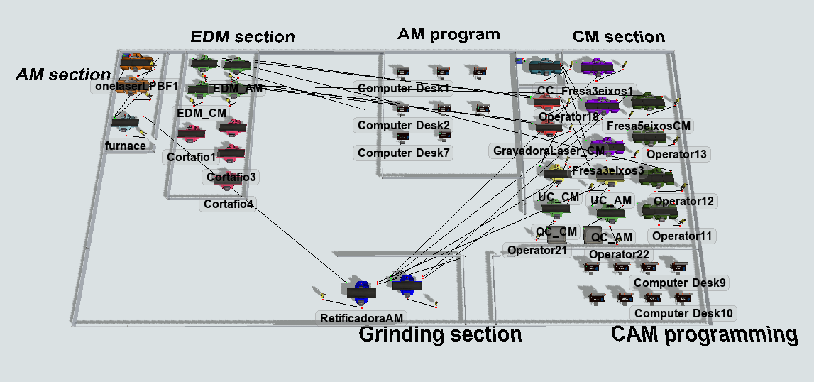

4. Results and Discussions

4.1 Simulation scenario analysis
Based on the Gantt charts generated by the FlexSim simulation — which analyzes the idle, processing, blocked, waiting for transport, and setup times of each machine — it can be observed that the scenario considered the operation of all machines, for both additive manufacturing and conventional manufacturing processes, at maximum capacity.
A period of one year was simulated, corresponding to 250 working days, with continuous operation 24 hours a day. During this period, 203 units of the mold were produced by AM and 518 units by CM, as shown in Table 3.
Table 3. Production per year by CM and AM.
 | CM | AM
Number of parts per year, 250 days of active work | 518 | 203

The simulation analysis showed that, in additive manufacturing, the main bottleneck is in the printing stage, where the LPBF laser machine has the highest processing occupancy rate, blocking subsequent stages. A second potential bottleneck is heat treatment, due to the long processing time and the availability of only one furnace. In conventional manufacturing, the most relevant bottleneck occurs in the 5-axis milling machine.
Different operating states were identified in both processes: idle, active processing, blocked due to unavailability of the next stage, waiting for material transport, and machine setup. In AM, there is longer continuous processing time on the initial machines, especially on the 3D printer, which causes upstream blockages and impacts the workflow. In CM, on the other hand, blocked states are predominant on several machines, which interrupts the flow even when there is available capacity, especially at the machining stations. Despite this, the final productivity of CM (518 parts) was significantly higher than that of AM (203 parts), indicating greater efficiency of the conventional process in the analyzed scenario.

4.2 Economic and variable analysis
The comparison between additive manufacturing and conventional manufacturing showed that CM has a lower initial cost, due to the use of widely available equipment, lower technological investment, and reduced raw material costs. The analysis also revealed significant differences in direct and indirect costs throughout the production chain.
In terms of productivity, CM manufactured 518 molds compared to 203 for AM, demonstrating greater efficiency even with bottlenecks. For industrial-scale operation, the estimated total cost of acquiring the factory is $4,240,000.00, with annual operating expenses of approximately $380,500.00 as shown in Table 4.
Table 4. Estimated Machine Acquisition, Maintenance Costs, and Quantities.
Machine | Estimated Acquisition Cost (USD) | Annual Maintenance Cost (%) | Number of machines
Three-axis milling machine | $80.000 – $120.000 | 8% | 3
Five-axis milling machine | $250.000 – $600.000 | 10% | 4
UC and QC laser engraver | $10.000 – $50.000 | 5% | 1
LPBF machine | $300.000 – $800.000 | 12% | 2
Industrial furnace | $20.000 – $100.000 | 6% | 1
Wire cutting machine | $50.000 – $150.000 | 7% | 4
EDM machine | $60.000 – $200.000 | 8% | 4
AM grinding machine | $30.000 – $100.000 | 6% | 2

Although additive manufacturing requires a higher initial investment in specific machines and uses metal powders that are more expensive than conventional manufacturing steel, it reduces operating costs and material waste, offering advantages in sustainability and economy. CM, on the other hand, is more affordable in the short term, especially for simple parts, and generally requires less post-processing time.
AM excels in the manufacture of parts with complex geometries and high customization, allowing digital modifications without the need for physical adjustments to tools, unlike CM. However, AM requires skilled labor in 3D software and printer adjustments, while CM relies on more readily available professionals.

5. Conclusion
This study compared the value chain of steel inserts for injection molding manufactured by AM and CM, based on FlexSim simulation and literature data. CM showed higher productivity in continuous and large-scale production, with shorter post-processing time, lower demand for skilled labor, and lower initial costs, making it more suitable for simple parts and traditional geometries. AM stood out for its sustainability, with less waste generation, and its ability to produce complex and customized parts without physical changes to the tools.
Despite the higher cost of raw materials and lower productivity over a one-year period, AM offers benefits in terms of flexibility, product innovation, and potential long-term reduction in operating costs, and should not be seen as a direct replacement for CM, but as a strategic and complementary technology depending on production volume, geometric complexity, required precision, and long-term objectives.
While the findings provide strong evidence of CM’s higher productivity and lower cost under the simulated conditions, they should not be generalized without caution. Variations in production scale, regional labor or energy costs, technological advancements in AM equipment, the specific feedstock materials used in additive manufacturing, or different product geometries could shift the balance of advantages. Additionally, the simulation relied on parameters from a specific industrial case study ([17]) and may not fully represent all operational environments. Future studies incorporating diverse case studies, updated cost data, and alternative manufacturing technologies would refine and expand the applicability of these results.

References

- Babulak E, Wang M. Discrete event simulation: state of the art. Int J Online Biomed Eng. 2008;4(2):60-3. doi:10.3991/ijoe.v4i2.451.
- Batista A. Processos de trabalho: da manufatura à maquinaria moderna. Serv Soc Soc. 2012;(112):736-56. Available from: https://www.scielo.br/j/sssoc/a/sVnSvDQm58XJh5h47c7Frkv/
- Ehsan M, Masood F, Madjid T, Morteza G, Amos HCN. Data-driven simulation-based decision support system for re` allocation in industry 4.0 and smart manufacturing. J Manuf Syst. 2024;72:287-307. doi:10.1016/j.jmsy.2023.11.019.
- EOS. Metal 3D printing machines [Internet]. 2025 Apr 23 [cited 2025 Apr 23]. Available from: https://www.eos.info/en/products/systems-equipment/metal.html
- Exapro. Used industrial machinery marketplace [Internet]. 2025 Apr 23 [cited 2025 Apr 23]. Available from: https://www.exapro.com/
- Feriotti MA, Formigoni A, Ribeiro RB. Aplicação da manufatura híbrida de metais no setor de ferramentaria: oportunidades e identificação de barreiras. Rev Eng Tecnol. 2023;12(3):45-58. Available from: https://www.academia.edu/123256009/Aplicação_da_Manufatura_Híbrida_de_Metais_no_Setor_de_Ferramentaria_Oportunidades_e_Identificação_de_Barreiras
- FlexSim Software Products, Inc. FlexSim simulation software [Internet]. 2025 Apr 23 [cited 2025 Apr 23]. Available from: https://www.flexsim.com
- Fundação de Apoio da UFMG – Fundep. Conecta Mais impulsiona a inovação e o desenvolvimento das ferramentarias brasileiras [Internet]. 2025 Apr 23 [cited 2025 Apr 23]. Available from: https://mover.fundep.ufmg.br/conecta-mais-impulsiona-a-inovacao-de-ferramentarias-brasileiras/
- Gomes BF. Manufatura aditiva e caracterização de componentes da liga Al-4,4%Mg utilizando diferentes processos de deposição metálica - CMT, PMC e PMC-MIX [dissertação]. Rio de Janeiro: Universidade Federal do Rio de Janeiro; 2018. Available from: https://pantheon.ufrj.br/bitstream/11422/12932/1/BiancaFerreiraGomes.pdf
- Groover MP. Fundamentals of modern manufacturing: materials, processes, and systems. 8th ed. Hoboken: Wiley; 2020.
- Intermach. História e desafios do setor de ferramentaria em Joinville [Internet]. 2025 Apr 23 [cited 2025 Apr 23]. Available from: https://intermach.com.br/joinville-cidade-dos-moldes-ferramentarias/
- Kalpakjian S, Schmid S. Manufacturing engineering and technology. 8th ed. Harlow: Pearson; 2022.
- Kingsun M. How much does CNC machining cost per hour? [Internet]. 2025 Apr 23 [cited 2025 Apr 23]. Available from: https://kingsunmachining.com/pt/blog/how-much-does-cnc-machining-cost-per-hour/
- MachineTools.com. Used CNC machines for sale [Internet]. 2025 Apr 23 [cited 2025 Apr 23]. Available from: https://www.machinetools.com/
- Manufatura Digital. Ferramentaria no Brasil: quais as principais dificuldades e oportunidades? [Internet]. 2021 Nov 18 [cited 2025 May 22]. Available from: https://www.manufaturadigital.com/ferramentaria-no-brasil-dificuldades-e-oportunidades/
- Mecheter A, Tarlochan F, Kucukvar M. A review of conventional versus additive manufacturing for metals: life-cycle environmental and economic analysis. Sustainability. 2023;15(16):12299. doi:10.3390/su151612299.
- Moshiri M, Raza M, Sahlab M, Malik AA, Bilberg A, Tosello G. Value chain comparison of additively and conventionally manufactured multi-cavity tool steel inserts: an injection molding industrial case study for high-volume production. Appl Sci. 2022;12(20):10410. doi:10.3390/app122010410.
- Oliveira JSA. Modelo customizado de simulação no FlexSim para análise de eficiência operacional em uma ferramentaria [trabalho de conclusão de curso]. Joinville: Universidade Federal de Santa Catarina; 2023.
- Onmaq Máquinas e Equipamentos. Centro de usinagem 5 eixos [Internet]. 2025 Apr 23 [cited 2025 Apr 23]. Available from: https://www.onmaq.com.br/centro-de-usinagem-5-eixos/
- Page MJ, et al. The PRISMA 2020 statement: an updated guideline for reporting systematic reviews. Syst Rev. 2021;10:89. doi:10.1186/s13643-021-01626-4.
- Pilz TL. Análise sistemática de estudos comparativos entre a manufatura aditiva e convencional com foco no desempenho ambiental das operações logísticas. Gest Prod. 2019;26(1):e3441. Available from: https://www.scielo.br/j/gp/a/gTByNcmNP56kgRZQdzYXPvQ/?format=pdf
- Siemens Digital Industries Software. Tecnomatix – digital manufacturing solutions [Internet]. 2025 Apr 23 [cited 2025 Apr 23]. Available from: https://www.plm.automation.siemens.com/global/en/products/manufacturing-planning/tecnomatix.html
- Souza J. Impacto da evolução da manufatura aditiva sobre o desenvolvimento de produto [monografia]. Curitiba: Universidade Tecnológica Federal do Paraná; 2016. Available from: https://riut.utfpr.edu.br/jspui/bitstream/1/19319/2/CT_CEGDP_2016_1_07.pdf
- Tanisha P, Kennedy JV, Potgieter J. A comparison of traditional manufacturing vs additive manufacturing, the best method for the job. Procedia Manuf. 2019;30:11-8. doi:10.1016/j.promfg.2019.02.003.

