**Innovations in Predictive Modeling for Renewable Energy Integration**

Alejandro García, Universidad EIA.

Sebastián Zapata, Universidad EIA.

**Abstract**

With the constant growth of renewable energy sources such as solar and wind energy, numerous challenges arise due to their variability and intermittence. These factors must be considered to effectively harness these energy sources, thus highlighting the necessity for a reliable method to predict energy generation. The ability to make accurate predictions becomes crucial in various applications, including energy market planning.

How can a company precisely predict its green energy generation? This question underscores the need to develop a model that enables users and market regulators to anticipate renewable energy generation. Such a tool would prove invaluable for daily planning and the efficient dispatch of energy. With access to this data in advance, one could not only foresee potential challenges in project planning but also champion the use of clean and sustainable energy.

**Objectives**

1. **General Objective:** Develop and validate a computational model based on machine-learning techniques capable of accurately predicting renewable energy generation using historical data and relevant environmental variables.
2. **Specific Objectives:**

* Analyze, gather, and process the data that influences renewable energy generation, such as climate, location, and available equipment.
* Develop and train a machine learning model to predict renewable energy generation over a specific period.
* Evaluate the accuracy of the model and make adjustments as necessary to enhance the reliability of predictions.

**Methodology**

To develop this model, we will be using the CRISP-DM methodology.

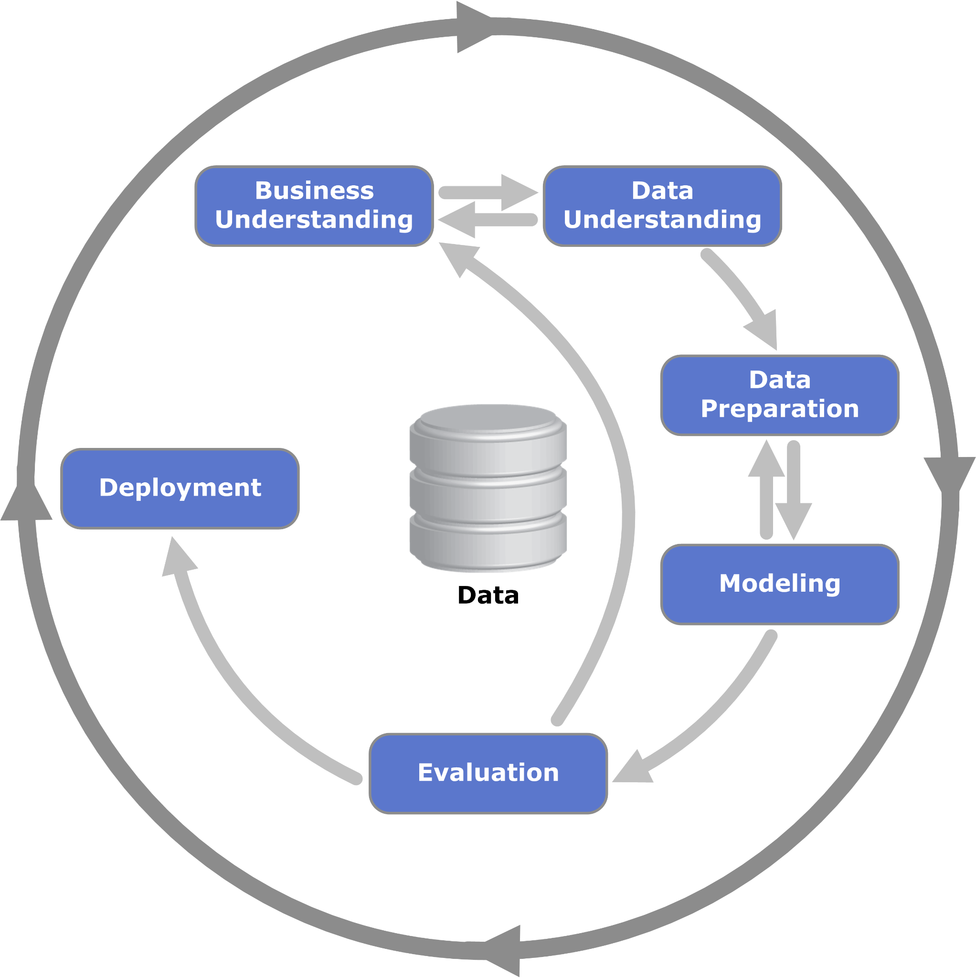

**Literature review:** The literature on predictive models for electricity generation planning in systems with a strong renewable component emphasizes the transition from traditional statistical forecasting methods to more sophisticated machine learning and deep learning techniques. These advancements aim to address the inherent variability and unpredictability of renewable energy sources, such as wind and solar power, by improving the accuracy of power generation forecasts. Research has increasingly focused on hybrid models that combine different forecasting approaches, including the integration of advanced weather predictions, to enhance reliability. Additionally, the integration of energy storage solutions and demand response programs plays a crucial role in mitigating renewable variability and ensuring grid stability. Despite progress, challenges remain in scalability, real-time data processing, and the integration of forecasts into grid operations, highlighting the need for further innovation and regulatory support to fully realize the potential of renewable energy in electricity systems.

**Expected outcomes:** It is anticipated to have a predictive model through which electricity generation planning can be executed, given the variability of renewable sources. This model becomes particularly crucial in systems with a strong renewable component, where the inherent unpredictability of sources such as wind and solar power poses significant challenges to grid stability and efficiency. By leveraging advanced forecasting techniques and machine learning algorithms, the model aims to accurately predict power generation levels from renewable sources. This allows for more effective grid management, optimizing the mix of renewable and conventional power sources to meet demand while minimizing waste and reducing reliance on fossil fuels. The success of such a model not only enhances the reliability and sustainability of the power system but also supports the transition towards more environmentally friendly and sustainable energy systems.

**References**

AlKandari, M., & Ahmad, I. (2019). Solar power generation forecasting using ensemble approach based on deep learning and statistical methods. Department of Computer Engineering, Kuwait University, Kuwait, emeral insight. https://www.emerald.com/insight/content/doi/10.1016/j.aci.2019.11.002/full/pdf?title=solar-power-generation-forecasting-using-ensemble-approach-based-on-deep-learning-and-statistical-methods

Barrera, J. E., Reina, A. E., Maté, A., & Trujillo, J. (2020). Solar Energy Prediction Model Based on Artificial Neural Networks and Open Data. Sustainability, 12(17), 6915. https://doi.org/10.3390/su12176915

Beatriz.Gil. (2019). CRISP-DM: La metodología para poner orden en los proyectos. Sngular. https://www.sngular.com/es/data-science-crisp-dm-metodologia/

colaboradores de Wikipedia. (2023a). Aprendizaje automático. Wikipedia, La Enciclopedia Libre. https://es.wikipedia.org/wiki/Aprendizaje_autom%C3%A1tico

colaboradores de Wikipedia. (2023b). Inteligencia artificial. Wikipedia, La Enciclopedia Libre. https://es.wikipedia.org/wiki/Inteligencia_artificial

IBM Documentation. (n.d.). https://www.ibm.com/docs/es/spss-modeler/saas?topic=dm-crisp-help-overview