A Review of Computational Vision applied to Materials Selection

Pedro Henrique D’Oliveira^{¹,*}, Joyce Batista Azevedo^{1,2,3} , Thiago Barros Murari^{1,2}
¹ CIMATEC University, PPG-GETEC, Salvador, Bahia, Brazil.
² INCITE Industry 4.0 , Salvador, Bahia,Brazil.
³ Federal University of Bahia, ICTI, Camaçari, Bahia,Brazil .
*Corresponding author:phd19994@gmail.com

Abstract: This bibliographic review shows the crescent works in the field of computational vision applied to materials selection within the framework yolo. The results obtained with the search present studies from the years of 2021 to 2025, published in the patforms Dimensions, Google Scholar and WebofScience. It was observed that studies in that field are crescent, have increased from 2023. Researches in that field indicate that solutions for defects, classification and material properties are the most common fields of study. Architectures of Deep Learning and Convolutional Neural Networks are the most common used techniques, together with framework Yolo for integration in already built-in solutions

Keywords: material selection, material identification, artificial intelligence, computer vision, yolo

1.Introduction

Currently the development of intelligent systems tends to use the generation of images and Artificial Intelligence (AI) elements of machine vision and computer vision [1] to raise the relevance in the field, since the task uses à lot of computer resources and needs a lot of data. That technology has been applied in material selection field, for example, recycling, for classification and sorting waste [2]. Other solutions consist of analyzing materials properties, using scanning electron microscopy (SEM) analysis, to identify microstructure degradation [3], but most of the solutions used currently are related to materials shortage, another related area is the solid waste identification, with Machine Learning ( ML ) algorithms that can identify metals, non-metals and plastic [5]. A tool identified in that bibliographic research for materials selection using AI is the YOLO framework, for it’s practicality and an already built-in interface for system integration and easily usage [8, 12, 14]. It has à CNN architecture build in it’s structure, and make easier for defining and changing hyperparameters, besides it has à wide benchmark of increased performance and resource usage. YOLO is an open source tool which enables its use and improvement by the community, It has an advantage of using pre-trained models and databases for an existing weight-model creation, which improves the accuracy of new models[15]. Models are influenced by the environment of the scene, when light is stronger or darker, some characteristics may be affected, dropping accuracy[4, 16], depending on the model architecture and tools used to create it, for that frameworks like YOLO within built in models are used for a wide range of applications strengthening their accuracy [ 21].
Yolo framework uses, Deep Learning (DL) architectures, that are suitable and used for crack detection in roads, as an example of applicable solution in traffic policies outperforming traditional techniques[6], and Convolutional Neural Networks (CNN) architechitures that are derived from DL. CNNs are used for segmentation tasks and more detailed information from images. Another field of study and application are the automotive industry, being enhanced by YOLO’s, techniques like data augmentation, and the use of CNN layer architectures are capable of identifying car damage better[7]. Another classification solution with the current methods are identifying variances in the same material, as plastic for example, it has transparent plastic, which is à hard task for humans, together with some systems it can complete those tasks[8]
Computational Vision can be integrated with robot systems, either for helping human tasks, or to improve them. Waste collection is a delicate activity, with challenges within sorting objects, not only from inorganic but from organic source [5, 19]. Health and Industry activities in that field may affect people constantly, for that solutions using AI with object detection and segmentation are applied, together with frameworks like YOLO[9]
In that context this work has the objective of searching studies in the field of AI and materials selection

2. Methodology
This literature review has the objective to summarize the fields of Computer Vision applied to the materials selection, with the most recent and discussed techniques and approaches. Therefore the research was done using scientific platforms like “ Google Scholar “, “Dimensions” and “ Web of Science” in the period of 2021 - 2025.
The research was made in the month of july of 2025, it involved a carefully key-word search to cover the main interest areas, they words were combined using boolean operators ( AND, OR ) to maximize the scope and the results relevance. The specific key-words combination was (“Material selection” OR “Material identification”) AND (“Artificial intelligence” OR “Computer vision”) AND "yolo" .
3. Results and Discussion
The results observed in the search appoint that there are many useful cases for applying object detection in current solutions, the most common cases are referred to identify materials patterns in 2D images[10], within the help of Deep Learning and Convolutional Neural Network techniques. There are many researches in quality control of materials, as defects are subject of many studies and are hard to detect [11].
The works and solutions available follow a pattern shown in Figure 1, most common tasks are Object Detection, Segmentation and Image Classification [2, 5, 11, 12]. Many of the works in the field have a challenge of using specific database for their needs, also there are ways of maximizing the efficiency of already existing tools[13], for instance in inspection systems, with the aid of CNN techniques
Figure 1. Standard workflow of Computational Vision solutions and the tools used.
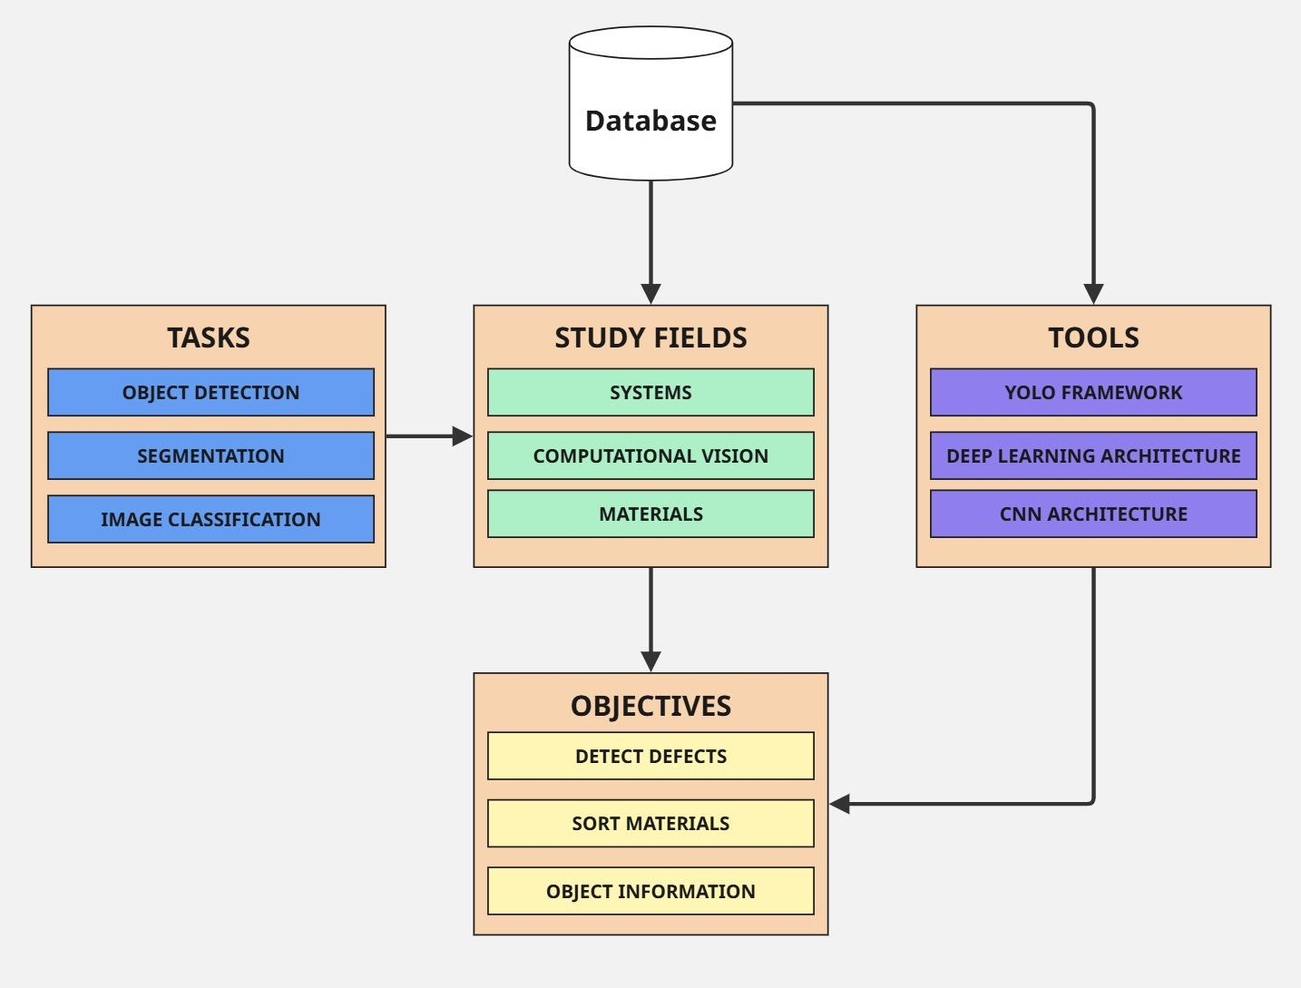
The search using keywords and their combinations resulted in a total of 146 publications. The quantitative of the studies is presented in figure 2, showing an increase from 2023 indicating an interest of the subject and it’s use.
Figure 2. Summary of the articles found researching through platforms, Dimensions, Google Academic, WebofScience
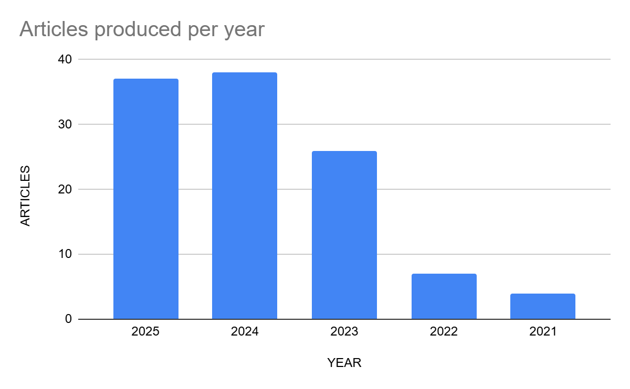
The main papers obtained as result of the search, those that used YOLO as a tool for AI with or without help of other techniques were highlighted.
Adetunji et al. (2025) [2] used YOLO, integrated with CNNs. The main objective of the work was the identification of plastic transparent bags inside an industrial environment, and the models generated through that architecture presented superior results even with different light conditions.
The influence of light conditions were evaluated in YOLO’s application to identify materials in civil construction field. This approach had the improvement of models and architectures by combining data from cameras and millimetric wave radars, that showed being necessary to raise the accuracy and recognition of materials in low contrast scenarios. The results indicate that it is possible to develop efficient and effective models, despite the image conditions, knowing that those parameters affect the model directly [4].
In the field of materials sorting for waste recognition, Hegde et al. (2024) [5], CNN models were used to classify the materials through collected images by treadmill cameras. The authors indicate that the applied methodology can be useful for cities and companies, in the waste management area, with the intention of adjusting trial practices applied, with reuse or recycling of materials. The results obtained through the models used were compared by their recognition capacity and identification, in terms of accuracy and inference. It was possible to classify the residues using the images, though the classification of materials in metals/non-metals, the results obtained were near 98%, according to the experiments the authors report some challenges within the application of tools, for example, the image quality depends on the physical state of the material, overlap of objects and if there is a proper light in the environment.
Applying YOLO for waste management, Sumathy et al. (2025) [13], combined that architecture with Vision Transformers (ViTs). The proposed method tried to surpass the limitations in traditional segregation processes, that require a long time to be completed and depends on intensive work, offering a faster and more efficient solution with less computational resource usage. To increase robustness of the model, specialized databases were used, that allowed a better adaptation in different visual conditions. The results indicate high precision for materials like glass (90%) and plastic PET (85%), despite the electronic waste classification still presents a lower performance (45%), highlighting an opening challenge.
Yolo combined with Neural Architecture Search (NAS) was used to identify materials with defects in the manufacturing process. The tool was applied in the injection process of plastic parts, with the idea of optimizing the workflow, reducing production of defect parts and directing the material for reprocessing. The inspection system (IMIS) captures the image logo after the press opening process and decides if there is a defect. If a defect is detected a control circuit sends a command to the machine before the next injection [11]. Another study by Dunli et al.(2022)[15], compared the YOLOv5 algorithm to the NVIDIA GeForce RTX 2080 Ti, for material detection in pallets through and automated mounting production line, the results indicated a significant reduction in the time needed for training the tool, showing viability to fast implementation in automated industrial scenarios.
Outside the industrial environment, the Scaled-YOLOv4 was used to detect materials in objects thrown in Pasig River, Philippines. The greatest challenge for applying the tool, according to the authors, was the presence of deformations, occlusions and variations in light conditions. The model achieved a precision in materials identification of 63%, from that total, 67% precision for plastic identification and 59% for paper identification [14].
A comparative study between the models (1) CNN e ResNet50 and (2) YOLO v3 and YOLOv4 was developed to classification and trial of medical wastes during the phase post-pandemic of Covid-19. The applied training in tools focused in objects like facial mask, gloves and syringes. The result shows that from 2207 medical waste images, CNN e ResNet achieved 89,35 e 85,75% of precision, while YOLOv3 and YOLOv4 used 3073 images for training and achieved 84,86 and 89,21% of medical precision. The limitations verified in the work are from wrong detections in real time using camera, similar shape objects of medical waste [17].
In summary the revised studies appoint YOLO as one of the most important AI architectures for detection and materials classification in industrial and environmental scenarios. Challenges as light, occlusion, visual similarity, between objects, still delimitates the accuracy in some of the cases, the results shows expressive improvements in efficiency, processing time and practical implementation.

4. Conclusion
The works from the search show that solutions used in the materials field are related to object segmentation, object detection and image classification, most of them are related to shortage of materials and identifying materials property, either for defects or quality control quantification.
Deep Learning and Convolutional Neural Networks are the architecture approaches used for modeling Computational Vision Solutions. They have better accuracy and response to modeling creation than other techniques.
YOLO is a well-known and solution integrated framework used in most cases. It enables the creation of faster and resource optimized models that can be used in many different cases and scenarios.

Acknowledgement

Thanks to the SENAI - CIMATEC University institution, this work was possible to be done and the support of the PP-GTEC (Post Graduation Program of Management and Industrial Technology) with all the available resources.

References

- Nussibaliyeva, Arailym, et al. "Development of an artificial vision for a parallel manipulator using machine-to-machine technologies." Sensors 24.12 (2024): 3792.
- Adetunji, Favour, et al. "Vision-based manipulation of transparent plastic bags in industrial setups." Frontiers in Robotics and AI 12 (2025): 1506290.
- Han, Ruitong, et al. "Machine learning of automatic hierarchical multi-label classification method for identifying metal failure mechanisms." Scientific Reports 15.1 (2025): 19904.
- Cai, Dengsheng, et al. "Material identification of construction machinery based on multisource sensor information fusion." Engineering Reports 4.10 (2022): e12512.
- Hegde, Saumya, et al. "Optimizing Solid Waste Management: A Holistic Approach by Informed Carbon Emission Reduction." IEEE Access (2024).
- Okran, Ammar M., et al. "Efficient crack segmentation with multi-decoder networks and enhanced feature fusion." Engineering Applications of Artificial Intelligence 152 (2025): 110697.
- Qaddour, Jihad, and Syeda Ayesha Siddiqa. "Automatic damaged vehicle estimator using enhanced deep learning algorithm." Intelligent Systems with Applications 18 (2023): 200192
- Shaju, Shawn, et al. "Conceptual design and simulation study of an autonomous indoor medical waste collection robot." IAES International Journal of Robotics and Automation 12.1 (2023): 29.
- Ramezani, Fereshteh, et al. "Automatic 2D material detection in optical images using deep-learning-based computer vision." AI and Optical Data Sciences IV. Vol. 12438. SPIE, 2023.
- Cao, Wenming, Qifan Liu, and Zhiquan He. "Review of pavement defect detection methods." IEEE access 8 (2020): 14531-14544.
- Asadi, Mohammadreza, Seyedeh Sogand Hashemi, and Mohammad Taghi Sadeghi. "Detection of defective products in injection molding process using YOLO-NAS." 2023 9th International Conference on Control, Instrumentation and Automation (ICCIA). IEEE, 2023.
- Tang, Yuk Ming, Andrew WH Ip, and Wenqiang Li. "Artificial intelligence approach for aerospace defect detection using single-shot multibox detector network in phased array ultrasonic." IoT and Spacecraft Informatics. Elsevier, 2022. 1-27.
- Sumathy, G., et al. "Enhanced Waste Segregation Using Vision Transformers and YOLO." 2025 International Conference on Frontier Technologies and Solutions (ICFTS). IEEE, 2025.
- Q. Tomas, John Paul, et al. "Trash detection for computer vision using scaled-yolov4 on water surface." Proceedings of the 11th International Conference on Informatics, Environment, Energy and Applications. 2022.
- Hu, Dunli, et al. "Detection of Material on a Tray in an Automatic Assembly Line Based on Convolution Attention and Multitask Loss." 2022 4th International Conference on Control and Robotics (ICCR). IEEE, 2022.
- Okran, Ammar M., et al. "Efficient crack segmentation with multi-decoder networks and enhanced feature fusion." Engineering Applications of Artificial Intelligence 152 (2025): 110697.
- Moktar, Muhammad Hafizuddin, et al. "Performance Review of Modern AI Algorithms Utilized for Medical Waste Sorting Works." International Conference on Mechatronics and Intelligent Robotics. Singapore: Springer Nature Singapore, 2023.
- Nguyen, Tien-Dung, et al. "Use of artificial intelligence to predict the performance of recycled aggregate concrete." Advances in Construction and Demolition Waste Recycling (2025): 295-315.
- Zhang, Heng, et al. "Airport foreign object small target detection dataset." 2023 IEEE 7th information technology and mechatronics engineering conference (ITOEC). Vol. 7. IEEE, 2023.
- Martínez, Julián Gabriel, Luis Carlos Timaná, and Carlos René Suárez. "Application of a Computer Vision Algorithm for Robot Motion Planning and Obstacle Avoidance." 2023 Congreso Internacional de Innovación y Tendencias en Ingeniería (CONIITI). IEEE, 2023.

