**ARÉA TEMÁTICA: ECOLOGIA**

**SUBÁREA TEMÁTICA: INVERTEBRADOS**

***Lepas* spp. ON TAR BALLS LANDED IN PERNAMBUCO COAST IN 2022**

Davy Barbosa Bérgamo¹, Nykon Craveiro¹, Karine Matos Magalhães², Gilvan Takeshi Yogui¹, Eliete Zanardi-Lamardo¹, Lino Angel Valcarcel Rojas¹, Maria Cecília Santana de Lima², Jose Souto Rosa Filho¹

¹ Universidade Federal de Pernambuco (UFPE), Campus Recife. E-mail (DBB): davybberg@gmail.com, (NC): nykoncraveiro@gmail.com, (GTY): gilvan.yogui@ufpe.br, (EZ): eliete.zanardi@ufpe.br, (LAVR): linomarvic@gmail.com, (JSRF): souto.rosa@ufpe.br

² Universidade Federal Rural de Pernambuco (UFRPE), Campus Recife*.* E-mail (KMM): karine.mmagalhaes@ufpe.br, (MCSL): cecilialimah@gmail.com

**INTRODUCTION**

Tar balls are originated by natural effects or anthropogenic actions and are considered the final stage of residual oil (Fingas, 2017). Similar to other floating materials such as buoys, pumice stones, and plastic debris, they can remain floating in the ocean for a long time until landing in the coastal regions, and act as substrates for the settlement, growth, and dispersal of marine organisms, such as macroalgae, mollusks, polychaetes, and crustaceans (Thiel and Gutow, 2005 a,b*; Bryan et al., 2012).

The oceanic crustacean gooseneck barnacles *Lepas* (*Lepas*) *anatifera* Linnaeus, 1758, and *Lepas* (*Lepas*) *anserifera* Linnaeus, 1767 are among the most abundant marine rafting organisms due to their recurrence and abundance, and adaptation to colonize floating objects (Darwin, 1854; Thiel and Gutow, 2005a,b*), being these species used as a reliable proxy to estimate the floating time of objects colonized in the sea (Magni et al., 2015; Mesaglio et al., 2021).

Based on their use, this study compares the tar balls from two landfall moments in 2022, August and September, using the physical characteristics of the tar balls and the population of *Lepas* spp. as examples of the possible dispersal implications of marine species in floating objects. Our hypothesis was that the tar balls had the same species populations and origins, but the influence of currents during their trajectories would have resulted in different floating times and successively different landfall moments.

**MATERIAL AND METHODS**

A total of 27 tar balls were collected in August and September 2022 in sandy beaches in Pernambuco, northeastern Brazil (Fig. 1). All tar balls were measured (length, width, and volume) and weighed. The attached organisms were counted and identified to species level. The capitulum of *Lepas* spp. were measured (length and width). The internal structures of *Lepas* spp. were examined to determine their maturation stage (presence of ovigerous lamellae) (Patel, 1959).

B

A

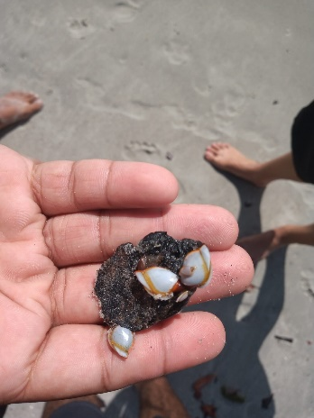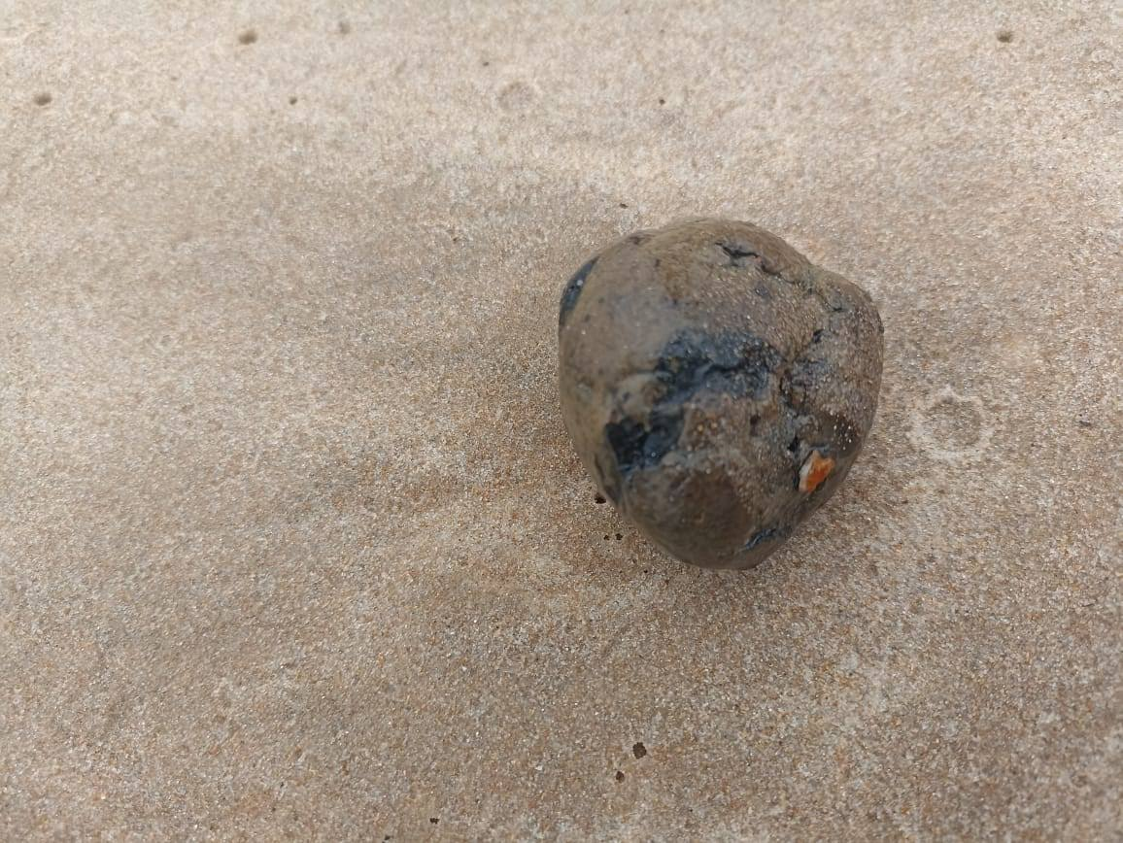

Figure 1. Photos of tar balls (A) and associated barnacles (B) collected from beaches in northeastern Brazil in late 2022.

The floating time of *L. anatifera* and *L. anserifera* were determined by dividing the capitulum length of the largest individuals by the minimum and maximum growth rates of each species of *Lepas* spp. proposed by Inatsuchi *et al.* (2010), Magni *et al*.(2015), and Mesaglio *et al.* (2021), added to five days required for larval settlement (Høeg et al., 2012).

**RESULTS AND DISCUSSION**

The tar balls were black, rounded, with diameters ranging from 2.65 to 9.95 cm, volumes from 9.73 to 515.52 cm³, and weights from 9.75 to 308.75 g. In September there was a maximum of 58 *Lepas anserifera* per tar ball.

There were 400 *Lepas anserifera* (August and September) and two *L. anatifera* (September). In addition, polychaeta, decapods and macroalgae were also found attached. Gooseneck barnacles of the genus *Lepas* are oceanic cosmopolitan species, commonly found in the Atlantic Ocean (Schiffer and Herbig, 2016) and have already been recorded on drifting objects that have stranded on the Brazilian coast as bales of raw rubber (Teixeira et al., 2021), vessel hulls (Skinner and Barboza, 2014), plastic, nylon and glass debris (Farrapeira, 2011), coconut, and in tar balls (Mello et al., 2023).

The capitulum of individuals had lengths ranging from 0.5 to 22.21 mm (Fig. 2). The maximum capitulum lengths recorded for *L. anatifera* and *L. anserifera* are 42.0 and 46.5 mm, respectively (Magni et al., 2015; Mesaglio et al., 2021), indicating that the individuals on the landed tar balls were still growing. The largest *L. anserifera* in August had capitulum length of 18.53 mm and age of 18-55 days old, in September the largest individual was 22.21 mm long 21-65 days old. The largest *L. anatifera* had a capitulum measuring 12.75 mm and was 14-66 days old. According to our longest estimate (55-66 days), the oil spill event occurred in early July to August 2022, and the different date of landfall may be due to a discontinuous oil spill or retention of some tar balls in currents and ocean gyres (Gordon and Bosley, 1991; Onink et al., 2019).

Ovigerous lamellae were present in 97 *L. anserifera*, indicating sexual maturity, and the smallest ovigerous female had capitulum length of 7.08 mm, which agrees with Inatsuchi *et al.* (2010) who states that this species reaches maturation at 5-8 mm (capitulum length). In turn, ovigerous lamellae were not observed in *L. anatifera* (>12mm). Differences in maturation length and growth rate between the two species explain the dominance of *L. anserifera*. The shorter maturation length and faster growth of *L. anserifera* allowed its successive reproductive cycles that resulted in three cohorts colonizing tar balls. Conversely, just the first generation of *L. anatifera* was able to colonize tar balls before their stranding on Brazilian beaches.

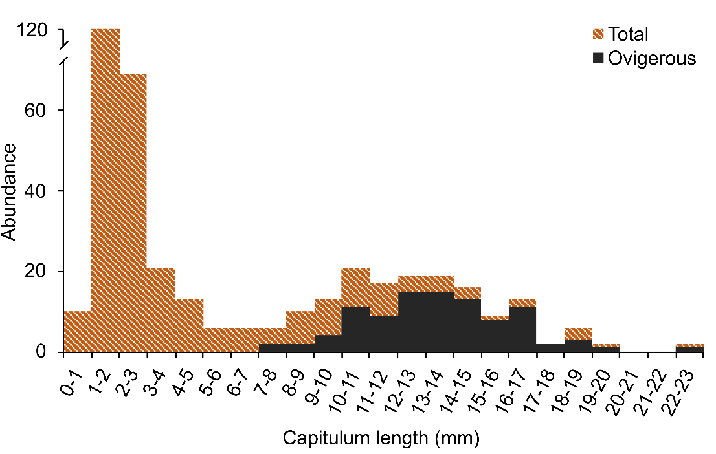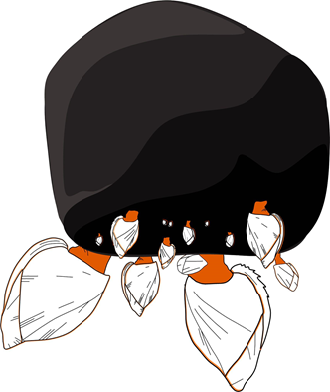

Figura 1. Legendas devem ser auto-explicativas, em Arial 10.

Figure 2. Size (capitulum length) distribution of *Lepas anserifera* found on tar balls collected on beaches of northeastern Brazil.

**CONCLUSION**

Tar balls that landed on the sandy beaches of Pernambuco in August and September 2022 had similar physical and biological characteristics possibly indicating the same origin and displacement trajectories. *Lepas anserifera* was the dominant gooseneck barnacle species. The short maturation length and fast growth of *L. anserifera* allowed this species to produce three generations before the tar balls stranded on the coast.

The occurrence of animals attached to the tar balls highlights these objects as potential vectors of dispersal of species from other parts of the world to Brazil, requiring precautions against possible impacts caused by the introduction of non-indigenous species.

**REFERENCES**

Bryan, S.R.; Cook, A.G.; Evans, J.P.; Hedben, K.; Hurrey, L.; Colls, P.; Jell, J.S.; Weatherley, D. & Firm, J. 2012. Rapid, long-distance dispersal by pumice rafting. PLoS ONE, 7(7): 1-13.

Darwin, C.R. 1854. A monograph on the sub-class Cirripedia, with figures of all the species. Ray Society.

Farrapeira, C.M.R. 2011. Macrobenthic invertebrates found in Brazilian coast transported on abiogenic solid floating debris. Revista da Gestão Costeira Integrada, 11(1): 85-96.

Fingas, M.F. 2017. Introduction to oil spill modeling. In: Fingas, M.F. Oil spill and technology, Gulf Publishing Company, 2: 419-454.

Gordon, A.L. & Bosley, K.T. 1991. Cyclonic gyre in the tropical South Atlantic. Deep-Sea Research, 29: 5323-5343.

Høeg, J.T.; Maruzzo, D.; Okano, K.; Glenner, H. & Chan, B.K.K. 2012. Metamorphosis in balanomorphan, pedunculated, and parasitic barnacles: a video-based analysis. Integrative and Comparative Biology, 52(3): 337-347.

Inatsuchi, A.; Yamato, S. & Yusa, Y. 2010. Effects of temperature and food availability on growth and reproduction in the neustonic pedunculate barnacles *Lepas anserifera*. Marine Biology, 157: 899-905.

Magni, P.A.; Venn, C.; Aquila, I.; Pepe, F.; Ricci, P.; Nunzio, C.D.; Ausania, F. & Dadour, I.R. 2015 Evaluation of the floating time of a corpse found in a marine environment using the barnacles *Lepas anatifera* L. (Crustacea: Cirripedia: Pedunculata). Forensic Science International, 247: 6-10.

Mello, L.C.; Nascimento, A.P.; Lopes, B.D.; Lima, A.D.F.; Bezerra, L.E.A.; Mendes, L.F.; Bastos, L.M.; Nossol, A.B.S.; Martins, M.M.; Martins, L.L. & Cavalcante, R.M. 2023. Tarballs on the Brazilian coast in late 2022 sustain Lepas anatifera Linnaeus, 1758 (Crustacea: Cirripedia): Occurrence and risk of petroleum hydrocarbon ingestion. Science of the Total Environment, 896, 1-8.

Mesaglio, T.P.; Schilling, H.T.; Adler, L.; Ahyong, S.T.; Maslen, B. & Suthers, I.M. 2021. The ecology of *Lepas*-based biofouling communities on moored and drifting objects, with applications for marine forensic science. Marine Biology,168(21): 1-16.

Onink, V.; Wichmann, D.; Delandmeter, P. & van Sebille, E. 2019. The role of Ekman currents, geostrophy, and stokes drift in the accumulation of floating microplastic. Journal of Geophysical Research: Oceans, 124: 1474 -1490.

Patel, B. 1959. The influence of temperature on the reproduction and moulting of *Lepas anatifera* L. under laboratory conditions. J. Mar. Biol. Ass. U.K., v. 38, p. 589-597.

Schiffer, P.H. & Herbig, H.G. 2016. Endorsing Darwin: global biogeography of the epipelagic goose barnacles *Lepas* spp. (Cirripedia, Lepadomorpha) proves cryptic speciation. Zoological Journal of the Linnean Society, 177: 507-525.

Skinner, L.F. & Barboza, D.F. 2014. Record of coastal colonization of the Lepadid goose barnacle *Lepas anatifera* Linnaeus, 1758 (Crustacea: Cirripedia) at Arraial do Cabo, RJ. Pan-American Journal of Aquatic Sciences, 9(1): 39-42.

Teixeira, C.E.P.; Cavalcante, R.M; Soares, M.O.; Ribeiro, F.B. & Bezerra, L.E.A. 2021. Marine debris from the past - Contamination of the Brazilian shore by a WWII wreck. Marine Environmental Research, 169(1): 1-7.

Thiel, M. & Gutow, L. 2005a. The ecology of rafting in the marine environment. I. The floating substrata. Oceanography and Marine Biology: An Annual Review, 43: 181-263.

Thiel, M. & Gutow, L. 2005b. The ecology of rafting in the marine environment. II. The rafting organisms and community. Oceanography and Marine Biology: An Annual Review, 43: 279-418.