Comparison of Yeast Cell Viability Assessment Techniques Post-Fermentation in Agave sisalana Juice
Paloma Freitas Araujo^{1*}, Aura Lacerda Crepaldi ¹, Ary Rocha Bezerra ¹, Júlia Alves Gribel de Oliveira², Ana Lucia Barbosa de Souza¹, Tatiana Oliveira do Vale¹, Claudia Ramos da Silva²
¹ SENAI CIMATEC University, Industrial Microbiology, Salvador, Bahia, Brasil
² SENAI CIMATEC University, Chemical Processes, Petrochemicals and Biotechnology, Salvador, Bahia, Brasil
*Corresponding author: paloma.araujo@fieb.org.br

Abstract: This study compares different methods for assessing yeast cell viability in Agave sisalana juice fermentation, focusing on first-generation ethanol production. Methylene blue staining, CFU counting, and resazurin assays were employed to evaluate cell viability. The results indicated a significant decrease in CFU of yeasts cultivated in Agave juice compared to the standard YPD medium. Methylene blue staining did not show a clear difference in viability between the two media. However, resazurin assays revealed a 90% reduction in viability at the 10⁻³ dilution. The study highlights the interference of Agave juice particles, color, and other compounds in the traditional viability assays. Despite these challenges, new methods demonstrated potential for rapid and accurate determination of yeast viability, offering a promising approach for optimizing biotechnological processes in Agave juice fermentation. Further research is needed to develop a customized, efficient, and industrially applicable protocol for cell viability assessment in Agave juice.
Keywords: Agave sisalana; Yeast viability; Fermentation; biofuels.

- Introduction
The determination of yeast cell viability is a critical step in monitoring and controlling alcoholic fermentation, particularly in industrial processes for bioethanol production. Accurate assessment of the physiological state of yeast cells directly impacts the efficiency of fermentation, alcohol yield, and the need for operational interventions such as the replacement of viable strains [1].
Viability studies are fundamental because they allow for the early diagnosis of physiological alterations that compromise fermentative performance, including membrane integrity loss, metabolic decline, and cell death. Through these analyses, it is possible to determine the proportion of live and dead cells, the degree of cellular stress, reproductive capacity, and the metabolic vitality of the yeast biomass, providing essential data for real-time decision-making [1-2].
Several factors, such as bacterial contamination, temperature fluctuations, improper nutrient dosing, and unfavorable physicochemical conditions, negatively affect yeast viability throughout the production cycle, as reported in Brazilian industrial ethanol plants using sugarcane juice [3].
In the context of ethanol production from Agave sisalana juice, a promising biomass in Brazil’s semiarid region, assessing yeast cell viability becomes even more strategic due to the substrate's distinct chemical composition and the scarcity of studies on its fermentative behavior. Selecting an appropriate analytical method is therefore essential to ensure accurate evaluation of both cell population dynamics and metabolic conditions during bioconversion.
This study aims to compare different techniques for assessing yeast cell viability used in the fermentation of Agave sisalana juice, focusing on the production of first-generation (1G) ethanol. The methods investigated include methylene blue staining, colony-forming unit (CFU) counting, and spectrophotometry, with emphasis on their accuracy, sensitivity, and applicability in this biotechnological context.
- Methodology
To assess yeast cell viability, two cultivation conditions were applied. The inoculation in YPD broth (Yeast Extract, Peptone, and Dextrose) and the inoculation in Agave blend broth (1:1 mixture of Agave pinha juice and Agave sisalana leaf juice) (Figure 1).
The inoculation in YPD aimed to observe yeast growth in an ideal medium, which was used as a control. A second control was also used, consisting only of Agave blend broth (1:1 mixture of Agave pinha juice and Agave sisalana leaf juice) without the yeast addition, to measure the interference of the “color” factor of the broth in the analyses.

Figure 1. Experiment with YPD and Agave broth using the commercial yeast CAT-1.
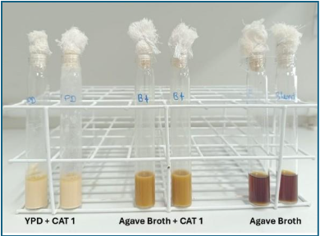
Source: authors.
The experiment was conducted by inoculating the commercial yeast CAT-1 (Saccharomyces cerevisiae) in tubes containing 5 mL of YPD or Agave broth, at a 10% (w/v) yeast proportion, and incubating them in a thermostatic chamber at 32ºC without agitation for a period of 4 hours.
After this period, a 1 mL aliquot was taken from each tube under aseptic conditions and centrifuged at 4000 rpm for 5 minutes. After centrifugation, the supernatant was discarded, and 1 mL of sterile saline (0.85%) was added to the pellet.
The material was resuspended and subsequently diluted in sterile saline (0.85%) to a dilution of 10⁻⁶. Aliquots of 100 µL from the 10⁻² and 10⁻⁶ dilutions were inoculated onto Petri dishes containing BDA medium (Potato Dextrose Agar), using a Drigalski loop and the “spread plate” technique. The seeded plates were incubated in a thermostatic chamber for 24 hours at 32ºC. Afterward, colony-forming units (CFU) were counted.
These same dilutions were also analyzed using the methylene blue and resazurin staining methods.
For methylene blue staining, aliquots from the 10⁻² and 10⁻⁶ dilutions were treated with 0.1% methylene blue at a 1:10 sample ratio. After 5 minutes, a drop of this mixture was placed on a Neubauer chamber, and counting was performed under a microscope. Cell viability was calculated using the following equation 1.

$Cells/mL=\left(\frac{N}{4}\right)x{10}^{4}xD$ (1)
Where:
- N = total number of viable cells counted in the four large quadrants at the edges.
- 10⁴ = chamber factor (each large quadrant has 10⁻⁴ mL).
- D = dilution inverse.
The resazurin staining was evaluated by scanning the dilutions from 10⁻¹ to 10⁻⁶, with undiluted samples used as a reference for comparison. A 200 µL aliquot from each dilution was placed in the wells of a 96-well microplate. A 20 µL aliquot of resazurin was added to the samples. This mixture was incubated at 32ºC for approximately 2 hours. After incubation, the plate was read for absorbance in a spectrophotometer at 570 and 600 nm.
For assay control, aliquots of the resuspended solution in saline and undiluted solution were added, in addition to wells containing only saline and saline + resazurin. The distribution of the samples is as illustrated in Figure 2. All samples were performed in duplicates.

Figure 2. Microplate containing the samples (A) and schematic distribution of the samples in the microplate (B).
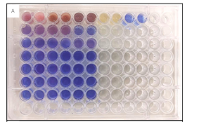
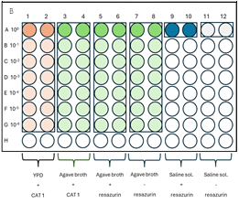
Source: authors.

- Results
3.1. Viability Assay Using Methylene Blue
Both methylene blue and resazurin are redox dyes that can cross cell membranes and participate in redox reactions within cells. Therefore, intact cells can metabolize these dyes and exhibit different coloration when observed under a microscope.
The difference between viable and non-viable cells is determined by the presence or absence of the dyes inside the cells. The analysis of viable cells using methylene blue staining in a Neubauer chamber showed the results presented in Table 1.

Table 1. Results of viability counts using methylene blue staining and CFU/mL in BDA culture medium.
Sample Type | Dilution Factor | Methylene Blue Staining  Viable Cells/mL | Seeded on BDA Medium  CFU/mL
YPD + CAT 1 | 10⁻²  10⁻⁶ | 1,37x10⁸  6,25x10⁹ | >3x10⁵  1,27x10⁹
Agave broth+ CAT 1 | 10⁻²  10⁻⁶ | 5,64x10⁸  5x10⁹ | >3x10⁵  8,3x10⁸
Agave broth (control) | 10⁻²  10⁻⁶ | 0  0 | 0  0
Source: authors

The differentiation was because viable cells appear transparent, while non-viable cells turn blue due to the retention of methylene blue inside, as observed in Figure 3.
Figure 3. Methylene blue staining difference between viable and non-viable cells, observed under an optical microscope at 400x magnification.
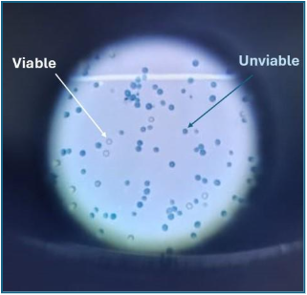
Source: authors.

3.2. Viability Count from Growth in BDA Medium
The colony-forming unit (CFU) count in plates containing BDA medium was performed after 24 hours from inoculation. The results are presented in Table 1.
3.3. Viability Count Using Resazurin
The cellular viability evaluation for the resazurin assay showed that, at the 10⁻¹ dilution, Agave broth exhibited maximum viability (Figure 4). At the 10⁻² dilution, no significant reduction was observed, with similar values between the media (47.6% for YPD and 47.4% for Agave broth). From the 10⁻³ dilution onwards, viability was significantly reduced, with values of 3.3% for YPD and 0.5% for Agave broth. No activity indicative of cellular viability was detected in subsequent dilutions for any of the treatments.

Figure 4. Viability results (%) of yeast cells based on resazurin staining.
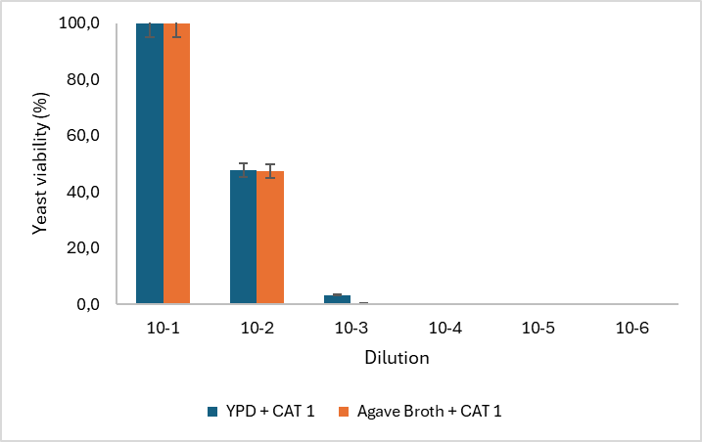
Source: authors

- Discussions
Some classical methods for determining cell viability may exhibit low efficiency under cellular stress conditions [4-5]. The production of ethanol from Agave sisalana juice is unprecedented, and therefore, studies on the behavior of yeasts in this material are virtually non-existent. Agave juice may contain components (particles, saponins, organic acids) that could affect the physiological behavior of yeasts, inducing stress in the cells.
It is noteworthy that counting a large number of samples also affects the efficiency of the method [6].
To reliably determine cell viability, CFU counting is the most suitable method [7]; however, it is time-consuming. Table 1 shows a 10x decrease in CFU of yeasts cultivated in Agave juice compared to the YPD cultivation medium. However, it was not possible to correlate the decrease in cell viability between the standard medium (YPD) and Agave juice using the methylene blue method.
Regarding the application of resazurin, a 90% reduction in cell viability was observed starting at the 10⁻³ dilution. It is possible that adjustments in incubation time and inoculum [8] could indicate a faster method for better response in cell viability analysis in Agave juice.
Cell viability assays commonly use dyes that change color under pH alterations or redox reactions. Many of these determine dehydrogenase activity [9], and the activity of these enzymes can be more accurately expressed depending on the different physiological states of the studied cells.
One hypothesis raised in this study concerns the particles in the juice, which may be an interfering factor in classical viability analyses using dyes. In spectrophotometry, solids artificially increase absorbance due to light scattering, chemically reacting and affecting readings at wavelengths used for dyes such as methylene blue or resazurin [10-12].
Thus, this study compares three different methods for analyzing cell viability, demonstrating that the microorganism and the medium in which it is cultivated determine which method is most appropriate. Moreover, adaptations must always be considered due to the specificities of each fermentation process.
- Conclusions
This study concludes that cell viability assays using dyes need to be customized or adapted when applied to fermentations with Agave juice. The particles in the medium, the color, and other unidentified compounds affect the analyses, resulting in inconclusive findings. However, this study also highlights the potential of new methods to be customized and quickly identify yeast viability accurately, with results consistent with those obtained from CFU counting. New methods can be evaluated to develop a personalized, efficient, rapid, and industrially applicable protocol for determining yeast cell viability in Agave juice.
Acknowledgement
The authors would like to thank SENAI CIMATEC and SHELL for developing the research, as well as the funding agencies EMBRAPII and ANP. Special thanks to the researcher from the SENAI Institute of Advanced Health Systems (ISI-SAS), Cássio Meira, for his valuable assistance.
References

- Jacob AB, Campos RT. Estudo sobre a viabilidade celular da levedura no processo de fermentação em uma usina de álcool e açúcar. Environ Sci Technol Innov. 2023;1(2):108-131.
- Kwolek-Mirek M, Zadrag-Tecza R. Comparison of methods used for assessing the viability and vitality of yeast cells. FEMS Yeast Res. 2014;14(7):1068-1079. Available from: https://doi.org/10.1111/1567-1364.12202.
- Nobre TP, Horii J, Alcarde AR. Viabilidade celular de Saccharomyces cerevisiae cultivada em associação com bactérias contaminantes da fermentação alcoólica. Ciênc Tecnol Aliment. 2007;27(1):20-25.
- Postgate JR. Viability measurements and the survival of microbes under minimum stress. Adv Microb Physiol. 1967; 1:1-23. Available from: https://doi.org/10.1016/S0065-2911(08)60248-9.
- Deere D, Shen J, Vesey G, Bell P, Bissinger P, Veal D. Flow cytometry and cell sorting for yeast viability assessment and cell selection. Yeast. 1998;14(2):147-160. Available from: https://doi.org/10.1002/(SICI)1097-0061(19980130)14:2<147:AID-YEA204>3.0.CO;2-L.
- Matsumoto A. A rapid and simple spectroscopic method for the determination of yeast cell viability using methylene blue. Yeast. 2022;39(1-2):30-36. Available from: https://doi.org/10.1002/yea.3662.
- Wang R, Lorantfy B, Fusco S, Olsson L, Franzén CJ. Analysis of methods for quantifying yeast cell concentration in complex lignocellulosic fermentation processes. Biotechnol Biofuels Bioprod. 2022;15:49. Available from: https://doi.org/10.1186/s13068-022-02118-6.
- Medina ABP, Piñanez JRC, Alvarez MFP, Farias CJ de. Use of 2,3,5-triphenyl tetrazolium chloride for detection of Fusarium semitectum viability in soybean seeds. J Seed Sci [Internet]. 2024;46:e202446021. Available from: https://doi.org/10.1590/2317-1545v46278215.
- Stockert JC, Horobin RW, Colombo LL, Blázquez-Castro A. Tetrazolium salts and formazan products in cell biology: Viability assessment, fluorescence imaging, and labeling perspectives. Acta Histochem. 2018;120(3):159-167. Available from https://doi.org/10.1016/j.acthis.2018.02.005.
- Harrison, P., et al. (2015). The influence of sample turbidity on spectrophotometric and fluorometric assays of microbial cell viability. Journal of Microbiological Methods, 119, 26–32. Available from: https://doi.org/10.1016/j.mimet.2015.09.004
- Holder SJ, Holland NB, Duncan R. Particle-induced artifacts in the MTT and LDH viability assays. Appl Sci. 2021;11(10):4410. Available from: https://doi.org/10.3390/app11104410.
- Rampersad, S. N. (2012). Multiple applications of Alamar Blue as an indicator of metabolic function and cellular health in cell viability bioassays. Sensors, 12(9),12347–12360. Available from: https://doi.org/10.3390/s120912347.

