**Title of Article in English**

**Title of the Article in Portuguese**

**Full Name of Author(s) (1); Full Name of Author(s) (2);**

**Full Name of Author(s) (3); Full Name of Author(s) (4);**

**Full Name of Author(s) (5); Full Name of Author(s) (6)**

(1)0000-0000-0000-0000; Higher Education Institution/Company, teacher or student, researcher (be brief and objective), Brazil, Email: xienccult@gmail.com.

(2)0000-0000-0000-0000; Higher Education Institution/Company, teacher or student, researcher (be brief and objective), Brazil, Email: xienccult@gmail.com.

(3)0000-0000-0000-0000; Higher Education Institution/Company, teacher or student, researcher (be brief and objective), Brazil, Email: xienccult@gmail.com.

(4)0000-0000-0000-0000; Higher Education Institution/Company, teacher or student, researcher (be brief and objective), Brazil, Email: xienccult@gmail.com.

(5)0000-0000-0000-0000; Higher Education Institution/Company, teacher or student, researcher (be brief and objective), Brazil, Email: xienccult@gmail.com.

(6)0000-0000-0000-0000; Higher Education Institution/Company, teacher or student, researcher (be brief and objective), Brazil, Email: xienccult@gmail.com.

All content expressed in this article is the sole responsibility of the authors.

**Abstrac**t: The abstract should contain no more than 200 words. It should briefly and concretely present the justification, objectives, methodology, development, and results (or expected results).

**Keywords:** Word 1, Word 2, Word 3 (separated by commas).

Resumo: The complete abstract must contain a maximum of 200 words. Present what the article is about, with brief and concrete information about the justification, its objectives, methodology, development, and results (or expected results).

Palavras-chave: Palavra 1, Palavra 2, Palavra 3 (separadas por virgulas).

**Introduction**

The identification of the authors should be indicated immediately below the names, as shown in the provided model. The **Orcid** of all authors must be included, the country of origin in English (e.g., Brazil). Include email and indicate the condition of scholarship holders from funding agencies, if applicable.

Leave a space between the title, authors, affiliations, and before the start of each new section (this model is already formatted).

The title should consist of up to **15 words** and be presented in both Portuguese and English.

The article structure should present the introduction, objectives, methodological procedures, development, and conclusion; the section titles should be clear and objective, reflecting the theme and the issues addressed.

All text should be in Corbel Light font, with the title in size 13 in Portuguese and 12 in English, section titles in lowercase, bold, size 11, authors in lowercase, bold, size 11, references in size 10; abstract and keywords in size 10. Follow the model format.

**The article should occupy a minimum of 7 pages and a maximum of 20 pages, including tables, figures, and references.**

**The text of the extended abstract should be at least 4 pages and at most 6 pages, including tables, figures, and references.**

References should include only the consulted authors, with abbreviated names, aligned to the left. Follow the template model for formatting.

The responsibility for the contents of the published articles lies exclusively with the authors. By submitting their articles to the XII Enccult 2022, authors automatically authorize the copyright transfer for publication and permission for the redistribution of the article and its metadata to indexing and reference services that the editors deem appropriate.

The authors are responsible for the proofreading of the submitted works.

**For Tables**

Tables in portrait format, numbered with Arabic numerals, should have a self-explanatory title in lowercase letters, without vertical lines to separate columns and without the location and date of the experiment. All tables should be referenced in the text and include the source (see Table 1).

Table 1. Cases of domestic violence in Brazil

|  |  |
| --- | --- |
| **2020** | 230.160 |
| **2019** | 246.664 |
| **2018** | 263.067 |
| **2017** | 252.895 |

Source: Brazilian Forum on Public Safety Yearbook, 2021.

**For Figures**

Figures (graphs, drawings, maps, or photographs) should be numbered with Arabic numerals and inserted in the text preferably as an object. Drawings and photographs should be digitized in high quality (JPEG). All figures, graphs, maps, etc., must be referenced in the text and include the source (see figure 1 and graph 1).

Figure 1. Map of Alagoas showing the municipality of União dos Palmares

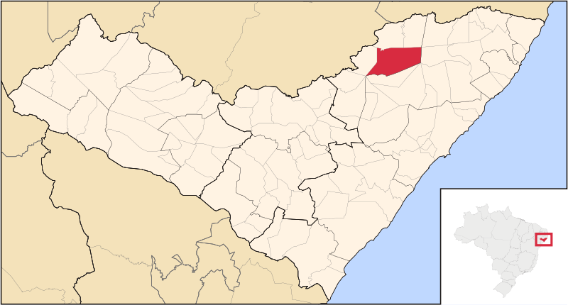

Source: Brazilian Institute of Geography and Statistics (2016). Available at: http://cod.ibge.gov.br/17R.

Accessed on: jan. 16, 2021.

Graph 1. Distribution of monoparasitized and poliparasitized ectoparasites by age group of students from two public schools in the municipality of União dos Palmares/AL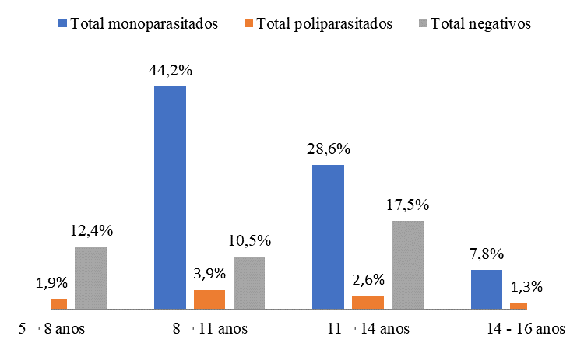

# Source: Research Data, 2022.

**REFERENCES**

References should list only works mentioned in the text, in alphabetical order by the first author's surname. Two or more authors should be separated by semicolons. Journal titles should not be abbreviated. The order of items in each reference must comply with the current guidelines of the Brazilian Association of Technical Standards (ABNT), as described below.

ARAÚJO, C. L. de O.; NICOLI, J. S. Uma revisão bibliográfica das principais demências que acometem a população brasileira. **Revista Kairós***:* Gerontologia, v. 13, n. 1, 2010.

BAGNE, B. M; GASPARINO, R. C. Qualidade de vida do cuidador do portador de Doença de Alzheimer. **Revista de Enfermagem UERJ**, v. 22, n. 2, março/abril, p: 258 – 263, 2014.

BRASIL. **Constituição da República Federativa do Brasil de 1988**. Brasília: 5de outubro de 1988. Disponível em: <http://www.planalto.gov.br/ccivil_03/constituicao/constituicaocompilado.htm>.

BRASIL. **Decreto no 6.800, de 18 de março de 2009**. Dá nova redação ao art. 2odo Decreto no 1.948, de 3 de julho de 1996, que regulamenta a Lei no 8.842, de4 de janeiro de 1994, que dispõe sobre a Política Nacional do Idoso, e dá outras providências. Brasília, 2009.

MAZZILLI, H. N. **A defesa dos interesses difusos em juízo**: meio ambiente, consumidor e outros interesses difusos e coletivos. 8. ed. São Paulo: Saraiva, 1997.

MINAYO, M. C. **O avesso do respeito à experiência e à sabedoria**.2. ed. Brasília: SEDH, 2005.