Viabilidade da aplicação da biomassa da mamona para a produção de biocombustível.
Yasmin Santos; Iago Novaes; Lázaro Miranda; Pablo Silva; Kauan Santos.
Universidade Senai Cimatec, Salvador, Bahia, Brasil
yasmin.v.santos8@ba.estudante.senai.br
Advisor: wadson.barbosa@fieb.org.br
Advisor: jarsia.santos@fieb.org.br

The use of renewable fuels stands out as an efficient alternative to fossil fuel consumption, especially in the context of the search for sustainable solutions with a lower environmental impact. This study aimed to analyze the viability of castor oil (Ricinus communis) as a raw material for biodiesel production, focusing on the acid transesterification process. The research was based on a literature review, addressing technical, productive, and environmental aspects related to biodiesel production from castor oil. The results indicate that castor oil has a high oil content, especially rich in ricinoleic acid, which confers favorable properties for biodiesel production, with good lubrication and performance in diesel engines. Furthermore, castor oil is notable for its ability to thrive in marginal soils and semiarid regions, offering a viable alternative for biofuel production in areas with agricultural limitations. The acid transesterification process proved suitable for converting castor oil into biodiesel, overcoming the limitations of other production methods. This study confirms the potential of castor oil as a sustainable raw material for biodiesel production, contributing to the diversification of the energy matrix and promoting the development of biofuels.

Keywords: Biofuel, Castor Bean Biomass, Viability

INTRODUCTION

The main global energy source has been petroleum-based fuels. However, growing environmental concerns and predictions that these resources are on the verge of extinction have led to a search for renewable energy sources. The continued increase in greenhouse gas emissions has intensified global warming. If humanity maintains its current energy production and consumption patterns, rising global temperatures could affect the survival of future generations.
In this context, castor bean biomass stands out in the search for new technologies, being categorized as an oilseed with high industrial value. The oil extracted from its seeds is used as a raw material in the production of lubricants, resins, enamels, synthetic fibers, plastics, and biodiesel. Furthermore, it has applications in the medical sector, particularly as biodegradable polymers used in the creation of artificial organs. Waste from industrial castor bean processing, such as cake, is also important for its ability to replenish poor or depleted soils resulting from intensive agricultural practices or natural degradation processes (PUPULIN et al., 2023).
Therefore, in the search for alternatives to mitigate problems related to energy scarcity, clean technologies that promote less environmental impacts are being analyzed. The production of biodiesel from vegetable oils, such as castor oil, emerges as a sustainable alternative, contributing to the diversification of the energy matrix and reducing the impacts caused by the use of fossil fuels (SANTOS et al., 2020). Furthermore, according to Cavalcante et al. (2022), biodiesel derived from castor oil has physical and chemical characteristics that confer good stability and compatibility with engines, which reinforces its applicability on an industrial scale.
The central questions of this study are: Is castor oil the most viable biomass for biodiesel production? Is acid transesterification the most viable production method? And finally, how do the physicochemical parameters of castor oil support its application?
The overall objective of this research is to study the feasibility of producing biodiesel from castor bean biomass, focusing on the acid transesterification process. The specific objectives are: to explain how biodiesel is formed through acid transesterification; to present the advantages of castor oil over other oilseeds; and to analyze the physicochemical parameters that demonstrate castor bean's potential as a raw material for biofuel production.

THEORETICAL BASIS

This article focuses on the main theorists who support the study of castor bean biomass for biofuel production: Gomes et al. (2008), Pupulin et al. (2023), and Cavalcante et al. (2022).
Gomes et al. (2008) conducted research on the feasibility and sustainability of biodiesel production from castor oil (Ricinus communis L.). Therefore, according to this author, biodiesel production from castor oil (Ricinus communis L.) may present both challenges and opportunities for the viability of castor bean biomass in biofuel production.
Pupulin et al. (2023) studied castor bean as a native raw material with potential for biodiesel production. Therefore, castor bean biomass is an alternative energy source with significant potential, especially in regions of Brazil such as the semiarid region. However, its viability and sustainability face technical, economic, and logistical challenges that must be overcome for this option to become an effective reality.
Petrobras Biocombustível's use of castor oil in biodiesel production focuses on implementing a technology that meets ANP (National Agency of Petroleum, Natural Gas, and Biofuels) specifications. The characteristics of the fruit and its productivity are key factors in demonstrating the advantages of castor oil over other crops for biodiesel production.
The castor bean has an oil content in its seed that can reach up to 50% (one of the highest among oilseeds), with a predominance of ricinoleic acid, a component that gives the oil unique properties, such as high viscosity and oxidative stability. These properties make castor oil technically more viable for biofuel production through viscosity reduction (transesterification), a process in which fatty acids react with alcohol, forming methyl esters (biodiesel) and glycerin.
Soybean oil is the main input used to produce biofuel, delivering relatively good results. However, a new and more promising crop, castor bean (Ricinus communis L.), has recently been discovered.
According to Embrapa (2011) and Agência Petrobras (2009), castor bean occurs naturally in several Brazilian states, such as Bahia, Maranhão, Mato Grosso do Sul, among others. Bahia is the largest producer of castor bean, accounting for approximately 80% of the country's production.
The authors also explain that castor oil plants have significant production potential due to their high oil content and ability to adapt to dense populations, with potential yields per area similar to those of oil palm. Castor oil plants (Ricinus communis) can produce over 1.2 tons of oil per hectare, demonstrating their high yield as an oilseed crop.
Furthermore, the plant adapts well to different soil types and climates, making them suitable for cultivation even in regions with low fertility. Another positive characteristic is that their oil production per area is significantly higher than that of soybeans, whose average ranges between 400 and 600 kg/ha, as cited by some authors. This clearly demonstrates the high production potential of castor oil plants, especially in areas with less favorable conditions for traditional agriculture.
Mamona (Ricinus communis L.), A plant known for the high oil content in its cotyledons. This oil can represent up to 45% of the seed mass, with a predominance of ricinoleic acid, a fatty acid that gives the oil unique properties, such as high viscosity and oxidative stability.
The richness of the oil in the castor bean's cotyledons makes this plant a promising raw material for biofuel production, especially through the transesterification process, in which fatty acids react with alcohol, resulting in biodiesel and glycerin.
The castor bean seed is composed of approximately 35% husk, the seed coat (seed coat): approximately 20%, and the kernel itself (cotyledons): approximately 75% to 80%, where the castor oil is concentrated. The castor bean has a slightly higher oil content in the kernel (75% to 80%) than in the husk (35%).
In their research, Cavalcante et al (2022) state that castor oil has greater potential for biodiesel production, being composed of two oily parts dominated by ricinoleic acid (84% to 91%) and linoleic acid (2.9% to 6.5%), which are fatty acids with good properties for industrial processing. Therefore, observing these data, it is possible to conclude that castor oil (Ricinus communis L.) has a large volume of oil composing its fractions, which is a variable that strongly reaffirms its excellent production capacity per hectare.

METODOLOGIA
The article presented was developed through a literature review, using technical data from scientific and academic journals, with the main keywords being: biofuel, castor bean biomass, and viability.
Based on the consultations, 17 articles were selected containing ideas related to the questions initially identified, such as: Why is castor bean the most viable feedstock among other crops for biodiesel production? Is transesterification the most viable production method? And finally, is acid catalysis more viable than base catalysis for castor oil?
The research was based on scientific studies grouped into four main areas: 40% addressed the viability, competitiveness, and sustainability of biodiesel production from castor beans; others (40%) focused on the availability of this raw material for small-scale production. The remaining 20% was divided between research on antioxidant additives for biodiesel (10%) and ricinoleic acid esters (10%). This choice placed greater emphasis on analyzing the structural composition of the product without neglecting the technical elements fundamental to biofuel excellence; however, the latter area was less in-depth.
The analysis of the scientific article adopted a qualitative approach, considering that the information examined is theoretically based and was used to answer the original questions about the viability of castor bean as a source of biodiesel feedstock compared to other agricultural crops. However, the study remained theoretical and did not present practical applications to validate the theories discussed regarding the difference between acidic and basic transesterification and the pros and cons of each method.
The purpose of the study was explanatory and based on already established information on the subject: such as the production of biodiesel from castor beans through the acid-catalytic transesterification process. The methodological approach was based on a review of the existing literature, seeking primary references cited by other researchers; however, experimental data or empirical analyses were not included. The sources consulted consisted of published academic articles and journals, which largely confirm the potential of castor oil in biofuel production.

RESULTADOS E DISCUSSÃO

In accordance with the theoretical basis presented, which discussed the viability of castor bean biomass for the production of biofuel, the results obtained will be presented below, accompanied by discussions for a better understanding of the article.According to research and work by the National Agency of Petroleum, Natural Gas, and Biofuels, biodiesel is a renewable fuel obtained through transesterification. Through this reaction, the lipids present in plant biomass (or animal fats) react with methanol or ethanol, producing ester and glycerin. The ester is the biodiesel itself, although it must be purified for commercialization.
Comparações entre a mamona e soja
The following tables present a comparative analysis between castor oil and soybeans, two of the main oilseeds used in biodiesel production.
The first table highlights the differences in seed oil content, yield per hectare, and the agricultural conditions required for each crop.
Castor oil stands out in the biofuels sector due to its high oil content (40-50%), higher than that of soybeans, and its ability to be cultivated in marginal soils. Its rich ricinoleic acid composition gives biodiesel properties such as lubricity and thermal resistance, making it an efficient raw material adaptable to regions with agricultural constraints.
Table 01 – Oil content and productivity
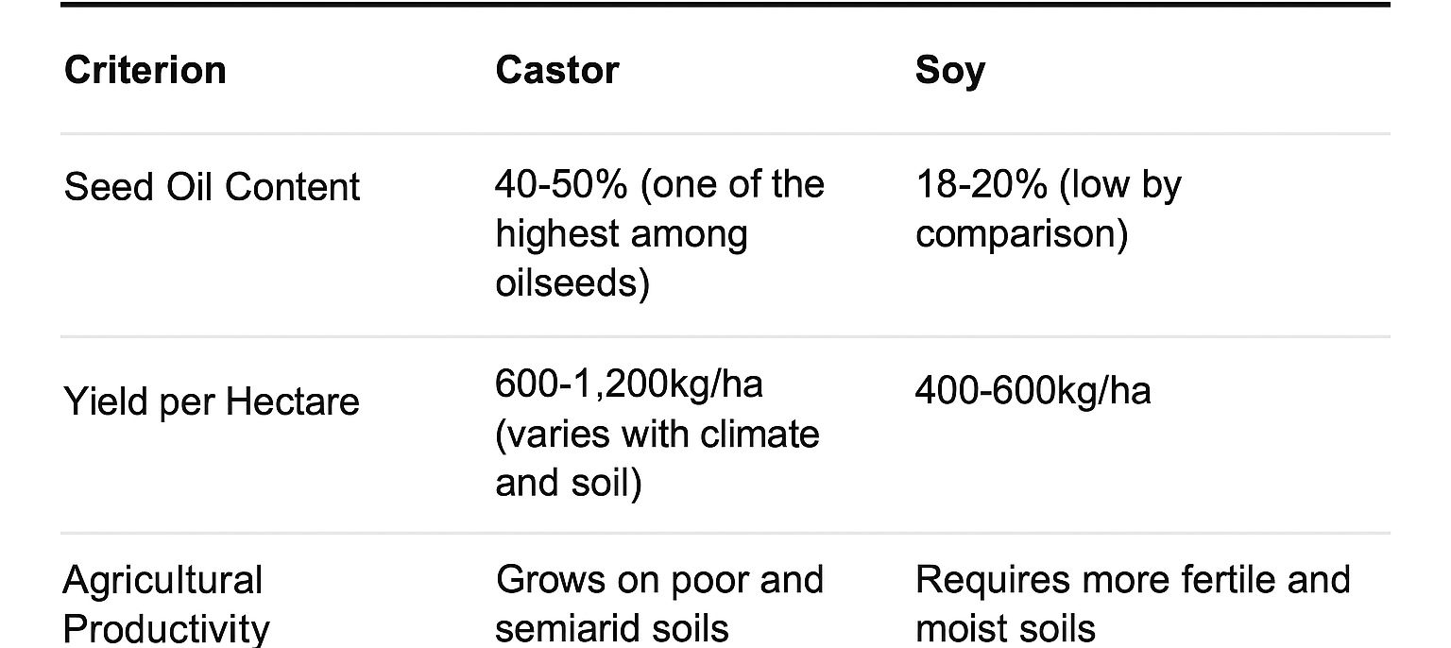
Source: Adapted by the author – 2025
The most revolutionary aspect of castor oil, however, lies in its remarkable ability to thrive in adverse soil and climate conditions. Unlike soybeans, which require fertile soils and regular water availability, castor oil plants demonstrate resilience in degraded soils, semiarid areas, and regions with irregular rainfall. This ecological flexibility opens up unprecedented possibilities for biofuel production in marginal areas that do not compete with food production, a constant dilemma in soybean cultivation. In the Brazilian context, particularly in the Northeast, castor oil plants emerge as a strategic alternative for sustainable regional development, enabling income generation in areas traditionally excluded from conventional agribusiness.
The second table compares the environmental impacts associated with the cultivation of each oilseed, including land use, agricultural input requirements, and CO₂ emissions.
Castor bean offers significant environmental advantages compared to soybeans, requiring fewer fertilizers and pesticides due to its natural resistance. This reduces problems such as river eutrophication and soil contamination, making it a more sustainable option for biofuel production.
Table 02 – Environmental Impacts
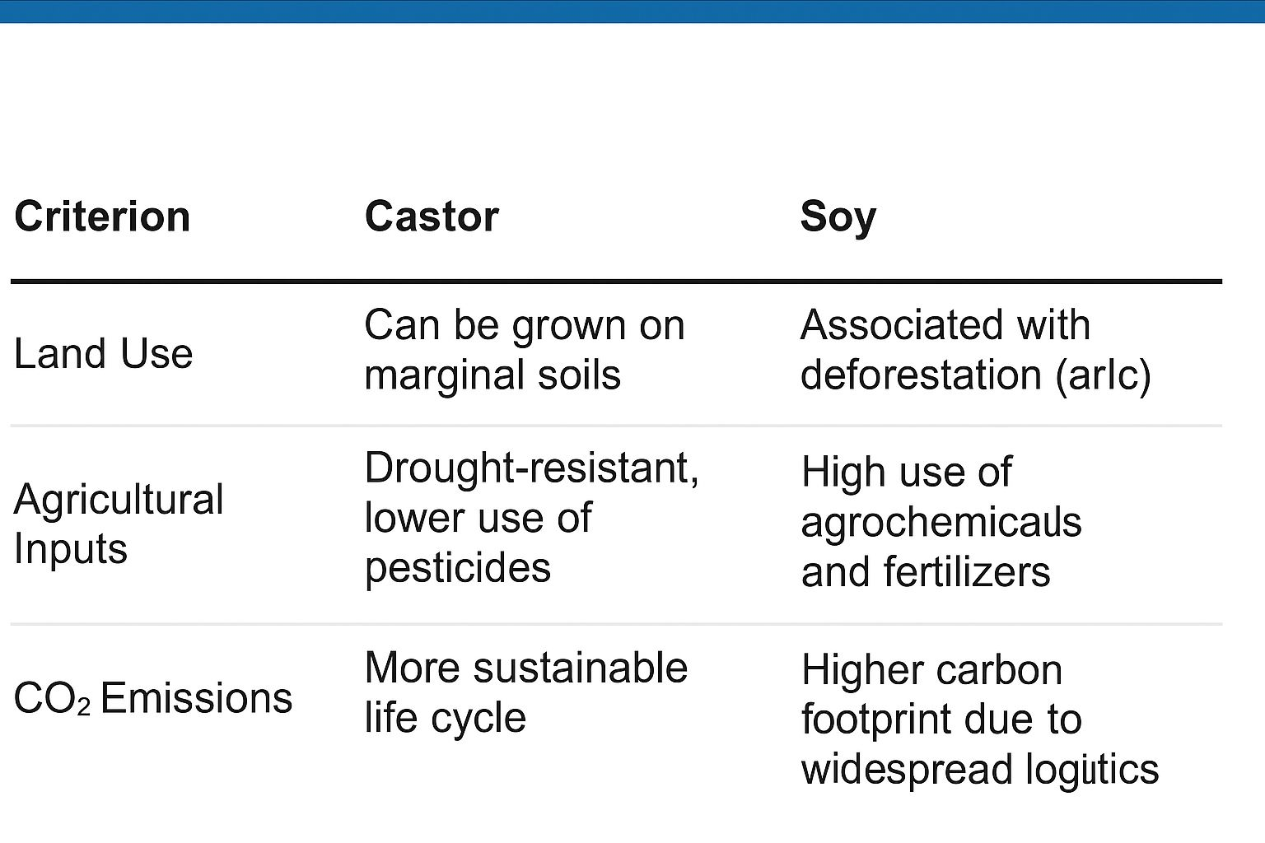
Source: Adapted by the author – 2025
From an ecosystem preservation perspective, castor oil offers an elegant solution to the dilemma between agricultural expansion and environmental conservation. While the advance of soybeans continues to put pressure on sensitive biomes such as the Cerrado and the Amazon, castor oil can be cultivated in areas already disturbed by human activity or areas with limited potential for other crops, acting as a barrier against deforestation. Life cycle analysis studies demonstrate that castor oil-based production systems have a significantly lower carbon footprint when all factors are considered, from soil preparation to final processing. This advantage becomes even more relevant in the context of climate change and the growing demand for truly sustainable energy solutions.
To assess the viability of castor oil in biofuel production, it is essential to analyze its physical and chemical parameters, which determine its behavior in engines, storage systems, and the transesterification process.
Table 3 – Typical physical and chemical parameters of castor oil
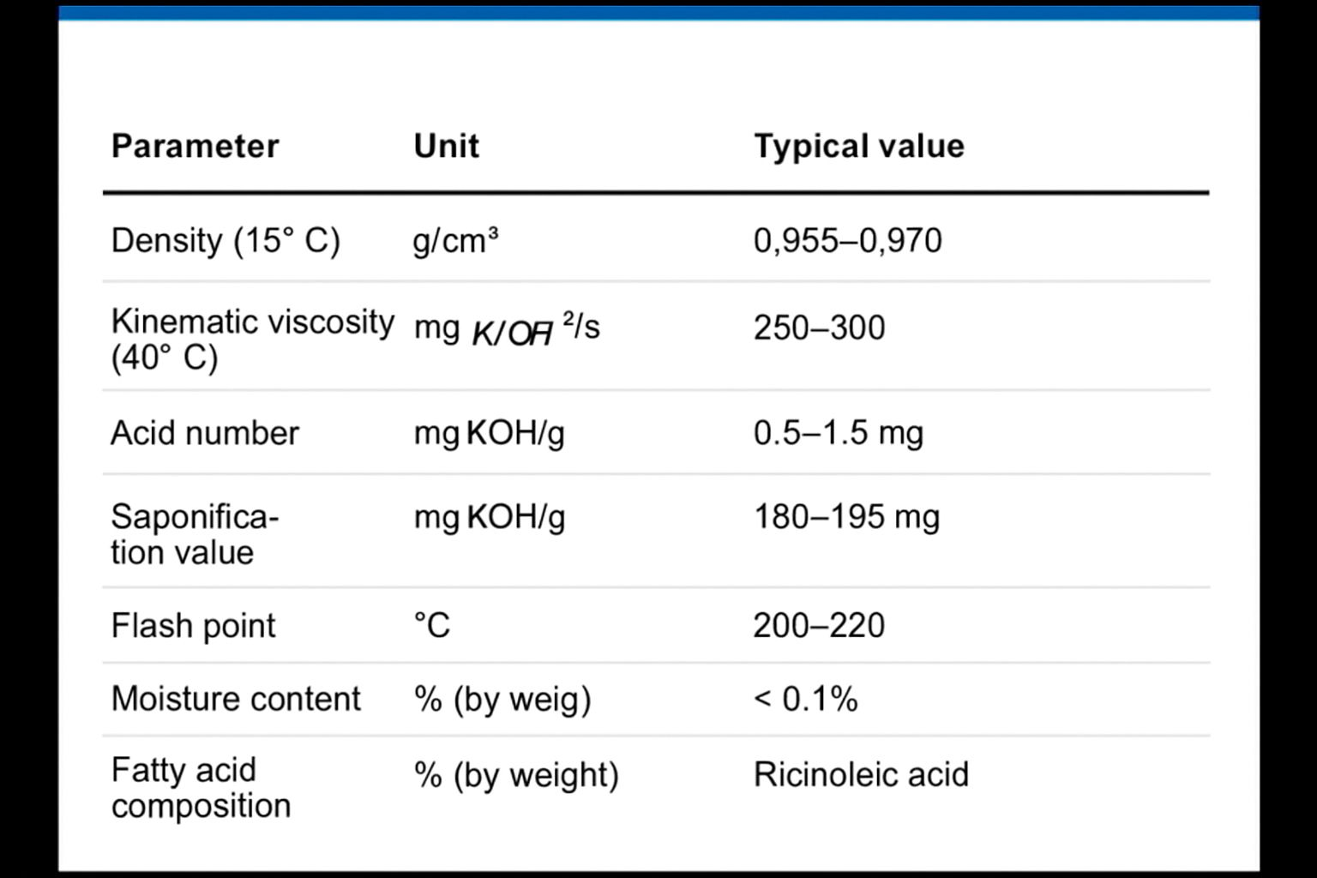
Operational care and pretreatment are required, but the oil's unsaturation and lubrication profile favors performance in diesel engines. Therefore, castor oil proves viable, provided appropriate processing routes are adopted (blending, heating, transesterification, and additives).
FINAL CONSIDERATIONS
This article aimed to comprehensively study the viability of castor bean as a raw material for biodiesel production through the acid transesterification process, achieving the proposed objectives. The main objective was to evaluate the potential of castor bean for biodiesel production using this method, considering its physical, chemical, and productive characteristics. Throughout the development process, the established specific objectives were achieved.
Initially, the advantages of castor oil over other oilseed crops were presented. The results highlighted the high productivity of castor oil, even in low-fertility soils and semi-arid regions, as well as its high ricinoleic acid content, which imparts specific properties to the biofuel produced.
The acid transesterification process, essential for the efficient conversion of castor oil into biodiesel, was then detailed. The data obtained indicate that castor oil, due to the presence of free fatty acids in high concentrations, is well suited for this method, overcoming the limitations of the traditional alkaline process and ensuring good reaction yields.
Finally, the physical and chemical properties of castor bean biodiesel were analyzed, proving satisfactory in accordance with the parameters established by the ANP (National Agency for National Petroleum and Gas Regulation). The iodine index, viscosity, and other characteristics evaluated demonstrate that the biodiesel derived from castor bean meets the required standards, albeit with some additional precautions regarding its high viscosity.
Therefore, it is concluded that castor bean has great potential as a raw material for biodiesel production, especially in regions where other crops would not be viable. Ricinus communis stands out for its agricultural adaptability, compatibility with the acid transesterification process, and the suitable properties of the biofuel it produces.
The results of this study reinforce the relevance of castor bean as a promising alternative to fossil diesel, contributing to the development of renewable and sustainable energy sources and paving the way for new research and investment in biofuels.
BIBLIOGRAPHICAL REFERENCES

ALMEIDA, T. S. et al. Transesterificação de óleo de mamona: otimização e caracterização. Biofuel Journal, v. 14, p. 79–90, 2021.

APROBIO – ASSOCIAÇÃO DOS PRODUTORES DE BIOCOMBUSTÍVEIS DO BRASIL. Biodiesel: pequenos produtores usam dendê, mamona e gordura animal. 23 maio 2023.

CARVALHO, H. S. et al. Aditivos antioxidantes para biodiesel: revisão e perspectivas. Renew. Mater., v. 7, p. 102–115, 2022.

CAVALCANTE, F. T. T.; SILVA, J. C. F.; SANTOS, J. C. R. Caracterização físico-química do óleo de mamona para fins de produção de biodiesel. Revista Brasileira de Energias Renováveis, v. 11, n. 4, p. 102–117, 2022.

CASTELLANELLI, s.n. 2016.

CASTRO, A. M. G. de et al. Viabilidade, competitividade e sustentabilidade da cadeia produtiva de mamona na obtenção de biocombustíveis.

CONGRESSO BRASILEIRO DE MAMONA, 3., 2008, Salvador. Energia e ricinoquímica: anais. Salvador: SEAGRI: Embrapa Algodão, 2008.

DANTAS, C. F. C. et al. Análise sobre a cadeia produtiva do biodiesel a partir da mamona no estado do Tocantins. EMBRAPA. Mamona: aspectos agronômicos e de produção. Empresa Brasileira de Pesquisa Agropecuária, 2011.

FERREIRA, L. M.; COSTA, F. L. Propriedades tribológicas dos ésteres de ácido ricinoleico. Tribology Letters, v. 60, n. 2, p. 1–9, 2022.

GOMES, P. R.; LIMA, D. A. Estabilidade ácida de biodiesel derivado de oleaginosas. Acta Ind. Química, v. 19, n. 3, p. 180–190, 2020.

GOMES, et al. Viabilidade e sustentabilidade da produção de biodiesel a partir do óleo de mamona (Ricinus communis L.). 2008.

MAGALHÃES, Lana. Transesterificação. Toda Matéria, [s.d.]. Disponível em: https://www.todamateria.com.br/transesterificacao/. Acesso em: 24 abr. 2025.

PETROBRAS. Agência Petrobras de Notícias. Biodiesel de mamona. 2009.

PUPULIN, et al. Mamona como matéria-prima nativa com potencial para produção de biodiesel. 2023.
SANTOS, M. A. Et al. Propriedades físico-químicas de óleos vegetais para biodiesel. Ver. Pesq. Energ. Renov., v. 8, n. 2, p. 45–56, 2022.3.

SANTOS, L. R.; ALVES, P. F.; MENDES, A. V. Produção de biodiesel a partir de óleos vegetais: alternativas sustentáveis para a matriz energética brasileira. Revista Científica Multidisciplinar Núcleo do Conhecimento, v. 7, n. 10, p. 83–99, 2020.

VEGETAL, 2., 2022, São Paulo. Anais…. São Paulo: Agron Food Academy, 2022.

