Topology Optimization of an Internal Combustion Engine Connecting Rod Using Finite Elements Method
Fernando de Alencar Silva Martinez^{1*}, Icaro Figueiredo Vilasboas², Joao Pedro Cheloni³, Abner Gabriel Miranda Araújo⁴, Lucas Lincoln Fonseca Soares⁵
¹ ² ³ ⁴ ⁵ SENAI CIMATEC, Industrial Product Development, Salvador, Bahia, Brazil
Fernando de Alencar Silva Martinez: SENAI CIMATEC Av. Orlando Gomes, 1845 - Piatã, Salvador - BA, 41650-010; f.alencar.martinez@gmail.com

Abstract: The connecting rod is a fundamental component in internal combustion engines, responsible for transmitting the combustion forces from the piston to the crankshaft. Due to the cyclic and dynamic nature of the loads it experiences, the design of the connecting rod requires a careful balance between strength, durability, and weight reduction to improve engine performance and efficiency. Advanced computational methods, such as the Finite Element Method (FEM) and topology optimization, have become essential tools in the modern design process of such mechanical components. This study presents an application of topology optimization on a connecting rod of an internal combustion engine using the finite element method. Initially, data on piston pressure throughout the crankshaft rotation was collected to accurately define the loading conditions. These data, combined with boundary conditions representative of the engine operation, were used in multibody dynamics simulations and structural analyses to determine the dynamic loads acting on the connecting rod under realistic operating conditions. Subsequently, a topology optimization approach was applied to the component with the objective of minimizing its mass while maintaining the structural integrity. A comparison of stress distributions was conducted between the optimized and non-optimized models. The results demonstrated that the optimized connecting rod achieved a weight reduction of 12.4%, while the maximum stress in the optimized geometry remained below approximately 73.2% of the material’s yield strength, indicating that the structural integrity was preserved. The integration of multibody dynamics, finite element analysis, and topology optimization in this work highlights an effective methodology for enhancing the design of engine components, contributing to improved fuel efficiency and reduced emissions by lowering the inertial forces within the engine.
Keyworks: Topology optimization. Finite element method. Connecting rod. Computational simulation.

1.Introduction

The connecting rod is a critical component in internal combustion engines, and all combustion engines have at least one of this component. It is responsible for transmitting the force generated by the combustion process from the piston to the crankshaft.[1] Due to its cyclic loading conditions and importance in engine performance and durability, its structural design must balance strength, stiffness, and weight [2]. The Finite Element Method (FEM) is a numerical technique widely employed for the structural analysis of engineering components, allowing the approximation of complex geometries and loading conditions through discretization into smaller elements [3]. FEM provides detailed insights into stress distributions, deformations, and dynamic responses, making it an essential tool in the design and evaluation of mechanical parts such as connecting rods in internal combustion engines. One of the FEM analysis types is motion analysis, that combines multibody dynamics (MBD) with finite element analysis (FEA) to study how structures respond to forces, accelerations, and kinematic constraints in moving systems. Segundo Shabana 2020 [4], numerous real-world engineering systems can be effectively represented as multibody systems, like machines, mechanisms, vehicles, robotic manipulators, and space structures. The elements can be treated as rigid or deformable, and the bodies may undergo large relative translational and rotational displacements.
One configuration commonly used in this type of analysis is set rigid bodies. A rigid bodies models are associated with mechanisms and are described as motion without any strain occurring. For each rigid body mode, there is no relative displacement between nodes of the body.
Topology optimization, on the other hand, is an advanced computational design approach aimed at determining the optimal material layout within a given design space, subject to performance constraints such as stiffness and strength [5]. The Topology optimization is applied by iteratively removing or redistributing material, and it enables significant weight reduction while ensuring that critical stress and deformation limits are not exceeded. The integration of FEM with topology optimization facilitates the development of lightweight, high-performance components by accurately predicting the structural behavior and guiding material distribution. In recent years, topology optimization has emerged as an effective design strategy to reduce weight while maintaining structural integrity, particularly in high-performance applications [6]. The main objective of this study is to apply FEM-based topology optimization to a connecting rod, of a internal combustion engine, to minimize its mass without exceeding material yield limits.

2.Methodology

The methodology employed in this work was based on collecting information for analysis inputs, such as pressures, dimensions, and material properties. Subsequently, the software Altair Inspire 2025 was used to conduct motion, structural, and topology optimization analyses.
2.1. Pressure in cylinder chamber

The cylinder pressure curve as a function of the crankshaft angle was derived from the work of Souza 2015 [7], which conducted a thermodynamic study on a Palio 1.0 MPI engine. In Souza’s study, a numerical simulation of Otto-cycle internal combustion engines was performed, establishing the dependence of temperature and pressure on crankshaft angle while applying the first law of thermodynamics to model heat release. Graphic 1 shows the piston head force curve obtained by Souza, which was adopted in this work.

Graphic 1. Force in cylinder head over time.
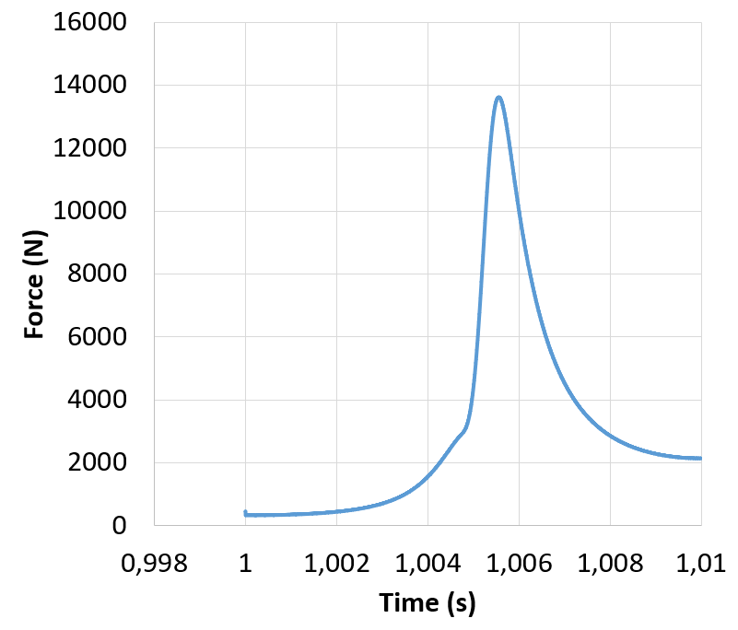

2.2 Connecting rod model

Based on Souza's 2015 study, the crank-connecting rod mechanism's dimensions were extracted from the engine. This information is presented in Table 1.

Table 1. Dimensions used in the mechanism
Data | Value | Units
Cylinder bore | 76 | mm
Connecting rod lenght | 100 | mm
Crankshaft Radius | 27.4 | mm
Connecting rod weight | 123.35 | g

With the defined dimensions, the CAD model of the connecting rod was generated using SolidWorks 2023, as shown in Figure 1.

Figure 1. CAD model obtained for the connecting rod.
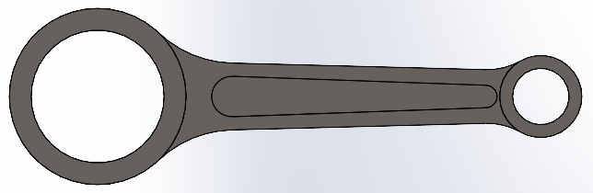

The material used was a steel alloy, used in the work of Mamidanna 2010. [8] It was performed a load analysis of a connecting rod for a single cylinder. The properties of the steel alloy can be seen in Table 2.

Table 2. Properties of the Alloy Steel.
Alloy Steel
Preperty Name | Value | Units
Elastic modulus | 72.12 | GPa
Poisson's ratio | 0.28 | NA
Shear modulus | 79 | GPa
Mass density | 7700 | kg/m³
tensile strength | 723.8 | MPa
Yield strength | 620.4 | MPa

2.3 Multibody and structural analysies

The multibody and structural analyses were performed using Altair Inspire 2025. For the simulation setup, a force curve was applied to the piston head based on Graphic 1. A maximum engine speed of 6000 RPM was defined to simulate the worst-case scenario for the component under study. The other parts included in the motion simulation were: the crankshaft, piston pin, and piston head, as shown in Figure 2.

Figure 2. Altair Inspire Motion model.
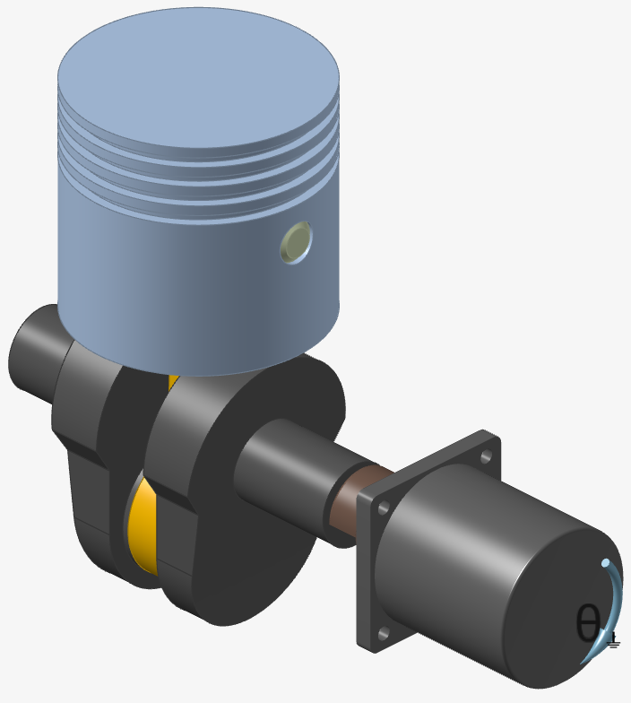

All bodies were defined as rigid. The analysis was performed using the Motion feature with frictionless joints and gravity disabled to streamline the simulation, which had high computational costs. To avoid sudden acceleration, the mechanism was driven at a constant rate by a virtual motor until it reached 6000 RPM over 1 second.
After this, an analysis time of 0.01 seconds was added, during which the piston completes one full revolution at constant speed. This 0.01 second interval was the critical timeframe for extracting system forces. From the multibody simulation results, a structural analysis was conducted with the connecting rod modeled as a flexible body using the finite element method (FEM). The element size was set to 1 mm.

2.4 Topology optimization

From the analysis results, a topology optimization was performed with the objective of maximizing stiffness while reducing the original part mass to approximately 30%. The optimization considered all data points within the time interval from 1 to 1.01 seconds. The resulting geometry from the topology optimization analysis was then processed in SolidWorks to create a new CAD model.
The processed CAD model was reinserted into the Inspire analysis. Finally, a comparison was made between the optimized part and original part regarding mass and stress values.

3. Results and Discussion

From the motion and structural analyses, the maximum von Mises stresses in the original part were obtained, as shown in Figure 3.

Figure 3. Von mises stress in original connecting rod.
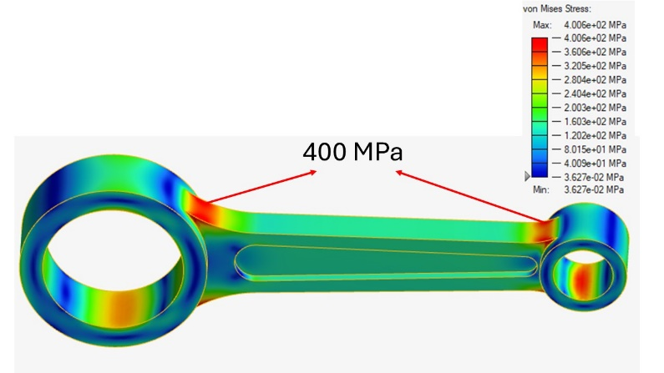

The results revealed that the peak stresses reached approximately 64.5% of the material's yield strength. These analysis results were then used to generate the topology optimization, which produced the geometry shown in Figure 4.

Figure 4. Result of the topology optimization.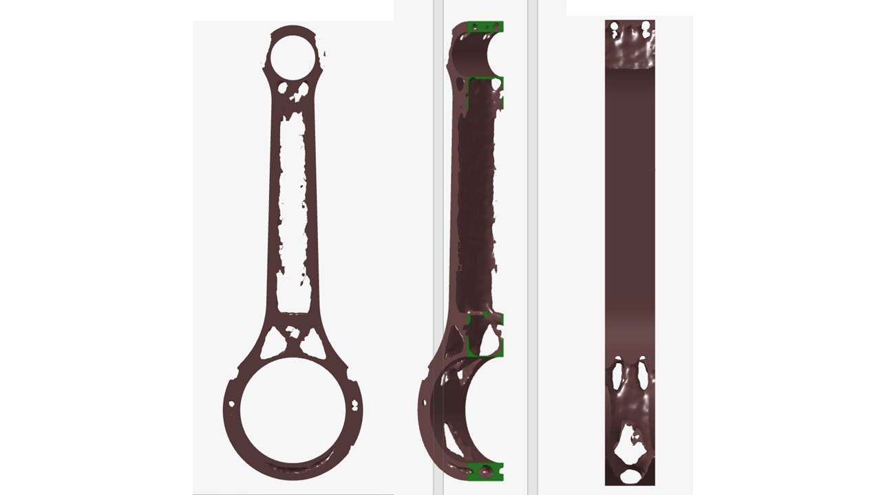

The generated geometry was used as a baseline to identify potential mass reduction areas. However, the material removal was observed to be excessively aggressive, necessitating geometric modifications to achieve a manufacturable component. Using the optimized representation and subsequent SolidWorks modifications, the final geometry was successfully generated as shown in Figure 5.

Figure 5. New CAD generated for the analysis.
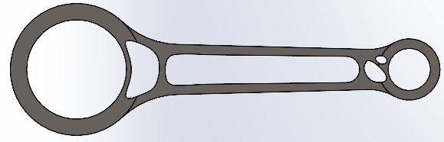

The optimized part's calculated mass was 108.3 grams, representing a 12.4% reduction from the original part's mass.
Finally, multibody and structural simulations were repeated to determine the maximum von Mises stresses in the optimized component, as illustrated in Figure 6.

Figure 6. Von mises stress in optimized connecting rod.
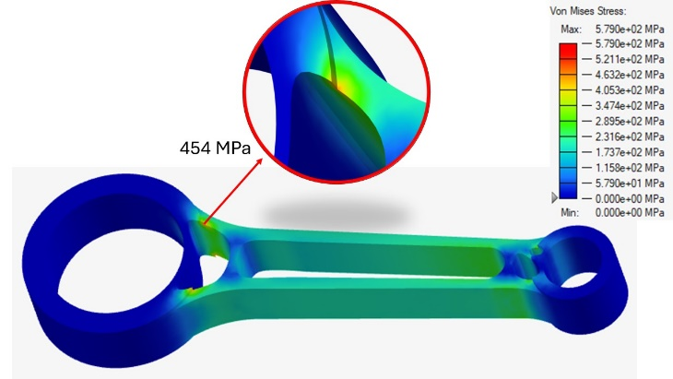

During the specified time intervals, the peak stresses were observed at approximately 73.2% of the material yield strength, resulting in a yielding safety factor of about 1.36.
It is important to note that the stress gradient exhibits certain values outside the time interval of interest for this analysis (prior to 1 second). Specifically, a stress value of 579 MPa occurs at earlier moments in the simulation and can therefore be disregarded for the purposes of this study.

4. Conclusion

Based on the analysis results, it was observed that the von Mises stresses did not increase significantly, confirming the viability of mass reduction for the connecting rod in this type of analysis. The mass reduction in the connecting rod is particularly important for high-performance applications or long-term fuel efficiency, as many engines utilize multi-cylinder configurations that benefit more substantially from this optimization. However, as a suggestion for future works, it would be valuable to perform a more comprehensive analysis incorporating friction, fatigue, and buckling effects to ensure more precise validation of the studied component.

Acknowledgement

The authors would like to thank SENAI CIMATEC for the support on research, development and innovation projects.

References

- Silva, Rafael A. L. Projeto Mecânico de Biela Automotiva Baseado em Otimização Estrutural. Campinas: Universidade Estadual de Campinas; 2013.
- Ferguson CR, Kirkpatrick A. Internal combustion engines: applied thermosciences. Chichester, West Sussex, United Kingdom: John Wiley & Sons, Inc; 2016.
- Madier D. Practical Finite Element Analysis for Mechanical Engineers. Canada: FEA Academy; 2020.
- Shabana A. Dynamics Of Multibody Systems. S.L.: Cambridge Univ Press; 2020.
- Morishita, G. S. D. L. Otimização Topológica de Mecanismo de Quatro Barras. Curitiba: Universidade Tecnológica Federal do Paraná; 2015.
- Gonçalves, Gonçalo Martins. Análise dos problemas de não-linearidade e singularidade em otimização topológica de estruturas e materiais com critérios de tensão. Lisboa: Universidade Nova de Lisboa; 2017.
- Souza, João Paulo S. T. Análise de um motor à combustão interna: Simulação numérica do ciclo Otto. Brasília: Faculdade UnB Gama; 2015.
- Mamidanna, A.M. Design and Load Analysis of a Connecting Rod. Northridge, California State University; 2010.

