Sustentoy: A Pedagogical Manual for Building Toys with Recyclable Materials

Davi dos Santos da Rocha¹, Paulo Manoel dos Santos Frias², Taís Alves Costa Matos³, Weslei de Oliveira Santos⁴, Pietro Carlos Gonçalves Conceição⁵, Clariane Teixeira Pessoa Mamona⁶

^{1,2,3,4} Senai Cimatec, NEM, Salvador, Bahia, Brasil
^{5,6} University Senai Cimatec, NEPE, Salvador, Bahia, Brasil
*Corresponding author: University Senai Cimatec; NEPE; clariane.pessoa@fieb.org.br

Abstract: This study investigates the impact of a pedagogical activity involving the construction of toys from recyclable materials on the development of socioemotional and cognitive skills, with a focus on consolidating soft skills among high school students in technical education. The main objective was to stimulate creativity, teamwork, concentration, problem-solving, and manual dexterity through interdisciplinary workshops aligned with educational guidelines emphasizing sustainability and student protagonism. A descriptive quantitative method was used, with data collected via questionnaires administered to first-year technical students during integrated workshops. The activity involved collaborative prototyping of sustainable toys, combining discussions on environmental awareness with practical tasks focused on planning, designing, and assembling products from discarded materials. Results indicated promotion of creativity, improvement in motor coordination, and enhancement of social sensitivity, as students collaborated effectively and adapted to challenges during toy construction. The project strengthened responsibility, engagement, and teamwork while fostering empathy and reflection on sustainable practices. Some students showed difficulty maintaining focus, suggesting the need for adjustments such as dividing tasks into smaller stages and incorporating reflective pauses. Overall, participants expressed motivation to engage in future projects, demonstrating the effectiveness of manual, creative, and cooperative practices for fostering socioemotional competencies. These findings highlight the value of experiential, interdisciplinary approaches for strengthening soft skills, promoting environmental education, and preparing students to face contemporary societal challenges in line with the Brazilian National Common Curricular Base (BNCC).

Keywords: Creativity. Soft skills. Environmental education. Collaborative learning. Motor skills.

1. INTRODUCTION
In the context of the New High School (NEM), there is a growing demand for active methodologies that promote student protagonism and the integral development of students [1]. However, many technical education students still face challenges related to the lack of stimulation of creativity, concentration, teamwork, and the development of fine motor skills, especially in more theoretical courses or those excessively mediated by screens [2, 3].
The school routine, often centered on content-heavy and digital materials, tends to reduce the space for practical, collaborative, and creative experiences that integrate different knowledge and skills [1, 2, 4].
The World Health Organization highlights that children and adolescents should spend less time sitting and more time engaged in playful and active experiences, benefiting their physical, cognitive, and socioemotional development [5].
In this scenario, the Sustentoy project proposes the creation of sustainable and recyclable toys, aimed at technical education students, as an interdisciplinary learning tool. The proposal seeks to encourage creativity, collaboration, and environmental awareness, while developing practical and psychomotor skills through the construction of toys made with recyclable materials. This approach allows the integration of knowledge areas such as Arts, Science, Environment, and Technology, promoting a more active and meaningful experience in the teaching-learning process [6, 7].
These proposals are also in line with the updated version of the Brazilian National Common Curricular Base, which emphasizes competencies such as responsibility, empathy, and critical thinking [1, 8]. This approach also responds to the demands of the Fourth Industrial Revolution, which requires education to develop adaptable, creative, and technology-integrated skills [9].
Sustentoy is based on the guidelines of the National Common Curricular Base (BNCC) and the formative itineraries of the New High School, allowing the customization of activities according to students' interests and the possibilities of the school context. The toy construction will be carried out collaboratively, stimulating teamwork, creative reasoning, and reflection on sustainability, conscious consumption, and the circular economy [1, 7].
The Sustentoy project proposal arises as a response to the need for pedagogical strategies that stimulate creativity, concentration, teamwork, and the development of practical skills in technical education students [2, 3, 10]. In an increasingly digitalized educational context, it is essential to offer concrete experiences that foster meaningful learning, autonomy, and youth protagonism [1, 3, 11].

Research shows that socioemotional skills such as teamwork, perseverance, and adaptability have a significant impact on academic and professional success, being as important as cognitive abilities [12].
By proposing the construction of toys with recyclable materials, the project acts from the perspective of environmental education, the development of socioemotional skills, and citizenship formation, by encouraging the reuse of resources and the practice of the circular economy [1, 7]. The manual and collaborative activity also strengthens student engagement and promotes interdisciplinarity, favoring learning that goes beyond formal content and connects with contemporary society's challenges [6, 7, 13].
The approach favors the development of general competencies from the BNCC, such as critical thinking, empathy, responsibility, and cultural repertoire, in addition to integrating relevant technical and practical knowledge for professional training [1, 9, 13].
Develop an interactive digital manual with sustainable and recyclable toys, aimed at Technical Education students, to stimulate creativity, teamwork, concentration, and the development of motor skills, in an interdisciplinary way and aligned with the BNCC and the formative itineraries of the New High School.
- Stimulate students' creativity and artistic expression through the construction of recyclable toys;

- Promote collaborative work among students, strengthening socioemotional skills and coexistence abilities;
- Develop motor and practical skills, contributing to active and concrete learning;
- Encourage the reuse of materials and reflection on conscious consumption and sustainability;
- Integrate different knowledge areas interdisciplinarily, especially Arts, Environment, Science, and Technology;
- Align the proposed activities with the BNCC components and the NEM formative itineraries, favoring meaningful and contextualized learning.

2. MATERIALS AND METHODS

This study is characterized as a descriptive quantitative research, using numerical data to analyze participants' perceptions about interdisciplinary practical activities. This method was chosen to objectively measure perceptions in a comparable way, identifying patterns and trends in the results. The technical procedure corresponds to field research conducted in the school environment through integrated workshops within the Curricular Unit (UC) Research and Experience of Professions.
The target population consisted of first-year students of the New High School (NEM) in 2024, enrolled in the technical courses of Biotechnology, Mechatronics, and Systems Development. All students in these classes participated in the workshops, constituting a census sampling. Additionally, visitors to the exhibition were invited to answer an external questionnaire, forming a distinct respondent group.
Data collection was carried out through digital questionnaires made available via Microsoft Forms, limited to students participating in the workshops and visitors to the internal exhibition held at the institution.
The adoption of project-based learning methodologies allows the development of 21st-century skills, fostering autonomy, problem-solving, and collaboration [15].

The integrated workshops followed these steps:

- Formation of heterogeneous groups based on students’ skills and interests.
- Presentation of real challenges related to social and environmental problems, emphasizing sustainability and solutions for low-income contexts.
- Practical execution using simple and low-cost materials, prioritizing manual prototyping.
- Correlation with industrial innovation by simulating prototypes applicable to real production sector issues.
- Final presentation of prototypes in an internal exhibition open to the school community and external visitors.

3. RESULTS AND DISCUSSION
The analysis of data collected through the questionnaire applied to high school students revealed relevant aspects in the development of socioemotional and cognitive skills, especially those associated with soft skills, through the toy-making activity.
When asked about the stimulation of creativity, half of the participants stated that creating the toy helped them a lot to think creatively, while the other half reported that this occurred to a lesser extent (Figure 1). This result indicates that the activity promoted creative thinking for all participants, although at different levels of intensity.
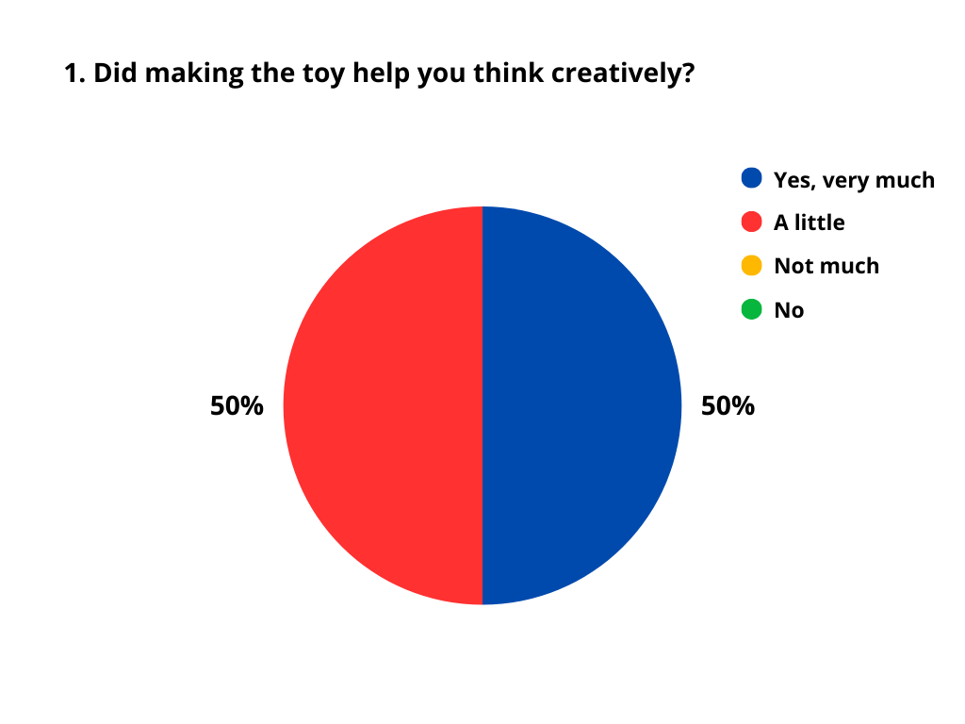
Figure 1 – Answers to the question “Did making the toy help you think creatively?”

Regarding the development of manual skills, all students responded positively, either directly (“Yes”) or emphatically (“Of course”), confirming that the activity contributed to improving motor coordination and practical dexterity (Figure 2).
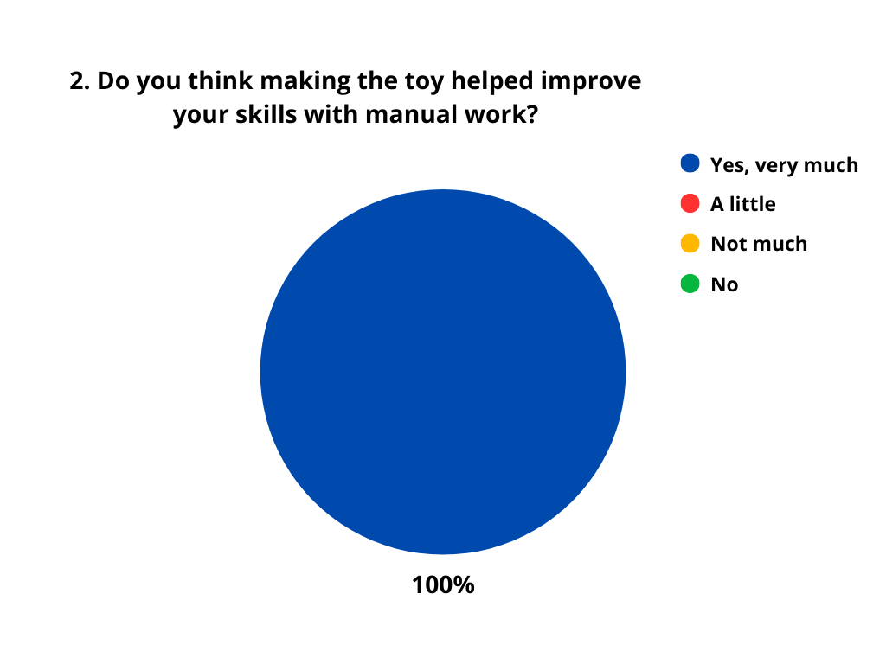
Figure 2 – Answers to the question “Do you think making the toy helped improve your skills with manual work?”

As for the ability to maintain focus until completing the task, most students stated they managed to concentrate “a little,” while a smaller portion answered “no” (Figure 3). This indicates that there is still some difficulty in sustaining attention during practical activities, pointing to the need for pedagogical strategies that foster concentration.
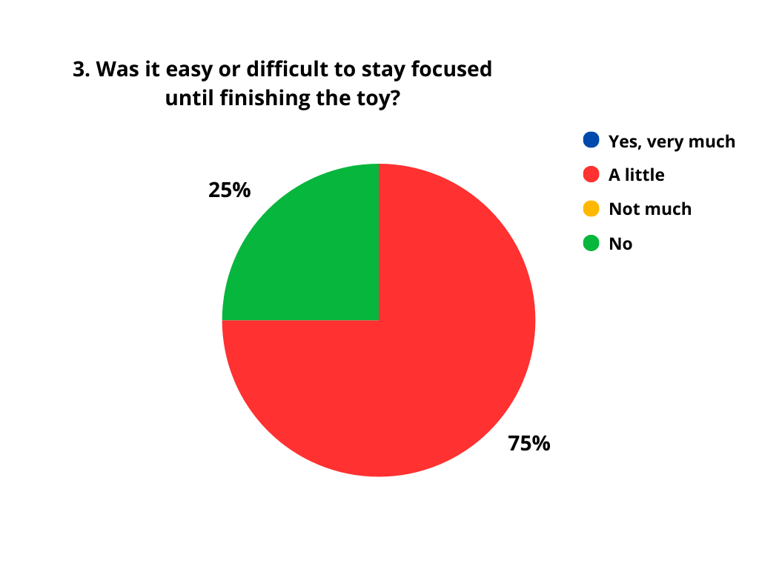
Figure 3 – Answers to the question “Was it easy or difficult to stay focused until finishing the toy?”

When asked whether the experience influenced the way they think about helping other people, most answered “a little,” while a smaller portion responded “not much” (Figure 4). This suggests that the collaborative experience fostered some degree of social reflection and empathy, although moderately.

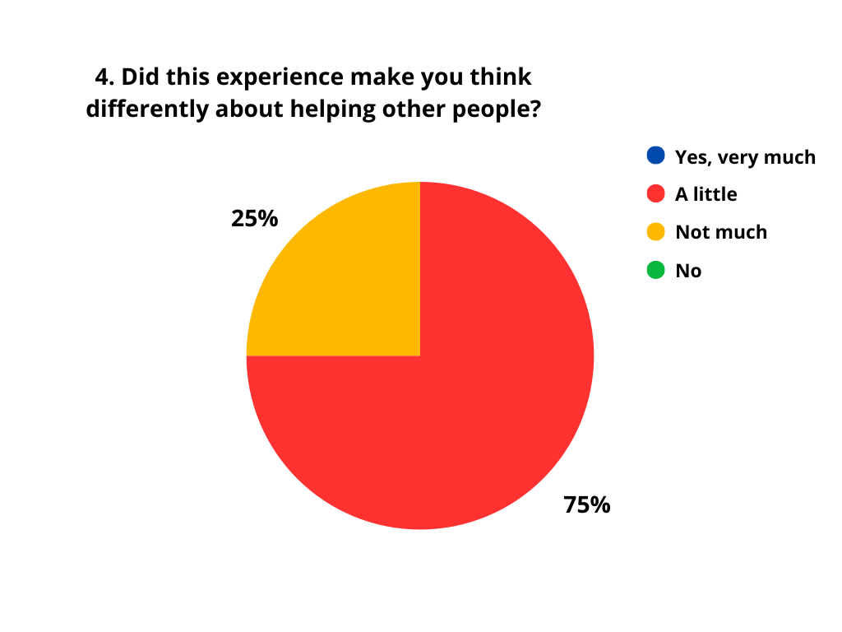
Figure 4 – Answers to the question “Did this experience make you think differently about helping other people?”

Finally, all participants expressed interest in joining more projects related to environmental care (Figure 5), reinforcing the potential of this methodology to engage students in socio-environmental causes.
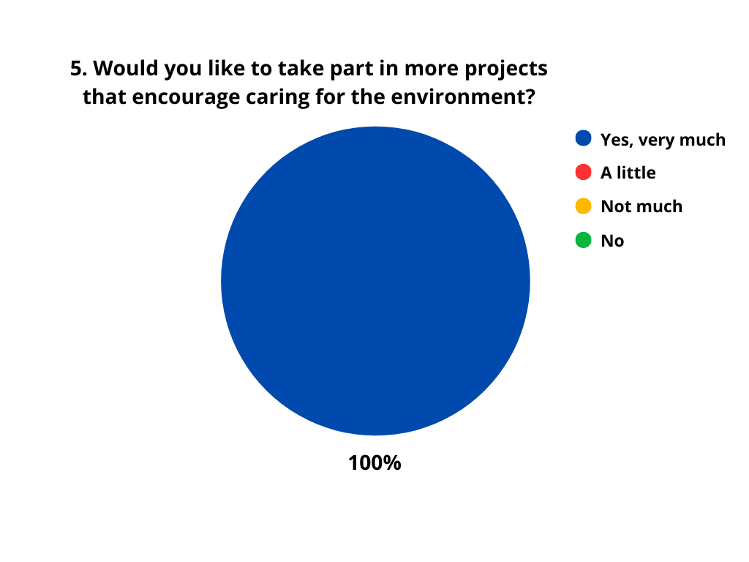
Figure 5 – Answers to the question “Would you like to take part in more projects that encourage caring for the environment?”

Based on these results, the project outlined the following expected outcomes:
- Stimulation of creativity as a tool for innovative problem-solving;
- Development of concentration and persistence in practical activities;
- Promotion of empathy and collaborative thinking;
- Strengthening of teamwork and interpersonal communication skills.
These findings reinforce the importance of pedagogical proposals that integrate manual and collaborative practices to develop soft skills, which are essential for the personal and professional growth of high school students.
Studies in technical education contexts confirm that project-based learning fosters socioemotional skills and enhances student engagement [17].
4. CONCLUSION
The toy-making activity proved effective in developing socioemotional and cognitive skills in high school students, particularly soft skills such as creativity, collaboration, empathy, and innovative thinking. It also enhanced motor coordination and manual dexterity, essential for overall development. However, some students faced challenges in maintaining focus, indicating the need for strategies that foster attention and persistence.
The collaborative process promoted social sensitivity and increased motivation for environmental projects, highlighting the potential of this methodology to encourage youth socio-environmental protagonism. These results reinforce the importance of integrating manual, creative, and cooperative practices in education, as advocated by Morin [16], to shape students capable of acting in a complex world.
To overcome the challenges identified, future applications should include measures such as dividing tasks into smaller stages, adding reflective pauses, diversifying activities, rotating group compositions, and incorporating peer feedback. Such practices can maximize the benefits of the methodology, ensuring stronger impacts on students’ socioemotional and cognitive development.

5. REFERENCES

[1] Amarante S. O uso das telas e o desenvolvimento infantil [Internet]. Rio de Janeiro: Instituto Fernandes Figueira – Fiocruz; 2022 [citado 2025 ago 2]. Disponível em: https://portal.fiocruz.br/noticia/o-uso-das-telas-e-o-desenvolvimento-infantil
[2] Brasil. Ministério da Educação. Base Nacional Comum Curricular – BNCC. Brasília: MEC; 2017.
[3] Brasil. Estatuto da Criança e do Adolescente (ECA). Lei n.º 8.069, de 13 de julho de 1990. Brasília: Diário Oficial da União; 1990.
[4] Cetin Dag N, Avci D, Yildirim S, Isik D. Children’s only profession: Playing with toys. North Clin Istanbul. 2021;8(4):414–20.
[5] Dag NC, Avci D, Yildirim S, Isik D. Brinquedos e desenvolvimento infantil: aspectos motores e cognitivos. North Clin Istanbul. 2021.
[6] Istenič A, Rosanda V, Gačnik M. Surveying parents of preschool children about digital and analogue play and parent–child interaction. Children (Basel). 2023;10(2):251.
[7] Nobre JNP, Ribeiro CCC, Pinho L, Pereira ER, Silva LA, Pereira E. Fatores determinantes no tempo de tela de crianças na primeira infância. Cien Saude Colet. 2021;26(3):1127–36.
[8] Sociedade Brasileira de Pediatria. Manual de orientação #MenosTelas #MaisSaúde. Rio de Janeiro: SBP; 2020.
[9] Sociedade Brasileira de Pediatria. Crianças no celular: saiba o tempo ideal para cada idade [Internet]. Rio de Janeiro: SBP; 2022 [citado 2025 ago 2]. Disponível em: https://www.sbp.com.br/imprensa/detalhe/nid/criancas-no-celular-saiba-o-tempo-ideal-para-cada-idade
[10] Secretaria Municipal de Educação de São Paulo. Estudantes transformam recicláveis em brinquedos e aprendem sobre sustentabilidade [Internet]. São Paulo: SME-SP; 2022 [citado 2025 ago 2]. Disponível em: https://educacao.sme.prefeitura.sp.gov.br
[11] World Health Organization. To grow up healthy, children need to sit less and play more [Internet]. Geneva: WHO; 2019 [citado 2025 ago 2]. Disponível em: https://www.who.int/news/item/24-04-2019-to-grow-up-healthy-children-need-to-sit-less-and-play-more
[12] Brasil. Ministério da Educação. Base Nacional Comum Curricular – BNCC. Brasília: MEC; 2018.
[13] Schwab K. A quarta revolução industrial. São Paulo: Edipro; 2016.
[14] Heckman JJ, Kautz T. Hard evidence on soft skills. Labour Econ. 2012;19(4):451–64.
[15] Bell S. Project-based learning for the 21st century: Skills for the future. Clear House. 2010;83(2):39–43.
[16] Morin E. A cabeça bem-feita: repensar a reforma, reformar o pensamento. 19ª ed. Rio de Janeiro: Bertrand Brasil; 2020.
[17] Costa H, Silva M, Andrade R. A aprendizagem baseada em projetos e o desenvolvimento das habilidades socioemocionais no ensino técnico. Rev Bras Educ Prof Tecnol. 2021;4(1):45–60.

