Investigation of Carbon Dioxide effect on Adsorption Behavior for Natural Gas Dehydration

Rafaela Martins Lazarini^{1*}, João Victor Santos Macena¹, Tamires dos Reis Menezes¹, Kimberly Paim Abeyta¹, Igor Oliveira de Freitas Campos¹, Amaro Gomes Barreto Junior^{1,2}
¹ SENAI CIMATEC, Petróleo e Gás, Salvador, Bahia, Brazil
² EPQB - Postgraduate Program in Chemical and Biochemical Process Engineering, Escola de Química (EQ), Universidade Federal do Rio de Janeiro, Rio de Janeiro, Brazil
*Corresponding author: rafaela.lazarini@fbter.org.br

Abstract: Dehydration is a crucial process to enable the use of pre-salt natural gas as a viable energy source, since it removes water and prevents pipeline corrosion and hydrate formation. The development of accurate and robust models based on industrial data is essential for optimizing the design and operation of dehydration units. Alternative modeling approaches that balance accuracy and computational efficiency play a key role in this optimization. Nevertheless, the simplifications adopted to improve computational efficiency may adversely affect model’s predictive accuracy. This work aims to evaluate a benchmark adsorption model and its inherent limitations, as well as to perform a sensitivity analysis to assess the impact of CO₂ at high pressure by incorporating fugacity of water into the equilibrium loading calculations. The results show that the isotherm model that was capable of describing both the steep initial increase and the plateau associated with multilayer adsorbate-adsorbate interactions was the Redlich-Peterson model. The sensitivity analyses demonstrate that incorporating fugacity for water is essential for accurately modelling the influence of CO₂ on adsorption equilibrium for water, with the CO₂ molar fraction playing a key role in breakthrough time. Unlike temperature, which exhibited a nearly constant average difference in breakthrough time, feed pressure showed a strong correlation with non-ideal behavior.

Keywords: Natural gas. Dehydration at high pressure. Thermodynamic non-idealities. Modeling. Simulation.

1. Introduction
Natural gas is widely used as an energy source due to its high calorific value. In the Brazilian pre-salt fields, this gas is extracted under high pressure and temperature conditions, and is also found in the presence of contaminants such as H₂O and CO₂. Therefore, purification process are necessary [1]. Among them, dehydration is essential to reduce pipeline corrosion caused by the presence of water and to prevent hydrate formation under high-pressure conditions [2].
The development of accurate and robust models based on industrial data is essential for optimizing the design and operation of dehydration units. Although robusts phenomenological models provide high-fidelity descriptions of process dynamics and mass transfer phenomena, their computational complexity can be prohibitive for real-time applications or large-scale simulations [3]. Consequently, alternative modeling approaches that balance accuracy and computational efficiency are highly valuable, as they enable faster simulations while maintaining reliable predictions of process performance. Nevertheless, the simplifications adopted to improve computational efficiency may adversely affect model’s predictive accuracy under the specific thermodynamic and operational conditions characteristic of Brazilian pre-salt environment.
Based on this context, the main objective of the present work is to evaluate a benchmark adsorption model and its inherent limitations, as well as to perform a sensitivity analysis to assess the impact of carbon dioxide content, temperature and pressure by incorporating fugacity for water into equilibrium loading calculations.
2. Methodology
A literature review was conducted to study the models available to describe natural gas dehydration. Besides, Campbell model [5] was studied as a possibility to predict breakthrough time to dehydration process using algebraic equations. After that, an study of different isotherms was conducted to identify the best fit with Campbell data [5]. With this result, inclusion of fugacity in isotherm calculations is proposed to describe the influency of CO₂ presence in breakthrough time. Finally, a sensitive analyses of the system were evaluated.
3. Modeling of adsorption process
Adsorption is the most applied process in the offshore industry for water removal. The development of models to describe the system is important to scale the adsorption vessels and operation monitoring, predicting and optimizing the separation.
Several models are available in literature. Cavalcante et al. (2023) [1] modeled the adsorption vessel using a system of partial differential equations (PDEs), involving mass, momentum, and energy balances, in addition to considering an adsorbent life factor. This model was validated with industrial data, describing the system with a 2.6% error in the early stage of adsorbent life. Nonetheless, for aged adsorbents, the results were not satisfactory.
Saadat et. al (2019) [2] also employed PDEs to evaluate the influence of a multilayer bed. The conclusion was the insertion of silica gel in the bed increases the breakthrough time.
Ghasemzadeh et al. (2022) [4] developed a model to describe water and heavy hydrocarbon removal from natural gas using Temperature Swing Adsorption (TSA) system. The adsorption equilibrium was represented by Langmuir mono-component model. A PDE system was solved, involving mass and energy balances coupled to momentum equation.
Furthermore, Campbell et al. (1992) [5] is the classical reference to estimate the adsorption vessel volume to TSA operation. This model also brings the prevision of the breakthrough time to dehydration process using algebraic equations. This model employs simplifications that deviates its application to the pre-salt exploration reality, as it neglected the presence of CO₂.
Solution of PDEs remains the most accurate way to represent the phenomenology involved in the adsorption process. This type of model showed a great agreement with industrial data, because it has few simplifications during development. Nonetheless, it demands more computational effort to obtain the solution.
Starting from PDEs, it is possible to introduce some simplifications to approximate the model to an algebraic system. This approach can be solved easier than PDEs system. Conversely, simplifications can distance the results from reality, especially in systems that operate in extreme conditions and in the presence of another components in addition to the adsorbate.
3.1 Simplified model
For an adsorption system applied to natural gas dehydration, the mass balance without axial dispersion effects can be expressed in Equation 1:
$$v\frac{∂C_{i}}{∂z}+\frac{∂C_{i}}{∂t}+\left(\frac{1-ε}{ε}\right)ρ_{p}\frac{∂q_{i}^{*}}{∂t}=0$$ |  | (1)
where $v$ is the intersticial gas velocity, $C_{i}$ is the component concentration in gas phase, $ε$ is the bed porosity, $ρ_{p}$ is the particle density and $q_{i}^{*}$ is the concentration in the adsorbed phase.
To solve Equation 1, it is necessary to solve a Differential Algebric Equation System (DAE) formed by Equation 1 coupled to na algebric equation that represent the adsorption isotherm equilibrium. With the purpose to simplify the system, Alves et al. 2024 [6] rewrote the loading derivative to allow the direct solution, with $q^{*}=f(C)$:
$$\frac{∂q_{i}^{*}}{∂t}=\frac{∂q_{i}^{*}}{∂C_{i}}\frac{∂C_{i}}{∂t}=f^{'}\frac{∂C_{i}}{∂t}$$ | (2)
Replacing Equation 2 in (1) and isolating the velocity, it is possible to write the Equation 3. This model represents the mass front velocity. This generates shock waves in the column. For favorable isotherms like the one used in this article, the waves stabilize with the operation time.
$$w(C_{i})=\frac{v}{\left(1+ρ_{p}\frac{1-ε}{ε}\frac{∆q_{i}^{*}}{∆C_{i,feed}}\right)}$$ | (3)
The breakthrough time is estimated as presented:
$$t_{b}^{*}(C_{i,feed})=\frac{L}{w(C_{i,feed})}$$ | (4)
where $L$ is the lenght of the column.
To calculate the adsorbed loading, the Campbell model [5] considers residual loading. This consideration is used to describe the real TSA cycle, because the regeneration does not remove all the water in the adsorbent, so there is water loading in the zeolites after this step.
Furthermore, the Campbell model [5] uses a life factor to make accounts the adsorbent aging. In this article, the life factor is 0.60.
To describe the adsorption equilibrium for dehydration, the Campbell data [5] were used. A study was conducted to verify which model better represents the experimental data. Different isotherm models were considered, including Langmuir, Freundlich, Aranovich-Donohue and Redlich-Peterson models [7-10]. The models analyzed were for a mono-component equilibrium.
3.2 Campbell model limitations
The isotherm is a function of partial pressure, which represents one of the limitations of this method. This variable neglected the influence of intermolecular interactions among components into the pore. The natural gas from pre-salt has a complex mixture of gases. For example, the presence of CO₂ in high concentration is an important aspect to consider to achieve good model accuracy.
Furthermore, the choice of which model is used to describe the equilibrium data of adsorption is important. Good accuracy in predicting the experimental data impacts the results of breakthrough time.
The assumption of ideal gas is another limitation of Campbell model [5]. Natural gas exploration in Brazilian pre-salt is at high pressure and high temperature conditions. This scenario deviates from ideal conditions, because of the influence of intermolecular forces.
3.3 Model modifications
The first proposed modification is to rewrite the isotherm, replacing the partial pressure with fugacity for water. This adjustment was made to better represent the intermolecular forces between H₂O and CO₂ in the bulk phase. Therefore, the equilibrium data from Campbell (1992) [5] needed to be adapted to fugacity terms. The mono-component model was maintained, considering that water has a higher affinity for adsorption compared to other components, such as CO₂. The fugacity coefficient for water vapor for several CO₂ and CH₄ wet gas mixtures was calculated using from Peng-Robinson model, combined with the Van der Walls mixture rule (Equation 5). Equation 5 reference and its variables meaning are available at Danesh (1998) [11].
$$\ln\left(ϕ_{i}\right)=\frac{b_{i}}{b_{m}}\left(Z-1\right)-\ln\left(Z-B\right)$$ | (5)
$$-\frac{A}{{B(δ}_{2}-δ_{1})}\left(\frac{\left(2\sum_{j=1}^{N}{y_{j}a_{ij}}\right)}{a_{m}}-\frac{b_{i}}{b_{m}}\right)\ln\left(\frac{Z+δ_{2}B}{Z+δ_{1}B}\right)$$ | (5)
The gas properties were calculated using Peng-Robinson model. This second modification was implemented to represent high temperature and high pressure conditions of pre-salt natural gas.
4. Results and Discussion
This section presents a comparative analysis of isotherm models to identify the one that best represents the experimental adsorption data for a Type 4A molecular sieve [5]. Furthermore, sensitivity analyses under different operating conditions are conducted to investigate the impact on benchmark modeling when thermodynamic non-idealities are incorporated into the model. The parameters used to perform the simulations, including the adsorption vessel configurations, the adsorbent properties, and the gas feed conditions, are summarized in Table 1 and 2.
Table 1. Vessel configuration parameters, and adsorbent properties [5].
Vessel length/(m) | 5.3
Vessel diameter/(m) | 2.9
Adsorbent | 4A
Particle size factor $(K_{MS})$ | 0.52
Life factor $(F_{L})$ | 0.6
Adsorbent constant $(A)$ | 74
Sieve porosity | 0.55
Bulk density of molecular sieve $(ρ_{MS})/$ $(kg/m^{3})$ | 705
Total amount of sieve in bed $(m_{T})/$ $kg$ | 24677,5
Table 2. Gas feed conditions [5].
Feed pressure/kPa | 6210
Feed temperature/K | 303
Feed flow rate/(Nm³/d) | 5.6E+6
4.1. Comparative analysis of isotherm models
Experimental adsorption data for a Type 4A molecular sieve were extracted from [5] to calculate the rate of amount of water adsorbed per 100 kg of activated adsorbent as a function of partial pressure at several system temperatures. For this purpose, a comparative analysis of isotherm models was carried out to determine the model that most accurately characterizes the water adsorption behavior of the specific molecular sieve under study. The isotherm models considered in this work were the Langmuir, Freundlich, Aranovich-Donohue and Redlich-Peterson models. It is important to note that the study aimed to consider different approaches to describing gas-solid phase adsorption, which justifies the inclusion of both monolayer and multilayer adsorption models.
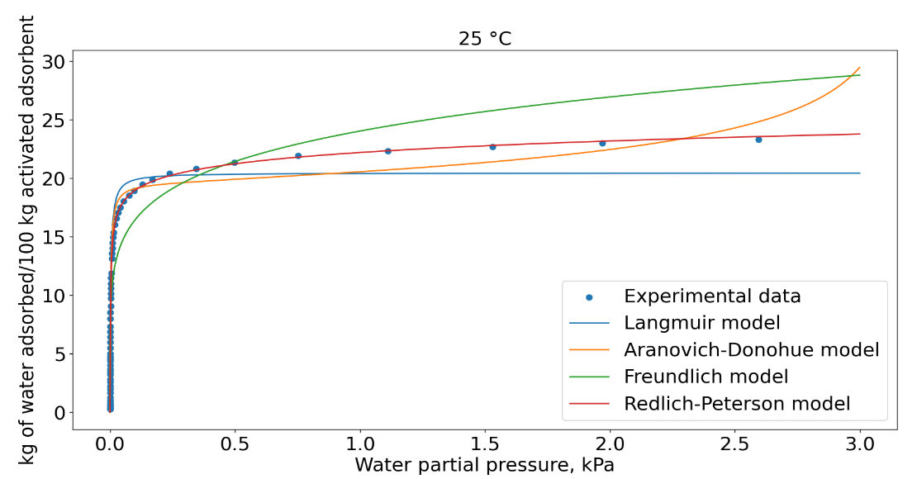
Figure 1 shows the experimental adsorption data of water as a function of partial pressure in a system at 25°C. In the low-pressure region, the isotherm exhibited a steep initial increase, followed by a gradually rising plateau in the higher partial pressure range. The formation of multiple adsorption layers at higher pressures is due to the interactions among adsorbed water molecules. Consequently, as illustrated in Figure 1, the Langmuir isotherm accurately describes the steep increase but fails to adequately capture the adsorption behavior as it approaches the plateau.
Figure 1. Comparative analysis of isotherm models – temperature is 25 ^{ο}C
On the other hand, the multilayer models Freundlich and Aranovich-Donohue also demonstrate inadequate fitting to the experimental data. However, the Redlich-Peterson model which was developed to capture heterogeneous surfaces, shows good agreement with the experimental data. All the isotherm parameters were optimized using a nonlinear least squares method.
4.2. Sensitivity analyses
A sensitivity analysis study was performed in order to evaluate the limitations of the benchmark model when thermodynamic non-idealities are neglected under different operating conditions. Consequently, the effects of three important operational parameters were studied: (i) CO₂ molar fraction; (ii) feed pressure; and (iii) feed temperature.
4.2.1. Molar fraction
The first operation parameter used to assess the effect of thermodynamic non-idealities on breakthrough time was the CO₂ molar fraction. Simulation was carried out considering a feed stream primarily composed of methane, CO₂, and water. Water concentration was fixed as 1000 ppm, while the molar fractions of the other two components were varied. As aforementioned, fugacity was included into the equilibrium loading calculations to capture the intermolecular interactions, mostly between the CO₂ and water.
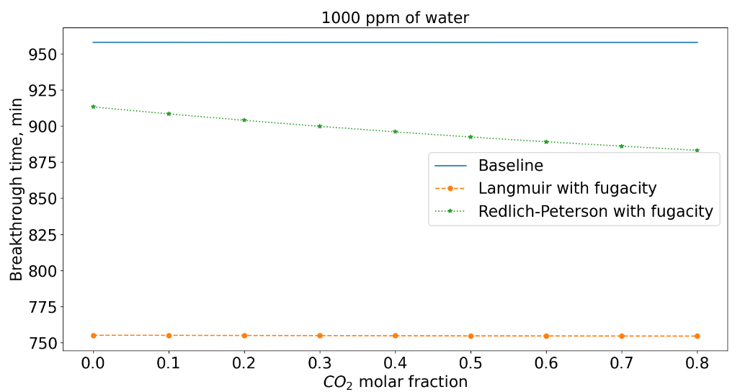
Figure 2 shows a breakthrough time for the benchmark model of 15h, represented by the blue solid line, which is in agreement with the calculations of Campbell (1992) [5]. As observed, the benchmark model results remain insensitive to variations in the CO₂ molar fraction. This can be primarily attributed to the simplification of employing a mono-component adsorption model, corroborated bythe strong interaction between water molecules and the active sites on the adsorbent surface. The occupation of these sites by strongly adsorbed water molecules suppresses the adsorption of CO₂ and CH₄ when ideal interactions are assumed. Nevertheless, when non-idealities are accounted for through fugacity calculations, the effect of CO₂ molar fraction becomes clear, as depicted in Figure 2. Increasing the CO₂ molar fraction in the feed gas diminishes the interactions between water molecules and the active sites on the adsorbent surface. This effect leads to a reduction in breakthrough time, with an average difference of $Δt=$61 minutes. The relative error between the simulation incorporating non-idealities via the Redlich-Peterson model and the benchmark model was 6.37%. However, when using the Langmuir model, which did not show a good agreement with the experimental data, the relative error increased to 21.02%, demonstrating the importance of selecting a model with a good fit.
Figure 2. Analysis of thermodynamic non-idealities with respect to variations in CO₂ molar fraction – water concentration is 1000 ppm
In addition, other simulations were conducted with varying water compositions of 100 ppm, 300 ppm, and 10,000 ppm. The results confirmed that the lower the water concentration, the more pronounced the effect of CO₂ becomes, therefore increasing the average difference in the breakthrough time.
4.2.2. Feed Pressure
The second analyzed operational parameter was the feed pressure. This is a very crucial parameter for gas adsorption, since the amount of adsorbed molecules depends on the partial pressure. Therefore, it is expected that as feed pressure increases, the deviation from ideal behavior between CO₂ and water molecules becomes more pronounced; in other words, the average difference in the breakthrough time increases. This behavior is depicted in Figure 3, which presents the profiles at 10 bar, 62 bar, and 120 bar. It is observed that with decreasing feed pressure, the interactions between the gas molecules approach ideal behavior, as confirmed by the lower relative error of 1.09% in the 10 bar simulations. In contrast, as the feed pressure increases, the non-idealities are highlighted, resulting in a higher relative error of 11.99%.
4.2.3. Feed Temperature
Finally, the separation performance was also evaluated at three different temperatures: 25 °C, 40 °C and 65 °C. Similarly to the aforementioned sensitivity analysis, these results also demonstrate the impact of including thermodynamic non-idealities in the modeling process, as illustrated in Figure 4. However, variations in temperature resulted in a nearly constant average difference in breakthrough time of approximately 2 hours. The relative error exhibits a slight increasing trend at higher temperatures, with values of 11.99%, 12.35%, and 13.20%, respectively.
This study also shows that lower temperatures favor the adsorption process, while a 40°C increase in the feed gas temperature leads to a reduction in the breakthrough time of 2.7 hours, indicating less efficient mass transport through the adsorbent bed.
5. Conclusion
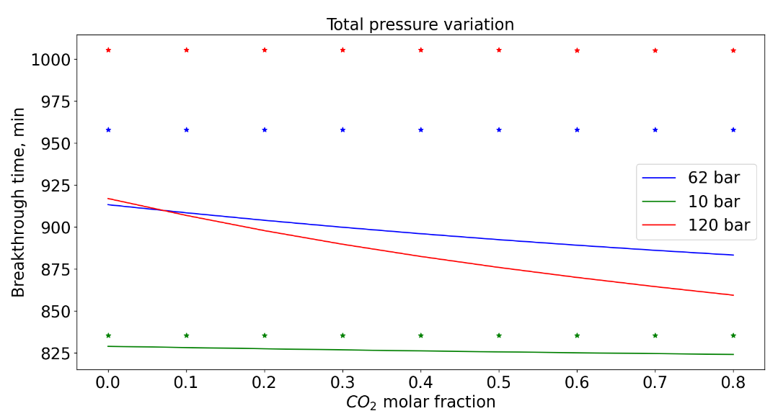
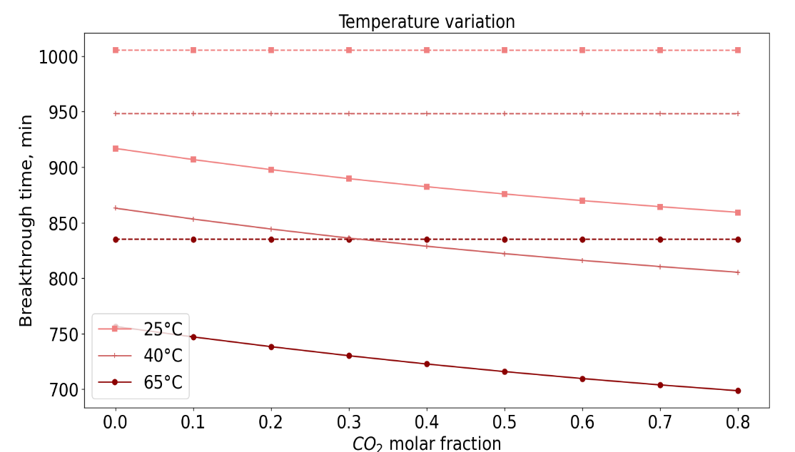
The isotherm model that capable of describing both the steep initial increase and the plateau associated with multilayer adsorbate-adsorbate interactions was the Redlich-Peterson model. This is attributed to the fact that the model was developed to capture both homogenous and heterogenous adsorption effects by combining features of the Langmuir and Freundlich models.
Figure 3. Analysis of thermodynamic non-idealities with respect to variations in feed pressure.
Figure 4. Analysis of thermodynamic non-idealities with respect to variations in feed temperature.
The sensitivity analyses demonstrated that incorporating fugacity is essential for accurately modelling the influence of CO₂ on the adsorption equilibrium, with the CO₂ molar fraction playing a key role in the breakthrough time. Unlike temperature, which exhibited a nearly constant average difference in breakthrough time, feed pressure shows a strong correlation with non-ideal behavior.
Nonetheless, Redlich-Peterson model is an empiric model, that difficults its use for extrapolation above the experimental data conditions. For future studies, it is necessary to find an isotherm model with a theorical development to extrapolate to pre-salt conditions with more thermodynamic confiability.
References
- Cavalcante, C.J., Pessoa, P.A., Modeling and simulation of an industrial adsorption process of dehydration of natural gas in 4A molecular sieves: Effect of adsorbent aging, Results in Engineering, 2023, 18, 101144.
- Saadat, S., Gholami, M., Ehsani, M.R., Mathematical modeling of adsorptive natural gas dehydration: the effect of layering the bed, Separation Science and Technology, 2019, Vol. 54, No. 14, 2212-2221.
- Chen, C, Mathias, P. M. Applied thermodynamics for process modeling, 2002.
- Ghasemzadeh, H., Mehrpooya, M., Pourfayaz, F., Jarrahian, A., Ganjali, M.R., Modeling and Investigation of an Industrial Dehydration and Hydrocarbon-Removal Process by Temperature Swing Adsorption, Catalysts, 2022, 12, 1509.
- Campbell, J.M., Gas conditioning and processing-Volume 2: The Equipment, modules. Campbell petroleum series, 1992.
- Alves, Y.P., Modelagem e Simulação de Adsorção de Água em Zeólitas em Leito Fixo, Dissertação de Mestrado, Programa de Pós-Graduação em Engenharia de Processos Químicos e Bioquímicos, UFRJ, Rio de Janeiro, 2024.
- Langmuir, I. The adsorption of gases on plane surfaces of glass, mica and platinum, Journal of American Chemical Society, 1918, 40, 9, 1361-1403.
- Freundlich, H.M., Over the Adsorption in Solution, Journal of Physical Chemistry A, 1906, 57, 385-470.
- Aranovich, G.L., Donohue, M.D., A New Approach to Analysis of Multilayer Adsorption, Journal of Colloid and Interface Science, 1995, 173, 515-520.
- Redlich, O., Peterson, D.L., A Useful Adsorption Isotherm, Journal of Physical Chemistry, 1959, 63, 1024-1024.
- Danesh, A., PVT and Phase Behaviour of Petroleum Reservoir Fluids, Developments in Petroleum Science, Elsevier Science & Technology Books, 1998.

