Applied Reliability Analysis of Gas Lift and Chemical Injection Valves

Arthur Rios de Azevedo^{1*}, Luiz Flavio da Silva¹, Vinicius Airão Barros², Marco Aurelio Pestana¹
¹ SENAI-CIMATEC, Oil & Gas, Salvador, Bahia, Salvador
² CENPES/PETROBRAS, Rio de Janeiro, Rio de Janeiro
*Corresponding author: SENAI-CIMATEC; addresses; arthur.azevedo@fbter.org.br

Abstract: The reliability of gas lift and chemical injection valves is critical for ensuring safety and continuous oil and gas production in offshore environments, especially in deep pre-salt fields. While the operational role of these valves is well acknowledged, limited studies have explored the impact of testing infrastructure on reliability estimation and their lifecycle performance. This study outlines a conceptual framework for evaluating the reliability of gas lift and chemical injection valves, along with the test systems used in their qualifications. The proposed approach is based on classical reliability engineering principles and integrates system modeling techniques such as Fault Tree Analysis Markov processes. Emphasis is placed on the influence of test unit performance on valve reliability data, especially under field-representative conditions. Failure modes, especially those involving check valves are discussed in relation to fluid dynamics, material degradation, and environmental constraints. Although empirical analyses are not presented at this stage, this work provides theoretical foundation for future reliability assessments, highlighting critical aspects such as failure taxonomy, system boundaries, and the role of structured reliability databases like OREDA. By bridging component and system-level reliability perspectives, the framework aims to foster technical advancements in valve design and promote discussion around reliability-centered testing in the oil and gas sector.
Keywords: Reliability. Oil & Gas. Artificial Lift. Chemical Injection.
Abbreviations: O&G, Oil & Gas; GLV, Gas Lift Valve; CIV, Chemical Injection Valve. UTEE, Unidade de Testes de Elevação e Escoamento.

1. Introduction

In January 2025, Oil & Gas (O&G) production from Brazil’s pre-salt fields increased by 2.4% compared to the same month in the previous year. This growth highlights the strategic importance of the pre-salt reservoirs, which now account for approximately 76% of the country's total O&G output. The Tupi and Búzios fields alone contributed 30% and 24% of that production, respectively, positioning Brazil as a major global player in the exploration and production of hydrocarbons under extreme subsea conditions [1].
Despite this high productivity, maintaining efficient and stable production in pre-salt wells requires the integration of advanced technologies. A common challenge in natural-flow wells is the gradual decline of reservoir pressure, which can eventually stop production altogether. Artificial lift methods are often employed to deal with this, with Gas Lift Valves (GLVs) representing one of the most versatile and widely used solutions. Through continuous gas injection into the production tubing, GLVs reduce the fluid density and help reestablish flow by effectively lowering the bottom pressure [2].
Even though the importance of GLVs is huge for production continuity, repair in subsea completion equipment is usually expensive. Choosing a GLV with a long service life is crucial for achieving reliable subsea operation. Subsea completion equipment, including GLVs, are subject to significant degradation from erosion, corrosion, and scaling. To mitigate such effects and prolong equipment life, Chemical Injection Valves (CIVs) are also deployed. CIVs enable the injection of specialized fluids, such as corrosion inhibitors, scale removers, and hydrate preventers from surface facilities directly into the well, thereby enhancing system resilience in harsh environments.
Given the critical role of both GLVs and CIVs in artificial lift and chemical treatment strategies, understanding their performance and reliability over the well’s lifecycle is essential. Failures in these components not only jeopardize production but also lead to costly and complex subsea interventions. As such, maintenance strategies must prioritize minimal intervention and maximum reliability.
To address these challenges, a collaboration between the Serviço Nacional de Aprendizagem Industrial (SENAI)/Centro Integrado de Manufatura e Tecnologia (CIMATEC) and Petróleo Brasileiro S.A. (Petrobras) has been established through the Laboratório de Desenvolvimento da Produção (LPD). This initiative supports the development and qualification of technologies for the O&G sector, ensuring that innovation does not compromise operational safety or efficiency.
Among the strategic projects under the LPD is the Unidade de Teste de Elevação e Escoamento (UTEE), a suite of test units designed to emulate real pre-salt field conditions. These test units enable evaluations of tightness, mechanical resistance, erosion, and functional performance for both GLVs and CIVs. Where there are two main goals: (i) assess whether these components meet design and operational specifications; (ii) establish probabilistic methodologies, combining empirical data, phenomenological modeling to estimate their reliability under representative field conditions.
In addition to valve reliability, this project also focuses on the reliability of the test systems themselves, ensuring that the test units operate with a level of robustness consistent with their intended use.
This paper does not aim to present empirical reliability results. Instead, it outlines the conceptual and methodological framework that will support future analyses of the performance and reliability of GLVs, CIVs, and the associated test systems. The focus is on defining the structure of the reliability study, including its failure modeling strategies, and data sources. The structure of this work is organized as follows: Section 2 describes the general concepts of reliability; Section 3 describes the basic function of GLVs and CIVs and their associated fail modes; Section 4 describes the reliability of systems such as the ones that will be used to test GLVs and CIVs and the data that is used in the estimation; Section 5 concludes with a discussion on implications and limitations of the current study.

2.Reliability
Traditional engineering design often assumes that systems are fully functional, safe, and failure-free. However, this deterministic vision is idealized and frequently impractical, both technically and economically. Major industrial accidents have demonstrated the limitations of this approach. In 2010, the Deepwater Horizon platform suffered a catastrophic blowout during drilling operations at the Macondo well in the Gulf of Mexico. The failure of the Blowout Preventer (BOP) a critical safety device was identified as one of the primary causes, leading to 11 fatalities and severe environmental consequences [3].
Such events underscore the importance of integrating reliability principles into the design and assessment of equipment and systems. Reliability is defined across the literature as the probability that an item performs its intended function, under specified conditions, for a designated period of time [4]. This applies not only to physical components but also to human actions [5]. The analysis of reliability begins with understanding what constitutes a failure.
According to [6], a failure is the termination of the ability of an item to perform a required function. It differs from the broader concept of a fault, which also includes delayed or degraded performance. Understanding this distinction is crucial when evaluating the safety-critical performance of industrial assets.

Items transition through various states (e.g., operational, degraded, fault), and these transitions can be triggered by physical deterioration, control logic, or from external sources. Figure 1 illustrates the distinction between a failure event and the subsequent failed state in a performance-degrading component. When performance drops below a predefined threshold, such as due to corrosion, the failure occurs. Yet the component remains in a failed state until repaired or replaced.

Figure 1. Difference between failure event and failed state in a degrading item [7].
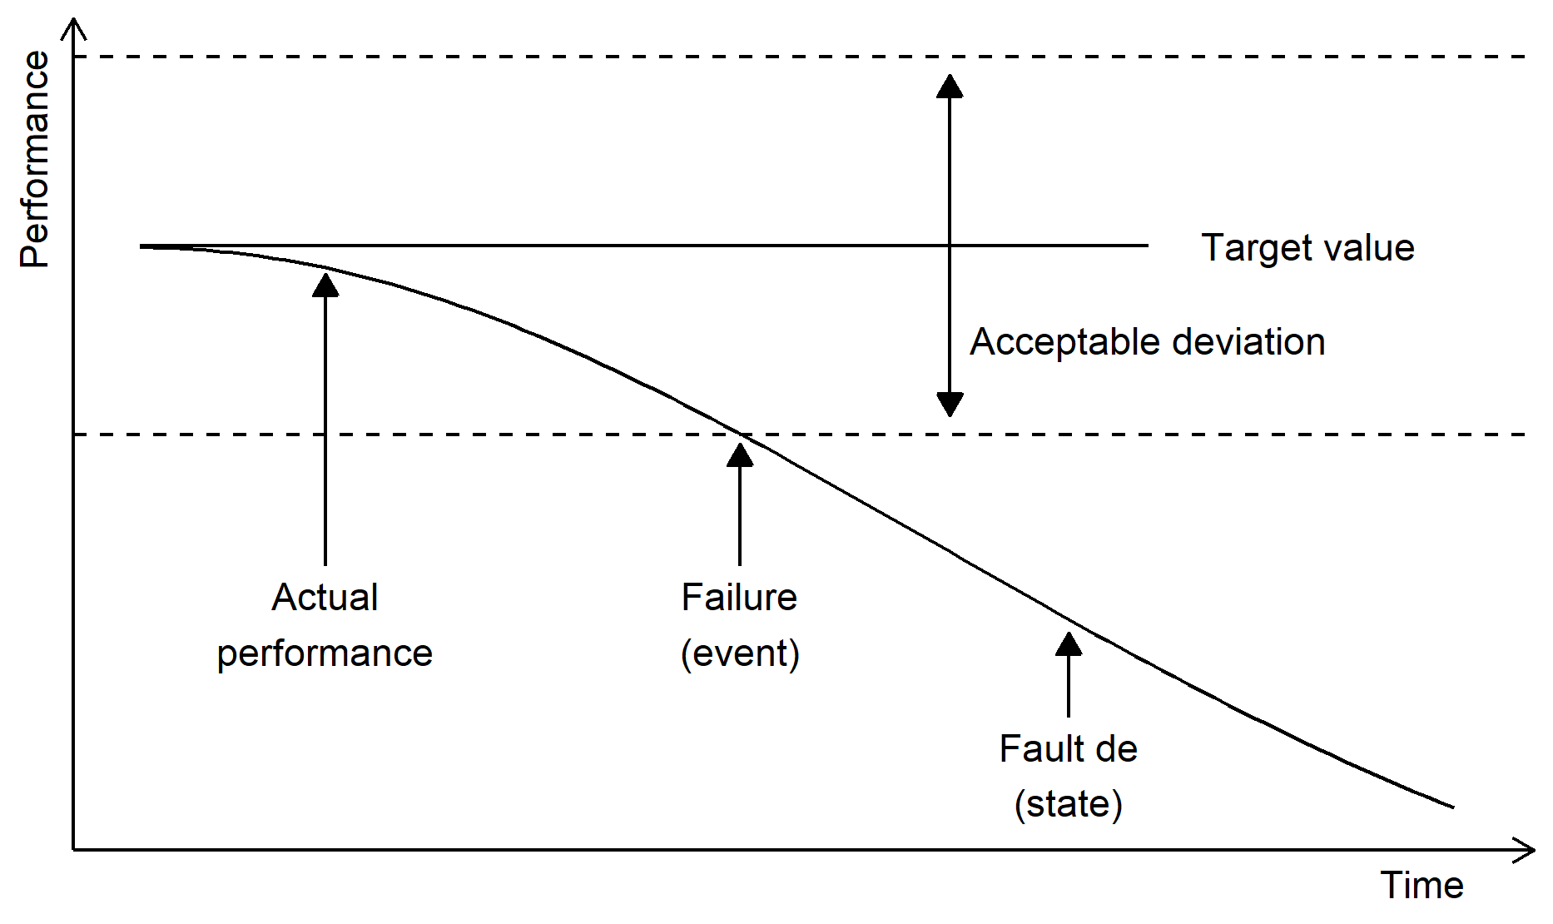

The failure event is often difficult to pinpoint precisely, especially when degradation is gradual. In such cases, identifying the mode, mechanism, and cause of failure becomes essential for effective modeling and mitigation. Failures can be classified as incipient, degraded, or critical, depending on the severity and impact on the system's functions [8].
Despite efforts to predict all potential failure modes, the complexity of industrial systems makes complete anticipation nearly impossible. In this paper, reliability is understood as the capability of a system, subsystem, or component to perform its required function within the specified constraints. This excludes variations in usage, environmental factors, or support conditions not considered in the original specifications.

3. Reliability of GLV and CIV
Ensuring the reliability of subsea flow assurance components, such as GVLs and CIV, is critical in offshore production systems. These components are often inaccessible or too costly for maintenance, making their failure not only costly but potentially hazardous.

GLVs are central to artificial lift systems, enabling gas injection from the annulus into the production tubing to facilitate oil lifting. They are designed to operate unidirectionally, allowing gas to pass into the tubing while preventing backflow of hydrocarbons into the annulus. However, failures such as leakage through damaged check valves or malfunction due to debris, improper pressure thresholds, or corrosion can compromise safety [9].

Gilbertson et. al. (2010) performed a comprehensive failure mode and sensitivity analysis of gas lift valves, revealing that valve performance is highly sensitive to design parameters such as bellows dimensions, injection gas pressure, tubing diameter, and dome volume. Using a quasi-steady-state model coupled with Monte Carlo simulations, they showed how small perturbations in these variables can trigger failure scenarios, particularly backflow of oil into the annulus, which is a major integrity concern.
On the other hand, CIV typically used to continuously inject scale inhibitors, represent another critical technology to maintain flow assurance and protect components such as the production tubing and downhole safety valve (DHSV). While CIV systems offer an elegant alternative to scale squeezing, their application introduces substantial reliability challenges [10]. These include chemical gunking, solvent evaporation under vacuum conditions, and aggressive corrosion, especially in long-distance injection lines or wells with deep injection points. Case studies revealed failure events caused by improper chemical qualification for downhole temperatures, leading to severe corrosion, as well as precipitation phenomena that blocked injection valves. Notably, both material compatibility and thermochemical behavior of the injected fluid were often underestimated, leading to premature failures [10]. The evolution of test protocols, particularly for CIV, has begun to address these needs, focusing on dynamic gunking tests, high-temperature corrosivity assays, and compatibility evaluations for multi-phase flow environments.
Overall, the long-term reliability of GLVs and CIVs systems hinges on multidisciplinary coordination, advanced simulation tools, and rigorous qualification frameworks that consider not only operational performance but also the evolving conditions over the field’s lifetime.
A particularly critical component in both systems is the check valve, whose integrity is directly associated with some of the most severe failure modes. In GLV, a malfunctioning check valve may allow backflow of hydrocarbons from the tubing into the annulus, compromising well integrity and posing serious safety risks. Similarly, in downhole chemical injection systems, check valves are responsible for preventing well fluids from invading the injection capillary. When these valves fail, either due to debris, improper material selection, or pressure imbalance, corrosive fluids can leak, leading to localized degradation and eventual rupture of the injection line. In both cases, the check valve represents the last line of defense against reverse flow, and its failure is often the initiating mechanism of cascading system-wide reliability issues.

4. Reliability of Systems
A system consists of a set of interconnected components or elements organized to perform one or more specific functions. The reliability of such a system depends not only on the reliability of its individual components but also on the configuration that defines how these components are physically arranged and interact. The most granular level of this structure is referred to as the component. A component may itself be a complex system with several internal parts, or it may be treated as a black box when the internal failure mechanisms are not under investigation.

In reliability studies, each item included in a system must be able to perform at least one function independently under specific environmental and operational conditions. These studies are guided by boundary conditions that define which items are considered internal to the system and which are external. System boundaries play a critical role in delimiting the elements under evaluation and in maintaining a coherent and autonomous internal structure.

Establishing a model that represents the structure and behavior of the system is a fundamental step in system reliability analysis. This model defines the system boundaries, the internal components, the interactions among these components, and the environmental conditions that may influence system behavior.
As the complexity of the system increases, more advanced methods become necessary. Among these, Fault Tree Analysis (FTA) and Markov processes are prominent tools for evaluating reliability in systems composed of multiple interdependent components or possessing dynamic failure and repair behavior. These methodologies provide complementary perspectives: FTA offers a deductive framework for understanding how component failures contribute to a specific system failure, while Markov models describe the probabilistic evolution of system states over time.

4.1. Fault Tree Analysis
Fault Tree Analysis is a deductive, top-down method for identifying the causes of an undesired event, referred to as the top event [11]. This technique constructs a logical tree structure that links the top event to intermediate and basic events through well-defined logical relationships, typically represented by “AND” and “OR” gates.

The top event may be defined as a system failure. From this point, the analysis proceeds downward by identifying combinations of events that can trigger the undesired outcome, such are called cut sets. The process continues until basic events are reached, that is events that are not further decomposed. FTA can be developed both qualitatively, by identifying minimal cut sets, and quantitatively, by calculating the probability of the top event based on the probabilities of the basic events.

One advantage of FTA is its flexibility to incorporate a wide range of probability distributions for basic events, allowing for more accurate modeling of real phenomena. Additionally, its logical structure enhances clarity and facilitates communication among engineers and stakeholders. However, this method does not account for the chronological sequence of failures and is generally limited to binary-state modeling. The representation of dependencies between events is also non-trivial and may require hybrid approaches, such as the integration of methods such Bayesian networks [12].

Despite its limitations, FTA remains a widely used and effective tool, particularly in industries with high safety and reliability requirements. The method can be enhanced through combinations with simulation-based approaches, such as Monte Carlo methods, or with probabilistic updates based on real-time data.

4.2. Markovian Reliability Models
Markov processes are stochastic models used to represent transitions between different system states over time. In the Markov process, the probability of transitioning to a future state depends solely on the current state, satisfying the memoryless property. This characteristic makes Markov models suitable for analyzing repairable systems and systems with multiple failure modes or degradation levels.

Markov Chains (MCs) are particularly relevant for modeling system reliability. These models are governed by two central mathematical constructs: the transition probability matrix and the transition rate matrix (also known as the generator matrix). The transition probability matrix defines the likelihood of moving from one state to another over a time interval, while the transition rate matrix characterizes the instantaneous rates of these transitions.

As a simple illustrative example, consider a parallel system composed of two identical and independent components, each with a failure rate $γ$ and a repair rate $μ$. The system can exist in one of three states: both components operational (state 2), one component failed (state 1), or both failed (state 0). Assuming that only one component can be repaired at a time, the system transitions between these states at rates derived from the failure and repair parameters. The associated transition rate matrix allows for the evaluation of metrics such as availability and mean time to failure. These methods can be implemented to estimate the reliability for the tests unites of UTEE.

4.3 Reliability Data
Reliability databases are structured repositories that aggregate information about failures, performance, and the service life of components and equipment across various industrial sectors. These databases are essential tools for reliability engineers, enabling statistical analysis of failure patterns, risk assessment, and the estimation of useful life for equipment and systems. Data can originate from field observations or laboratory testing, and support the development of predictive models, the optimization of preventive and corrective maintenance strategies, and compliance with safety and performance standards.

The primary contribution of OREDA lies in enhancing the safety, cost-efficiency, and operational effectiveness of oil and gas production units. This is achieved by enabling shared access to reliability and maintenance data among participating companies. As of today, the OREDA database includes data from over 300 installations, covering more than 18,000 equipment units, 43,000 failure events, and 80,000 maintenance records. For subsea equipment, it contains data from 170 installations, 3,000 equipment units, 63,000 components, and over 3,000 failure records.
5. Discussion
This study outlines a structured approach for investigating the reliability of GLV and CIV, with particular attention to the influence of test units used during qualification and operation. While the analyses have not yet been conducted, the conceptual framework proposed integrates foundational reliability engineering principles, failure mode characterization, and system-level modeling through techniques such as FTA and Markov processes. By bridging component-level behavior with system-level performance, this work emphasizes the importance of understanding how testing procedures and auxiliary systems affect the perceived and actual reliability of subsea valves.

References

1. Agência Nacional do Petróleo, Gás Natural e Biocombustíveis. Dados Abertos [Internet]. 2025. Available from: https://www.gov.br/anp/pt-br/centrais-de-conteudo/dados-abertos
2. Takács G. Gas lift manual. Tulsa, Okla: PennWell; 2005. 478 p.
3. US Chemical Safety, Hazard Investigation Board. Macondo Investigation Report. CSB; 2016.
4. Modarres M, Kaminskiy M, Krivtsov V. Reliability engineering and risk analysis: a practical guide. Third edition. Boca Raton, FL: CRC Press; 2017. 1 p.
5. Kirwan B. A Guide To Practical Human Reliability Assessment. 2017.
6. ABNT. Indústrias de Petróleo e Gás Natural - Coleta e intercâmbio de dados de confiabilidade e manutenção para equipamentos. Abnt; 2011.
7. Rausand M, Barros A, Høyland A. System reliability theory: models, statistical methods, and applications. Third edition. Hoboken, NJ: Wiley; 2021. 813 p. (Wiley series in probability and statistics).
8. Mendes R. The Concept of OREDA on Data Treatment for Equipment. 2017.
9. Gilbertson E, Hover F, Colina E. Failure Mode and Sensitivity Analysis of Gas Lift Valves. In American Society of Mechanical Engineers Digital Collection; 2010 [cited 2025 Jan 21]. p. 305–14. Available from: https://dx.doi.org/10.1115/OMAE2010-20343
10. Hustad BM, Svela OG, Olsen JH, Ramstad K, Tjomsland T. Downhole Chemical Injection Lines - Why Do They Fail? Experiences, Challenges and Application of New Test Methods. In: SPE International Conference on Oilfield Scale [Internet]. Aberdeen, UK: SPE; 2012 [cited 2025 Feb 12]. p. SPE-154967-MS. Available from: https://onepetro.org/SPEOSS/proceedings/12OSS/12OSS/SPE-154967-MS/158149
11. Stamatelatos M, Vesely W, Dugan J, Fragola J, Minarick J. Fault Tree Handbook with Aerospace Applications. 2002. (NASA).
12. Amin MdT, Khan F, Ahmed S, Imtiaz S. A data-driven Bayesian network learning method for process fault diagnosis. Process Saf Environ Prot. 2021 June 1;150:110–22.

