Model for pre-design of Darrieus wind turbine H-Type
Lucas Lincoln Fonseca Soares^{1*}, Gabriel Aelo Ribeiro¹, Joao Pedro Cheloni¹, Fernando de Alencar Silva Martinez¹, Juan Romero Albino¹, Icaro Figueiredo VilasBoas¹, Rodrigo Silveira de Santiago¹
¹ SENAI CIMATEC, Industrial Product Development, Salvador, Bahia, Brazil
*SENAI CIMATEC; Av. Orlando Gomes; lucas.fs@fieb.org.br

This work presents a simplified fluid-structure interaction model for pre-design of Darrieus wind turbine. The modeling of Darrieus turbine is a challenging task due to the aerodynamic complexity associated with its operation. One challenge is determining the drag and lift coefficients for each position during the circular motion of the blades, due mainly to changes in Reynolds number and attack angle. Structural calculations are also challenging, as the blades operate in a rotating bending regime and must withstand alternating loads. For the development of the mathematical model of this work, the main geometric and operating parameters of the turbine were considered, and can estimate aerodynamic forces, torque, and blade structural deflections. To characterize the profile's aerodynamic behavior, lift and drag coefficient data obtained from the airfoil-tools website, based on data from the XFOIL software, were used. The mathematical model was implemented in a Scilab code, allowing simulation of the turbine operation under different conditions. The graphs presented were generated by the developed code. It was considered that the turbine operates at constant rotational velocity. The radial and tangential forces on the blades were determined from the lift and drag components, as a function of the instantaneous attack angle. Subsequently, the torque was calculated during the movement, allowing estimate the available power. The blade deflections were analyzed, considering the distributed loads and the cross-sectional moment of inertia, based on a simplified modeling of a bi-supported beam. The results obtained allow a preliminary assessment of the turbine aerodynamic performance and structural integrity. The model can provide initial design support, with low computational cost and good applicability in conceptual stages.
Keywords: Darrieus Turbine. Pre-design. FSI, Fluid structure Interaction. Aerodynamics simulation. Structural simulation.

1.Introduction

Wind turbines convert wind kinetic energy into electrical energy, playing an increasingly central role in the global energy mix as renewable and sustainable sources. Wind turbines can generally be divided into two categories: horizontal-axis wind turbines (HAWT) and vertical-axis wind turbines (VHTT), Figure 1 (Hosseini [1]).
HAWTs are the most common, with large blades rotating around an axis parallel to the ground, while VHTTs operate with blades rotating around an axis perpendicular to the ground, allowing wind to capture from any direction. In particular, the Darrieus turbine (DT) functions as airfoils rotating around a central axis (Figure 1b). In these models, the blades can be straight, as is the case with the H-type. DT operates by generating torque from an aerodynamic lift. Its design makes it suitable for urban or building-integrated applications due to its lower sensitivity to wind direction. However, one of its typical limitations is difficulty in self-starting, which can be overcome through optimized geometries or starting systems (Rogowski [2]).
The pre-design of DT is a challenging task due to the aerodynamic complexity associated with its operation. One challenge is calculating the drag and lift forces during the circular motion of the blades, due to changes in Reynolds number, attack angle, and the nonlinear effects of aerodynamic stall (boundary layer detachment) and wake formation. Structural calculations are also challenging, as the blades operate in a rotating bending regime and must withstand alternating loads. Another challenge is determining the tip speed ratio, which directly influences turbine efficiency but depends on wind velocity and the chosen blade aerodynamic profile. Finally, the development of detailed DT designs requires iterative numerical methods, or numerical simulations based on volumes or finite elements, to couple aerodynamic and structural dynamics models (Siregar [3]).
Several studies in literature investigate the performance of Darrieus wind turbines, most of which are based on numerical simulations, with emphasis on the use of Computational Fluid Dynamics (CFD) simulations. Hosseini, 2022, [1] proposed a hybrid turbine design, combining Bach-type Savonius rotors (another type of VHTT) with an H-type Darrieus rotor, to improve starting capacity and expand the operating range. Using CFD, the author identified that, although the isolated Darrieus rotor has a high-power coefficient, its starting is limited. The hybrid configuration improved the overall system efficiency and performance, even at low wind speeds.
Rogowski [2] investigated the aerodynamic performance of H-type DTs with different profiles from the NACA series. Using CFD, the author concluded that the NACA 1418 profile offers the best performance in blade configurations, achieving an optimal power coefficient, and is a promising option for future vertical turbine designs. Siregar [3] presented two relevant studies. The first is a comprehensive literature review on H-type Darrieus rotors, covering topics such as aerodynamic modeling, CFD simulation techniques, starting behavior, blade-vortex interaction, and design optimization strategies. The second paper describes the development and simulation of a DT optimized for operation in low-wind-speed regions. The proposed model's performance was evaluated through CFD, demonstrating its viability for small-scale power generation.
Ghiasi [4] and Singh [5] investigated the impact of geometry on H-type DT performance. Ghiasi identified an ideal height-to-diameter ratio to optimize aerodynamic efficiency at low tip speeds, while Singh, through 3D simulations, showed that lower aspect ratios favor performance in exhaust flows, highlighting the influence of geometry on turbine adaptation to operating conditions. These works show the importance of numerical simulations as essential tools for the study and development of DT, however there is little development of models for pre-dimensioning, which makes this a motivator for the development of the present work.
1.1 Objective
The objective of this work is to present a proposed model for the pre-design of a Darrieus wind turbine H-Type. The preliminary dimensioning consists of developing an initial geometric model so that more accurate numerical simulations can be performed during turbine design development.
The methodology proposed in this work applies basic principles of aerodynamics and material strength to develop a simplified mathematical model of fluid-structure interaction (FSI). The turbine will be assumed to be operating at constant velocity. This calculation will require determining the forces and moments on the blades, and the results will be used to calculate stress and blade deflection. In this proposal, the determination of aerodynamic forces (drag and lift) will be performed using data from the airfoiltools website, which mainly uses results from the XFOIL (free software used to calculate aerodynamic forces on airfoils in subsonic flow). The software combines potential flow theory with approximate solutions for fluid dynamic boundary layer flow and is widely used in aeronautical engineering and wind turbine design, for example. However, XFOIL is limited to two-dimensional geometries and does not capture the nonlinear effects of flow, which can be solved with the Navier-Stokes equations in finite volume software, for example. On the other hand, deflection and stress distribution calculations are performed using classical beam element theory.
2. Mathematical model
In general, wind turbines can be characterized by two parameters: the blade tip speed ratio ($λ$) and the power coefficient ($C_{p}$). The first parameter relates the turbine rotational velocity to the wind velocity, such as:
$$λ=\frac{Rω}{U}$$ | (1)
where $R$ is the radius of the turbine rotor, $ω$ is the angular velocity of the blades, and $U$ is the wind velocity. The second parameter relates the power available in the wind to the mechanical power developed by the turbine:
$$C_{p}=\frac{Tω}{0,5ρAU^{3}}$$ | (2)
where $T$ is the torque generated by the turbine, $ρ$ is the specific mass of the fluid (in this case, air), and $A=2Rb$ is the effective wind capture area. Graphic 1 illustrates the variation of $C_{p}$ with $λ$ for some types of wind turbines, and Figure 2 illustrates the DT model considered in this work.
In DT, the local Reynolds number and attack angle changes according to the circular motion of the blades. The blade experiences an incident flow with the magnitude and direction of the relative velocity (relative flow), and therefore, the aerodynamic data are determined based on this velocity. Figure 3 shows the aerodynamic forces acting on the blade. The drag force is parallel to the relative flow direction, and the lift force is perpendicular to the relative flow direction. It is worth noting that, based on the results of the mathematical model for a single blade, it is possible to calculate the contribution of the other blades to the forces and moments on the turbine. Based on Figure 3, the relative velocity can be calculated as:
$$v_{rel}=U\sqrt{{\left(λ+sinθ\right)}^{2}+{\left(cosθ\right)}^{2}}$$ | (3)
where $θ$ is the angular displacement of the blades (position blade), which is the independent variable that varies from 0 to 2π with each blade revolution. Thus, the local Reynolds number can be calculated as:
$$R=\frac{ρcv_{rel}}{μ}$$ | (4)
where $c$ is the airfoil chord, and μ is the dynamic viscosity of the air. The attack angle is formed by the reference line of the airfoil chord with the direction of the relative flow, that is:
$$α=\operatorname{atan}\left(\frac{cosθ}{λ+sinθ}\right)$$ | (5)

With the Reynolds number and attack angle calculated for each turbine position $θ$, it is possible to determine the coefficients and calculate the aerodynamic forces as:
$$F_{d,l}=0,5ρ v_{rel}^{2}bc C_{d,l}$$ | (6)
where the drag and lift coefficients are $C_{d}\left(R,α\right)$ e $C_{l}\left(R,α\right)$, respectively. In this work, these coefficients are determined using data from airfoiltools.
In DT, the tangential force distribution (7) produces the torque required to calculate the power coefficient, while the radial force distribution (8) is used for the structural calculation.
$$F_{t}=F_{l}\sin{α}-F_{d}\cos{α}$$  $$F_{R}=F_{l}\cos{α}+F_{d}\sin{α}+m R ω^{2}$$ | (7)  (8)
where $m R ω^{2}$ is the centrifugal force due to blade rotation, $m$ is the blade mass, and $R$ is the rotor radius. To calculate the total force generating the torque on the turbine, it is necessary to consider the contribution of the other blades. Thus, for 3 blades the phase shift angle is 120°, so:
$$F_{tot}=F_{t}{\left.​\right|}_{θ}+F_{t}{\left.​\right|}_{θ+120}+F_{t}{\left.​\right|}_{θ+240}$$ | (9)
The torque acting on the turbine shaft is $T=F_{tot}R$, the power is $P=Tω$, and the power coefficient calculated by equation 2.
With the forces determined, a blade free-body diagram can be developed for structural calculation. It was assumed that the forces are distributed uniformly along the length of the blade in a bi-supported beam model, as illustrated in Figure 4. The beam will be subjected mainly to radial loads. With $q=F_{R}/b$ defined, it is possible to calculate that the reactions at the supports are $R_{A}=R_{B}=0.5qb$. Thus, the solutions for the bending moment and deflection can be determined according to equations 10 and 11, respectively, for any position $x$ along the length of the blade, starting from one end of the blade.
$$M(x)=0,5qx^{2}-R_{A}{〈x-e〉}^{1}-R_{B}{〈x-\left(b-e\right)〉}^{1}$$  $$υ(x)=\frac{1}{EI}\left[\frac{qx^{4}}{24}-\frac{R_{A}{〈x-e〉}^{3}}{6}-\frac{R_{B}{〈x-\left(b-e\right)〉}^{3}}{6}+C_{1}x+C_{2}\right]$$ | (10)  (11)
where $e$ is the distance from the blade ends to the support, $E$ is the linear elasticity modulus of the blade material, and $I$ is the moment of inertia of the blade cross-section, which will depend on the geometry of the chosen airfoil. The constants $C_{1}$ and $C_{2}$ can be calculated by solving the linear system resulting from the conditions $υ=0$ at $x=e$ and $x=b-e$, so that:
$$\left[\begin{matrix}e & 1 \\ b-e & 1\end{matrix}\right]\left\{\begin{matrix}C_{1} \\ C_{2}\end{matrix}\right\}=\left\{\begin{matrix}-qe^{4}/24 \\ -q{\left(b-e\right)}^{4}/24+R_{A}{\left(b-2e\right)}^{3}/6\end{matrix}\right\}$$ | (12)
Finally, the stress distribution due to bending moment can be calculated as:
$$σ=My/I$$ | (13)
where $y$ corresponds to half the maximum airfoil thickness.
3. Numerical Implementation
The mathematical model was implemented in Scilab code. The main input parameters are the rotor radius ($R$), blade height ($b$), airfoil chord ($c$), distance from the blade ends to the suports ($e$), wind velocity ($U$), blade tip speed ratio ($λ$), and blade mass ($m$). Thus, the rotation of the turbine can be calculated using equation (1). In the sequence, the angle $θ$ was implemented, varying from 0 to 2π, divided into $n_{p}$ points, and the relative velocity, the Reynolds number, and attack angle were calculated.
The aerodynamic coefficient data were determined using a linear interpolation algorithm (based on data from airfoiltools). The data was organized into tables for a range of Reynolds numbers, with a relationship between the variables: attack angle, lift coefficient, and drag for each Reynolds number. The algorithm identifies the Reynolds number calculated for a position $θ$, interpolates the variables from the table, and then, when it identifies the attack angle (at $θ$), stores the lift and drag coefficient values at that position. Thus, the aerodynamic forces are calculated using equation (6), the tangential (7) and radial (8) components, the total force (9), and finally the torque and power coefficient (2).
For the structural calculation, the distributed force $q$ was calculated, and equations (10) to (13) were used to determine the stress and deflection distribution along the blade.
4. Results
The results presented consist mainly of graphs of aerodynamic forces for each $θ$ position, the tangential and radial forces, the torque generated by the turbine, the maximum stress for each $θ$ position, and a graphical representation of turbine and a blade deflected at the position where the stress is maximum. Only one design case was evaluated, with the input parameters described in Table 1. The value of $λ$ = 5 was defined as shown in Graphic 1, considering the maximum value of $C_{p}$. The variable θ (0 to 2π) was divided in $n_{p}$ = 60 points. For the blade profile, the symmetrical airfoil NACA0012 was considered due to its wide use for academic studies (Graphic 2).
When calculating the Reynolds number, it is important to verify that the range of values is consistent with the airfoiltools data. In this case, the data corresponds to the range of 100.000 to 1.000.000, and the calculated values correspond to 198.000 to 297.000. The interpolated lift and drag values, as a function of position $θ$ (in degrees), are presented in Graphic 3. Graphic 4 shows the distribution of tangential and radial forces as a function of position $θ$. Note that radial forces predominate. Therefore, in this work, only radial forces were considered for structural calculation. Additionally, the moment of inertia is greater in the direction of the moment caused by tangential loading.
Graphic 5 shows the torque in the turbine considering one and three blades. Note that one blade is not sufficient to maintain the torque in a single direction, contrary to the use of three blades, which maintain positive torque. Graphic 6 shows the maximum stress during the movement, acting on the rod attachment points (as can be verified by the bending moment diagram of a bi-supported beam). Graphic 7 shows the representations of turbine, and a blade deflected at the maximum stress position, near the start of the movement (on a scale increased 10 times). Finally, Table 2 presents the results for some turbine operating parameters for the provided input data in Table 1. Note that the power coefficient (0,43) was higher than the reference in Graphic 1 for $λ$ = 5 (0,40), but this is justifiable because mechanical and generator losses were not considered.
5. Conclusions and Future Works
This work presented a simple fluid-structure interaction model for pre-design of Darrieus wind turbine HType. The aerodynamic coefficients were determined through a linear interpolation algorithm with base in data from the airfoiltools website. Tangential and radial forces, moments, stress distributions, and deflection were then calculated. In general, the lift force was higher than the drag force, indicating that the input parameters and chosen aerodynamic profile were appropriate. The torque generated by the turbine (3 blades) shows that the direction of rotation is constant during movement. Finally, stress and deflection distributions allow assessing whether the pre-design meets engineering criteria.
It is important that future studies be conducted to validate the proposed model, either through more precise numerical methods or experimental data.
Acknowledgement
We thank Senai Cimatec University for the support and resources allocated to the development of this work.
References

- Hosseini, A., & Goudarzi, N. (2019). Design and CFD study of a hybrid vertical-axis wind turbine by employing a combined Bach-type and H-Darrieus rotor systems. Energy Conversion and Management, 196, 1372-1387.
- Rogowski, K., Hansen, M. O., & Bangga, G. (2020). Performance Analysis of a H-Darrieus Wind Turbine for a Series of 4-Digit NACA Airfoils. Energies, 13(12), 3202.
- Siregar, Y., Prayogo, A., Mohamed, N. N., & Ngamroo, I. (2025). Design of micro-scale wind power plant with vertical axis wind turbine darrieus type-H. International Journal of Innovative Research and Scientific Studies, 8(2), 1-8.
- Singh, E., Roy, S., Yam, K., & Law, M. (2023). Numerical analysis of H-Darrieus vertical axis wind turbines with varying aspect ratios for exhaust energy extractions. Energy, 272, 127186.
- Ghiasi, P., Najafi, G., Ghobadian, B., & Jafari, A. (2021). Analytical and Numerical Solution for H-type Darrieus Wind Turbine Performance at the Tip Speed Ratio of Below One. International Journal of Renewable Energy Development, 10(2), 319-329.

Figure 1. (a) HAWT e (b) VHTT
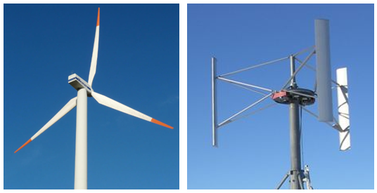
- (b)
Graphic 1. Power coefficient as a function of tip speed ratio for 3 types of wind turbines.
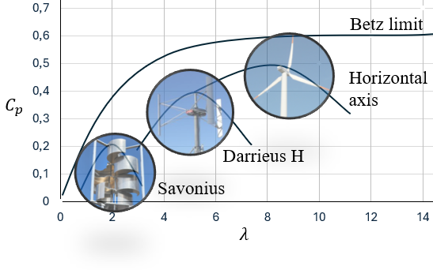
Figure 2. H Darrieus wind turbine H-Type model
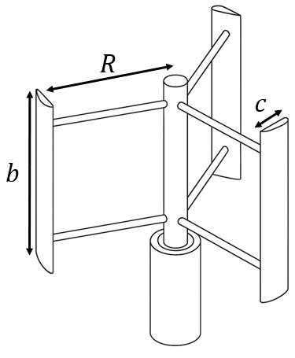

Figure 3. (a) Velocity decomposition on Darrieus turbine blade, and (b) drag and lift forces on blade.
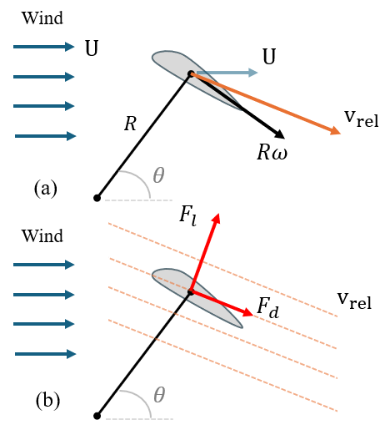
Figure 4. (a) Free-body diagram of the blade, and (b) bi-supported beam model.
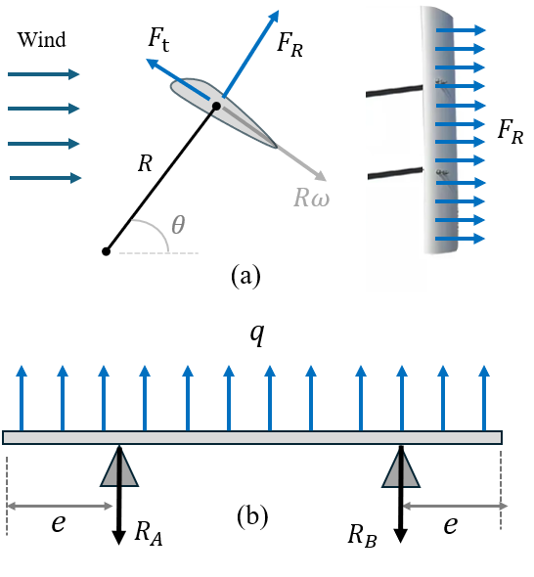
Graphic 2 –NACA0012 airfoil
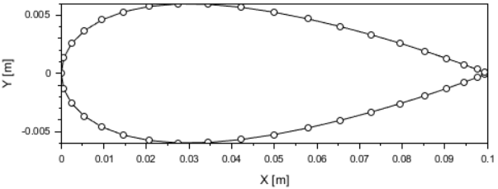
Graphic 3 – Lift and drag forces on blade
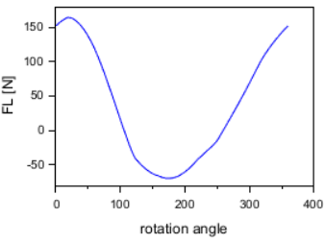
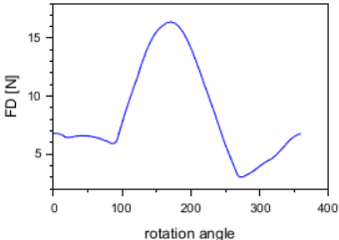
Graphic 4 – Tangential and radial forces;
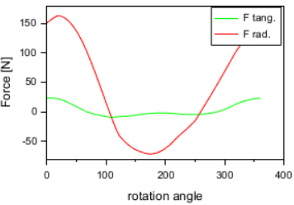
Graphic 5 – Tangential and radial forces
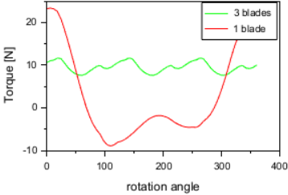
Graphic 6 – Maximum stress on external blade surface
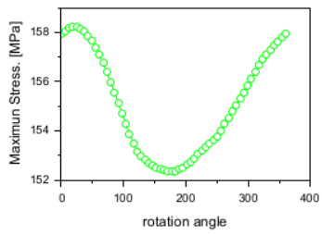
Graphic 7 – Maximum deflection
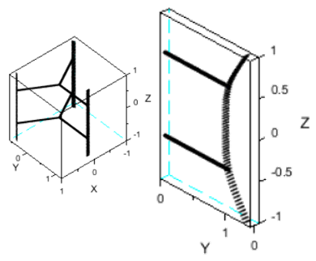
Table 1 – Input parameters
Rotor Radius ($R)$ | 1,0 m
Blade Height ($b$) | 2,0 m
Airfoil Chord ($c$) | 0,1 m
Support Distance ($e$) | 0,5 m
Wind velocity ($U$) | 7 m/s (25,2 km/h)
Air density ($ρ$) | 1,2 kg/m³
Air dynamic viscosity ($μ$) | 1,8 kg/ ms
Elasticity modulus (blade) ($E$) | 70 GPa
Blade mass ($m$) | 5 kg
Moment of inertia ($I$) | 1,4 10⁻⁸ m⁴

Table 2 – Calculated operating parameters
Rotation | 334,22 RPM
Average turbine torque | 10.60 Nm
Average turbine power | 334 W
Average turbine power coef. | 0,43

