Numerical and Experimental Analysis of a Pre-Stressed Aluminum 6061-T6 Chassis for Offshore Structural Applications

Juan Carlos Romero Albino^{1*}, Roberto Guilherme Lopes², Jhonderson Oliveira Brazil³, Frederico Garcia de Oliveira⁴, Lucas Lincoln Fonseca Soares⁵, Toni Antunes Ferraz⁶
*Corresponding author: SENAI CIMATEC, Industrial Product Development; Salvador, Bahia, Brazil; juan.albino@fieb.org.br

Abstract: This paper presents an integrated experimental and numerical investigation of the tensile and modal behaviors of a pre-stressed aluminum chassis (Al 6061-T6) designed for offshore structural applications. The chassis, composed of four metallic parts assembled with a 0.15 mm interference fit, was subjected to a tensile test in which the base was fixed using bolted plates and the upper part was pulled via a gripping device. The experimental force–displacement curve revealed a maximum force of 486.6 N at 1.25 mm displacement. To complement the experimental results, a finite element analysis (FEA) was performed in ANSYS Workbench, employing a nonlinear contact model with friction. Simulations were conducted with friction coefficients of 0.15 and 0.3, and the best agreement with the experimental data was achieved for μ = 0.15, yielding a maximum force of 474.9 N at the same displacement. Modal analyses were carried out for two assembly conditions: bonded contact (no interference) and interference fit with μ = 0.15. The bonded model exhibited natural frequencies of 29.015 Hz, 117.47 Hz, 137.76 Hz, 142.81 Hz, 168.04 Hz, and 344.21 Hz, while the pre-stressed model showed significantly higher values: 72.543 Hz, 73.861 Hz, 83.645 Hz, 217.59 Hz, 264.61 Hz, and 267.74 Hz. These results demonstrate that pre-stressing through interference fit not only enhances the static load-bearing capacity but also increases the dynamic stiffness, shifting natural frequencies to higher values. The findings provide valuable insights for the design and reliability assessment of pre-stressed metallic components in offshore environments. This integrated approach, combining experimental validation and advanced numerical modeling, supports the development of safer and more efficient offshore structural systems, ensuring improved performance under demanding operational conditions.

Keywords: aluminum chassis, interference fit, finite element analysis, modal analysis, offshore structures.

1. Introduction

Offshore structures are constantly exposed to complex loading and environmental conditions, which demand robust design and evaluation methodologies to ensure their structural integrity and longevity. The dynamic and static behavior of structural components, especially those involving pre-stressed assemblies, is of paramount importance in offshore engineering, given its direct influence on safety, reliability, and service life [1], [2]. Pre-stressing, achieved through interference fits or other methods, can significantly alter both the load-bearing capacity and the vibrational characteristics of metallic structures, impacting their response to operational and extreme events [1], [2], [3].
However, assembly methods, including interference fits and bolted connections, introduce additional complexities into the mechanical behavior of these components. The interaction between contact surfaces, friction, and pre-stress levels can modify stress distribution, stiffness, and modal properties, all crucial aspects for static and fatigue performance [4], [5].
Aluminum alloys, such as 6061-T6, have been increasingly employed in offshore applications due to their favorable strength-to-weight ratio, corrosion resistance, and manufacturability. Experimental investigations, such as tensile testing, provide direct insights into the force-displacement behavior and failure mechanisms of assembled structures. These tests are essential for validating numerical models and for understanding the influence of assembly parameters, such as interference fit and friction, on the overall mechanical response [36]. In parallel, finite element analysis (FEA) has become an indispensable tool for simulating complex contact interactions, nonlinear material behavior, and dynamic responses under various loading scenarios [6], [7]. The integration of experimental and numerical approaches allows for a more accurate and comprehensive assessment of structural performance, facilitating the optimization of design and maintenance strategies for offshore components.
Modal analysis, both experimental and numerical, is widely used to characterize the dynamic properties of offshore structures, including natural frequencies and mode shapes. These properties are sensitive to changes in boundary conditions, pre-stress levels, and assembly methods, making modal analysis a powerful technique for damage detection, structural health monitoring, and reliability assessment [4],[7],[8]. Recent advances in operational modal analysis and structural health monitoring have further enhanced the ability to detect and localize damage, evaluate fatigue life, and inform maintenance decisions in offshore environments [7], [8].
This study focuses on the experimental and numerical analysis of an aluminum chassis assembled with a 0.15 mm interference fit. The objectives are: (1) to characterize the tensile behavior through experimental testing, (2) to calibrate a finite element model to replicate the observed force-displacement response, and (3) to investigate the impact of pre-stressing on the modal properties of the assembly. By systematically comparing bonded and interference-fit conditions, the study elucidates the role of assembly-induced pre-stress and friction in governing both static and dynamic behaviors. The results contribute to a broader understanding of pre-stressed metallic structures in offshore applications, supporting the development of more reliable and efficient design methodologies [1], [2], [4], [7].

2. Methodology
The investigation began with the fabrication of an aluminum chassis composed of four Al 6061-T6 parts, assembled using a 0.15 mm interference fit. The assembly process ensured uniform contact and pre-stress across all interfaces. The chassis was prepared for tensile testing by securing its base with two bolted plates, while the upper section was connected to a gripping device designed to apply axial loads in a controlled manner (Figure 1).
The experimental tensile test was conducted using a universal testing machine. The load was applied at a constant displacement rate, and both force and displacement were recorded continuously. The test proceeded until a maximum displacement of 1.25 mm was reached, at which point the maximum force was documented. The resulting force-displacement curve provided a direct measure of the assembly’s stiffness and load-bearing capacity.
To complement the experimental work, a detailed finite element model of the chassis was developed in ANSYS Workbench. The model incorporated the precise geometry of the assembly, including the interference fit. Nonlinear contact elements were employed to simulate the interaction between mating surfaces, with friction modeled using a Coulomb friction law. Two friction coefficients, μ = 0.15 and μ = 0.3, were considered to assess their influence on the simulated response.
The FEA simulations replicated the experimental boundary conditions, with the base fixed and a prescribed displacement of 1.25 mm applied to the upper section. The resulting force-displacement curves were extracted for both friction coefficients and compared to the experimental data (Figure 2). The friction coefficient yielding the closest agreement with the experimental maximum force was identified as the most representative of the actual assembly conditions.
Modal analyses were performed on the finite element model to evaluate the dynamic properties of the chassis under different assembly scenarios. Two cases were considered: (1) bonded contact, representing an idealized assembly without interference or friction, and (2) interference fit with μ = 0.15, reflecting the pre-stressed condition observed experimentally. The analyses computed the first six natural frequencies and corresponding mode shapes for each scenario. The results were visualized to illustrate the impact of pre-stressing on vibrational behavior (Figures 3 and 4).
A comparative assessment of the natural frequencies obtained from both models was conducted and summarized in Table 1. This comparison provided quantitative insights into the effect of assembly-induced pre-stress and friction on the dynamic characteristics of the structure.
Throughout the study, the integration of experimental and numerical methods enabled a robust evaluation of the chassis’s mechanical and dynamic performance. The approach facilitated the calibration of model parameters, the validation of simulation results, and the interpretation of the influence of assembly conditions on both static and modal behaviors. The methodology aligns with established practices in offshore structural analysis, where combined experimental and computational techniques are employed to address the complexities of pre-stressed metallic assemblies [1], [2], [4], [7].

3. Results and Discussion
The experimental tensile test generated a force-displacement curve characterized by an initial linear region, followed by a plateau as the maximum force was approached. The maximum recorded force was 486.6 N at a displacement of 1.25 mm. This result served as a benchmark for evaluating the accuracy of the numerical simulations.
Finite element simulations with friction coefficients of μ = 0.15 and μ = 0.3 yielded distinct force-displacement responses. The model with μ = 0.15 produced a maximum force of 474.9 N at 1.25 mm displacement, closely matching the experimental result. In contrast, the μ = 0.3 model overestimated the force, indicating that a lower friction coefficient more accurately represented the actual assembly conditions. The comparison of experimental and numerical curves is presented in Figure 2.
Modal analysis of the bonded contact model revealed natural frequencies of 29.015 Hz, 117.47 Hz, 137.76 Hz, 142.81 Hz, 168.04 Hz, and 344.21 Hz. These values served as a baseline for assessing the impact of pre-stressing. When the interference fit (0.15 mm) and μ = 0.15 friction were introduced, the natural frequencies increased significantly to 72.543 Hz, 73.861 Hz, 83.645 Hz, 217.59 Hz, 264.61 Hz, and 267.74 Hz. The mode shapes for both scenarios are illustrated in Figures 3 and 4.
Table 1 summarizes the comparison of natural frequencies between the bonded and interference-fit models. The results demonstrate that pre-stressing through interference fit and friction not only enhances the stiffness of the assembly but also elevates its dynamic response, as evidenced by the higher natural frequencies. This behavior is consistent with findings in the literature, where pre-loading and assembly conditions are shown to influence both static and dynamic properties of offshore structural components [1], [4], [7].
4. Conclusions and Future Works
This study offers a detailed experimental and numerical evaluation of the tensile and modal behaviors of a pre-stressed aluminum chassis for offshore structural applications. The integration of interference fit and friction in the assembly process demonstrated a significant influence on both the static load-bearing capacity and the dynamic characteristics of the structure.
The experimental tensile test established a maximum force of 486.6 N at 1.25 mm displacement, serving as a crucial reference for model calibration. Finite element analysis, incorporating nonlinear contact and friction, demonstrated that a friction coefficient of μ = 0.15 resulted in the best agreement with experimental data, highlighting the importance of accurate parameter selection in numerical simulations.
We observed a significant increase in the chassis's natural frequencies due to pre-stressing from the interference fit, indicating improved dynamic stiffness. This finding strongly supports established trends in pre-stressed metallic structures [1], [4], [7]. Our results align with Zeinoddini et al. [1], who demonstrated that axial pre-loading can profoundly alter the dynamic characteristics of structural members, affecting their load-carrying capacity and energy absorption. Furthermore, consistent with the core principles of modal analysis for structural assessment [4], [7], our results highlight how pre-stressing effectively modifies stiffness distribution, leading to measurable shifts in vibrational properties. By providing detailed experimental and numerical data for an Al 6061-T6 chassis with a 0.15 mm interference fit, our study presents a specific case that reinforces these broader insights, particularly relevant for offshore applications. This consistency underscores the importance of incorporating pre-stressing into design to optimize dynamic response and enhance the reliability of components in demanding environments.
The combined experimental and numerical approach adopted in this study offers a robust framework for evaluating the mechanical and dynamic behaviors of pre-stressed assemblies. The insights gained contribute to the optimization of design methodologies and the advancement of structural health monitoring and damage detection techniques in offshore engineering. Future work may extend these findings by exploring the effects of varying interference levels, material properties, and environmental conditions on the performance of offshore structural components.

Acknowledgement

We thank Senai Cimatec University for the support and resources allocated to the development of this work.

References

- Zeinoddini, M., Harding, J., & Parke, G. (1999). Dynamic behaviour of axially pre-loaded tubular steel members of offshore structures subjected to impact damage. Ocean Engineering, 26(10), 1045-1063.
- Lian, J., Ding, H., Zhang, P., & Yu, R. (2012). Design of large-scale prestressing bucket foundation for offshore wind turbines. Transactions of Tianjin University, 18(2), 89-97.
- Han, S., Zhou, A., & Ou, J. (2021). Relationships between interfacial behavior and flexural performance of hybrid steel-FRP composite bars reinforced seawater sea-sand concrete beams. Composite Structures, 273, 114287.
- Liu, G., Yuanzhuang, Z., Leng, D., Tian, X., & Weilei, M. (2017). Research on structural damage detection of offshore platforms based on grouping modal strain energy. Ocean Engineering, 142, 571-582.
- Adumene, S., Khan, F., Adedigba, S., Zendehboudi, S., & Shiri, H. (2021). Offshore pipeline integrity assessment considering material and parametric uncertainty. Journal of Pipeline Science and Engineering, 1(3), 265-276.
- Berkia, A., Rebai, B., Mansouri, K., Chitour, M., & Khadraoui, F. (2023). Using finite element modeling to predict stress concentration factors in tubular T, Y and K joints. Engineering Solid Mechanics, 11(4), 307-316.
- Khosravan, A., Asgarian, B., & Shokrgozar, H. R. (2020). Improved Modal Strain Energy Decomposition Method for damage detection of offshore platforms using data of sensors above the water level. Ocean Engineering, 218, 108198.
- Nabuco, B., Tarpø, M., Tygesen, U. T., & Brincker, R. (2020). Fatigue Stress Estimation of an Offshore Jacket Structure Based on Operational Modal Analysis. Shock and Vibration, 2020, 1-13.

Figure 1. Experimental tensile test setup and finite element model.
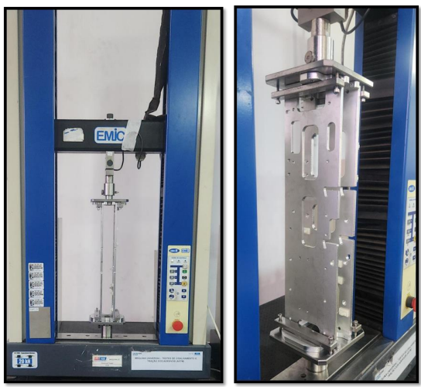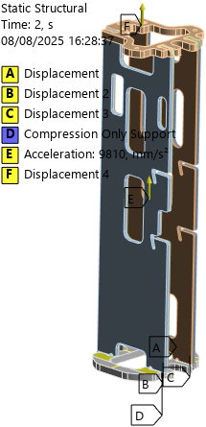

Figure 2. Experimental and numerical (μ = 0.15 and μ = 0.3) force–displacement curves.
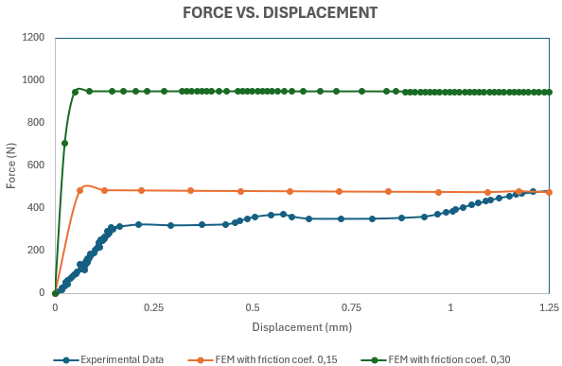

Figure 3. Vibration modes of the numerical model with bonded contact.
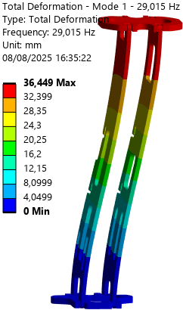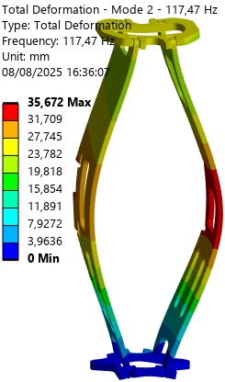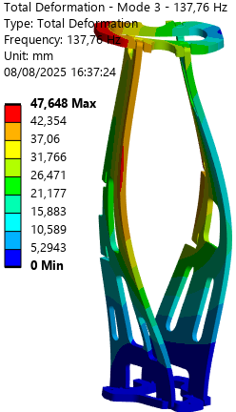
Mode 1 Mode 2 Mode 3

Figure 4. Vibration modes of the numerical model with 0.15 mm interference and μ = 0.15.
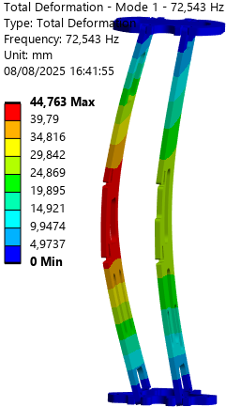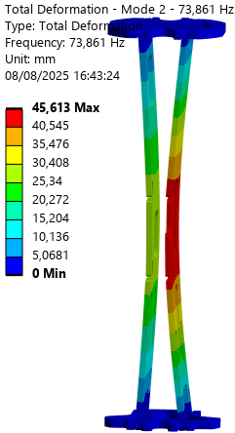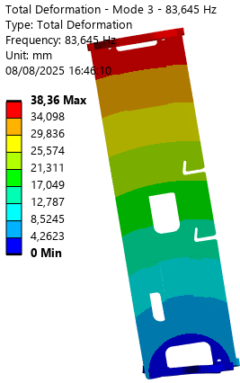
Mode 1 Mode 2 Mode 3

Table 1 - Comparison of natural frequencies between bonded contact and interference (μ = 0.15) models.
Mode | Bonded Contact (Hz) | Interference Fit (Hz)
1 | 29.015 | 72.543
2 | 117.47 | 73.861
3 | 137.76 | 83.645
4 | 142.81 | 217.59
5 | 168.04 | 264.61
6 | 344.21 | 267.74

