Process Parameters Investigation of Lignin Content in Residual Biomass
Davi Vieira Rosa^{1*}, Diana Catalina Cubides Roman ², Paulo Victor Rocha Brandao ²
1 SENAI CIMATEC University, Chemistry, Petrochemistry, and Biotechnology, Salvador, Bahia, Brazil
² SENAI CIMATEC University, Chemical, Petrochemical, and Refining Processes, Salvador, Bahia, Brazil
*Corresponding author: SENAI CIMATEC University; Salvador-BA; davieiros@gmail.com

Abstract: The pulping stage is critical for lignin removal in lignocellulosic biomass, directly influencing the efficiency of subsequent stages. In the case of residual biomass from already established production chains, its use represents a strategic alternative to add value to byproducts and reduce environmental liabilities. This exploratory study evaluated the influence of sodium hydroxide concentration and solid-to-liquid ratio on the residual lignin content. Trials were conducted at 80 °C for one hour, using NaOH at 4%, 8%, and 16%, with fiber-to-solution ratios of 1:10 and 1:20. Agitation was controlled and standardized for all samples, ensuring homogeneous mixing. Lignin quantification was performed using the Kappa number method (TAPPI T 236 om-22). The condition of 4% NaOH and a 1:20 ratio presented the lowest Kappa number, indicating high efficiency with lower reagent consumption. The results guide the definition of operational parameters that combine performance with rational use of inputs.
Keywords: lignin, pulping, biomass, Kappa number.
Abbreviations: NaOH – sodium hydroxide; KMnO₄ – potassium permanganate.

1. Introduction

Lignocellulosic biomass is primarily composed by cellulose, hemicelluloses, and lignin, along with small fractions of extractives and minerals [1]. Cellulose is a fibrous polysaccharide with high crystallinity that provides mechanical strength; hemicelluloses are amorphous polymers that contribute to matrix flexibility; and lignin acts as a binding agent, imparting rigidity and impermeability to cell walls. This complex structure ensures plant stability but hinders separation processes and industrial utilization [2].
Proportions of these constituents vary according to plant species, age, and growth conditions, directly impacting the selection and optimization of treatments.

Figure 1. Arrangement of cellulose, hemicellulose, and lignin in plant cell walls. Source: Adapted from Hosokawa Alpine Group 2025 [3].
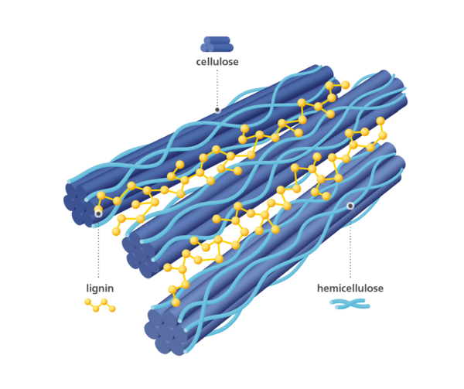
When this biomass originates from residues of other industrial processes, as in the case of this study, its utilization represents a strategic opportunity within the concept of a circular economy. The use of residual biomass reduces the need for virgin raw materials, mitigates the environmental impacts associated with disposal, and adds value to underutilized streams, aligning production with more sustainable practices [4].
Lignin, in particular, represents a physical and chemical barrier to reagent penetration, making its removal essential for fiber liberation. Pulping aims to break this barrier. It is one of the key stages in the processing of lignocellulosic biomass, being responsible for fiber separation and lignin removal, with a direct impact on pulp quality and the performance of subsequent processes. In non-woody biomass, chemical composition and anatomical structure differ significantly from those of traditional woods, requiring the adaptation of operational parameters [1].
To evaluate lignin removal efficiency, the Kappa number is commonly employed. This method, based on oxidation titration, indirectly quantifies the fraction of residual lignin in the pulp. The reaction occurs predominantly with lignin but may also involve other non-lignin structures containing carbonyl groups or double bonds, such as α,β-unsaturated aldehydes and α-ketocarboxylic acids, which likewise consume potassium permanganate (KMnO₄) in an acidic medium [5]. Under specific conditions, the formation of oxidizable byproducts, such as hexenuronic acids (HexA), may contribute to an increase in the measured value, since they also react with the oxidant. Thus, although traditionally used in the pulp industry to estimate lignin content and determine reagent charges for subsequent stages, the Kappa number reflects the overall oxidant consumption by lignin and other compounds present in the biomass, providing a comprehensive indicator of pulp condition.
In this study, we investigated the influence of NaOH concentration and solid-to-liquid ratio on the reduction of lignin content, in a non-conventional lignocellulosic biomass, determined by the Kappa number, focusing on defining more efficient and economically viable conditions.

2. Methodology

2.1. Pulping
Pulping was carried out at 80 °C for one hour, using different sodium hydroxide concentrations (4%, 8%, and 16%) and solid-to-liquid (s/l) ratios of 1:10 and 1:20. The biomass used was previously dried to a moisture content of approximately 15%, milled, and sieved through a 40-mesh screen to standardize particle size. The process consisted of heating and controlled, standardized agitation for all samples, sufficient to maintain a homogeneous mixture throughout the treatment. After draining the black liquor, an intermediate washing of the fibers with distilled water was performed to remove liquor residues and prepare the sample for subsequent stages.

2.2. Kappa Number Determination

The residual lignin content was estimated using the Kappa number method (ANSI/TAPPI T 236 om-22). This titration method indirectly quantifies lignin by measuring the consumption of potassium permanganate (KMnO₄) in an acidic medium. Initially, the sample is weighed considering its moisture content and mechanically dispersed in distilled water to ensure complete fiber separation. Subsequently, 4N sulfuric acid is added to provide the acidic conditions required for the reaction, followed immediately by the addition of a 0.1N KMnO₄ solution. The mixture is kept under constant stirring for 10 minutes. The reaction is then stopped by adding 1N potassium iodide solution, which releases iodine proportional to the remaining permanganate. This iodine is titrated with 0.1N sodium thiosulfate until a pale-yellow color is reached, at which point a starch solution is added as an indicator. The titration continues until the disappearance of the blue color, indicating the endpoint. The Kappa number calculation considers the volume of reagent consumed, its normality, the dry mass of the sample, and temperature and calibration correction factors.
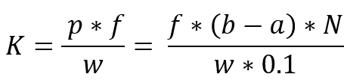 (1)
The parameters used in Equation (1) are defined as follows: K represents the Kappa number (dimensionless); f is the correction factor for 50% permanganate consumption (dimensionless); w is the oven-dried pulp weight of the specimen, expressed in grams (g); p corresponds to the volume of 0.1 N potassium permanganate actually consumed by the test specimen, in milliliters (mL); b is the volume of sodium thiosulfate consumed in the blank determination, in milliliters (mL); a is the volume of sodium thiosulfate consumed by the test specimen, also in milliliters (mL); and N is the normality of the sodium thiosulfate solution (N).

3. Results and Discussion

3.1. Solid-to-Liquid Ratio 1:10

It was observed that the Kappa numbers remained higher under this condition, with variations among concentrations indicating a partial reduction when the NaOH content was increased. Table 1 presents the Kappa number values and the percentage of residual lignin obtained for the 1:10 ratio at all concentrations evaluated.

Table 1. NaOH Concentration – Kappa Number and Residual Lignin (1:10 S/L)
NaOH Concentration (w/v) | Kappa Number | % Residual Lignin
4% | 64,45 | 9,7
8% | 67,67 | 10,2
16% | 78,89 | 11,8

It is evident that the decrease in Kappa number with increasing NaOH concentration does not follow a linear relationship. Between 4% and 8%, there is a more pronounced drop, attributed to the greater availability of OH⁻ ions to break ester and ether bonds between lignin and carbohydrates. Above 8%, the effect becomes less significant, possibly due to the saturation of the liquor with reaction products, reducing the chemical gradient necessary for diffusion. Thus, the magnitude of the decrease was modest, suggesting that liquor availability was a limiting factor for hydroxide ion diffusion and for the solubilization of lignin and hemicelluloses. This effect is consistent with scenarios in which the liquor rapidly becomes saturated with extractives and solubilized products, reducing concentration gradients and hindering further lignin removal. Figure 2 shows the behavior of these values as a function of alkaline concentration.

Figure 2. Residual Lignin (%) for Different NaOH Concentrations (1:10 S/L)
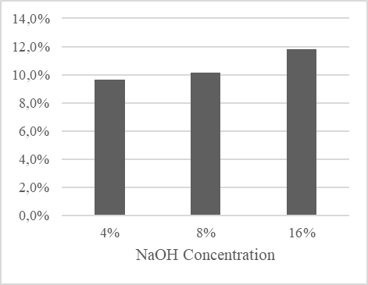
The percentage of residual lignin presented in tables and figures is inversely related to the efficiency of the pulping process. Higher values indicate lower lignin removal during treatment, as they represent a greater fraction of the component remaining in the biomass, which translates into poorer performance in the delignification stage. Lower percentages of residual lignin reflect more efficient conditions and favor subsequent processes.
In addition, the Kappa reading may have been influenced by the formation of non-lignin oxidizable species. Nevertheless, the overall trend observed in Figure 2 confirms that increasing NaOH improves the response up to a point at which further gains become negligible under the 1:10 ratio, as shown by the near-asymptotic profile of the graph.

3.2. Solid-to-Liquid Ratio 1:20

For 1:20 solid-to-liquid ratio condition, it was observed that the Kappa number was consistently reduced, and consequently, the percentage of residual lignin, when compared to the previous condition. This is evidenced in Table 2.

Table 2. NaOH Concentration – Kappa Number and Residual Lignin (1:20 S/L)
NaOH Concentration (w/v) | Kappa Number | % Residual Lignin
4% | 49,09 | 7,4
8% | 51,62 | 7,7
16% | 56,05 | 8,4

The condition with 4% NaOH stands out not only for presenting the lowest Kappa number in the entire study but also for achieving results very close to those obtained at higher concentrations, despite using the smallest amount of reagent, as shown in Figure 3. This reinforces its advantage both in terms of efficiency and reagent economy. At higher concentrations, the additional gains were limited, possibly due to the formation of oxidizable groups that also consume permanganate during titration.

Figure 3. Residual Lignin (%) for Different NaOH Concentrations (1:10 S/L)
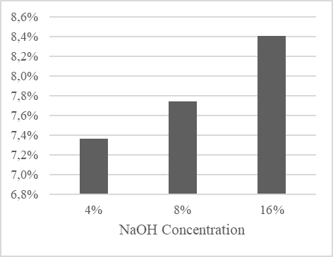
As in the 1:10 ratio, an inverse relationship between residual lignin and pulping efficiency is also observed here, but with slightly more favorable results. In other words, lower percentages of lignin indicate more effective removal, while higher values signal lower efficiency in the delignification stage. This pattern reinforces that liquor availability plays a central role in process effectiveness and prepares the pulp for subsequent stages such as bleaching and hydrolysis.
A combined analysis of the Kappa numbers and residual lignin percentages shows that, although both solid-to-liquid ratios present a tendency toward reduced values as alkaline concentration increases, the 1:20 ratio stands out for achieving lower levels of residual lignin without the need for extreme NaOH concentrations. This performance reinforces that adjusting liquor availability can be as or more effective than simply increasing the alkaline charge, since the larger solution volume favors hydroxide ion diffusion, lignin solubilization, and the removal of other compounds present in the biomass. Compared with the 1:10 ratio, the 1:20 ratio showed consistent reductions in the Kappa number at all concentrations evaluated, demonstrating that increasing liquor volume provides a less saturated reaction medium and maintains delignification reaction efficiency for longer.
Furthermore, it is noted that, beyond a certain point, increasing alkaline concentration results in more limited gains, indicating the existence of a technical limit at which excess reagent does not translate into a proportional increase in lignin removal. These findings reinforce the importance of balancing the solid-to-liquid ratio and NaOH concentration, seeking conditions that maximize efficiency without waste of inputs, with direct implications for the optimization of industrial processes aimed at reducing operational costs and environmental impacts.

4. Conclution

The condition of 4% NaOH and a 1:20 solid-to-liquid ratio balances efficiency and reagent economy, making it the most promising. The solid-to-liquid ratio exerts a strong influence on delignification, and the gains from increasing alkaline concentration become limited beyond a certain point. It is recommended that future studies explore complementary methods to quantitatively confirm these results, assess the economic impact of reagent use, and extend the study to other biomasses, thereby consolidating robust parameters. As well as important to explore another temperatures and pressures of pulping process.

Acknowledgement

We thank SENAI CIMATEC for the technical support and infrastructure that enabled the execution and analysis of this study, Embrapii, Green Coco Europe GmbH and Dicoco Agroindustrial for the financial support and fiber supply, and the project team for conducting the experiments and analyzing the results.

References

- POORNACHANDRA, C.; JAYABALAKRISHNAN, R. M.; BALASUBRAMANIAN, G.; LAKSHMANAN, A.; SELVAKUMAR, S.; MAHESWARI, M.; JOHN, J. E. Coconut husk fiber: a low-cost bioresource for the synthesis of high-value nanocellulose. Biomaterial Research in Applied Chemistry, v. 13, n. 6, p. 504, 2023
- PIRAH, S.; WANG, X.; JAVED, M.; SIMAIR, K.; WANG, B.; SUI, X.; LU, C. Lignocellulose extraction from sisal fiber and its use in green emulsions: a novel method. Polymers, 14(11), 2299, 2022.
- HOSOKAWA ALPINE GROUP. Lignin. Available at: https://www.hosokawa-alpine.com/powder-particle-processing/industries/chemicals/lignin. Accessed on: Aug. 10, 2025.
- FORCELINI, F.; DOMINGOS, A. N.; CARNEIRO, L. M. Fibras naturais vegetais e desenvolvimento sustentável: extração, beneficiamento e aplicação no design de produtos [Plant-based natural fibers and sustainable development: extraction, processing, and application in product design]. In: ENCONTRO DE SUSTENTABILIDADE EM PROJETO – ENSUS 2025, 13., 2025, Florianópolis. Anais… [Proceedings…] Florianópolis: Universidade Federal de Santa Catarina, 2025.
- CORREIA, F. M.; D’ANGELO, J. V. H.; SILVA JÚNIOR, F. G. Revisitando número kappa: conceitos e aplicações na indústria de celulose [Revisiting the Kappa number: concepts and applications in the pulp industry]. O Papel, v. 80, n. 7, p. 77–89, July, 2019.

- TAPPI. T 236 om-22. Kappa number of pulp. Atlanta, EUA: Technical Association of the Pulp and Paper Industry, 2022.

