Review on Well Control Applied to Light Well Intervention

André Vianna^{1*}, Juliana Sousa¹, Juliana Barretto¹, Bruno Arvan¹, João Pedro Cheloni²

¹ SENAI CIMATEC, Embedded Systems, Salvador, Bahia, Brazil
² SENAI CIMATEC, Development of Industrial Projects - DPI, Salvador, BA, Brazil
*andre.v@fieb.org.br

Abstract: The growing global demand for energy is placing increasing pressure on existing oil reserves. One of the strategies to address this challenge is to enhance the recovery rates of offshore wells. However, a major barrier lies in the high cost and operational risks associated with subsea interventions, particularly in deepwater environments. These constraints often delay or prevent routine maintenance activities, potentially reducing production efficiency by up to 30% compared to surface wells. A promising approach to reduce intervention costs is the adoption of Light Well Intervention (LWI) systems, which utilize smaller vessels and lighter equipment, leading to operational cost reductions of up to 50%. Nevertheless, LWI systems remain limited in terms of their well control capabilities. This study aims to review the current state of well control technologies in LWI operations and identify industry-driven technological developments. A bibliometric analysis was conducted using targeted keyword strings across major scientific databases, filtered for works related to well control or LWI by AI tools. The most relevant publications were selected and detailed the well control relevance in the results section. The search is located about eleven publications with nine patents for developing systems of entire RLWI systems with convergence solutions. The review output selected key papers and patents that show the evolution of light well intervention systems, especially for deepwater use. The papers show that capacity increase for deeper waters goes through the equipment miniaturization, electrification, and automation, with electric actuators replacing hydraulics. Redundant and modular architecture improves flexibility and efficiency. Patents highlight ROV-based interconnection and smart subsea modules with autonomous control.
Keywords: Riserless, Light Well Intervention, Workover, Offshore, Well Control.
Abbreviations: R.L.W.I, Riserless Light Well Intervention; R.L.C.P, Riserless Light Coiled Tubing

1. Introduction

The oil and gas exploration market is increasingly focused on deepwater offshore operations to meet the demand for petroleum and derivates, as more accessible reservoirs become increasingly depleted (Osmundsen, 2013 [1]). Despite the latent need for exploration, the difficult operation and maintenance of deepwater wells (Jossang et al. 2008) are factors that hinder the use of these reservoirs. According to Karlsen 2013 [3], reservoirs with subsea wells have a recovery rate that is 10% to 30% lower than their onshore or fixed-platform counterparts.
One of the central factors to a financially healthy operation of an offshore well is the implementation of intervention after the completion process to recover its production rate (Nelson, 2014 [4]). Empirical data shows that an offshore well requires some type of intervention approximately every 4 years, on average (Munkerud, 2007 [5]). However, even smaller activities can incur high costs, causing operators to implement a lower frequency of interventions, which limits operational efficiency. Thus, to enable a greater oil recovery rate, it is essential to mitigate the associated costs of subsea well interventions.
The offshore intervention equipment can be classified into three major categories: (Nelson, 2014 [4]; Khurana, 2003 [6])
Heavy Workover: The main well interventions that require conventional rigs to rescue tubing strings, perform re-entry drillings, side tracking, etc., fall into this category. Also called BOP intervention, it is characterized by the use of MODUs (Mobile Offshore Drilling Units), which are semi-submersible platforms or monohull vessels equipped with marine drilling and lifting equipment.
Medium Workover: Interventions that utilize semi-submersible platforms or large vessels using a rigid tube, called a riser, to create the connection with the subsea well. It has the capability to perform most of the intervention operations; the same equipment is used for well completion operations.
Light Workover: Intervention utilizing a smaller vessel, with a hull area up to 10,000 ft, usually capable of using wireline(e-line) operations and with most of the intervention equipment being submerged in direct contact with the Wet Christmas Tree (WCT), called stack. It is better known as “Riserless Light Well Intervention” (RLWI).
The intervention categories are compatible among themselves, and the Heavy Workover is capable of doing several types operations more than the other categories, but its high mobilization cost makes it only suitable for operations that the Medium and Light Workover equipment cannot execute. (Nelson 2014 [4]) makes a connection between the suitable operation types for each operation in Figure 1.
Figure 1. Relation between operations
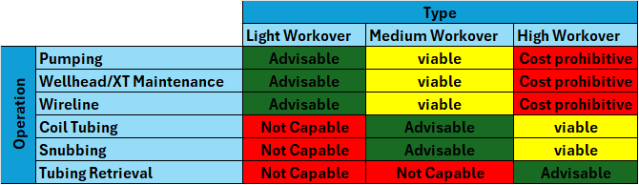
The RLWI approach has been widely studied to allow the execution of higher frequency maintenance, given its potential to mitigate CAPEX/OPEX (Acquisition and Operation Cost) values. The use of smaller vessels allows an intervention cost reduction up to 50% compared to the solution utilizing risers (Fjaertoft & Sønstabø, 2011 [7]; Jossang et al., 2008 [2]). Another benefit of RLWI use, in addition to enabling the use of smaller vessels, is greater operational flexibility. Because it utilizes smaller and lighter tools, a larger variety can be made available on the ship if necessary (Karslen, 2013 [3]).
The RLWI stack is typically made of the following equipment: PCH (Pressure Control Head), provides a dynamic sealing between the cable and the well casings to keep the pressure control and avoid that the well fluids leak into the environment; Lubricator, retaining the intervention tool string and part of the wireline cable or coiled tubing; WCP (Well Control Package), that has a similar function to the BOP (Blowout Preventer), being the main security barrier in direct contact with the WCT. Figure 2 contains the stack of FMC’s RLWI equipment.

Figure 2. Diagram of the up-to-date FMC’s RLWI stack [23]
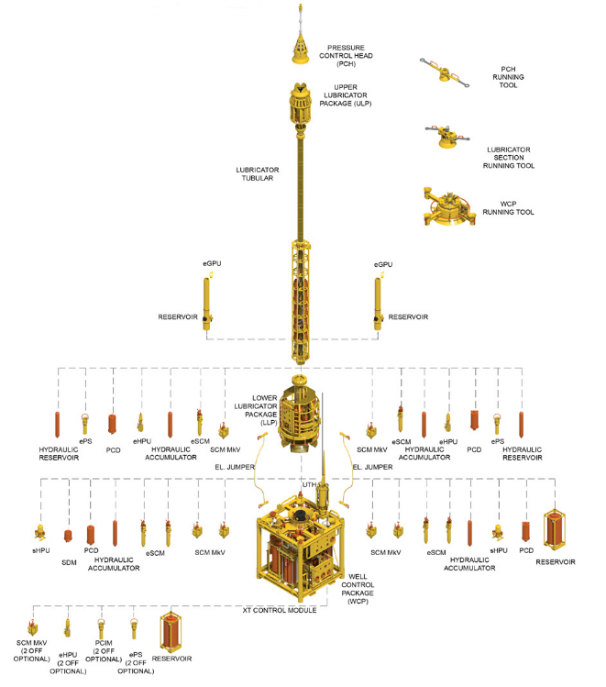

As well as production control, the intervention control system, also known as IWOCS (Intervention Workover Control System), must provide hydraulic and/or electrical drive and monitor the subsea equipment during installation or maintenance operations. Additionally, it must also provide shutdown functions (ESD), close all barriers and contain hydrocarbon leaks, and emergency disconnection (EQD) of the intervention equipment (Bai and Bai, 2019 [8]). In the case of RLWI, it cuts the wireline and umbilical connection coming from the surface. The control of hydraulic intervention equipment can be of four types: Direct, Piloted, Electro-hydraulic, and Multiplexed (Bai and Bai, 2019 [8]; Crumpton, 2014 [9]). The use of multiplexed control is done through a subsea control module (SCM) that communicates electrically with the surface, translating commands into hydraulic drives with directional valves.
This paper aims to investigate the literature related to well control for light workover operations in offshore wells, in addition to surveying the history of patents related to the development of well control for intervention.

2. Methodology

To feed the technological review of well control, a method with 3 stages was undertaken, which can be seen in Figure 3. The first was a generalized search of scientific databases (Google Scholar; Google Patent; Elsevier; Derwent) through the automatic search engine of their platforms guided by key terms. The key terms were raised by the authorship team, based on their knowledge, the most important keywords, as shown in Table 1. From these keywords, search chains were established, called Strings, using the following law of formation:

String = [Application] AND [Environment] AND [Activity] AND [Subsystem] AND [Equipment]
Within each key, the keywords, intermediated by OR, are used. From the results, filtering was made aided by tools specialized in reading PDF files, NotebookLM, and ChatPDF, to indicate which patents are related to well control or well control related to light intervention. After this filter, a search was made among the references of the filtered works that were not included in the global search and were added to the list to be analyzed. In the resulting publications, their titles, year of publication, and the quality of the content were analyzed. The most relevant works were selected.

Table 1. Global Search keywords
Application | Environment | Activity | Subsystem | Equipment
Oil | Subsea | Wireline | Well Control System | SCM
Gas | Offshore | Coiled Tubbing | Subsea control | Subsea Control Module
Oil&Gas | Underwater | Slickline | Subsea Well | WCP
Oil and Gas | External Subsea | Workover | Well Intervention | Lubricator
Hydrocarbon |  | Riserless Light Well Intervention | Well Workover | Umbilical
 |  | Intervention |  | Subsea Christmas Tree
 |  | Intervention Method |  | Sensors
 |  |  |  | Subsea Electrical Connector

Figure 3. Search methodology diagram
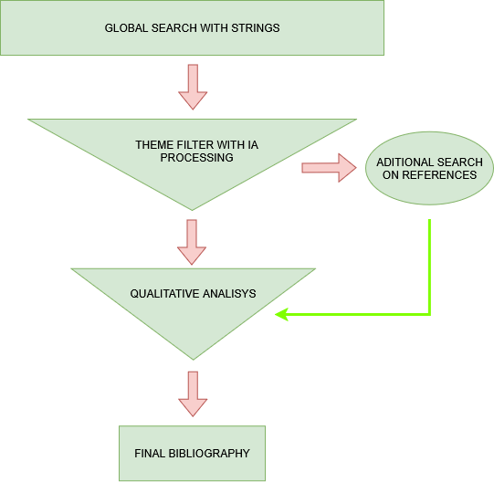

3. Results

The analyses localized many papers and patents related to well and RLWI systems that, after the qualitative filtering, resulted in 5 articles and 9 patents.
The report by Mathiassen et al. [10] provides a visualization of experience in light intervention in shallow waters and the technological evolution of FMC's RLWI system, Mark, which is now able to operate in deep waters, more than 3000 meters deep. The first generation of equipment uses direct hydraulic control for its stack, which made the equipment operation much heavier due to the demand for umbilical and more robust equipment. The solution was to implement multiplexed control with two redundant SCMs and to replace hydraulic actuators, such as grease seal control, with electric motors. Having a progressively more electric control system makes it possible to have a greater miniaturization of the system, because hydraulic actuation demands a larger system with accumulators and pumping, in addition to enabling the implementation of a lighter umbilical. Various authors indicate the advances in the use of RLWI due to the expansion of operating capabilities with an LWI infrastructure. Jossang and Nelson [2][4] indicated that LWI equipment was only applicable for slickline or E-line operations, but they already foresaw an implementation of Coiled Tubing (CT) operations. The paper by Haheim et al. [11] already presents a concept of an RLWI system for operation with CT in which the control system is identical to an IWOCS of a riser system with the addition of synchronization with the boat's heaving compensation to keep the CT tensioned during the intervention. More recently, Buset et al. [12] reports the execution of RLWI operation with CT. The system no longer needs the installation of a tensioning mechanism and only needs heaving compensation control at the time of entry of the intervention tools.
Boyce and Bath 2011 [13] presents an RLWI system that includes BOP interfacing between the ANM and a well control module similar to a WCP. Hydraulic needs are provided by a submarine skid. A control differential of this system is the use of a double ROV to make an electrical connection to the topside, in order to control monitoring and hydraulics to the subsea skid for hydraulic pumping. Similarly, Camus et al. 2019 [14] proposes an RLWI system via wireline that, however, does not require a derrick to install and operate the subsea equipment. The control unit is located on the vessel and is always mediated by a ROV, either via cable or wireless communication, but which preserves a hydraulic supply for control.
Salen and Endresen 2012 [15] present an SCM model with internal electronics (SEM) redundant and replaceable, a concept that is similarly used in the system proposed by Brock and Johnston 2014[22], presenting an IWOCS system composed of a surface mount and another subsea mount responsible for monitoring and controlling valves.
Machin and Nelessen 2015 [16] propose a well intervention solution that uses pumps and fluid reservoirs located on the seabed. The system is specifically composed of a lubricator and the subsea pumping unit. Fluid pumping and storage equipment are stored in a subsea environment. The patent indicates a drastic reduction in losses due to friction in distribution lines and the suppression of return lines. The system can be coupled with an existing control system for power supply and communication sharing.
For systems with Coiled Tubing (CT) operation, Crawford et al. 2016 [17] introduces an RLWI solution for CT with a dynamic tensioning mechanism. The system is controlled by a subsea control module electrically connected to the support vessel. The hydraulic control of the Snubbing Jack is subsea and remotely controlled through an electric umbilical, reducing latency in the subsea hydraulic control. The operation control itself is done by a WCP connected directly to the WCT. More advanced system is proposed by Ewen and Iqbal 2020 [18], featuring a dynamic and static well interface and sealing system for offshore CT operations. It consists of an upper and lower stage; the upper one contains the activation of safety barriers, while the lower one makes the electrical and hydraulic connection with the power sources and supervisory control system. The invention can be used as a subsea hydraulic power supply and is compatible with hydraulic and electric motor drives.
Reynolds [19] describes a modular, distributed subsea control system that is ROV-retrievable, designed for use with a BOP configuration in deepwater environments. The control module is arranged in a vertical matrix, so that its programming is easily adjusted for other operations or other types of equipment. It features "Wet mate" access, which allows local installation and ROV access. This system offers electrical and hydraulic power supply through tracks moored in the Riser. Advancing on the issue of underwater autonomy of the control system, Bourgeau and Aspin 2020 [20] indicate an underwater system for the storage of electrical and hydraulic energy, and control for BOP equipment, with at least one shear ram. Energy for underwater storage can be provided by a surface umbilical, a remotely operated vehicle (ROV), or by underwater electrical generation from stored hydraulic power. The energy transfer is bidirectional, as electric energy is also used to regenerate hydraulic energy within the system. The solution has a modular registration and telemetry system, with integrated modules with multiple pressure, energy, flow sensors, among others, to monitor conditions with high resolution and, in the local control system, process that information and act in pre-programmed conditions. In this way, it can operate even in the event of a loss of communication with the topside.
Sand et al. 2020 [21] presents a modular control cabin that provides specific programming and capabilities for each operation, with the purpose of overcoming the limitations of conventional systems, which are complex and specific to each operation. The control cabin has a fixed interface component with the subsea equipment and accommodates replaceable control modules selected according to operation. It claims to reduce costs, handling time, and personnel requirements, and can be implemented both onshore and on LWI vessels.
4. Conclusion
The qualitative filtering resulted in a representative set of academic papers and patents that illustrate the continuous evolution of light well intervention (LWI) systems, with special emphasis on their application in deepwater environments. The technological solutions identified point to a clear trend towards miniaturization, electrification, and automation of control systems, evidenced by the progressive replacement of hydraulic components with electric actuators, as well as the adoption of architectures with redundancy and modularity, which provide greater flexibility and operational efficiency. The patents analyzed reinforce these trends, highlighting the use of ROVs for interconnection with topside systems, as well as the development of subsea modules with intelligent control and autonomous response capabilities.
Acknowledgement

The authors would like to thank CIMATEC and PETROBRAS for providing infrastructure and financial support to perform the research.

References

- Osmundsen P. Choice of Development Concept--Platform or Subsea Solution? Oil and Gas Facilities. 2013 Aug 18;2(05):64–70.
- Jossang SN, Friedberg R, Buset P, Buset B. Present and Future Well Intervention on Subsea Wells. In: IADC/SPE Drilling Conference [Internet]. 2008. Available from: https://onepetro.org/SPEDC/proceedings-abstract/08DC/All-08DC/SPE-112661-MS/143933
- Ole Eddie Karlsen, Morrison B, Maciel P. Improved Recovery Rate in Brownfield Subsea Wells Using Riserless Light Well Intervention. OTC Brasil All Days. 2013 Oct 29; DOI: https://doi.org/10.4043/24367-MS
- Nelson ME, McLeroy PG. Subsea Well Intervention: Recent Developments and Recommendations to Increase Overall Project Returns. SPE Annual Technical Conference and Exhibition. 2014 Oct 27; DOI: https://doi.org/10.2118/170980-MS
- Munkerud PK, Inderberg O. Riserless Light Well Intervention (RLWI). Offshore Technology Conference. 2007 Apr 30; DOI https://doi.org/10.4043/18746-MS
- Khurana S, DeWalt B, Headworth C. Well Intervention Using Rigless Techniques. OTC All Days. 2003 May 5; DOI: https://doi.org/10.4043/15177-MS
- ‌ L.. Fjærtoft, G.. Sønstabø. Success from Subsea Riserless Well Interventions. SPE/ICoTA Coiled Tubing & Well Intervention Conference and Exhibition. 2011 Apr 5; DOI: https://doi.org/10.2118/143296-MS
- Bai Y, Qiang Bai. Subsea engineering handbook [e-book]. Cambride, Ma: Gulf Professional Publishing; 2019. Available from: https://www.elsevier.com/books/subsea-engineering-handbook/bai/978-0-12-812622-6
- Crumpton H. Well control for completions and interventions. Cambridge, Ma: Gulf Professional Publishing; 2018. DOI: https://doi.org/10.1016/C2014-0-00602-8
- Erling Mathiassen, Skeels HB. Field Experience With Riserless Light-Well Intervention. Offshore Technology Conference. 2008 May 5; DOI: https://doi.org/10.4043/19552-MS
- Svein Håheim, Hoen C, Birger Heigre, Heim E, Øystein Windsland. Riserless Coiled-Tubing Well Intervention. Offshore Technology Conference. 2003 May 5; DOI: https://doi.org/10.4043/15179-MS
- P. Buset, Gramstad B, Howitt M, S. Mæland, Sbordone A, Stinson T, et al. Riserless Coiled Tubing Services from Light Well Intervention Vessel - First Operation in a Live Subsea Well. SPE/ICoTA Well Intervention Conference and Exhibition. 2025 Mar 18; DOI: https://doi.org/10.2118/224032-MS
- Boyce C, Bath W. Riserless modular subsea well intervention, method and apparatus [Internet]. 2009. Available from: https://patents.google.com/patent/US7891429B2/en?oq=US+Patent+7891429
- Camus M, Blanckaert T, Malanda J. Subsea well intervention method [Internet]. 2022. Available from: https://patents.google.com/patent/US11585180B2/en?oq=US+Patent+11585180
- Salen A, Endresen B. Subsea control modules and methods related thereto [Internet]. 2012. Available from: https://patents.google.com/patent/US9303489B2/en?oq=US+Patent+9303489
- Machin J, Nelessen P. Subsea well intervention lubricator and method for subsea pumping [Internet]. 2015. Available from: https://patents.google.com/patent/US8978767B2/en?oq=US+Patent+8978767
- Crawford N, Newman KR, BOLT T, HARMAN B, Cook JR, EWEN RL, et al. System and method for riserless subsea well interventions [Internet]. 2017. Available from: https://patents.google.com/patent/US20170260835A1/en?oq=US+Patent+20170260835
- Ewen R.L, Iqbal H.A. Open Water Coiled Tubing Sealing Device [Internet]. 2022. Available from: https://patents.google.com/patent/US20200362657A1/en?oq=US+Patent+20200362657
- Reynolds G.E Modular, distributed, ROV retrievable subsea control system, associated deepwater subsea blowout preventer stack configuration, and methods of use [Internet]. 2007. Available from: https://patents.google.com/patent/US7222674B2/en?oq=US+Patent+7222674
- Bourgeau E. P. K. Subsea energy storage for blow out preventers (BOP) [Internet]. 2021. Available from: https://patents.google.com/patent/US11060372B2/en?oq=US+Patent+11060372
- Sand F, Lindanger I, Sekkingstad IM, Slettum S, Dypevik T, Drønen H, et al. Modular system and method for controlling subsea operations [Internet]. 2020. Available from: https://patents.google.com/patent/US10570682B2/en?oq=US+Patent+10570682B2
- Brock S, Johnston C. Subsea intervention system [Internet]. 2016. Available from: https://patents.google.com/patent/US9273536B2/en?oq=US+Patent+9273536
- Riserless Light Well Intervention Reducing the cost of offshore intervention operations [Internet]. Available from: https://www.technipfmc.com/media/fmwmxe42/ss0025-brochure_rlwi_digital.pdf

