Bibliographic Analysis of Compressive Sealants for Metal-Supported Solid Oxide Fuel Cells and Electrolyzers
Guilherme Santos Niekraszewicz^{1*}, Iuri Dantas Passos da Mota¹, Gerhard Ett², Julia Fernandes Gabriel²
¹ University SENAI CIMATEC, Chemical Engineering Department, Salvador, Bahia, Brazil
² FEI, Chemical Engineering Departament, São Bernardo do Campo, São Paulo, Brazil
*Corresponding author: University SENAI CIMATEC; Av. Orlando Gomes, 1845 - Piatã, Salvador - BA, 41650-010; guilherme.niekraszewicz@aln.senaicimatec.edu.br

Abstract: Metal-supported solid oxide fuel cells (MS-SOFCs) and solid oxide electrolysis cells (SOECs) stand out for high power density, fuel flexibility, and long-term stability. Their durability relies on compressive sealants that prevent gas crossover and maintain integrity under high temperatures. Mica- and vermiculite-based gaskets are widely used for compliance, easy assembly, and hermeticity without high-temperature processing. This work reviews compressive sealant materials, configurations, and hybrid strategies for MS-SOFC and SOECs. Emphasis is placed on the structural, thermal, and chemical behavior of phlogopite papers and Thermiculite® gaskets, which show superior stability, low porosity, and reduced leakage, especially with glass-ceramic layers. Hybrid approaches, such as transient liquid-phase bonding, are also considered for lowering operating temperatures while preserving strength. Finally, the availability of Brazilian phlogopite and vermiculite is highlighted as an opportunity for cost-effective, locally sourced sealants.
Keywords: Compressive Sealants. Metal-Supported SOFC. Vermiculite. Mica Paper. Thermiculite®.
Abbreviations: MS-SOFC, Metal-Supported Solid Oxide Fuel Cell. SOFC, Solid Oxide Fuel Cell. CEV, Chemically Exfoliated Vermiculite. ECS, Electrochemical Society.
Análise Bibliográfica de Selantes Compressivos para Células Combustível de Óxido Sólido Suportadas em Metal e Eletrolisadores de Óxido Sólido
Resumo: As células de combustível de óxido sólido suportadas por metal (MS-SOFCs) e as células de eletrólise de óxido sólido (SOECs) destacam-se pela alta densidade de potência, flexibilidade de combustível e estabilidade a longo prazo. Sua durabilidade depende de selantes compressivos que impedem o cruzamento de gases e mantêm a integridade sob altas temperaturas. Juntas à base de mica e vermiculita são amplamente utilizadas por sua conformidade, fácil montagem e hermeticidade sem processamento em alta temperatura. Este trabalho analisa materiais de vedação compressivos, configurações e estratégias híbridas para MS-SOFC e SOECs. A ênfase é colocada no comportamento estrutural, térmico e químico dos papéis de flogopita e juntas Thermiculite®, que apresentam estabilidade superior, baixa porosidade e vazamento reduzido, especialmente com camadas de vitrocerâmica. Abordagens híbridas, como a ligação em fase líquida transitória, também são consideradas para reduzir as temperaturas de operação, preservando a resistência.
Palavras-chave: Selantes Compressivos. MS-SOFC. Vermiculita. Papel de Mica. Thermiculite.
Abreviações: MS-SOFC, Célula Combustível de Óxido Sólido Suportadas em Metal. SOFC, Célula Combustível de Óxido Sólido. CEV, Vermiculita Exfoliada Quimicamente. ECS, Sociedade Eletroquímica.

1.Introduction
With the continuous growth of global energy demand, the search for cleaner and more sustainable methods of electricity generation has intensified [1]. In this context, hydrogen-based technologies such as fuel cells have gained prominence by combining low environmental impact with a high degree of technological maturity [2].
Among the various types, metal-supported solid oxide fuel cells (MS-SOFCs) stand out for operating at high efficiency levels, surpassing the thermodynamic limitations imposed by the Carnot cycle on conventional heat engines [3]. The operating principle of SOFCs involves the reduction of oxygen at the cathode to produce O²⁻ ions, which migrate through a ceramic electrolyte to the anode. There, they react with hydrogen to form water vapor and release electrons. These electrons travel through an external circuit, generating electric current, and return to the cathode to complete the electrochemical cycle [2], as illustrated in Figure 1 and described on Equations 1 and 2 [2].
Figure 1. Schematic of the Metal-Supported Solid Oxide Fuel Cell Operating Principle
Source: [1]
Equation 1. Oxigen reduction at the cathode
$\frac{1}{2}O_{2}+2 e^{-} →O^{2-}$ (1)
Equation 2. Hydrogen oxidation at the anode
$H_{2}+O^{2-} →H_{2}O+2 e^{-}$ (2)
A MS-SOFC comprises five primary components: the metal support, the anode, the electrolyte, the cathode, and the sealant. The metal support, often made from oxidation-resistant ferritic stainless steels such as Crofer 22 H, provides mechanical strength, electrical conductivity, and thermal stability at high operating temperatures [4]. The anode is typically a Ni–YSZ (yttria-stabilized zirconia) cermet, which offers high electronic conductivity and catalytic activity for hydrogen oxidation [5]. The electrolyte, commonly YSZ, ensures high O²⁻ ionic conductivity within the operating temperature range and acts as a gas-tight barrier between electrodes [5]. The cathode is often composed of perovskite oxides such as LSCF (La₀.₆Sr₀.₄Co₀.₂Fe₀.₈O₃–δ), applied by techniques like plasma spray to maximize oxygen-reduction reaction rates [6].
Sealing these components into a hermetic stack is crucial for maintaining efficiency and long-term durability under continuous operation. Sealants for SOFCs are classified into three main families: rigid (glass-ceramic-based), compressive (mica- or vermiculite-based), and compliant (braze-based) [7]. Among these, compressive sealants have drawn significant attention due to their excellent leak-tightness and ease of assembly [7]. Techniques such as Ni–Sn transient liquid-phase bonding using Crofer 22 H interconnects have been explored to create low-temperature metal seals, highlighting the versatility of combining metallic and compressive methodologies for enhanced sealing performance [4].
Despite these advances in materials and cell architecture, one of the main technological bottlenecks for commercial deployment of SOFCs is the sealing of the system [7]. The high operating temperatures (700–1000 °C) and the porous nature of many components, as shown in Figure 2, pose serious challenges to achieving a durable, hermetic, and reliable seal [3].
Figure 2. Key Components of a Metal-Supported Solid Oxide Fuel Cell Stack
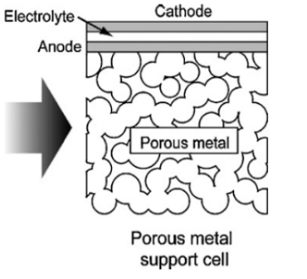
Source: [3]
Solid Oxide Electrolysis Cells (SOECs) operate on principles similar to those of SOFCs but in reverse, using electrical energy to drive the electrochemical splitting of steam (and sometimes CO₂) into hydrogen and oxygen at elevated temperatures. In an SOEC, steam is introduced at the cathode, where it receives electrons to form hydrogen gas and oxygen ions (O²⁻). These oxygen ions migrate through a dense ceramic electrolyte to the anode, where they release electrons and form O₂ gas. This reaction is described by Equations 3 and 4.
Equation 3. Hydrogen reduction at the cathode
$H_{2}O+2 e^{-}→H_{2}+O^{2-}$ (3)
Equation 2. Oxigen oxidation at the anode
$O^{2- }→\frac{1}{2}O^{2}+2 e^{-}$ (4)
The high operating temperatures (700–900 °C) of SOECs improve thermodynamic efficiency and enable the co-electrolysis of H₂O and CO₂ to produce syngas (H₂ + CO), a valuable feedstock for synthetic fuels. However, this high-temperature environment imposes stringent requirements on all cell components, particularly the sealants, which must maintain hermeticity and chemical stability over prolonged operation in dual atmospheres (reducing on the cathode side and oxidizing on the anode side).
Glass-ceramic sealants were investigated specifically for SOEC applications and highlighted that maintaining compatibility between the thermal expansion coefficients (CTEs) of the sealant and adjoining components is essential to avoid mechanical failures during thermal cycling [8]. It was proposed a BaO–SiO₂-based composition with optimized CTE and good long-term adhesion in H₂/H₂O atmospheres, maintaining structural integrity after 2000 h of exposure at operating conditions without delamination or gas leakage [8].
Further developments introduced SrO-containing glass-ceramics tailored for SOEC use [9]. These sealants exhibited high electrical resistivity (>10⁵ Ω·cm), stable sealing behavior under simulated electrolysis conditions, and appropriate softening temperatures (Tg and Tfs) for stack assembly and operation [9]. The composition designated HJ14 showed promising results due to its thermal stability and mechanical robustness, indicating its potential as a candidate for long-duration SOEC operation [9].
These findings underscore the critical role of tailored sealant design for the durability and efficiency of SOECs, especially under the combined challenges of high temperature, differential pressure, and dual-gas atmospheres.
Choosing a suitable sealant is crucial not only for structural integrity but also for maintaining cell efficiency and long-term durability under continuous operation.
The main sealant families for SOFCs and SOECs can be divided into three groups: rigid (glass-ceramic-based), compressive (mica- or vermiculite-based), and compliant (braze-based). Among these, the compressive sealants have attracted attention for their excellent leak-tightness and ease of use [2].
In Bahia, the occurrence of phlogopite—a rock used to produce phlogopite mica—in the Carnaíba district of Pindobaçu has been widely investigated by CETEM as a potassium source and as a promising raw material for mica-based compressive sealants [10]. Moreover, the municipality of Brumado hosts vermiculite and talc mining concessions operated by companies such as Mineração Urimamã, evidencing local deposits of this key vermiculite for compressive sealants [11]. With significant reserves also in states like Goiás and Piauí, Brazil holds strategic potential to become a major national producer of mica and vermiculite compressive sealants, meeting sealing demands in SOFCs and other high-performance industrial applications [12].
In this scenario, the present article aims to perform a comparative analysis of the main compressive sealants applied in solid oxide fuel cells and electrolyzers.
2. Methodology
A bibliographic review was performed using the Scopus database and the Bibliometrix software.
The keywords “Sealing” and “SOFC” were used to identify articles containing both terms in the title, abstract, or keywords, yielding 465 papers.
The number of citations per article was then analyzed, revealing that the most-cited paper was published in 2009; hence, a filter was applied to include only articles published from that year onward, resulting in 348 documents.
Graphs illustrating the bibliographic dynamics of the topic were generated with Bibliometrix, as shown in Figure 3.
Figure 3. Bibliometric Analysis of SOFC Sealing Literature
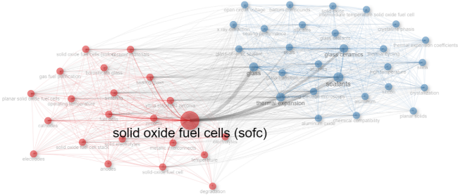
Source: Made by the authors
3. Results and Discussion
Based on the bibliographic review, it was possible to understand the sealing process using compressive sealants and their physical properties. These sealants consist of mineral flakes (mica or vermiculite) bound together with an organic or inorganic binder, forming a sheet-like material [13], as shown in Figure 4.
Figure 4. Photographic Comparison of Compressive Sealant Materials
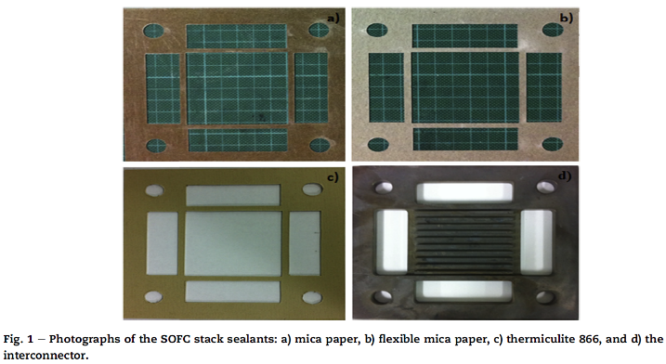
Source: [5]
During sealing, the gasket material is subjected to a compressive force, either via springs or bolts through the stack structure [14]. Under compression, the mineral flakes rearrange, and at high temperatures they retain this compressed arrangement, preventing gas leakage.
The main compressive sealants can be divided into two subgroups: mica-based sealants and vermiculite-based sealants (Thermiculite®) [13].
3.1 Mica-Based Sealants
Mica-based sealants are composites made by incorporating mica flakes into a cellulose pulp, which is then formed into sheets through a process analogous to paper making [15]. This yields a material with excellent electrical insulation properties. However, the presence of organic binders can lead to material degradation during SOFC thermal cycling [13]. In comparative leak-rate tests, mica paper sealants exhibited higher leakage rates than vermiculite-based sealants at both room temperature and at 800 °C [5]. Expansion tests also showed that mica paper undergoes significantly greater thickness increase upon heating, indicating higher final porosity under operating conditions [5].
3.2 Thermiculite® (Vermiculite-Based)
Thermiculite® is a sealing material manufactured from vermiculite, a phyllosilicate mineral similar to mica [13]. Specifically, Thermiculite® 866 consists of chemically exfoliated vermiculite (CEV) and steatite, with no organic binders, thereby avoiding degradation during fuel cell operation [13].
To further enhance performance, Thermiculite® 866 LS was developed by applying a glassy sealant layer to the contact surfaces of the material, enabling effective sealing at lower compressive pressures, as shown in Figure 5 [13].
Figure 5. Sealing Parformance: Thermiculite® 866 vs. 866 LS under Varying Conditions
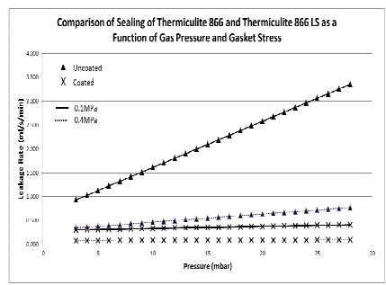
Source: [13]
Studies on Thermiculite® CL87 and CL87 LS models indicate that material compressibility significantly decreases by 200 °C, suggesting that initial compression should be performed at room temperature before the first heat-up cycle [15].
3.3. Comparison
When comparing mica-based and vermiculite-based (Thermiculite®) compressive sealants, critical differences emerge. Thermiculite® demonstrates superior dimensional stability, with only 0.068 mm thickness change after 100 hours at high temperature, whereas mica paper and flexible mica paper expand by 0.51 mm and 0.48 mm, respectively [16]. This lower expansion in Thermiculite® corresponds to lower final porosity and improved leak tightness, as confirmed by lower leak-rate measurements under identical hydrogen flow and temperature conditions (Figure 6) [5].
Figure 6. Leakage Rate Comparison of Mica- and Vermiculite-Based Sealants
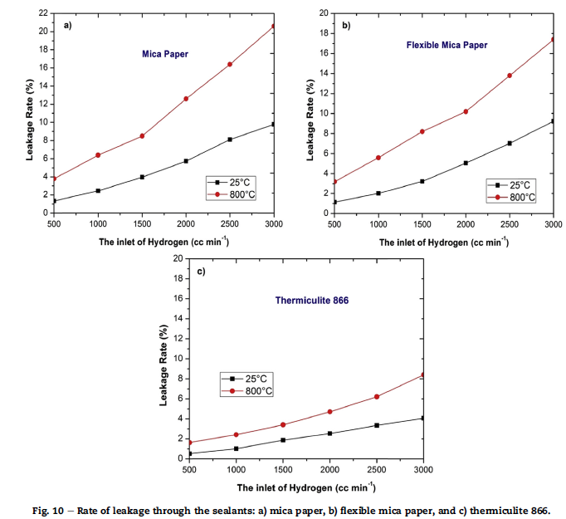
Source: [5]
Comparative life-cycle assessments have shown that vermiculite-based sealants have a lower environmental footprint, considering raw material extraction and end-of-life recyclability, compared to synthetic polymer-based gasket alternatives [17]. Preliminary evaluations suggest that leveraging domestic vermiculite resources could offer cost benefits over some imported sealant materials, potentially supporting the economic viability of large-scale SOFC implementation.
Practically, Thermiculite® also requires a lower compressive force to achieve adequate sealing compared to Mica [13]. A hybrid approach—combining compressive and rigid sealant features—has emerged as promising. Coating Thermiculite® with a glass-ceramic layer (e.g., 866 LS and CL87 LS) drastically reduces leakage and enhances resistance to internal pressure variations, merging the mechanical resilience of compressive sealants with the low permeability of glasses, while requiring less compressive load [13].
4. Conclusion
The comparative analysis of mica- and vermiculite-based compressive sealants reveals the clear superiority of Thermiculite® for SOFC and SOEC applications. Its higher dimensional stability at elevated temperatures, lower porosity, and consequently lower leak rates make it a more reliable and efficient option. Additionally, the ability to achieve hermetic sealing at reduced compressive forces—especially in glass-coated versions like Thermiculite® 866 LS—offers significant advantages for stack structural integrity and longevity. The advancement toward hybrid sealant solutions, combining the best traits of compressive and rigid materials, represents a promising pathway to overcome sealing challenges in SOFCs and SOECs, supporting the commercial viability of this clean energy technology.
5. References
- FALLAH VOSTAKOLA, Mohsen; AMINI HORRI, Bahman. Progress in material development for low-temperature solid oxide fuel cells: A review. Energies, v. 14, n. 5, p. 1280, 2021.
- ANJANA, P. S.; SALINIGOPAL, M. S.; GOPAKUMAR, N. Glasses and glass-ceramics as sealants in solid oxide fuel cell applications. In: Energy Materials. Elsevier, 2021. p. 373-404.
- TUCKER, Michael C. Progress in metal-supported solid oxide fuel cells: A review. Journal of Power Sources, v. 195, n. 15, p. 4570-4582, 2010.
- CAO, Jian et al. A low-temperature sealing method for metal-supported oxide fuel cell applications: Ni–Sn transient liquid phase bonding. Vacuum, v. 187, p. 110048, 2021.
- NGUYEN, Xuan-Vien et al. Study of sealants for SOFC. International Journal of Hydrogen Energy, v. 41, n. 46, p. 21812-21819, 2016.
- GAO, Jiu-Tao et al. Performance and stability of plasma-sprayed 10× 10 cm 2 self-sealing metal-supported solid oxide fuel cells. Journal of Thermal Spray Technology, v. 30, p. 1059-1068, 2021.
- FERGUS, Jeffrey W. Sealants for solid oxide fuel cells. Journal of Power Sources, v. 147, n. 1-2, p. 46-57, 2005.
- JAVED, Hassan et al. Glass-ceramic sealants for SOEC: Thermal characterization and electrical resistivity in dual atmosphere. Energies, v. 13, n. 14, p. 3682, 2020.
- JAVED, Hassan et al. Novel SrO-Containing Glass-Ceramic Sealants for Solid Oxide Electrolysis Cells (SOEC): Their Design and Characterization under Relevant Conditions. Materials, v. 15, n. 17, p. 5805, 2022.
- Centro de Tecnologia Mineral (CETEM). Beneficiamento do flogopitito da região de Pindobaçu-BA como fonte de potássio para a agricultura brasileira. Rio de Janeiro: CETEM; Available: https://pantheon.ufrj.br/bitstream/11422/13397/1/Tainara%20Cristina%20de%20Assis.pdf
- Ministério de Minas e Energia. Perfil da vermiculita: concessão para lavra em Brumado-BA. Brasília: MME; Available: https://www.gov.br/mme/pt-br/arquivos/p28-rt48-perfil-da-vermiculita.pdf
- UGARTE, José Fernandes de Oliveira; MONTE, Marisa Bezerra de Mello. Estudo da vermiculita como adsorvente de óleo e metal pesado. 2005.
- HOYES, John Robert; RAUTANEN, Markus. SOFC sealing with thermiculite 866 and thermiculite 866 LS. ECS Transactions, v. 57, n. 1, p. 2365, 2013.
- LEE, Sanghun et al. Reliable sealing design of metal-based solid oxide fuel cell stacks for transportation applications. International Journal of Hydrogen Energy, v. 44, n. 57, p. 30280-30292, 2019.
- XANTHOS, Marino. Mica flakes. Functional fillers for plastics, p. 149, 2005.
- RAUTANEN, Markus et al. Effects of the first heat up procedure on mechanical properties of solid oxide fuel cell sealing materials. Journal of Power Sources, v. 284, p. 511-516, 2015.
- SINGH, Kulvir; WALIA, Trisha. Review on silicate and borosilicate‐based glass sealants and their interaction with components of solid oxide fuel cell. International Journal of Energy Research, v. 45, n. 15, p. 20559-20582, 2021.

