Development of a hair tonic from the plant extract of jaborandi (Pilocarpus jaborandi) and copaiba (Copaifera langsdorffii) to aid in the treatment of seborrheic dermatitis
Débora de Souza Acácio, Tayná Arcanjo da Costa, Thais Alves Rodrigues, Natália Leite Ferreira, Tatiana Oliveira do Vale, Erica Patrícia Lima Pereira
SENAI, CIMATEC, Salvador, Bahia, Brasil
ABSTRACT : Seborrheic dermatitis is a chronic inflammatory dermatosis characterized by scaling, sores and other symptoms that negatively impact the patient's quality of life. The aim of this study is to develop a herbal tonic from jaborandi extract (Pilocarpus jaborandi) and copaiba oil (Copaifera langsdorffii) that can help treat this condition, analyzing the effectiveness of each substance. The research has a qualitativequantitative approach, experimental methodology and descriptive objective. For the microbiological tests, specific analyses were carried out to assess the tonic's potential to promote the growth of microorganisms. The results indicated positive properties of the compounds, revealing, in direct application, the absence of mold and staphylococcus growth in the treated samples. This finding suggests that the extracts potentially have effective antifungal and antimicrobial properties, since they are not capable of enabling the development of microorganisms under the experimental conditions tested. In addition, the organoleptic tests and the flavonoid detection assay also pointed to the efficiency of the compound. Therefore, based on these results, it can be concluded that the herbal tonic made from jaborandi and copaiba extracts is potentially effective in the treatment of dermatitis. In this way, it provides an effective product at a lower cost, making it more accessible to a large part of the population.
Keywords: Tonic; Herbal medicine; Seborrheic dermatitis; Jaborandi; Copaiba.

1. INTRODUCTION
Seborrheic dermatitis is a very common skin disease that causes scaling, redness, itching, sores, alopecia and general discomfort on the skin. It mainly affects the scalp and areas of the head that may include the face, but it is also present in other oily areas of the body, such as the chest and back.

Therefore, as it is a condition that requires constant and intensive treatment, most products for treating dermatitis are expensive and not very accessible to a large part of the group affected by this disease. Because of this, and in order to mitigate this obstacle, the project aims to develop a more cost-effective and accessible herbal hair tonic that meets the demands and effectively aids in the treatment of seborrheic dermatitis. This product will be developed from the oils of Pilocarpus Jaborandi and Copaifera langsdorffii, popularly known as jaborandi and copaiba, respectively, because these plants are chemically composed of substances that have antioxidant, antibacterial, anti-inflammatory and other properties, which are capable of alleviating the symptoms of seborrheic dermatitis and strengthening the hair. In addition, this study also aims to explore and prove the efficacy of the plants, as well as the potential and behavior of their respective properties. It is worth mentioning that microbiological tests will be carried out and the components will be observed in triplicate, precisely in order to highlight the susceptibility of the herbal hair tonic.
2. THEORETICAL BACKGROUND

In this topic, the research associated with the use of Copaifera Iangsdorffii oil and Pilocarpus Jaborandi extract as an auxiliary product in hair treatment will be analyzed. Information will then be presented that underpins the project and scientifically proves the efficacy of the oils, as well as their respective properties.
It is stated that jaborandi extract contains a large amount of alkaloids, coumarins, flavonoids and terpenes that can be used to treat scalp ailments. Copaiba oil also contains the substances cariophylene and bisabolene, which can help the healing process and act as an anti-inflammatory. Therefore, these data reiterate the susceptibility of the hypothesis under analysis. Therefore, the aim is that the combination of jaborandi extract and copaiba oil can help in the treatment of seborrheic dermatitis.

2.1 Seborrheic dermatitis
Seborrheic dermatitis (SD) is a conventional, non-contagious, chronic inflammation that affects around 1 to 3% of the immunocompetent population (CASAGRANDI,
2020). It has various causes, including: allergies, stress, use of some medications, the presence of a fungus (Malassezia furfur) and there may be a genetic predisposition, the diagnosis must be clinical and it is a disease that has no cure, only mitigating treatment. However, treatment is not very accessible, due to the high cost of products that have to be used continuously.
SD is characterized by the appearance of disfigured reddish patches and scaling, which often cause enormous social discomfort. The most affected areas are those with an abundance of sebaceous glands. There is therefore an urgent need for an alternative, more accessible herbal product to help treat the disease.
2.2 Jaborandi Extract (Pilocarpus
Jaborandi)
Jaborandi is widely used in the cosmetics industry, as its antioxidant properties are capable of treating various hair problems, as they act on cell renewal, stimulate hair growth, have a moisturizing action and combat dandruff.
The jaborandi plant is rich in pilocarpine, its main chemical component, which is an alkaloid soluble in water, alcohol and chloroform; its melting point is 34°C and its boiling point is 260°C¹ (TINOCO, 2021). This substance is able to promote normalization of the follicle cycle, as it acts directly on the scalp, thus prolonging hair growth.
Based on studies that have already been completed and proven, the influence of the action of flavonoids has been determined. These stand out among the group of natural phenolic products due to their use to treat hair loss, seborrhea and other scalp conditions (TINOCO, 2021). Flavonoids have anti-inflammatory, antimicrobial, antioxidant and enzyme-inhibiting properties and can even be used to prevent scalp diseases.
2.3. Copaiba oil (Copaifera langsdorffii)
Copaiba is a plant that has various therapeutic properties, which are still being explored by researchers. The main ones are: antiinflammatory, healing, antiseptic, antibacterial, germicidal, antitumor and analgesic. It's worth noting that the prevalence of each substance depends on the species of copaiba.
The oil is rich in sesquiterpenes and diterpenes, which are the active substances responsible for its properties. Studies have proven the efficacy of copaiba's chemical compounds in medicinal treatment, the main and most analyzed of which are cariophylene and bisabolene, which have antifungal, anti-inflammatory, anti-oedemic and antibacterial activity.

2.4 Panthenol
Panthenol, or pro-vitamin B5, is a vitamin synthesized by the body. It is responsible for maintaining the natural hydration of the skin and hair. This vitamin is already widely used in cosmetics due to its moisturizing and healing properties. Furthermore, studies have shown that the higher the concentration and frequency of use of panthenol, the greater the use of its moisturizing properties (CAMARGO, 2006). Panthenol is therefore a viable ally for the treatment of SD.

63. MATERIALS AND METHODS
The article consists of a qualitative approach, as the aim of the research is to jointly evaluate the efficacy of the antifungal properties present in jaborandi and copaiba plants. Using an exploratory methodology, we aimed to produce a herbal hair tonic to help treat seborrhea and strengthen hair.
Pilocarpus microphyllus and Copaifera langsdorffii will be collected from local businesses in Salvador, Bahia. Both plants will be collected from the same place, however, the copaiba oil will be purchased ready-made, while the jaborandi oil will be extracted by the team in the biotechnology laboratory at Senai Cimatec.

3.1 Extraction
To extract pilocarpine from jaborandi, a methodology was adopted in which its use was proven and analyzed in the literature. Initially, it is necessary to prepare the tincture, which will be obtained by macerating the dried leaves of Pilocarpus microphyllus and using ethyl alcohol as the extracting liquid. After obtaining the tincture, 50ml of the tincture should be evaporated and the residue treated with 10ml of water and five drops of hydrochloric acid. The sample should be filtered and then washed with ethyl ether, ammonium hydroxide will be used to make the medium basic, and it should be stirred twice with 5ml of chloroform. To separate the phases, the chloroform fractions with the nitric acid should be stirred and then mixed with the acid solution. After combining the substances, the chloroform phase will acquire a blue color, showing the presence of an imidazole or glyoxyl nucleus. Finally, the plate will dry for a while in the oven and come into contact with other solvents to determine the zones of each solution. 3.2 Tests

3.2.1 Organoleptic tests
The organoleptic testing stage is crucial in the production of a herbal medicine, since it will be examined and characterized by the organs of sense in the following parameters: sensation to touch, smell and color. For this study, the test will be carried out by comparing it to a standard reference sample with controlled environmental factors.

3.2.2 Hydrogen potential test - pH
To carry out the hydrogenic potential (pH) test, a sample of the product will be used, following the protocol of ANVISA RDC No. 67 (2007) for the pH hydrogenic potential test, using the pH electrode device. A sample of the product is added to a beaker and then the pH electrode is immersed directly into the liquid so that the bulb is completely submerged.

3.2.3 Microbiological tests
Microbiological tests are essential for detecting risks of contamination and microbiological growth in the tonic. Therefore, the test was carried out in accordance with the Guide to the Stability of Cosmetic Products (ANVISA,14). In addition, solid culture media were prepared and each analysis was carried out in duplicate. Plates made up of Standard Counting Agar (PCA) were used to count mesophiles, after 48 hours of incubation at 37°C. For the analysis of molds and yeasts, Potato Dextrose Agar (BDA) was used, on plates incubated at 22°C for 3 to 5 days. For the analysis of Staphylococcus aureus, a sample was incubated on the surface of Mannitol-salt at 35°C for 48 hours. After the incubation times for each sample, the result of each plate was checked to determine whether it met the expected to obtain the planned effect for the product.

3.2.4 Flavonoid test
The flavonoid determination test was responsible for identifying the presence or absence of flavonoids in the plant extract, exploring their anti-inflammatory and antioxidant properties. The solution is made up of jaborandi extract and a methanolic solution of the extract, with a concentration of 0.05 mg/mL. 5mL of the methanolic solution of the jaborandi extract (0.05 mg/mL) will be added to a test tube and 5mL of the AICL3 solution, at a concentration of 2%, will need to be added. The solution must be stirred for 1 min and reacted for 30 min. Once this step has been completed, 5mL of AlCL3 solution (2% concentration) must be mixed with 5mL of methanol. To carry out the technique, the spectrophotometer needs to be adjusted to the absorbance at 415 nm, a blank solution will also be used to determine the zero of the spectrophotometer, finally, simply measure the absorbance of the prepared sample by operating the spectrophotometer.

4. RESULTS AND DISCUSSION

4.1 Formulation
Table 1. Formulation of the tonic.
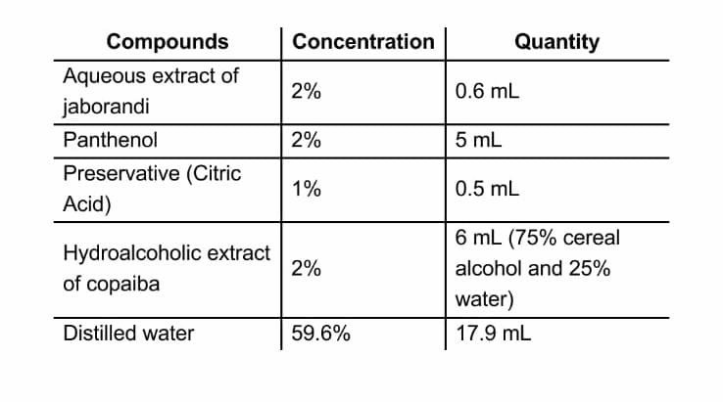
Source: author, 2024.
The tonic was produced satisfactorily from a simple mixture of the compounds, 0.6ml of aqueous extract of Pilocarpus jaborandi, 5ml of panthenol, 0.5ml of citric acid (preservative) and 6ml of the hydroalcoholic extract of copaiba. Everything was mixed together and then placed in the chosen container and stored in an airy, dark place. 4.2 Relevance of this study
In order to prove the relevance of the study and the veracity of the problem discussed, a survey was carried out using a form, which indicated the prevalence of data that reaffirms the significance of the study, in the population studied (table 2) it is possible to observe the difficulties, preferences and reliability of the group when obtaining a herbal product. Thus, confirming the theory addressed in the study, regarding lack of access and high costs, highlighting the need to create a product that fully serves patients.
Table 2. Research relevance of the study.
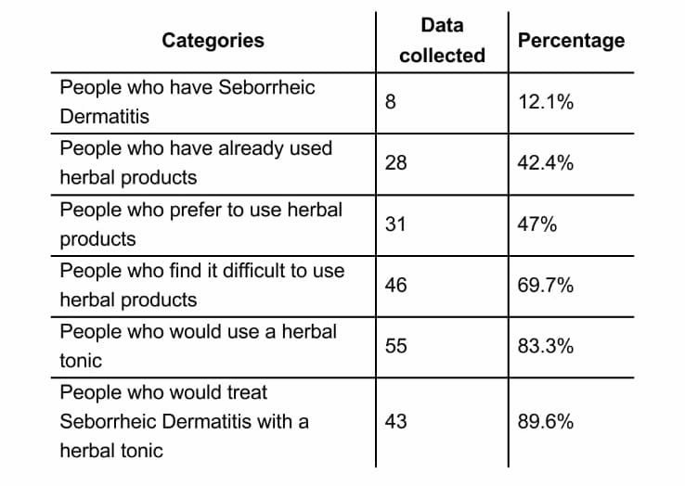
Source: author, 2024.

4.3 Testing stage
Following the Quality Control Guide for Cosmetic Products (ANVISA, 2007), physical and chemical tests were carried out in order to ascertain and prove the quality and healthiness of the hair tonic. In summary, satisfactory results were obtained, within the standards established by ANVISA.
The organoleptic tests were carried out on two different samples of the tonic, which were checked for smell, color and a pleasant sensation to the touch. Table 3 shows the results of each analysis. In addition, the pH test was also carried out on two different samples and there were no variations, even in different media and prepared at different times. It is therefore worth noting that the product meets the required standards. Table 3. Sample analysis
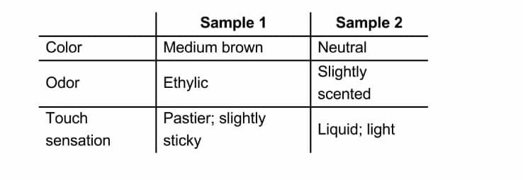
Source: author, 2024.
As for the density test, it was carried out using a pycnometer, only once, the sample was measured and after following the entire protocol, the calculation was carried out and the density found was 1.250 g/mL, thus meeting the standard established for cosmetics.
Table 4: pH and density test.
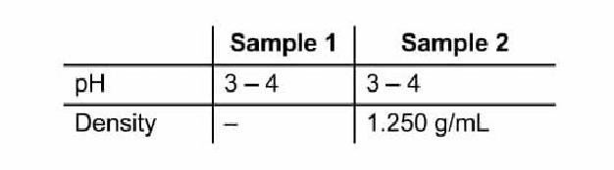
Source: author, 2024
The microbiological tests were carried out in duplicate and the plates analyzed were not contaminated, nor did they allow the growth of moulds and yeasts, except for the analysis of mesophiles, in which one colony grew, as shown in the table. However, it was not possible to carry out the Staphylococcus aureus analysis, as the Mannitol-salt plates were contaminated, indicating that there had been some carelessness during the preparation of the media and the plates were unusable. So, with regard to these studies that determine the viability of the cosmetic to provide an ideal environment for the development of microorganisms, we have incomplete data, but it still points to the non-contamination of the hair tonic.
Table 5 Microbiological tests

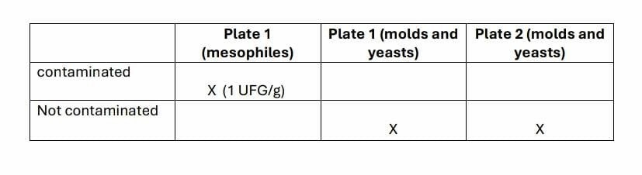
Source: author, 2024.

4.4 Flavonoids
Flavonoids are antioxidant and anti-inflammatory compounds that are extremely important for ensuring the efficacy of hair tonics. For this reason, a methodology was used that was capable of detecting and indicating the presence of flavonoids in the extract, which proved to be positive, as evidenced by the change in the color of the extract to an orange tone, which is equivalent to the presence of flavone, a subtype of flavonoids. The presence of flavonoids in the product is therefore proven, indicating a likelihood of success for the properties explored in this study.
The results obtained from using the tonic to help treat seborrheic dermatitis show a promising alternative for managing the disease. The composition of jaborandi extract with copaiba oil is potentially effective in helping to treat the symptoms of dermatitis. Compared to conventional treatments, such as antifungal shampoos and topical corticosteroids, the jaborandi and copaiba tonic presents a more natural and less aggressive approach, not only for the individual, but also for nature. However, conventional treatments, although more intensive and with immediate results, are often associated with side effects, such as scalp irritation and microbial resistance, as well as being more expensive on the market. Therefore, the use of herbal medicine can offer a less aggressive alternative that is more affordable for the patient, as well as generating less waste to dispose of. Furthermore, despite the encouraging results, this study has some limitations, such as the lack of direct tests on the Malassezia furfur fungus and the short duration of follow-up. Future research should involve a larger number of participants and longer observation periods to confirm these findings and better understand the mechanisms of action of the active compounds. Standardizing the concentration of the jaborandi and copaiba extracts is also crucial to ensure the consistency of the results. The hair tonic based on jaborandi and copaiba has therefore emerged as a promising, natural alternative to support the treatment of seborrheic dermatitis, offering and enabling an improvement in patients' quality of life. However, more studies are needed to confirm its long-term efficacy and safety.

6. FINAL CONSIDERATIONS
Therefore, the components of Pilocarpus jaborandi have vasodilating, antioxidant, anti-inflammatory and antimicrobial actions. In addition to promoting various benefits for the treatment of hair problems, such as cell renewal, stimulation of hair growth, moisturizing and anti-dandruff action. Among the substances present in the leaves of Pilocarpus Jaborandi, pilocarpine, the active ingredient explored in this study, which has a high vasodilating action, enables the normalization of the follicle cycle, acting directly on the scalp. Copaiba, a plant also explored during the study, has various therapeutic properties, such as antiinflammatory, healing, antiseptic, antibacterial, germicidal, antitumor and analgesic action. However, the prevalence of each activity depends on the species. Copaiba oil is full of sesquiterpenes and diterpenes, which are the active ingredients that give the leaves their properties. And studies have already proven the substance's susceptibility. Thus, the use of jaborandi and copaiba is very promising for helping to treat SD, since the tests and bibliographical research point to the efficacy and guarantee of the expected action of the product and the increase in its potential when compiling the elements. Finally, the study achieved the desired result and fulfilled the objective of exploring the behavior of each component in the face of the problem presented, and the tests carried out highlighted the properties and advantages associated with the use of phytotherapics, thus bringing more visibility and corroborating the development of studies that promote the growth of the use of phytotherapic products, since they are more beneficial to human health and the environment.
REFERENCES
[1] CAMARGO JUNIOR, Flavio Bueno de.

Development of cosmetic formulations
containing panthenol and evaluation of their moisturizing effects on human skin by cutaneous bioengineering. 2006. Dissertation (Master's Degree in Medicines and Cosmetics) - Ribeirão Preto School of Pharmaceutical Sciences.
Preto, University of São Paulo,
Ribeirao Preto, 2006. doi:10.11606/D.60.2006.tde-17012007-143439.
Accessed on: 2024-05-23.
[2] CARVALHO, L. O.; MILKE, L. T.

Importância Terapêutica Óleo-resina de Copaíba: Enfoque para Ação Anti-inflamatória e Cicatrizante. Revista Eletrônica de Farmácia,
Goiânia, v. 11, n. 2, p. 12, 2014. DOI:
10.5216/ref.v11i2.27852.
Available at: https://revistas.ufg.br/REF/article/view/27852.
Accessed on: April 8, 2024.
- CASAGRANDI, Isabela. Seborrheic
Dermatitis: A Literature Review on General Aspects. Barra Funda, SP: 2020. Available at:
Primum Journal
https://bwsjournal.emnuvens.com.br ' ...PDF Seborrheic dermatitis: a literature review on general aspects. Accessed on: 05/03/2024
- FORMARIZ, Thalita; SPERA, Luigina; CONCENZA, Maria Cristina; CINTO, Priscila.
Seborrheic Dermatitis: Causes, Diagnosis and Treatment. Araraquara, SP: 2005.
Available at:
https://www.cff.org.br/sistemas/geral/revista/pdf/72
/i06-infdermatite.pdf. Accessed on: 25/09/2023
- LIMA, Cristina Gizelle. COMARELLA,

Larissa. Suggestion for the Development of
Auxiliary Soap-Shampoo Formulations for the Treatment of Seborrheic Dermatitis. Brazil: May 6, 2013. Available at: https://revista.uniandrade.br/index.php/revistaunian drade/article/view/43Vhttps://revis ta.uniandrade.br/index.php/revistauniandrade/article
/view/43. Accessed 25/09/2023.
[6] SANTOS, Francisco; et al. Use of Coconut Oil

(Attalea speciosa) as an Emollient in a
Phytocosmetic Formulation with Moisturizing Action. Imperatriz - MA: 2020. Available at: http://ojs.unirg.edu.br/index.php/1/article/download
/3227/1708 Accessed on: 23/04/2024
[7] TINOCO, Érica Ellen; SOUSA, Keliane; Marques, Maria José; Silva, Natalia Cristina.

Development of a Hair Tonic Using Pilocarpus Extract
Jaborandi. Iapu, MG: 2021. Available at: http://www.mastereditora.com.br/bjscr.
Accessed on: 05/03/2024

