**ARÉA TEMÁTICA:** Ecologia

**SUBÁREA TEMÁTICA:** Invertebrados

**PERFORMANCE OF NATIVE AND EXOTIC BENTHIC MACROINVERTEBRATES UNDER**

**EXTREME CLIMATE SCENARIOS IN THE SEMI-ARID REGION**

Dalescka Barbosa de Melo1*, Franciely Ferreira Paiva1, Lívia Maria Osório de Sousa1, Joseline Molozzi 1

¹ Universidade Estadual da Paraíba (UEPB), Campus Campina Grande. E-mails (DBM): dalescka@gmail.com; (FFP): [franciely.paiva@aluno.uepb.edu.br](mailto:franciely.paiva@aluno.uepb.edu.br); (LMOS): livia.sousa@ aluno.uepb.edu.br; (JM): jmolozzi@servidor.uepb.edu.br.

**INTRODUCTION**

Precipitation has a direct influence on the survival of species, especially in freshwater aquatic ecosystems, which are totally dependent on rainwater for the maintenance (Chesson et al., 2004). Climate change scenarios tend to favour severe changes in global precipitation rates (IPCC, 2022). In this case, in semi-arid regions whose climate is dry and hot due to few annual precipitation cycles, climate change tends to promote more extreme droughts (Melo et al., 2022). This leads to changes in water volume level, the ecological quality of aquatic ecosystems and consequently implications for species diversity and functionality (Melo et al., 2022; Paiva et al., 2023).

Although, the extreme drought severe conditions can limit the ecological success of some species at the same time can promote a suitable environment to dominance exotic species that had width range abiotic tolerance (Jovem-Azevêdo et al., 2021) making them strong competitors and a threat to native species (Crespo et al., 2021). In view of this, the aim of this study was to assess how changes in water volume levels caused by extreme drought affect exotic and native benthic macroinvertebrates in semi-arid reservoirs.

**MATERIAL AND METHODS**

***Study area***

The study was conducted in the reservoirs of two river basins, the Paraíba River (Cordeiro, Sumé and Poções) and Piranhas-Açu River (Cruzeta, Sabugí and Passagem das Traíras) located in Northeast Brazil’ semi-arid region. The classification of the region is BSh climate – dry semi-arid, with temperature varying between 18º and 31ºC, and an average precipitation of 400 mm/year according to Köppen-Geiger classification (Alvares et al., 2013).

***Biological and environmental characterization***

A total of 256 points were sampled in the edge region during the years 2014, 2015 and 2019. This was the period of the most extreme drought which occurred in last 50 years in the Brazilian semi-arid region. The sediment was sampled using an Eckman-Birge dredger (225 cm²) to collect benthic macroinvertebrates. In the laboratory, samples were washed in running water using 0.5 mm mesh sieves. The organisms were then separated and identified to the lowest possible taxonomical level (Trivinho-Strixino & Strixino, 1995).

Water volume data of the reservoirs were obtained from the Executive Water Management Agency (AESA), National Water Agency (ANA) platforms online. When analyzing the water volume in the collection years, it was possible to establish three categories of water volume: 1) volume < 10%, when the reservoirs reached between minimum water level and dead volume; 2) volume between 10 to 20%, when the reservoirs were between minimum water volume and useful volume; and 3) volume > 20%, since none reservoirs analyzed managed to reach 50% of their maximum water storage capacity.

***Data analysis***

In order to assess the differences in the benthic macroinvertebrate’s abundance (exotic and native separately) between the water volume categories a Multivariate Permutational Analysis of Variance was performed (PERMANOVA, Anderson et al., 2008) under a Bray-Curtis distance. Subsequently to assess the change partner and tipping points in the abundance and frequency of exotic and native organisms in relation to the water volume gradient a Threshold Indicator Taxa Analysis was performed (TITAN, Baker & King, 2010). All analyses were performed in the R software version 3.5.1 (R Development Core Team, 2017).

**RESULTS AND DISCUSSION**

In basins, a total of 23408 benthic macroinvertebrates were found, with 8079 native individuals of the Chironomidae family and 15329 exotic individuals of the specie *Melanoides tuberculata* (Muller 1774). There were differences in native abundance between water volume categories (F2.196 = 7.24; p= 0.0001), but not significant for the exotic (F2.163 = 0.35; p= 0.8885). The TITAN analysis showed that the exotic species *M. tuberculata* had a higher occurrence in water volume < 20%, while some native taxa, such as *Clinotanypus* (Kieffer 1913)and *Saetheria* (Jackson 1977) genera were associated with water volume <10% (Figure 1). Only native taxa, such as *Parachironomus* (Lenz 1921)and *Asheum* (Sublette 1964) were associated with volume < 20% (Figure 1).

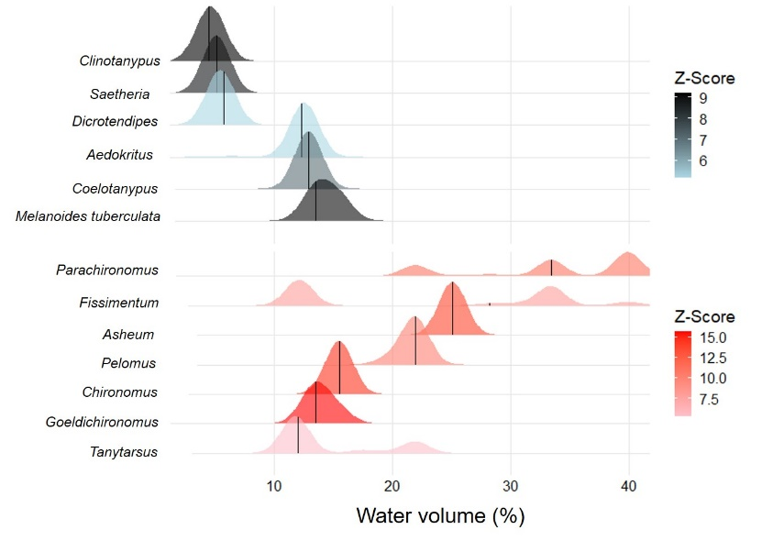

Figure 1. TITAN analysis results of the frequency and abundance of the benthic macroinvertebrates (exotic and native) in the reservoirs in relation to water volume gradient.

The reservoirs in this study have a history of environmental impact (Paiva et al., 2023), and when in situations of minimum water volume and dead volume, the environmental quality of this ecosystems declines even further (Melo et al., 2022). In this sense, the high abundance of exotic species, as well as their persistence regardless of the water volume level is justified. Severe environmental conditions associated with different water volume level favour the high fecundity, density and dispersion rates of this species (Paiva et al., 2018). However, as has also observed, some native organisms can withstand low water volume levels because these organisms have the potential to colonize different habitat types, including those most impacted, as they are considered generalist species (Vodopich & Cowell, 1984; Higuti & Takeda, 2002; Henriques-Oliveira et al., 2003).

The presence of some native species only at higher water volume indicates these species are more sensitive to the water stress conditions caused by low volumes, as also observed by Melo et al., (2022). This study, showed that as the volume decreases, the frequency and abundance of exotic species remain while native species decreases. Scenario like this can lead to a loss of the functions these native species perform in the ecosystems.

**CONCLUSIONS**

Climate change manifested in extreme drought causes severe change in aquatic ecosystems, which affects the structure of communities so that organisms react differently to such conditions. In our study, some species were favored even in the most critical volume situation, showing ecological success due to their tolerant habits, as evidenced by high frequency and abundance. On the other hand, not all organisms showed the same tolerant potential since the occurrence was recorded only when the reservoirs reached higher volumes.

Therefore, the differences in tolerance of benthic macroinvertebrates in reservoirs to volume decline directly affect the ecosystem dynamic, leading to the loss of native species and likely the loss ecosystem functions performed by these organisms. Consequently, this can lead to less resistant and/or resilient macrobenthic communities, especially when future predictions indicate a greater frequency of extreme drought in semi-arid regions in the face of climate change.

**REFERENCES**

Alvares, C. A.; Stape, J. L.; Sentelhas, P. C.; Moraes, G.; Leonardo, J.; Sparovek, G. 2013. Köppen's climate classification map for Brazil. Meteorologische Zeitschrift, v. 22, p. 711-728.

Anderson, M., Gorley, R., & Clarke, K. P. 2008. for Primer: Guide to Software and Statistical Methods; PRIMER-e: Plymouth, UK.

Baker, M.E., King, R.S. 2013. Of TITAN and straw men: an appeal for greater understanding of community data. *Freshwater* Sciece. 32 (2), 489–506.

Chesson, P., Gebauer, R. L., Schwinning, S., Huntly, N., Wiegand, K., Ernest, M. S., ... & Weltzin, J. F. 2004. Resource pulses, species interactions, and diversity maintenance in arid and semi-arid environments. Oecologia, 141, 236-253.

Crespo, D., Leston, S., Rato, L. D., Martinho, F., Novais, S. C., Pardal, M. A., & Lemos, M. F. 2021. Does an Invasive Bivalve Outperform Its Native Congener in a Heat Wave Scenario? A Laboratory Study Case with Ruditapes decussatus and R. philippinarum. Biology, *10*(12), 1284.

Henriques-Oliveira, A. L.; Nessimian, J. L.; Dorvillé, L. F. M. 2003. Feeding habits of chironomid larvae (Insecta: Diptera) from a stream in the Floresta da Tijuca, Rio de Janeiro, Brazil. Brazilian Journal of biology, v. 63, p. 269-281.

Higuti, J.; Takeda, A. M. 2002. Spatial and temporal variation in densities of chironomid larvae (Diptera) in two lagoons and two tributaries of the upper Paraná River floodplain, Brazil. Brazilian Journal of Biology, v. 62, p. 807-818.

IPCC: Annex III: Scenarios and modelling methods, in: IPCC, 2022: Climate Change 2022: Mitigation of Climate Change. Contribution of Working Group III to the Sixth Assessment Report of the Intergovernmental Panel on Climate Change, Cambridge University Press, Cambridge, UK and New York, NY, USA.

Jovem-Azevêdo, D., Bezerra-Neto, J. F., Feio, M. J., Fernandes, R., Gomes, W. I. A., Thomaz, S. M., & Molozzi, J. 2021. Modelling the abundance of a non-native mollusk in tropical semi-arid reservoirs. Hydrobiologia, 1-15.

Melo, D. B., Dolbeth, M., Paiva, F. F., & Molozzi, J. 2022. Extreme drought scenario shapes different patterns of Chironomid coexistence in reservoirs in a semi-arid region. Science of The Total Environment, 153053.

Paiva, F. F., Gomes, W. I. A., Medeiros, C. R., Álvaro, É. L. F., Ribeiro, I. M. S., & Molozzi, J. 2018. Environmental factors influencing the occurrence of alien mollusks in semi-arid reservoirs. Limnetica, *37*(2), 187-198.

Paiva, F. F., Melo, D. B., Dolbeth, M., & Molozzi, J. 2023. Functional threshold responses of benthic macroinvertebrates to environmental stressors in reservoirs. Journal of Environmental Management, *329*, 116970.

Trivinho-Strixino, S., & Strixino, G. 1995. Larvas de Chironomidae (Diptera) do Estado de São Paulo: guia de identificação e diagnose dos gêneros.

Vodopich, D. S.; Cowell, B. C. 1984. Interaction of factors governing the distribution of a predatory aquatic insect. *Ecology*, v. 65, p. 39-52.